Nama : Bima Hayu Nugraha

NIM : 20190140031

Kelas : A

Matkul : Pengembangan Aplikasi Terdistribusi (PAT)

**Tugas Praktikum 10**

1. 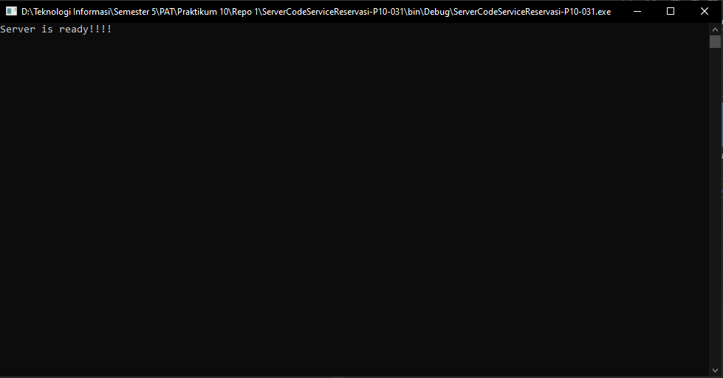**Screenshot Tampilan Hasil Run Server Reservasi**

Gambar 1 Screenshot Tampilan Hasil Run Server Reservasi

1. **Graphical user interface

   Description automatically generatedScreenshot Tampilan Awal Client Reservasi**

Gambar 2 Screenshot Tampilan Awal Pada Form Client Reservasi

1. **Graphical user interface

   Description automatically generatedScreenshot Tampilan Saat Simpan Data**

Gambar 3 Screenshot Tampilan Saat Sukses Menyimpan Data

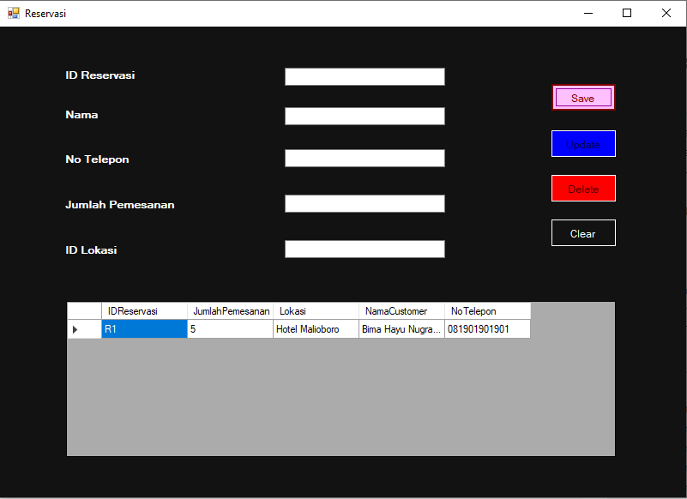

Gambar 4 Screenshot Tampilan Data Yang Muncul Setelah Sukses Menyimpan Data

1. 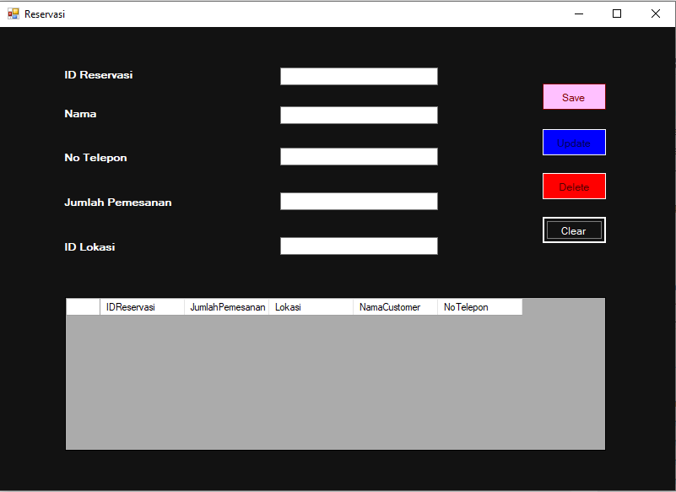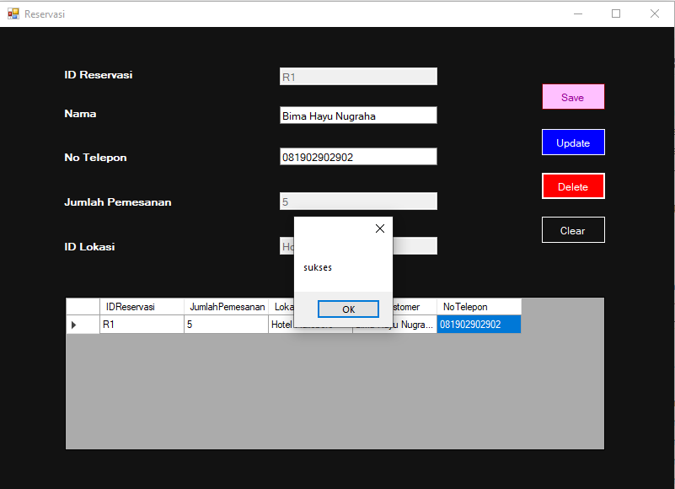**Screenshot Tampilan Saat Delete Data**

Gambar 5 Screenshot Tampilan Data Terhapus Setelah Sukses Delete Data

Gambar 6 Screenshot Tampilan Saat Sukses Delete Data

1. 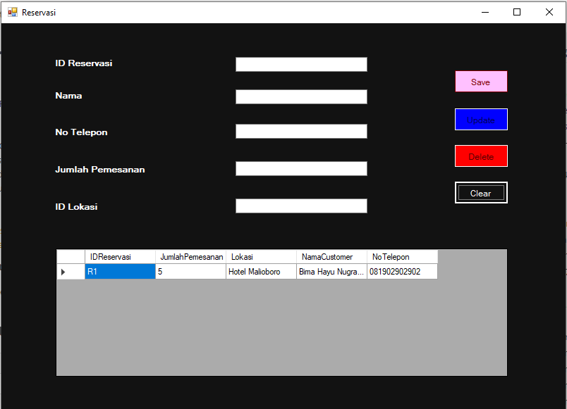**Graphical user interface

   Description automatically generatedScreenshot Tampilan Saat Update Data**

Gambar 7 Screenshot Tampilan Data No Telepon Terupdate Setelah Sukses Update Data

Gambar 8 Screenshot Tampilan Saat Sukses Update Data

**Link Github:**

1. **Server Reservasi:** <https://github.com/PAT-A-2021/ServerReservasi-031>
2. **Client Reservasi:** <https://github.com/PAT-A-2021/ClientReservasi-031>