**LAB 1**

Q1. Write a Java program to print "Hello, World!" to the console.

**Program:**

**package** com.example.myapp;

**public** **class**

{

**public** **static** **void** main(String[] args) {

// **TODO** Auto-generated method stub

System.***out***.println("Hello World");

}

}

Q2. Write a program to find the sum of two numbers entered by the user.

**Programe:**

**package** com.example.myapp;

**import** java.util.Scanner;

**public** **class** SumOfTwoNumbers

{

**public** **static** **void** main (String[]args)

{

**try**(Scanner scanner=**new** Scanner(System.***in***))

{

System.***out***.println("Enter the first number:");

**int** num1=scanner.nextInt();

System.***out***.println("Enter the second number:");

**int** num2=scanner.nextInt();

**int** sum=num1+num2;

System.***out***.println("The sum of two number is:"+sum);

}

}

}

Q3.Write a Java program to check whether a given number is even or odd.

**Programe:**

**package** com.example.myapp;

**import** java.util.Scanner;

**public** **class** WheatherEvenOrOdd

{

**public** **static** **void** main(String[] args)

{

Scanner scanner = **new** Scanner(System.***in***);

System.***out***.println("Enter a number: ");

**int** number = scanner.nextInt();

**if** (*isEven*(number))

{

System.***out***.println(number + " is even.");

} **else**

{

System.***out***.println(number + " is odd.");

}

}

**public** **static** **boolean** isEven(**int** number)

{

**return** number % 2 == 0;

}

}

Q4. Write a java program to find greatest of 2 numbers.

**Programe:**

**package** com.example.myapp;

**import** java.util.Scanner;

**public** **class** GreatestOfTwo

{

**public** **static** **void** main(String[] args) {

Scanner scanner = **new** Scanner(System.***in***);

System.***out***.println("Enter the first number: ");

**int** num1 = scanner.nextInt();

System.***out***.println("Enter the second number: ");

**int** num2 = scanner.nextInt();

**int** greatest = *findGreatest*(num1, num2);

System.***out***.println("The greatest number is: " + greatest);

}

**public** **static** **int** findGreatest(**int** a, **int** b) {

**if** (a > b) {

**return** a;

} **else** {

**return** b;

}

}

}

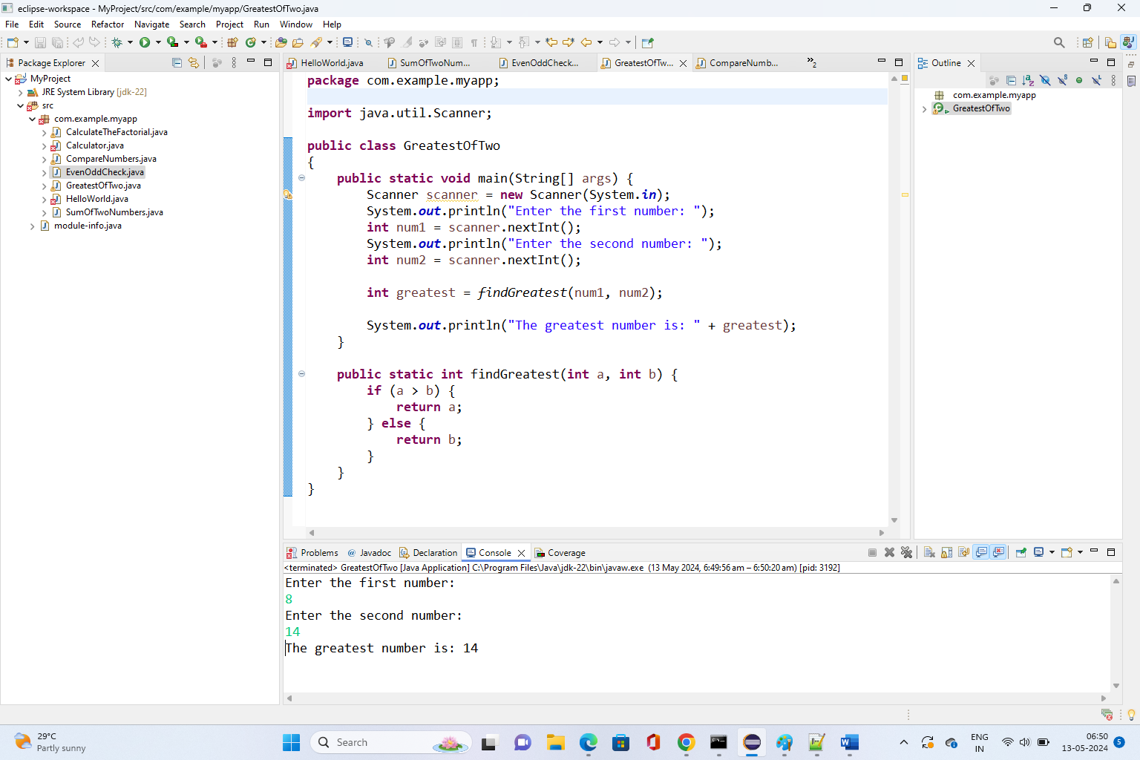

Q5.Write a program to implement a basic calculator that takes input as a string expression and evaluates it.

**Programe:**

**package** Demo;

**import** java.util.Scanner;

**public** **class** Calci {

**public** **static** **void** main(String[] args) {

Scanner s = **new** Scanner(System.***in***);

**float** a, b;

**float** c = 0;

**char** op;

System.***out***.println("Select an operator: +,-,*,/");

System.***out***.print("Operator: ");

op = s.next().charAt(0);

System.***out***.print("Enter first number: ");

a = s.nextFloat();

System.***out***.print("Enter second number: ");

b = s.nextFloat();

**if** (op == '+') {

c = a + b;

} **else** **if** (op == '-') {

c = a - b;

} **else** **if** (op == '*') {

c = a * b;

} **else** **if** (op == '/') {

**if** (b != 0) {

c = a / b;

} **else** {

System.***out***.println("Error: Division by zero is not allowed.");

}

} **else** {

System.***out***.println("Invalid operator. Please try again.");

}

**if** (c != 0) {

System.***out***.println("Result: " + c);

}

s.close();

}

}

Q6.Write a Java program to check if a given number is even or odd.

**Programe:**

**package** com.example.myapp;

**import** java.util.Scanner;

**public** **class** EvenOddCheck

{

**public** **static** **void** main(String[]args)

{

**try**(Scanner sc=**new** Scanner(System.***in***))

{

System.***out***.print("Enter the number =");

**int** num = sc.nextInt();

**if**(num % 2 == 0)

{

System.***out***.print("Enter number is even");

}

**else**

{

System.***out***.print("Enter number is odd");

}

}

}

}

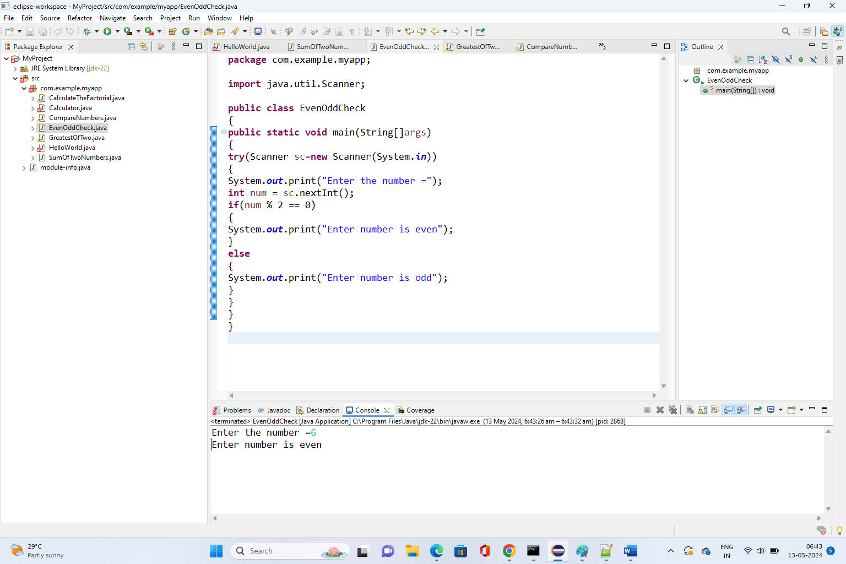

Q7.Create a Java program that compares two numbers and prints the larger one.

**Programe:**

**package** com.example.myapp;

**import** java.util.Scanner;

**public** **class** CompareNumbers

{

**public** **static** **void** main(String[] args) {

Scanner scanner = **new** Scanner(System.***in***);

System.***out***.println("Enter the first number: ");

**int** num1 = scanner.nextInt();

System.***out***.println("Enter the second number: ");

**int** num2 = scanner.nextInt();

**if** (num1 > num2) {

System.***out***.println(num1 + " is larger.");

} **else** **if** (num2 > num1) {

System.***out***.println(num2 + " is larger.");

} **else** {

System.***out***.println("Both numbers are equal.");

}

}

}

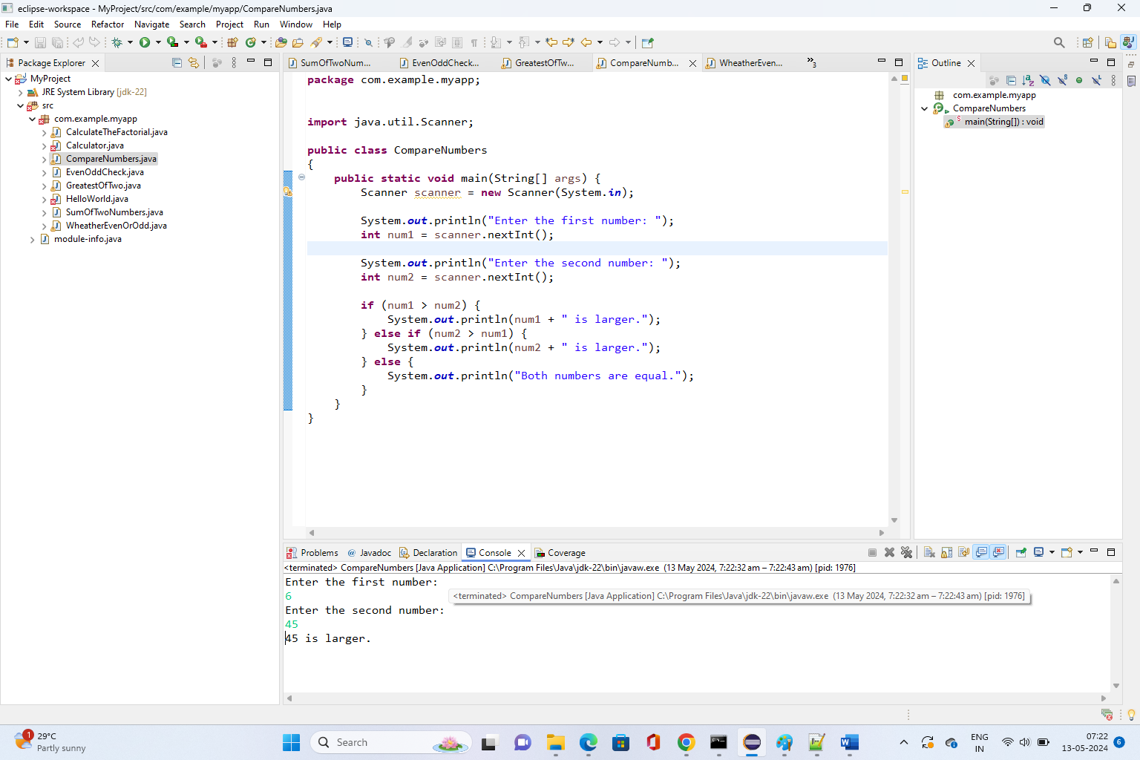

Q8.Write a Java program that takes an age input from the user and determines if they are eligible to vote (considering the legal voting age).

**Programe:**

**package** com.example.myapp;

**import** java.util.Scanner;

**public** **class** VotingAge

{

**public** **static** **void** main(String[] args)

{

Scanner scanner = **new** Scanner(System.***in***);

System.***out***.println("Enter your age: ");

**int** age = scanner.nextInt();

**if** (*isEligibleToVote*(age))

{

System.***out***.println("You are eligible to vote.");

}

**else**

{

System.***out***.println("You are not eligible to vote.");

}

}

**public** **static** **boolean** isEligibleToVote(**int** age)

{

// Assuming the legal voting age is 18

**return** age >= 18;

}

}



