
Product Dissection for
YouTube
Schema Design, ER Diagram & Platform Case Study

1. Platform Understanding

Company Overview
YouTube is the world's largest video-sharing platform, launched in February 2005 by Steve Chen, Chad Hurley, and Jawed Karim. Acquired by Google in 2006 for $1.65 billion, it now attracts over 2.7 billion logged-in users per month and hosts more than 800 million videos. Every minute, over 500 hours of video content is uploaded to the platform.
YouTube operates as a multi-sided platform connecting four key stakeholders:
- Viewers: consume content on-demand across devices
- Creators: upload, monetize, and grow their audience
- Advertisers: run targeted ad campaigns via Google Ads
- Developers: integrate YouTube data via the YouTube Data API

Platform Type
Platform Category: Entertainment / Social Media / User-Generated Content (UGC)
Database Suitability: Highly suitable for relational database design due to structured entities (users, videos, comments, subscriptions) with clear many-to-many and one-to-many relationships.

2. Product Dissection & Real-World Problems Solved
YouTube's design philosophy is built around solving tangible real-world problems at scale. Below are the key challenges and YouTube's solutions:

Problem 1: Limited Access to Knowledge & Education
Challenge: In remote or under-resourced areas, quality education is expensive or inaccessible. Traditional learning methods fail to accommodate diverse learning styles.
YouTube's Solution: Free educational library with channels like Khan Academy and CrashCourse. Playlists, Chapters, subtitles, and multi-language support democratize learning globally.

Problem 2: Difficulty in Discovering Relevant Content
Challenge: With billions of videos, users struggle to find high-quality content matching their interests without getting overwhelmed.
YouTube's Solution: An advanced recommendation engine powered by AI/ML that curates personalized video feeds based on watch history, search behavior, and user preferences. The Trending tab and category browsing further aid discovery.

Problem 3: Lack of Creative Monetization Opportunities
Challenge: Aspiring creators struggle to earn income from their content. Traditional media has high entry barriers, limiting opportunities for independent talent.
YouTube's Solution: YouTube Partner Program (YPP) enables monetization via ads, channel memberships, Super Chats, and Super Thanks. YouTube Shorts and merchandise integrations open further income streams.

Problem 4: Language & Accessibility Barriers
Challenge: Global audiences face language barriers and accessibility challenges when consuming video content.
YouTube's Solution: Auto-generated captions in 10+ languages, community-submitted subtitles, playback speed controls, and audio descriptions make the platform inclusive for diverse audiences worldwide.

3. Case Study: User Problems & YouTube's Innovative Features
Meet Riya — a 22-year-old engineering student from a small town in Rajasthan. She wants to learn advanced data structures for her placement exams but cannot afford coaching. Through YouTube, she discovers free structured playlists from top educators, follows channels, enables notifications, and uses playback speed controls. Within weeks, she cracks her campus interview — all at zero cost.
This story reflects how YouTube's core features directly solve real problems. The table below maps user challenges to platform features:

User Challenge | YouTube Feature | Outcome
No access to quality education | Free educational channels + Playlists | Self-paced structured learning
Can't find relevant videos | Recommendation Engine + Trending | Personalized content discovery
Creator wants to earn income | YouTube Partner Program (YPP) | Sustainable creator economy
Language barrier | Auto-captions + Multilingual subtitles | Global content accessibility
Missing new uploads | Subscriptions + Notification Bell | Real-time creator-audience connect
Disorganized content | Playlists + Tags + Chapters | Structured navigation experience

4. Top Features of YouTube
- User Channels: Creators set up personalized channels with banners, profile pictures, and About sections representing their brand or identity.
- Video Uploads: Core feature enabling content upload in multiple formats. Creators control title, description, tags, thumbnails, and visibility (public/private/unlisted).
- Engagement Tools: Likes, dislikes, comments, shares, Save to Playlist, and Watch Later empower interactive viewer participation.
- Subscriptions: Viewers subscribe to channels; the notification bell ensures real-time alerts for new videos and live streams.
- YouTube Recommendations: AI-driven algorithm on the Home and Up Next feed curates personalized video suggestions based on behavior.
- Playlists & Tags: Organize related videos for structured navigation; tags improve discoverability across search and browse.
- YouTube Shorts: Short-form video format (up to 60 seconds) for quick-consumption content and creative expression.
- Live Streaming: Real-time broadcasts with Super Chats, polls, and live chat for creator-audience interaction.
- YouTube Partner Program: Monetization ecosystem: ad revenue, channel memberships, merchandise shelf, and Super Thanks.

5. Schema Design
The YouTube schema is built around 7 core entities interconnected through well-defined relationships. The design follows 3rd Normal Form (3NF) to eliminate redundancy and ensure data integrity.

5.1 User Entity
Attribute | Type | Description
UserID | INT (PK) | Unique identifier for each user account
Username | VARCHAR(50) | Chosen display name for the account
Email | VARCHAR(100) | Email address for login and communication
Full_Name | VARCHAR(100) | User's full name (optional)
Bio | TEXT | Channel About section or personal bio
Profile_Picture_URL | VARCHAR(255) | Link to profile picture image
Registration_Date | DATE | Date the user registered on YouTube
Country | VARCHAR(50) | User's country for regional content
Account_Type | ENUM | Viewer, Creator, or Both

5.2 Video Entity
Attribute | Type | Description
VideoID | INT (PK) | Unique identifier for each video
UserID | INT (FK) | References the creator (User Entity)
Title | VARCHAR(255) | Video title shown on cards and in search
Description | TEXT | Detailed description with links and context
Video_URL | VARCHAR(255) | Streaming URL of the video file
Thumbnail_URL | VARCHAR(255) | Preview image shown on video cards
Upload_Date | DATETIME | Timestamp when the video was uploaded
Duration | INT | Video length in seconds
Category | VARCHAR(50) | Genre: Education, Music, Gaming, etc.
View_Count | BIGINT | Total number of views
Visibility | ENUM | Public, Private, or Unlisted
Status | ENUM | Active, Deleted, or Under Review

5.3 Comment Entity
Attribute | Type | Description
CommentID | INT (PK) | Unique identifier for each comment
VideoID | INT (FK) | References the video being commented on
UserID | INT (FK) | References the commenter (User Entity)
Parent_CommentID | INT (FK) | References parent comment (for replies)
Text | TEXT | The text content of the comment
Comment_Date | DATETIME | Timestamp when comment was posted
Like_Count | INT | Number of likes the comment has received

5.4 Like Entity
Attribute | Type | Description
LikeID | INT (PK) | Unique identifier for each reaction
VideoID | INT (FK) | References the video being reacted to
UserID | INT (FK) | References the user giving the reaction
Like_Type | ENUM | Like or Dislike
Like_Date | DATETIME | Timestamp when the reaction was recorded

5.5 Subscription Entity
Attribute | Type | Description
SubscriptionID | INT (PK) | Unique identifier for the subscription
SubscriberUserID | INT (FK) | User who is subscribing
ChannelUserID | INT (FK) | Creator/channel being subscribed to
Subscription_Date | DATETIME | When the subscription was initiated
Notification_Enabled | BOOLEAN | Whether bell notifications are on

5.6 Tag Entity
Attribute | Type | Description
TagID | INT (PK) | Unique identifier for the tag
Tag_Text | VARCHAR(100) | The keyword or phrase (e.g., python, cooking)

5.7 VideoTag Entity (Junction Table)
Attribute | Type | Description
VideoTagID | INT (PK) | Unique identifier for the association
VideoID | INT (FK) | References the tagged video
TagID | INT (FK) | References the tag applied to the video

6. Schema Relationships
The following table defines all relationships between entities, their cardinality, and the business logic they represent:

From Entity | Relationship | To Entity | Description
User | 1 : Many | Video | A creator uploads multiple videos; each video belongs to one creator
User | 1 : Many | Comment | A user can post multiple comments; each comment has one author
Video | 1 : Many | Comment | A video can have many comments; each comment belongs to one video
Comment | 1 : Many | Comment | A comment can have many replies (self-referential relationship)
User | 1 : Many | Like | A user can like/dislike many videos
Video | 1 : Many | Like | A video can receive many likes/dislikes
User | Many : Many | User | Users subscribe to other users (via Subscription table)
Video | Many : Many | Tag | Videos have multiple tags; tags are reused across videos (via VideoTag table)

7. ER Diagram
The ER Diagram below visually represents all 7 entities of YouTube's schema — Users, Videos, Comments, Likes, Subscriptions, Tags, and VideoTags — along with their attributes, primary keys, foreign keys, and relationships. Created using dbdiagram.io.

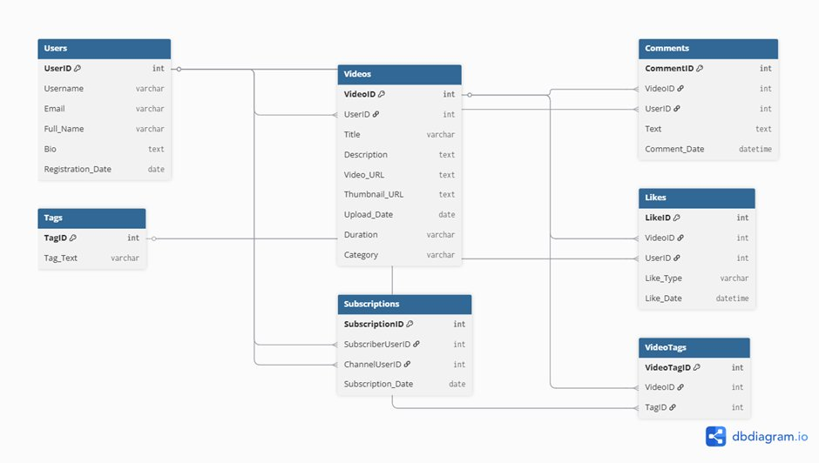
Figure 1: YouTube Schema ER Diagram (Source: dbdiagram.io)

Reading the ER Diagram
- Users → Videos (1:Many): One user (creator) can upload many videos. UserID is a foreign key in the Videos table.
- Videos → Comments (1:Many): One video can have many comments. VideoID is a foreign key in the Comments table.
- Users → Comments (1:Many): One user can post many comments. UserID is a foreign key in the Comments table.
- Videos → Likes (1:Many): One video can receive many likes/dislikes. VideoID is a foreign key in the Likes table.
- Users → Likes (1:Many): One user can like/dislike many videos. UserID is a foreign key in the Likes table.
- Users → Subscriptions (Many:Many): Users subscribe to other users. The Subscriptions table holds SubscriberUserID and ChannelUserID, both referencing Users.
- Videos ↔ Tags (Many:Many): One video can have many tags; one tag can appear on many videos. The VideoTags junction table resolves this with VideoID + TagID.

8. Rationale Behind Design Choices

Why Each Table is Needed
- User Table: Every action on YouTube is user-centric. Without a User table, no content, interactions, or personalization is possible.
- Video Table: Core content entity. Stores metadata essential for search, recommendation, and playback.
- Comment Table: Enables community engagement. The self-referential FK (Parent_CommentID) allows threaded replies without a separate Replies table.
- Like Table: Separating likes into their own entity avoids nullable columns in the Video table and supports historical reaction tracking.
- Subscription Table: Models the many-to-many self-relationship between users cleanly. Also stores notification preferences.
- Tag & VideoTag Tables: Normalizing tags prevents duplication. A junction table handles the many-to-many Video-Tag relationship per 3NF.

Normalization Strategy
The schema adheres to 3NF: no repeating groups (1NF), no partial dependencies (2NF), and no transitive dependencies (3NF). For example, video Category is stored as a string rather than a separate Category table to balance normalization with query simplicity at YouTube's scale.

9. SQL / Implementation Thinking
Below are sample SQL CREATE statements that implement the schema in PostgreSQL:

CREATE TABLE Users (
UserID SERIAL PRIMARY KEY,
Username VARCHAR(50) UNIQUE NOT NULL,
Email VARCHAR(100) UNIQUE NOT NULL,
Registration_Date DATE DEFAULT CURRENT_DATE
);
CREATE TABLE Videos (
VideoID SERIAL PRIMARY KEY,
UserID INT REFERENCES Users(UserID),
Title VARCHAR(255) NOT NULL,
Upload_Date TIMESTAMP DEFAULT NOW()
);
-- Common JOIN query: Get all comments on a video
SELECT u.Username, c.Text, c.Comment_Date
FROM Comments c
JOIN Users u ON c.UserID = u.UserID
WHERE c.VideoID = 101 ORDER BY c.Comment_Date DESC;

Indexing considerations: VideoID and UserID are indexed as FK columns. Additional indexes on Upload_Date and View_Count support time-based and popularity queries efficiently.

10. Challenges, Optimizations & Future Improvements

Challenges Faced
- Identifying entities: Distinguishing what deserves its own table vs. an attribute. E.g., deciding whether Category warrants a separate lookup table.
- Many-to-many relationships: Handling User-User (subscriptions) and Video-Tag required junction tables, which adds query complexity.
- Self-referential relationships: Comments can be replies to other comments. Modeling this cleanly without a separate Replies table needed a nullable Parent_CommentID.
- Balancing simplicity vs. completeness: Deciding to exclude tables like Analytics, Ads, or Playlists to keep the schema focused yet functional.

Optimizations Applied
- ENUM types: Used for Like_Type, Visibility, and Account_Type to enforce valid values at the DB level.
- NOT NULL constraints: Applied on critical fields like Email and Title to ensure data integrity.
- Normalized Tags: Avoids tag string duplication across millions of videos by reusing TagID.

Future Improvements
- Playlist Entity: Add Playlists and PlaylistVideos tables to model the playlist feature structurally.
- Analytics Table: Track watch_time, retention_rate, and click_through_rate per video for creator analytics.
- Ad Entity: Model the YouTube Ads system with advertiser, campaign, and targeting tables.
- Partitioning & Sharding: At YouTube's scale, horizontal partitioning of the Videos table by Upload_Date would be essential for performance.
- Full-Text Search Index: Add GIN indexes on Title and Description for fast search queries.

Conclusion
This product dissection of YouTube demonstrates how a well-structured relational schema can model a complex, real-world platform with billions of interactions. The 7-entity design — Users, Videos, Comments, Likes, Subscriptions, Tags, and VideoTag — captures YouTube's core functionality while following normalization principles for scalability and consistency.
By understanding how features map to entities, attributes, and relationships, we gain insight into how data architecture drives user experience at scale. YouTube's success is not just a product of great features — it is equally a result of thoughtful data modeling that powers search, recommendations, monetization, and community engagement across the globe.

