Credit Risk Analysis
Data Visualization Project Documentation
PaisaBazaar Dataset | Power BI Dashboard

Prepared by: Pawan Prasad
April 2026

1. Project Title
Credit Risk Analysis using Power BI — PaisaBazaar Dataset

2. Dataset Name and Description

Dataset Name
PaisaBazaar Credit Dataset

Description
The PaisaBazaar dataset is a comprehensive financial dataset containing customer-level credit information from one of India's leading fintech and financial marketplace platforms. It includes a wide range of attributes that capture the credit behavior, financial habits, and risk profiles of customers.
Key attributes include:
- Credit Score Classification (Good, Standard, Poor)
- Number of Loans and Credit Accounts
- EMI to Income Ratio and Monthly Balance
- Payment History and Delayed Payments
- Credit History Age and Credit Utilization
- Investment Rate and Spending Pattern
- Minimum Payment Behavior
- Age Group Classification (Teen, Young, Middle, Senior)

3. Dashboard Objective
The primary objective of this project is:
- To identify high-risk customers before loan approvals using data-driven insights.
- To analyze credit behavior patterns across different demographic and financial segments.
- To help financial institutions reduce default risk by understanding customer financial profiles.
- To present complex credit data in a clear, interactive, and actionable format using Power BI.
Business Question: How can we identify high-risk customers before approving loans?

4. Tools and Technologies Used
Tool | Purpose
Python | Data analysis and preprocessing
Pandas & NumPy | Data cleaning and transformation
Matplotlib & Seaborn | Exploratory Data Analysis (EDA)
Power BI | Interactive dashboard creation and visualization

5. Dashboard Screenshots
The Power BI report consists of four interactive pages, each focusing on a different dimension of credit risk analysis.

5.1 Executive Summary
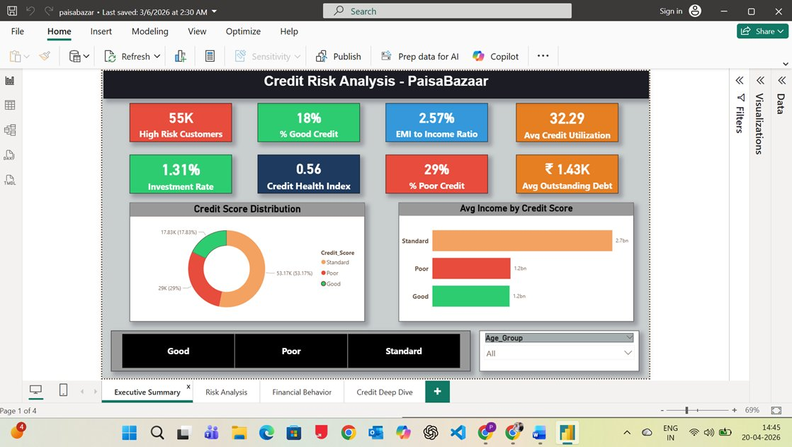
Fig 1: Executive Summary — Overview of KPIs including 55K high-risk customers, 18% good credit, Credit Health Index of 0.56, and credit score distribution.

5.2 Risk Analysis
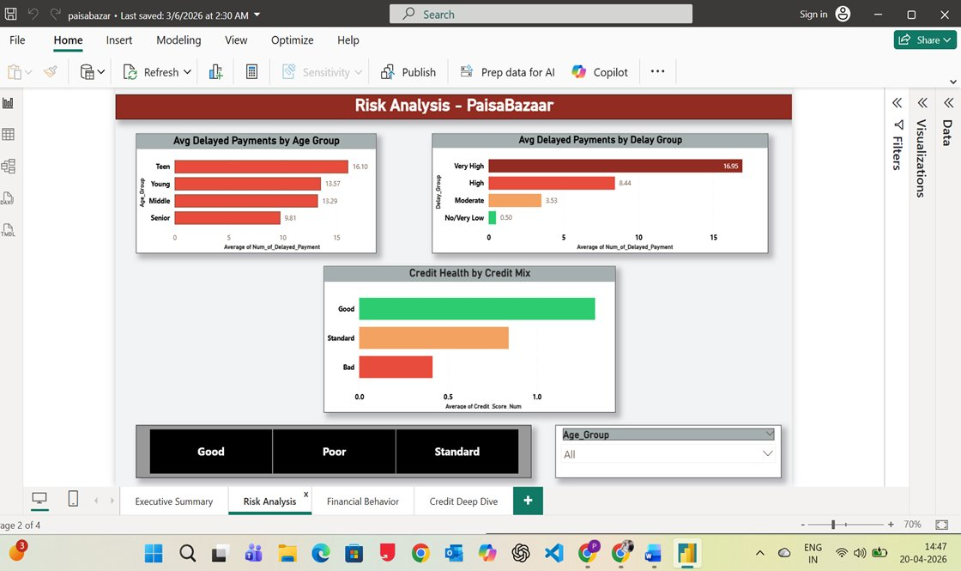
Fig 2: Risk Analysis — Delayed payment patterns by age group and delay severity; Teens lead in defaults. Credit mix strongly correlates with credit health.

5.3 Financial Behavior
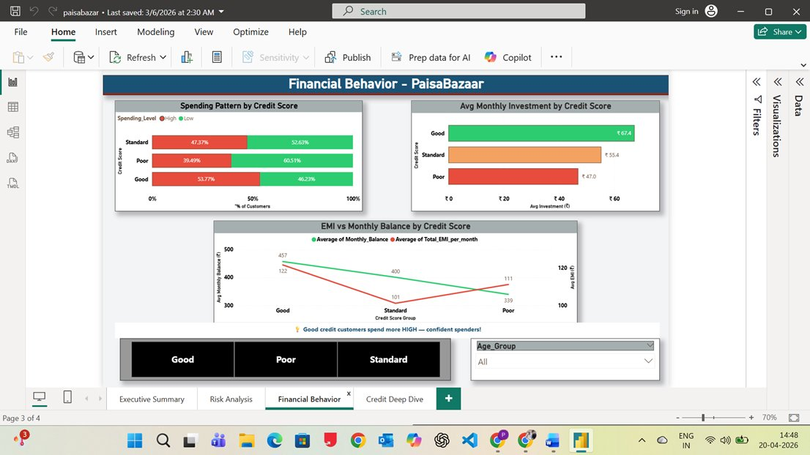
Fig 3: Financial Behavior — Spending patterns, monthly investments, and EMI vs balance comparison across credit score groups.

5.4 Credit Deep Dive
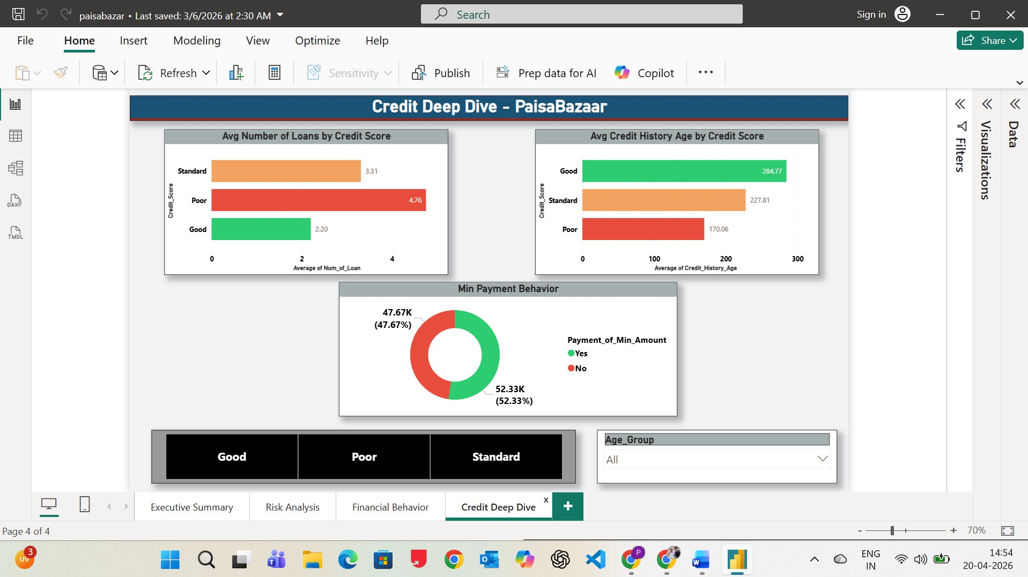
Fig 4: Credit Deep Dive — Loan count, credit history age, and minimum payment behavior analyzed by credit score category.

6. Key Insights and Explanations

6.1 Executive Summary Insights
- 55,000 customers are classified as high-risk — a significant portion of the total dataset.
- Only 18% of customers hold good credit, while 29% fall in the poor credit category.
- The EMI to Income Ratio of 2.57 indicates a considerable financial burden on many customers.
- Average Credit Utilization of 32.29% is moderate but trending toward risk territory.
- Credit Health Index of 0.56 suggests average overall financial health across the portfolio.
- Investment Rate of just 1.31% reflects weak financial planning among most customers.
- Standard customers earn the highest average income (2.7bn) — yet many still face credit risk.

6.2 Risk Analysis Insights
- Teens have the highest average delayed payments (16.10), making them the most at-risk age group.
- The 'Very High' delay group averages nearly 17 missed payments — indicating chronic payment issues.
- Senior customers show the lowest delayed payments (9.81), reflecting better financial maturity.
- Customers with a diverse credit mix consistently show better credit health scores.
- Poor credit customers have the lowest credit health index, confirming credit mix as a key indicator.

6.3 Financial Behavior Insights
- Good credit customers invest the most (avg. Rs. 67.4/month) and maintain the highest balances (Rs. 457).
- Poor credit customers carry higher EMI burdens (Rs. 111/month) with significantly lower balances.
- Good credit holders show higher high-spending proportions — indicating financial confidence.
- Financial discipline in spending and investing strongly correlates with better credit scores.

6.4 Credit Deep Dive Insights
- Poor credit customers carry the most loans on average (4.76) — indicating over-leveraging.
- Good credit customers have the longest credit history (avg. 284 months vs 170 for poor).
- Over 52% of customers pay only the minimum amount due — a major red flag for long-term debt.
- A longer, stable credit history is one of the strongest predictors of creditworthiness.

7. Business Impact Summary
The insights derived from this dashboard can help financial institutions make more informed, data-driven lending decisions. Key business impacts include:

Business Area | Impact
Early Risk Identification | Proactively flag high-risk customers before loan disbursement using behavioral and credit metrics.
Improved Loan Decisions | Use data-backed credit profiles to approve loans with higher confidence and lower default probability.
Reduced Default Rate | Target interventions for customers with poor payment habits, high EMI ratios, or minimum-only payments.
Customer Segmentation | Tailor financial products and credit limits based on age group and credit score segment.
Portfolio Health Monitoring | Track overall portfolio credit health index and act early on deteriorating segments.

8. Project Demo Video Link
Click the link below to watch the full project walkthrough and dashboard demo:
Video Link: https://drive.google.com/file/d/1hE6xb1vFqpduatSUn5HnDYnOPff2bM6c/view?usp=sharing

9. Future Scope
- Integrate Machine Learning models (Logistic Regression, Random Forest) to predict credit default probability.
- Add real-time data refresh capabilities to the Power BI dashboard via API connections.
- Expand the analysis to include geographic and income-segment-level risk profiling.
- Build an automated early-warning system for banks to flag at-risk accounts in real time.

10. Conclusion
This project demonstrates how data visualization can transform raw financial data into meaningful and actionable business insights. By analyzing the PaisaBazaar dataset through four focused Power BI dashboards — Executive Summary, Risk Analysis, Financial Behavior, and Credit Deep Dive — we were able to uncover clear patterns that differentiate high-risk customers from creditworthy ones.

Credit risk is strongly influenced by payment behavior, number of active loans, length of credit history, spending habits, and overall financial discipline. These insights equip financial institutions with the knowledge to make smarter, faster, and fairer lending decisions.

"Data visualization transforms raw numbers into decisions that matter."

