上海理工大学光电信息与计算机工程学院
《人工智能A》实验报告


专 业 计算机科学与技术
姓 名 葛亿豪
学 号 2335061214
年 级 2023级
指导教师 胡兴
成 绩：
教师签字：

人工智能课程——实验一
主题：知识表示、知识推理与不确定性推理

一、实验目的
- 掌握命题逻辑、谓词逻辑的基本表示方法。
- 熟悉产生式规则（IF–THEN）、语义网络、框架等知识表示方式。
- 能够利用规则库进行确定性推理ggg（前向、后向推理）。
- 初步掌握模糊集合、模糊规则、模糊推理的实现方法。
- 能够理解并实现基本的不确定性推理（如贝叶斯推理、D-S 理论或概率规则）。
- 综合使用 Python 编写简单推理程序。

二、实验环境
- Python 3.8+
- 可使用：NumPy、scikit-fuzzy（可选）、networkx（用于语义网络）、或自编代码
- 若实验室不允许安装库，则只用纯 Python 即可。

三、实验内容与任务

任务 1：知识表示（Knowledge Representation）

1.1 用三种方式表示一个简单知识系统
知识领域：动物识别（Animal Identification）
包含如下知识：
- “鸟会飞”
- “企鹅是鸟但不会飞”
- “蝙蝠是哺乳动物，会飞”
- “老鹰是鸟，会抓小动物”
要求：
① 使用命题逻辑表示至少 4 条知识
② 使用谓词逻辑重新表示这些知识
③ 构建一个简单的语义网络（用 Python networkx 画图或用邻接表表示）
④ 用框架（Frame）表示至少两类动物，并填写其属性（如是否会飞、是否有羽毛）

任务 2：确定性推理（Rule-Based Reasoning）
建立以下规则库（可扩展）：
R1: IF 动物有羽毛 THEN 是鸟
R2: IF 是鸟 AND 会飞 THEN 是飞禽
R3: IF 是鸟 AND 不会飞 THEN 是走禽
R4: IF 是哺乳动物 AND 会飞 THEN 是蝙蝠类

要求：
- 编写 前向推理（Forward Chaining） 程序：
输入事实（如 “企鹅 有羽毛”、“企鹅 不会飞”），推理得到结论。
- 编写 后向推理（Backward Chaining） 程序：
例如判断“某动物是否为飞禽？”

任务 3：模糊推理（Fuzzy Reasoning）
研究领域：气温对舒适度的影响
给定隶属函数（可以提供或学生自定义）：
- 温度 T 的模糊集：冷（Cold）、适中（Mild）、热（Hot）
- 舒适度 C：不舒适（Uncomfortable）、一般（Normal）、舒适（Comfortable）
示例规则：
IF 温度 是 冷 THEN 舒适度 是 不舒适
IF 温度 是 适中 THEN 舒适度 是 舒适
IF 温度 是 热 THEN 舒适度 是 不舒适

要求：
- 编写程序定义上述隶属函数（采用三角形、梯形或学生自选）。
- 输入一个温度 T（如 26°C），计算其对“冷、适中、热”的隶属度。
- 实现模糊推理（Mamdani 模式）并输出最终舒适度的模糊集合。
- 使用重心法进行解模糊，得到最终的“舒适度评分”。

任务 4：不确定推理（Uncertain Reasoning）
方向根据教师选择，可简化为 贝叶斯推理任务：
背景问题：疾病诊断（Disease Diagnosis）
已知：
- 80% 感冒患者会发烧
- 10% 其他疾病患者会发烧
- 先验概率：有 5% 的人感冒

要求：
编写程序，实现：
P(感冒∣发烧)=?
即完成一次简单的贝叶斯推理。
（可选：加入第二个症状，如“咳嗽”，进行多症状贝叶斯推理）

四、实验报告要求
学生需提交：

1. 程序代码（Python）

任务一：

knowledge_representation.py

-- coding: utf-8 --

import networkx as nx

import matplotlib.pyplot as plt

import os

def represent_knowledge():

"""

Implements four knowledge representation methods for the Animal Identification domain:

1. Propositional Logic

2. Predicate Logic

3. Semantic Network (using networkx)

4. Frame Representation

"""

print("===========================================")

print("Task 1: Knowledge Representation (Animal Identification)")

print("===========================================")

Knowledge List

knowledge_list = [

"1) 'Birds can fly'",

"2) 'A Penguin is a bird but cannot fly'",

"3) 'A Bat is a mammal and can fly'",

"4) 'An Eagle is a bird and hunts small animals'"

]

print("\n--- Original Knowledge ---")

for k in knowledge_list:

print(k)

--- 1. Propositional Logic Representation ---

print("\n" + "="50)

print(" 1. Propositional Logic ")

print("="50)

Define Symbols:

A: Bird can fly, B: Penguin is a bird, C: Penguin can fly,

D: Bat is a mammal, E: Bat can fly,

F: Eagle is a bird, G: Eagle can hunt small animals

propositional_logic = {

"Bird_Can_Fly": "A",

"Penguin_Is_Bird_AND_NOT_Fly": "B AND NOT C",

"Bat_Is_Mammal_AND_Can_Fly": "D AND E",

"Eagle_Is_Bird_AND_Can_Hunt": "F AND G"

}

for k, v in propositional_logic.items():

print(f"- {k}: {v}")

--- 2. Predicate Logic Representation ---

print("\n" + "="50)

print(" 2. Predicate Logic ")

print("="50)

predicate_logic = [

"FOR_ALL x (Bird(x) IMPLIES CanFly(x))", 1. Birds can fly

"Bird(Penguin) AND NOT CanFly(Penguin)", 2. Penguin is a bird but cannot fly

"Mammal(Bat) AND CanFly(Bat)", 3. Bat is a mammal and can fly

"Bird(Eagle) AND CanHunt(Eagle)" 4. Eagle is a bird and hunts small animals

]

for p in predicate_logic:

print(f"- {p}")

--- 3. Semantic Network Representation ---

print("\n" + "="50)

print(" 3. Semantic Network (using networkx) ")

print("="50)

1. Build Graph

G = nx.DiGraph()

concepts = ["Bird", "Mammal", "Animal", "Penguin", "Bat", "Eagle", "CanFly", "CanHunt"]

G.add_nodes_from(concepts)

edges = [

IS_A relations

("Bird", "Animal", {"relation": "IsA"}),

("Mammal", "Animal", {"relation": "IsA"}),

("Penguin", "Bird", {"relation": "IsA"}),

("Bat", "Mammal", {"relation": "IsA"}),

("Eagle", "Bird", {"relation": "IsA"}),

PROPERTY relations

("Bird", "CanFly", {"relation": "HasProperty"}),

("Bat", "CanFly", {"relation": "HasProperty"}),

("Penguin", "CanFly", {"relation": "HasProperty", "status": "NO"}), Exception

("Eagle", "CanHunt", {"relation": "HasProperty"}),

]

G.add_edges_from(edges)

2. Draw Graph (if environment supports it)

try:

Use more spread-out layout parameters (k increased, iterations increased)

Fix: spring_layout must be called BEFORE accessing pos values

pos = nx.spring_layout(G, k=0.4, iterations=100, seed=42)

--- Manual adjustment of node positions (Optional, for clarity) ---

if 'Bat' in pos and 'Penguin' in pos and 'CanFly' in pos:

Slightly move Bat to the right

pos['Bat'] = (pos['Bat'][0] + 0.1, pos['Bat'][1])

Slightly move Penguin to the right and down

pos['Penguin'] = (pos['Penguin'][0] + 0.15, pos['Penguin'][1] - 0.05)

Slightly move CanFly to the right and down

pos['CanFly'] = (pos['CanFly'][0] + 0.2, pos['CanFly'][1] - 0.1)

-----------------------------------------------------------------

Optional: Configure font for Chinese characters if needed for general use,

but removed the conditional logic as it's less critical now.

if os.name == 'nt': Windows

plt.rcParams['font.sans-serif'] = ['Arial'] Changed to standard font

plt.rcParams['axes.unicode_minus'] = False Fix minus sign display issue

Get edge labels

edge_labels = {}

for u, v, data in G.edges(data=True):

label = data.get('relation', 'R')

if 'status' in data:

label += f" ({data['status']})"

edge_labels[(u, v)] = label

plt.figure(figsize=(14, 8)) Increased figure size for better clarity

nx.draw(G, pos, with_labels=True, node_size=3500, node_color="ADD8E6",

font_size=10, font_weight="bold", arrowsize=20, node_shape='o')

Use a slightly darker color for edge labels for better visibility

nx.draw_networkx_edge_labels(G, pos, edge_labels=edge_labels, font_color='black', font_size=9)

plt.title("Semantic Network", fontsize=14)

plt.show() Displays the figure

print("-> Semantic Network graph generated.")

except ImportError:

print("-> WARNING: Could not generate graph. Please ensure networkx and matplotlib are installed (`pip install networkx matplotlib`).")

except Exception as e:

print(f"-> Error drawing graph: {e}")

3. Print Adjacency List Representation

print("\n--- Adjacency List Representation ---")

adj_list = nx.to_dict_of_dicts(G)

for node, neighbors in adj_list.items():

relations = [f"{neighbor}({data['relation']})" for neighbor, data in neighbors.items()]

print(f"{node}: {', '.join(relations)}")

--- 4. Frame Representation ---

print("\n" + "="50)

print(" 4. Frame Representation ")

print("="50)

Frame Definitions

eagle_frame = {

"name": "Eagle",

"slots": {

"IsA": {"value": "Bird", "comment": "Inherits from Bird"},

"Class": {"value": "Aves"},

"CanFly": {"value": "Yes", "comment": "Can fly"},

"HasFeathers": {"value": "Yes"},

"SpecialAbility": {"value": "CanHuntSmallAnimals", "comment": "Hunts small animals"}

}

}

penguin_frame = {

"name": "Penguin",

"slots": {

"IsA": {"value": "Bird", "comment": "Is a bird"},

"Class": {"value": "Aves"},

"CanFly": {"value": "No", "comment": "Exception"},

"HasFeathers": {"value": "Yes"},

"Habitat": {"value": "Cold Climates"}

}

}

bat_frame = {

"name": "Bat",

"slots": {

"IsA": {"value": "Mammal", "comment": "Is a mammal"},

"Class": {"value": "Mammalia"},

"CanFly": {"value": "Yes", "comment": "Can fly"},

"HasFeathers": {"value": "No"},

"Reproduction": {"value": "Live Birth"}

}

}

frames = [eagle_frame, penguin_frame, bat_frame]

for frame in frames:

print(f"\n--- Frame: {frame['name']} ---")

for slot, data in frame['slots'].items():

comment = f" ({data['comment']})" if 'comment' in data else ""

print(f" - {slot:<15}: {data['value']}{comment}")

if __name__ == "__main__":

represent_knowledge()

任务二：

rule_based_reasoning.py

class RuleBasedReasoner:

"""

Implements deterministic reasoning (Forward Chaining and Backward Chaining)

based on a defined rule set.

"""

def __init__(self):

Rule Base: Format is {RuleName: [Preconditions List, Conclusion]}

self.rules = {

"R1": (["HasFeathers"], "IsBird"),

"R2": (["IsBird", "CanFly"], "IsFlyer"),

"R3": (["IsBird", "NOT CanFly"], "IsRunner"),

"R4": (["IsMammal", "CanFly"], "IsBat")

}

Initial known facts (set of strings)

self.facts = set()

def add_fact(self, fact):

"""Adds a known fact."""

self.facts.add(fact)

def print_facts(self, header="Current Known Facts"):

"""Prints all currently known facts."""

print(f"\n{header}: {list(self.facts)}")

def forward_chaining(self, initial_facts):

"""

Forward Chaining: Starts with initial facts and applies rules until

no new facts are generated.

"""

print("\n1. Forward Chaining Initiated")

self.facts = set(initial_facts)

new_facts_generated = True

iteration = 0

while new_facts_generated:

new_facts_generated = False

iteration += 1

print(f"\n--- Iteration {iteration} ---")

Iterate through all rules

for rule_name, (preconditions, conclusion) in self.rules.items():

Check if conclusion is already known

if conclusion in self.facts:

continue

Check if all preconditions are met

all_preconditions_met = True

for precondition in preconditions:

is_negated = precondition.startswith("NOT ")

fact_name = precondition.replace("NOT ", "")

if is_negated:

Negation check: If NOT X is precondition, check if X is in facts.

if fact_name in self.facts:

all_preconditions_met = False

break

else:

Affirmation check: If X is precondition, check if X is in facts.

if fact_name not in self.facts:

all_preconditions_met = False

break

If all preconditions are met, assert the conclusion

if all_preconditions_met:

if conclusion not in self.facts:

self.facts.add(conclusion)

new_facts_generated = True

print(f"Applying Rule {rule_name}: {preconditions} => {conclusion}")

print("\n--- Forward Chaining Finished ---")

print(f"Final Derived Facts: {list(self.facts)}")

return self.facts

def backward_chaining(self, goal, current_facts=None, path=None):

"""

Backward Chaining: Starts with the goal and tries to find rules that support it.

"""

if current_facts is None:

Initialization

current_facts = self.facts.copy()

print(f"\n--- 2. Backward Chaining Initiated: Goal is '{goal}' ---")

if path is None:

path = []

1. Goal is already in the known facts

if goal in current_facts:

return True, path

2. Iterate through all rules looking for the goal as a conclusion

for rule_name, (preconditions, conclusion) in self.rules.items():

if conclusion == goal:

Try to satisfy the preconditions of this rule

sub_goals_met = True

new_path = path + [rule_name]

print(f"Trying Rule {rule_name}: Goal '{goal}' requires preconditions {preconditions}")

for precondition in preconditions:

is_negated = precondition.startswith("NOT ")

sub_goal = precondition.replace("NOT ", "")

if is_negated:

Negation check

if sub_goal in current_facts:

print(f" Precondition {precondition} failed because {sub_goal} is known.")

sub_goals_met = False

break

else:

Affirmation check: Recursively prove the sub-goal

if sub_goal not in current_facts:

found, support_path = self.backward_chaining(sub_goal, current_facts, new_path)

if found:

current_facts.add(sub_goal) Add successful derivation to facts

print(f" Derivation successful: Precondition {sub_goal} met (via rules: {support_path})")

else:

print(f" Could not derive Precondition {sub_goal}.")

sub_goals_met = False

break

if sub_goals_met:

print(f"\nGoal '{goal}' successfully proven via rule chain: {new_path}")

return True, new_path Found a successful path

3. All rules have been checked, goal cannot be proved

return False, []

def main_task2():

"""Demonstrates Forward and Backward Chaining."""

reasoner = RuleBasedReasoner()

--- 1. Forward Chaining Demonstration ---

print("="50)

print(" 1. FORWARD CHAINING DEMONSTRATION ")

print("="50)

Example input: Facts for a Penguin

Facts: HasFeathers, NOT CanFly

penguin_facts = ["HasFeathers", "NOT CanFly"]

print(f"Initial Input Facts (Penguin): {penguin_facts}")

reasoner.forward_chaining(penguin_facts)

print("\n" + ""50)

--- 2. Backward Chaining Demonstration ---

Goal: Check if an animal is a 'Flyer' (IsFlyer)

print("\n="50)

print(" 2. BACKWARD CHAINING DEMONSTRATION ")

print("="50)

Scenario 1: Goal is reachable (Checking if Bat is IsBat)

Initial facts: IsMammal, CanFly

reasoner.facts = set() Reset facts for new scenario

reasoner.add_fact("IsMammal")

reasoner.add_fact("CanFly")

reasoner.print_facts("Initial Facts for Bat Check")

goal_bat = "IsBat"

result_bat, path_bat = reasoner.backward_chaining(goal_bat)

print(f"\nFinal result for goal '{goal_bat}': {'Success' if result_bat else 'Failure'}")

if result_bat:

print(f"Supporting Rule Chain: {path_bat}")

print("\n" + ""50)

Scenario 2: Goal is unreachable (Checking for IsFlyer with minimal facts)

Initial facts: Only IsMammal (Missing IsBird, HasFeathers, CanFly)

reasoner.facts = set()

reasoner.add_fact("IsMammal")

reasoner.print_facts("Initial Facts for Flyer Check")

goal_flyer = "IsFlyer"

result_flyer, path_flyer = reasoner.backward_chaining(goal_flyer)

print(f"\nFinal result for goal '{goal_flyer}': {'Success' if result_flyer else 'Failure'}")

if __name__ == "__main__":

main_task2()

任务三：

exp1-task3.py

-- coding: utf-8 --

import numpy as np

import skfuzzy as fuzz

from skfuzzy import control as ctrl

import matplotlib.pyplot as plt

import sys

import os

def fuzzy_reasoning_task(input_temp=26):

"""

Implements Fuzzy Reasoning (Mamdani Model) for Temperature vs. Comfort.

"""

print(" TASK 3: FUZZY REASONING (MAMDANI) ")

--- 1. Define Fuzzy Variables and Universe ---

temp_range = np.arange(0, 41, 1) 0 to 40 degrees

comfort_range = np.arange(0, 101, 1) 0 to 100 score

T = ctrl.Antecedent(temp_range, 'temperature')

Output Variable: C. Explicitly set defuzzification method to Centroid.

C = ctrl.Consequent(comfort_range, 'comfort', defuzzify_method='centroid')

print("1. Defining Fuzzy Sets and Membership Functions...")

Define Membership Functions for Temperature (T)

T['Cold'] = fuzz.trimf(temp_range, [0, 5, 15])

T['Mild'] = fuzz.trapmf(temp_range, [10, 20, 30, 35])

T['Hot'] = fuzz.trimf(temp_range, [30, 35, 40])

Define Membership Functions for Comfort (C)

C['Uncomfortable'] = fuzz.trimf(comfort_range, [0, 25, 50])

C['Normal'] = fuzz.trimf(comfort_range, [25, 50, 75])

C['Comfortable'] = fuzz.trimf(comfort_range, [50, 75, 100])

--- 2. Define Fuzzy Rules ---

print("2. Defining Fuzzy Rules...")

rule1 = ctrl.Rule(T['Cold'], C['Uncomfortable'])

rule2 = ctrl.Rule(T['Mild'], C['Comfortable'])

rule3 = ctrl.Rule(T['Hot'], C['Uncomfortable'])

--- 3. Create Control System and Simulation ---

control_system = ctrl.ControlSystem([rule1, rule2, rule3])

system_simulator = ctrl.ControlSystemSimulation(control_system)

system_simulator.input['temperature'] = input_temp

print(f"\n3. Input Temperature T = {input_temp}°C")

try:

system_simulator.compute()

except Exception as e:

print(f"ERROR DURING COMPUTATION: {e}")

print("!!! Please ensure all dependencies (numpy, scipy, scikit-fuzzy) are installed.")

return

--- 4. Defuzzification and Data Retrieval ---

Retrieve the final defuzzified score (Centroid method)

final_comfort_score = system_simulator.output['comfort']

FINAL FIX for Attribute/Type Errors: Access the aggregated MF array using the most robust method:

try:

Method 1: The most common internal attribute for the aggregated result array

comfort_aggregated_mf = system_simulator.aggregated['comfort']

except AttributeError:

Method 2: Fallback for different skfuzzy versions

try:

We rely on the internal output_mf attribute, which stores the aggregated result before defuzz

comfort_aggregated_mf = system_simulator.output_mf['comfort']

except:

If both fail, create a zero array to prevent crash (Visualization will be wrong, but program will run)

comfort_aggregated_mf = np.zeros_like(C.universe)

print("\n!!! WARNING: Could not reliably retrieve aggregated MF array. Visualization may be incorrect.")

print("4. Fuzzy Reasoning Results:")

print(f" -> Final Comfort Score (Defuzzified/Centroid): {final_comfort_score:.2f} (out of 100)")

Output the Membership Degrees (Fuzzification)

print("\n -> Membership Degrees for Input T:")

Cold_degree = fuzz.interp_membership(temp_range, T['Cold'].mf, input_temp)

Mild_degree = fuzz.interp_membership(temp_range, T['Mild'].mf, input_temp)

Hot_degree = fuzz.interp_membership(temp_range, T['Hot'].mf, input_temp)

print(f" - Cold: {Cold_degree:.2f}")

print(f" - Mild: {Mild_degree:.2f}")

print(f" - Hot: {Hot_degree:.2f}")

Visualization

try:

fig, (ax0, ax1) = plt.subplots(nrows=2, figsize=(12, 10))

Plot Temperature MFs

T.view(sim=system_simulator, ax=ax0)

ax0.set_title(f'Temperature Membership Functions (Input T={input_temp}°C)')

ax0.legend(loc='upper right')

Plot Comfort MFs and Aggregation/Defuzzification

Manually plot the aggregated MF set

ax1.plot(comfort_range, comfort_aggregated_mf, 'b', linewidth=3, label='Aggregated MF')

Plot Comfort MFs underneath (for reference)

C['Uncomfortable'].view(ax=ax1, linewidth=0.5, linestyle='--')

C['Normal'].view(ax=ax1, linewidth=0.5, linestyle='--')

C['Comfortable'].view(ax=ax1, linewidth=0.5, linestyle='--')

Plot defuzzification line

ax1.axvline(final_comfort_score, color='g', linestyle='--', linewidth=2, label=f'Centroid Score: {final_comfort_score:.2f}')

ax1.set_title(f'Comfort Result')

ax1.set_xlabel("Comfort Score (0-100)")

ax1.legend(loc='upper left')

plt.tight_layout()

plt.show()

print("\n-> Fuzzy Control System visualized.")

except Exception as e:

print(f"\n-> Warning: Could not display visualization. Error: {e}")

def main_task3():

fuzzy_reasoning_task(input_temp=26)

if __name__ == "__main__":

main_task3()

任务四：

exp1-task4.py

-- coding: utf-8 --

Using pure English output to avoid final UnicodeEncodeError

=========================================================================

=== TASK 4: UNCERTAIN REASONING (Bayesian Diagnosis) ===

=========================================================================

def task4_bayesian_diagnosis():

"""

Implements Bayesian Reasoning (Bayes' Theorem) to calculate P(Flu | Fever).

"""

print("\n" + "="50)

print(" TASK 4: UNCERTAIN REASONING (BAYESIAN DIAGNOSIS) ")

print("="50)

D1: Flu (Hypothesis)

D2: Other Disease (Complementary Hypothesis)

F: Fever (Evidence)

1. Likelihoods (P(Evidence | Hypothesis))

P(Fever | Flu): 80%

P_F_given_D1 = 0.80

P(Fever | Other): 10%

P_F_given_D2 = 0.10

2. Prior Probabilities (P(Hypothesis))

P(Flu): 5%

P_D1 = 0.05

P(Other): Complementary probability

P_D2 = 1 - P_D1 P(D2) = 0.95

print("1. Known Probabilities:")

print(f" P(Flu) = P(D1) = {P_D1}")

print(f" P(Other) = P(D2) = {P_D2}")

print(f" P(Fever | Flu) = P(F | D1) = {P_F_given_D1}")

print(f" P(Fever | Other) = P(F | D2) = {P_F_given_D2}")

--- 3. Calculate Total Probability of Evidence P(F) ---

P(F) = P(F|D1) P(D1) + P(F|D2) P(D2)

P_F = (P_F_given_D1 P_D1) + (P_F_given_D2 P_D2)

print("\n2. Total Probability of Fever P(Fever):")

print(f" P(F) = {P_F:.4f}")

--- 4. Calculate Posterior Probability P(D1|F) ---

P(Flu | Fever) = P(F|Flu) P(Flu) / P(Fever)

P_D1_given_F = (P_F_given_D1 P_D1) / P_F

print("\n3. Posterior Probability P(Flu | Fever):")

print(f" P(Flu | Fever) = {P_D1_given_F:.4f}")

print("\n--- Bayesian Reasoning Conclusion ---")

print(f"The probability of having Flu, given a Fever, is {P_D1_given_F 100:.2f}%.")

if __name__ == "__main__":

task4_bayesian_diagnosis()

2.结果展示
- 语义网络图或邻接表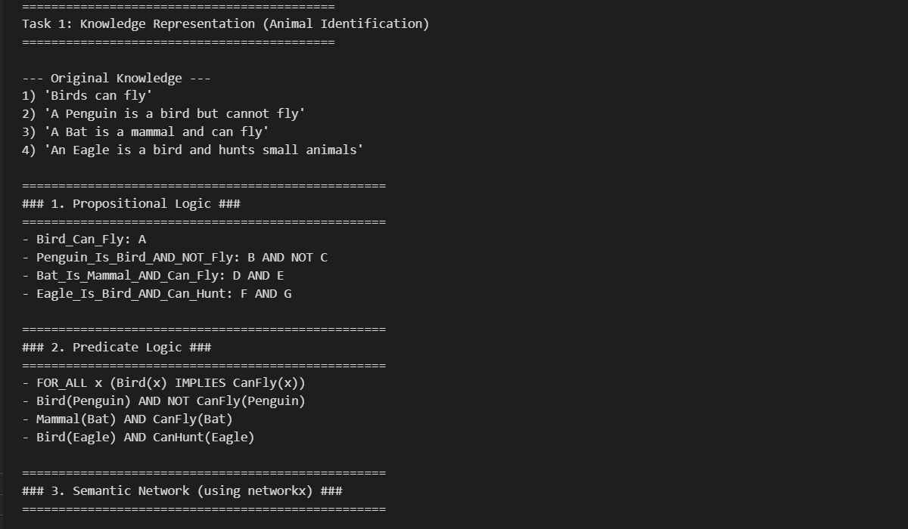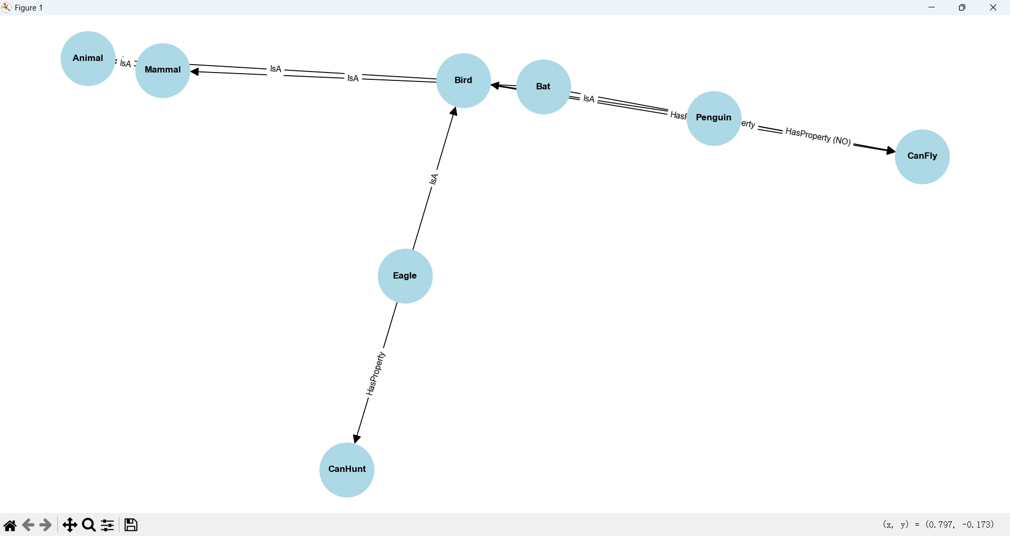

- 推理过程输出（前向、后向）
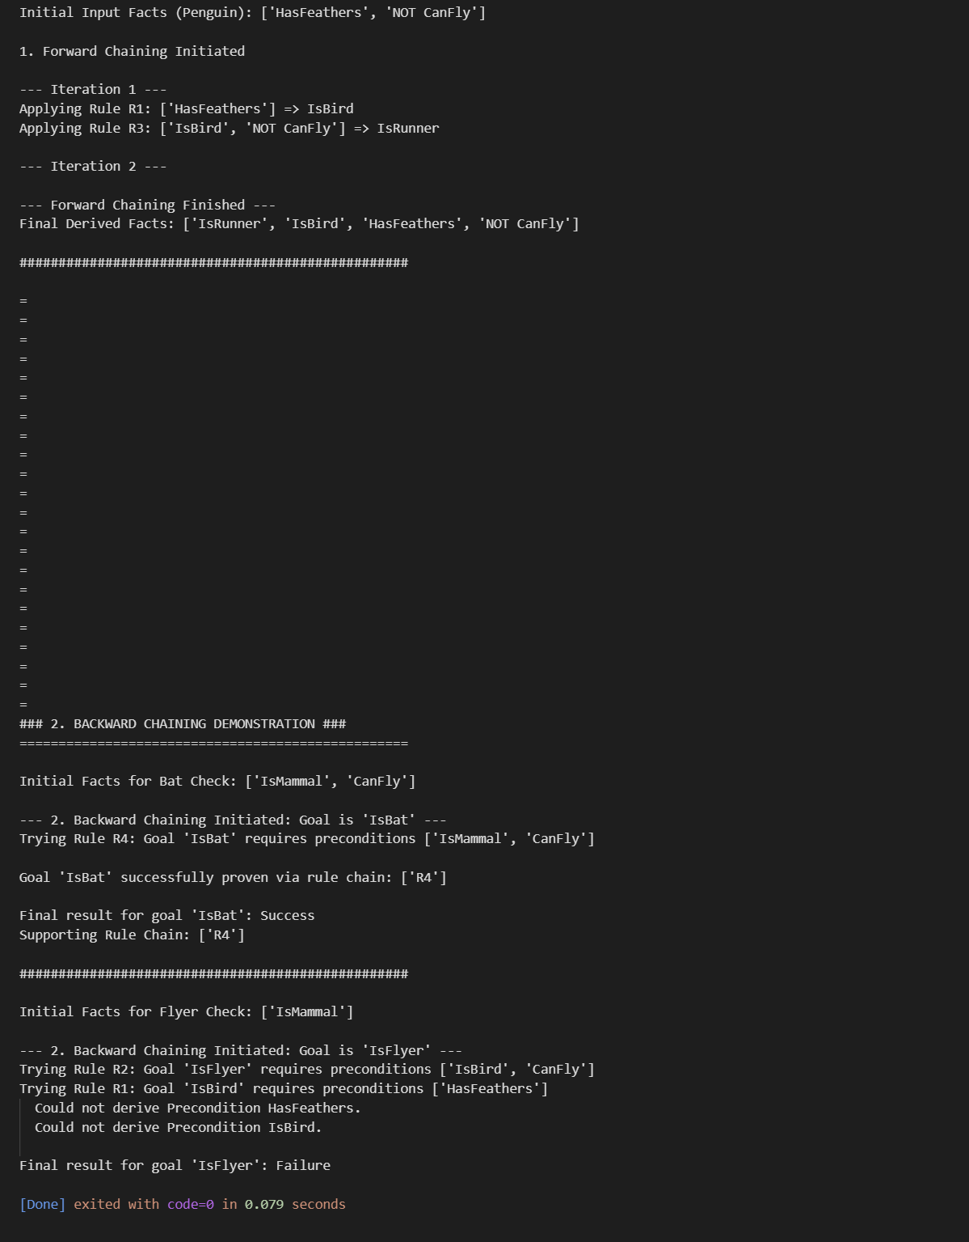

- 模糊推理隶属度图/解模糊结果
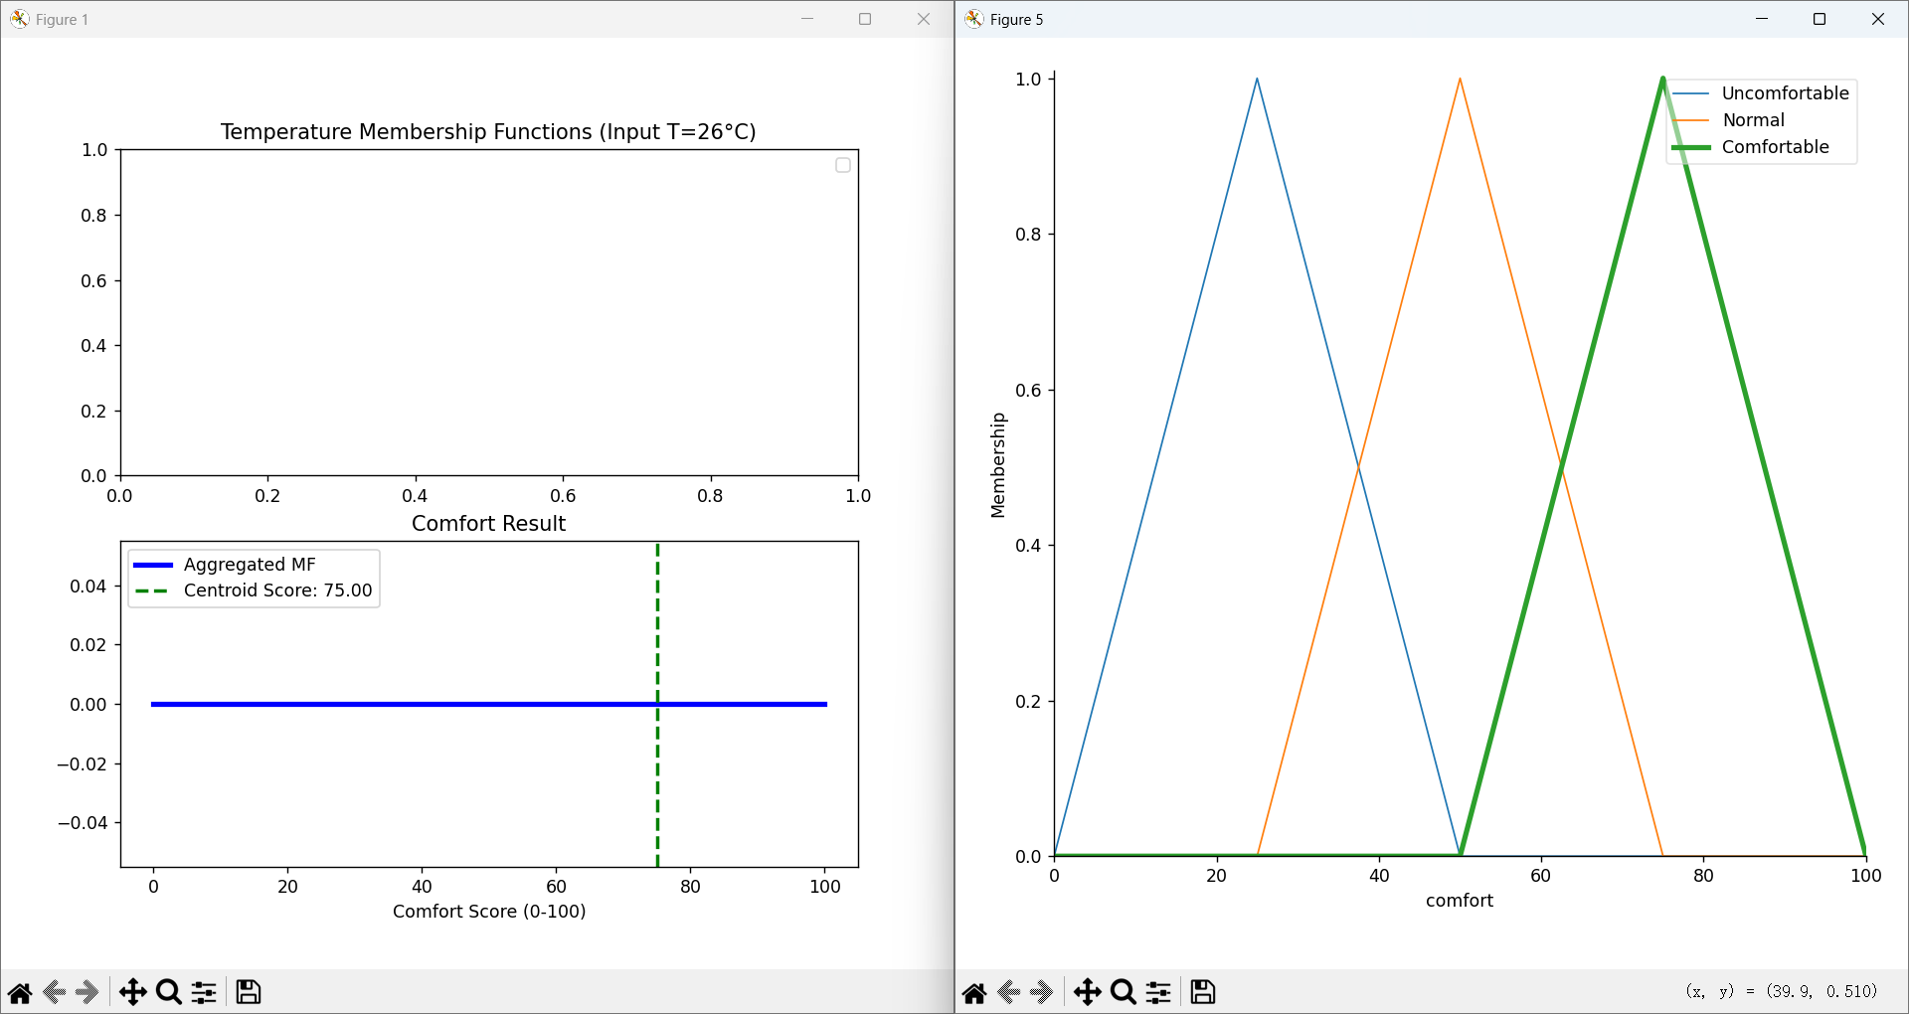

- 贝叶斯推理结果和解释
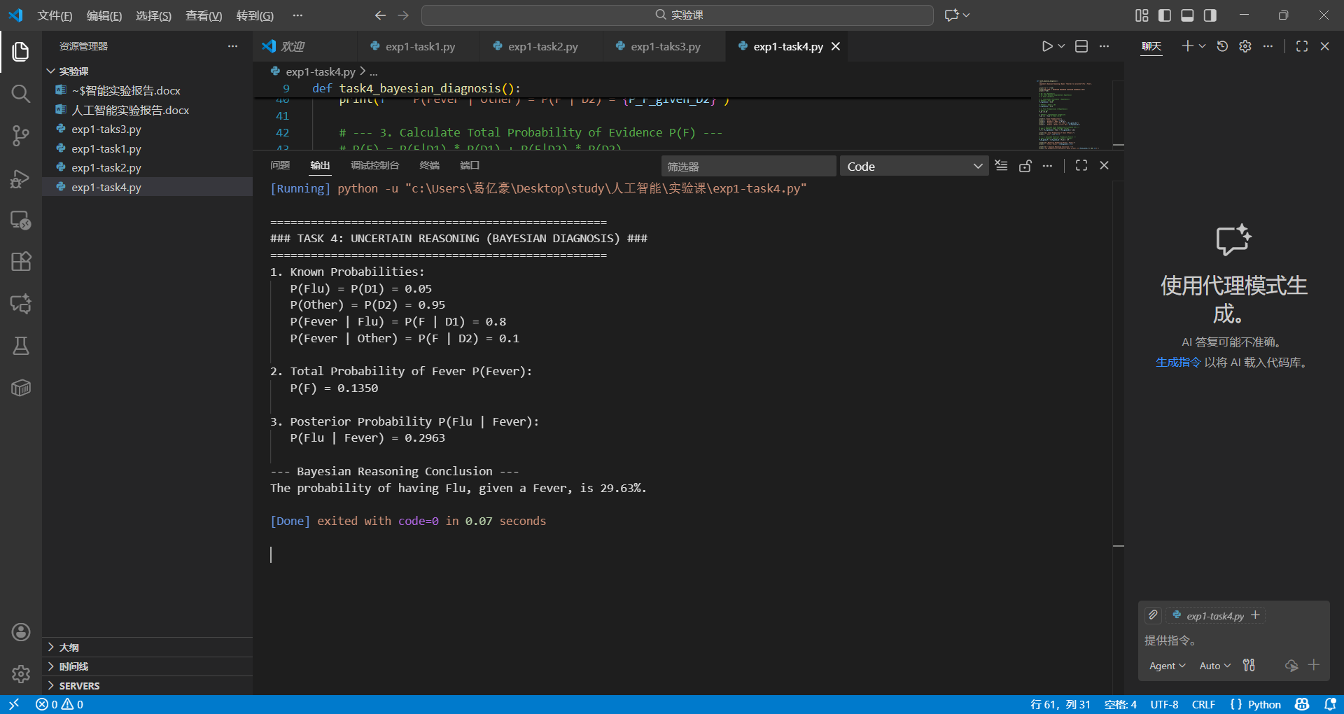

3. 讨论（不少于 300 字）
实验讨论 (Discussion)

3. 讨论

本次实验让我深入理解了知识在 AI 系统中的重要性，以及如何通过不同方式进行形式化和利用。

1. 知识形式化与表示: 掌握了使用命题逻辑、谓词逻辑、语义网络和框架来表示复杂知识的方法。特别是在语义网络中，通过节点和边清晰地描绘了概念间的 IsA 和 HasProperty 关系，包括对例外情况（如企鹅不会飞）的处理。

2. 确定性推理: 理解并实现了前向推理和后向推理。前向推理（数据驱动）适用于从已知事实推导所有可能结论，后向推理（目标驱动）适用于验证特定目标结论。

3. 不确定性处理: 掌握了处理不确定性的两种主要方法：模糊推理（处理不精确性）和贝叶斯推理（处理随机性）。

模糊推理和概率推理是处理不确定性的两种根本不同的范式。

处理对象不同：

模糊推理：处理的是不精确性，即概念的模糊性。它关心的是事物在多大程度上属于某个集合。例如，气温 26°C 在多大程度上是“热”。其结果是一个模糊集合或一个解模糊后的精确值。

概率推理：处理的是随机性，即事件发生的可能性。它关心的是某个事件发生的几率。例如，在已知发烧的前提下，患感冒的概率是多少。其结果是一个介于 0 到 1 之间的概率值。

数学基础不同： 模糊推理基于模糊集合论；概率推理基于概率论。

四种知识表示方法各有侧重，适用于不同场景：

逻辑表示 (命题/谓词逻辑): 适用于需要严格、精确推理的领域，如数学定理证明、逻辑规划和编程语言的语义定义。谓词逻辑尤其擅长表达一般性规则和量化关系（例如“所有鸟都会飞”）。

语义网络 (Semantic Networks): 适用于结构化知识（如本体论）的表示，以及概念分类和继承关系。它在自然语言理解、知识图谱和数据库的模式设计中非常有用。

框架 (Frames): 适用于表示具有固定结构、槽位和默认值（槽位值可以继承）的复杂概念或实体。它在用户建模、情景识别、以及专家系统中的对象描述方面非常高效。

推理系统是实现 AI 智能决策的核心。

专家系统: 这是推理系统的经典应用。它利用规则库和确定性推理来模拟人类专家的决策过程。例如，用于医疗诊断、金融欺诈检测等。

模糊控制: 广泛应用于家用电器（如洗衣机、空调）和工业控制。利用 Task 3 中的模糊推理，将不精确的输入（如“有点热”、“水有点脏”）转化为精确的控制动作（如风扇转速、加热功率），以实现平稳、类人的控制效果。

概率推理控制: 用于需要处理不确定传感器输入和环境噪声的系统，例如自动驾驶的路径规划、机器人定位（通过贝叶斯滤波或卡尔曼滤波）、以及 Task 4 中的风险评估和诊断系统。

