**Step 1. Sourcedata Organization**

* Verify correct file structure and naming conventions.

**Step 2. Make sure folder is correctly moved into the BIDS dataset Sourcedata folder.**

**Step 3. Access** [**https://github.com/iNRLab/BIDS_tools/tree/main**](https://github.com/iNRLab/BIDS_tools/tree/main) **repository.**

**Step 4. Convert Session 1 imaging and physio data to BIDS.**

* Make sure fmri environment (or other custom env with packages installed) is active ($conda activate fMRI)
* Run the command line code for BIDS_process_ses-1.py

python ~/Documents/MATLAB/software/iNR/BIDS_tools/BIDS_process_ses-1.py ~/Documents/MRI/LEARN/BIDS_test/ --start-id sub-LRN029 --end-id sub-LRN029 (--pydeface)

* The above code can be run subject by subject or can loop through a contiguous series of subject ids. Note the -–pydeface function works but adds a lot of processing time.

**Step 4a. Reprocess physio data in the case of extra invalid runs.**

* In the case where an invalid run is mis-identified and linked with the wrong physio data, we need to remove the existing physio files for the subject from the derivative/physio folder and the dataset folder and re-run the BIDS_process_physio_ses_1.py script with the –invalid run_id flag.

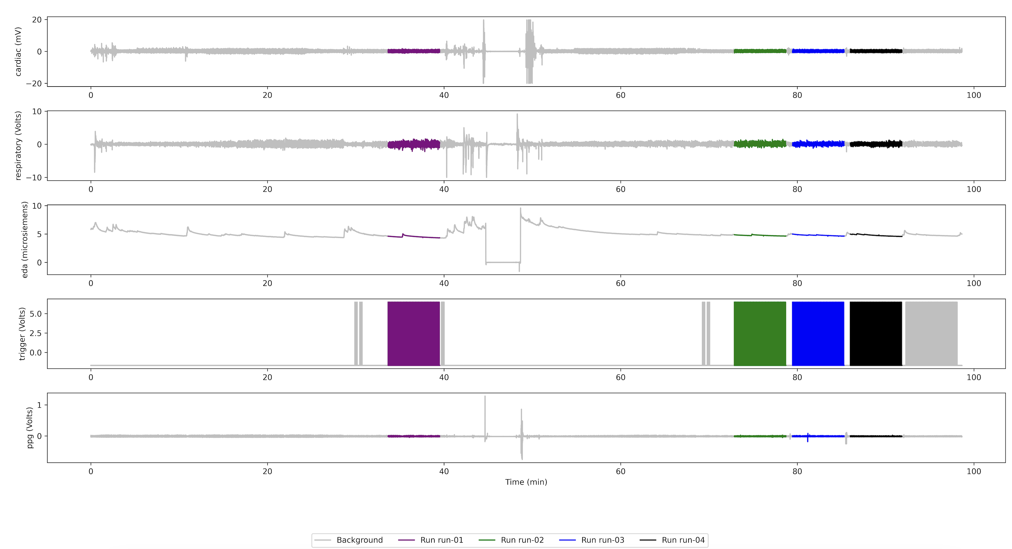

e.g.,

python ~/Documents/MATLAB/software/iNR/BIDS_tools/BIDS_process_physio_ses_1.py ~/Documents/MRI/LEARN/BIDS_test/sourcedata/sub-LRN033/ses-1/physio/ ~/Documents/MRI/LEARN/BIDS_test/dataset --invalid run-01

For example, the –invalid run-01 flag effectively skips the first full length invalid run and correctly identifies the next full length run as run-01.

***Note – to facilitate the code functionality, in cases with abnormal runs, the dicom files are manually deleted for the invalid runs. The code then takes into account labeled invalid runs and parses the physio data accordingly. This has been tested for 1 first run but not yet tested for multiple invalid runs or for invalid “not first” runs…

**Step 5. Preprocess Session 1 physio data (EDA first)**

* Change active repo to physio_stats: <https://github.com/iNRLab/physio_stats/tree/main>
* Ensure that subjects to be processed are correctly entered into participants.tsv file.
* Activate nipype env (conda activate nipype)
* Make sure in right repo sub dir (clean)

~/Documents/MRI/LEARN/BIDS_test/code/physio_stats/clean/

* Run command line loop code:

python clean_physio_task-rest_cvxEDA.py

**Step 6. Preprocess Session 1 PPG data**

From same repo dir and env, run command line loop code:

**Step 7. QC output files**

* Navigate to /Users/PAM201/Documents/MRI/LEARN/BIDS_test/derivatives/physio/rest/plots/ and check the physio segmentation by run to ensure no errors in processing.

**Step 8. Convert Session 2 imaging and physio data to BIDS.**

* Return to fmri env and BIDS_tools repo.
* As before, execute from command line:  
    
  python ~/Documents/MATLAB/software/iNR/BIDS_tools/BIDS_process_ses-2.py ~/Documents/MRI/LEARN/BIDS_test/ --start-id sub-LRN026 --end-id sub-LRN040 (--pydeface)

** note that BIDS_process_physio_ses-2.py might need to be run manually with the –force flag in cases where the physio parsing doesn’t work correctly. This functionality also needs to be built into the ses-1 code.

**Step 9. QC output files for run matching and proceed with –force flag re-runs if required.**

* In the case where an invalid run is mis-identified and linked with the wrong physio data, we need to remove the existing physio files for the subject from the derivative/physio folder and the dataset folder and re-run the BIDS_process_physio_ses_2.py script with the –invalid run_id flag.

python ~/Documents/MATLAB/software/iNR/BIDS_tools/BIDS_process_physio_ses_2.py ~/Documents/MRI/LEARN/BIDS_test/sourcedata/sub-LRN028/ses-2/physio/ ~/Documents/MRI/LEARN/BIDS_test/dataset --invalid run-00

For example, the –invalid run-00 flag effectively skips the two invalid partial “pre localizer” runs and correctly identifies the first full length localizer.

