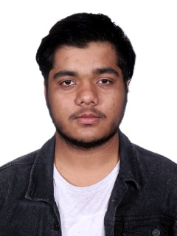

**Achivements**

**Coding Bee Season 1 National Winner** **2021**

Coding Bee-Times of India

Basic Hardware of Computer

**Cyber Shadez 2021 –First Prize** **2021**

GLS University

Intro to R and Data Science

**Revalent Cources**

**Hardware Networking** **2017**

CDAC

Basic Hardware of Computer

**Data Science for Engineer** **2023**

IIT Madras, NPETL

Intro to R and Data Science

Aspiring IT Professional with a proven academic Experience alongside practical Experience of Building a Website and MobileApp. Seeking an Entry Level Position as an IT Professional to Further Develop Exiting IT Skills and Leverage a Career in IT Industry.

**EDUCATION**

**BTech. Computer Engineering** **2021-present**

Gandhinagar Institute of Technology, GTU

Clubs & Societies: Robotics Society, NSS

**HSC Board** **2021**

Divan Ballu Bhai Secondary School, GSEB

Graduated

HINDI

◼◼◼◼◼

GUJARATI

◼◼◼◼◼



bhavsarpurven515@gmail.com

**PURVEN BHAVSAR**

HOBBIES

ENGLISH

◼◼◼◼◼

LANGUAGES

Problem Solving

◼◼◼◼◼

Programming

◼◼◼◼◼

Python, R, CSS,HTML

◼◼◼◼◼



9016679929



Ahmedabad, Gujarat

SKILLS

CONTACT