**Description**

In this assignment, learners will collaborate to create an AI-powered digital branding agency using tools like ChatGPT and Canva Magic Media. They will go through branding setup, content creation, and monetization strategies, working towards a marketable digital branding portfolio.

**Objectives**

By the end of this assignment, learners will be able to:

1. Understand the role of AI in branding and digital marketing.
2. Use ChatGPT to generate compelling branding stories and marketing copy.
3. Use Canva Magic Media to create logos, social media graphics, and promotional materials.
4. Develop a structured approach to branding and client outreach.
5. Apply business and monetization strategies to create a profitable AI-powered branding service

### ****Phase 1: Branding & Business Setup****

**Task:**

1. Brainstorm and create a business name, tagline, and brand mission.
2. Use **ChatGPT** to **generate a compelling brand story** that highlights AI-driven branding.
3. Use **Canva Magic Media** to create a **unique AI-generated logo**.

**Vibe Coding Prompts for Phase 1: ChatGPT Prompt:** "Imagine you're creating a futuristic digital branding agency powered by AI. Generate a business name, tagline, and a compelling brand story that appeals to startups."

**Canva Magic Media Prompt:** "Create an AI-generated logo for a modern digital branding agency. The theme should be sleek, futuristic, and tech-driven."

### ****Phase 2: AI-Generated Design & Marketing Content****

**Task:**

1. **Social Media Content:** Generate AI-enhanced posts and graphics.
2. **Website Mockups:** Use Canva to design sample website layouts.
3. **Marketing Copy:** Use ChatGPT to write engaging ads, blog posts, and product descriptions.

**Vibe Coding Prompts for Phase 2m** **Social Media AI Prompt (ChatGPT):** "Generate five engaging social media post ideas that promote AI-powered branding services. Each post should have a call to action."

**Canva Magic Media Prompt:** "Generate an AI image of a vibrant social media post showcasing the power of AI branding for businesses."

**Marketing Copy Prompt (ChatGPT):** "Write an AI-generated blog post explaining why businesses should use AI-powered branding services to stay competitive."

### ****Phase 3: Client Outreach & Monetization****

**Task:**

1. Develop strategies for selling branding assets to clients.
2. Use ChatGPT to craft compelling sales pitches and outreach emails.
3. Design a Canva pitch deck to attract clients for your AI-powered branding service.

**Vibe Coding Prompts for Phase 3:** **Sales Pitch Prompt (ChatGPT):** "Write a persuasive email to a potential client explaining how AI-generated branding can help elevate their business presence."

**Canva Presentation Prompt:** "Design a clean and compelling presentation slide that highlights the advantages of AI-generated branding for startups and small businesses."

### 

### ****18TH AUGUST 2025****

**Business Name:** NeuraBrand

**Tagline:** *“Intelligence that Inspires Identity.”*

**Brand Story:**  
In today’s hyper connected world, branding moves at the speed of culture. Startups often struggle to keep up—big ideas can lose momentum before they even launch. That’s where **NeuraBrand** comes in.

We are a next-generation digital branding agency powered by artificial intelligence, built for founders who dream fast and scale faster. Our AI-driven creative engine fuses data, design, and storytelling to craft brands that don’t just look good, but *think* ahead.

From predictive audience insights to instant identity generation, NeuraBrand transforms startup visions into market-ready brands that evolve with their customers. We help you cut through the noise, stand out with precision, and build identities that resonate across cultures and platforms.

At NeuraBrand, we believe the future belongs to startups bold enough to harness intelligence—not just to build products, but to build meaning. We’re here to give your brand the speed, clarity, and adaptability it needs to thrive in the era of exponential growth.

**AI powered branding services**

**1. before & After Brand Glow-Up**

**Visual:** Side-by-side mockup of a plain logo vs. a sleek AI-enhanced logo and identity system.  
**Caption:**  
From “just an idea” to *brand-ready in minutes.* Our AI branding engine transforms your vision into a powerful identity that connects with your audience.  
 Don’t settle for ordinary when your startup deserves extraordinary.  
 *Ready for your brand glow-up? Book a demo today!*

**2. The Speed of AI Creativity**

**Visual:** Countdown timer with a tagline: *“Your brand in under 24 hours.”*  
**Caption:**  
Why wait weeks for what AI can craft in hours?  
With NeuraBrand, you get logos, color palettes, and messaging—all powered by intelligence that evolves with your startup.  
Don’t just keep up. Stay ahead.  
*Start your brand journey now!*

**3. Startup Founder Spotlight**

**Visual:** Short reel with a founder explaining how AI branding helped them launch faster.  
**Caption:**  
We went from concept to launch-ready branding in days, not months—thanks to AI.”  
Your story could be next.  
⚡ let’s make your startup unforgettable.  
👉 *DM us to get started!*

**4. Interactive Quiz Post**

**Visual:** Carousel: *“What’s your brand personality? AI knows.”*  
**Caption:**  
Every startup has a unique personality. Do you know yours?  
Take our AI-powered quiz and discover a brand identity that truly represents your vision.

From bold disruptors to sleek minimalists—your perfect match is waiting.  
*Try the quiz today!*

**5. Future of Branding Post**

**Visual:** Futuristic cityscape with glowing logos hovering like holograms.  
**Caption:**  
The future of branding is intelligent, adaptive, and unstoppable.  
AI doesn’t just design—it predicts, adapts, and helps you grow.  
Join the new wave of founders building brands that evolve in real-time.  
 *Claim your AI-powered brand consultation now!*

AI image of a vibrant social media post showcasing the power of AI branding for businesses

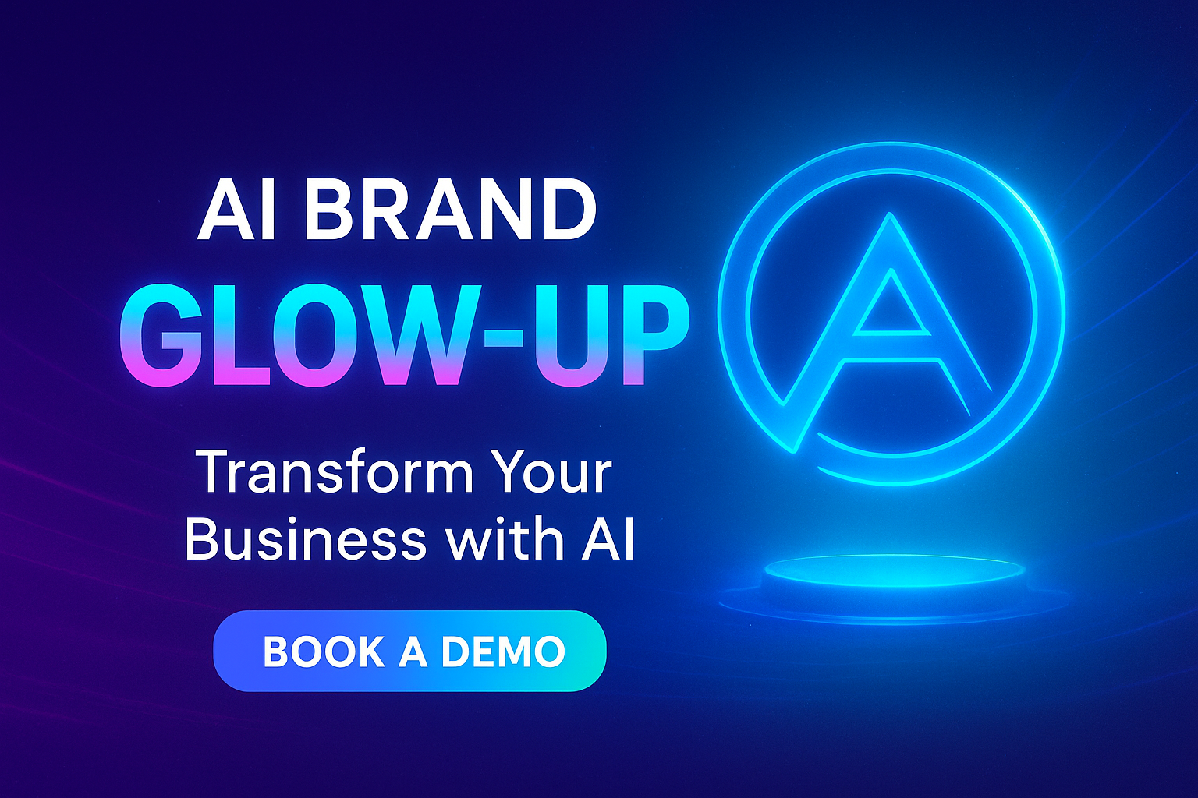

**Why Businesses Should Embrace AI-Powered Branding to Stay Competitive**

In today’s fast-moving digital economy, businesses are under increasing pressure to stand out, connect with customers, and adapt quickly to ever-changing market trends. Traditional branding approaches, while still valuable, can no longer keep pace with the speed and complexity of modern consumer behavior. This is where AI-powered branding services are transforming the game.

### 1. Speed and Efficiency

Branding once required weeks or even months of research, design iterations, and testing. AI shortens this timeline dramatically. Through intelligent algorithms, businesses can instantly generate logos, color palettes, slogans, and even marketing strategies that are data-driven and tailored to their audience. This means startups and enterprises alike can launch campaigns faster and seize opportunities before competitors do.

### 2. Data-Driven Insights

AI thrives on data. By analyzing consumer behavior, market trends, and competitor activity, AI-powered branding tools provide insights that human teams might overlook. Businesses can uncover what resonates most with their target audiences and adjust branding strategies in real time. This reduces guesswork and ensures branding decisions are rooted in evidence rather than assumptions.

### 3. Personalized Customer Experiences

Modern consumers expect personalization. AI-powered branding can dynamically adapt content, visuals, and messaging for different audience segments. Whether it’s tailoring website experiences, customizing ad creatives, or adjusting tone of voice, AI ensures that brands speak directly to individuals—not just the masses. This level of personalization strengthens customer loyalty and increases conversion rates.

### 4. Cost-Effective Creativity

Hiring traditional branding teams can be costly, especially for startups operating on limited budgets. AI-driven branding platforms provide high-quality creative assets at a fraction of the price, freeing up resources for other areas of growth. Businesses gain access to professional-grade designs, messaging, and analytics without the heavy financial burden.

### 5. Future-Proofing the Brand

The digital landscape evolves rapidly, and brands that remain static risk falling behind. AI doesn’t just create branding—it evolves it. With predictive analytics, businesses can anticipate shifts in consumer behavior and adapt their identity accordingly. This ensures longevity and relevance in an increasingly competitive marketplace.

### Final Thoughts

In an age where innovation determines survival, businesses can’t afford to rely solely on outdated branding methods. AI-powered branding services provide the speed, insight, personalization, and adaptability needed to thrive. Whether you’re a startup aiming to make a splash or an established company seeking to stay ahead, embracing AI in your branding strategy is not just an advantage—it’s a necessity.

**Subject: Elevate Your Brand with the Power of AI 🚀**

Hi [Mary Wambui],

I hope this message finds you well! I wanted to reach out because I believe your business is at a point where the right branding can make a big difference in how you stand out and connect with your audience.

Traditional branding often takes weeks of back-and-forth design work and guesswork about what resonates. With **AI-powered branding**, we remove the uncertainty. Our platform analyzes market trends, customer behavior, and competitor activity to create a brand identity that is not only visually stunning but also strategically aligned with your audience’s needs.

Here’s how AI-generated branding can elevate your business presence:

* **Speed & Agility** – Go from concept to brand-ready identity in days, not months.
* **Data-Driven Precision** – AI ensures your logo, messaging, and visuals connect with the right people.
* **Personalization at Scale** – Tailored content and branding for different audience segments.
* **Future-Proof Identity** – Branding that adapts as your market and customers evolve.

Whether you’re looking to launch stronger, rebrand, or simply sharpen your digital presence, AI branding gives you the tools to move faster, spend smarter, and grow bigger.

Would you be open to a quick call this week to explore how AI branding can be tailored to your goals?

Looking forward to hearing from you!

Best regards,  
[NeuraBrand]  
[Company]  
[@NeuraBrand]

Link below is for Presentation slide that highlights the advantages of AI-generated branding for startups and small businesses

<https://www.canva.com/design/DAGwcxGSuNw/f9rgUfhExQuQQ17nyimhKQ/edit>

https://www.canva.com/design/DAGwcTyDbGw/z4SY32l4rcEbWWHw7lXdGQ/edit