Contents:

What is Computer?

What is Hardware &Software?

System Architecture and Functionality

System Input Devices

System Output Devices

System Unit Devices

System IO Bus

System IO ports

System Bios

Commands for hardware information in Windows

Commands for hardware information in Linux / Linux Desktop

**What is Computer?**

A **computer** is an electronic device that manipulates information, or data. It has the ability to**store,** 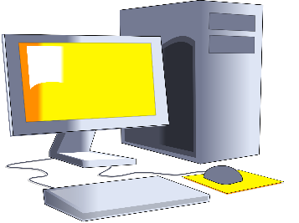**retrieve,** and **process** data. You can use a computer to type documents,send email, and browse the Web. You can also use it to handle spreadsheets, accounting, database management, presentations, games, and more.

What is Hardware?

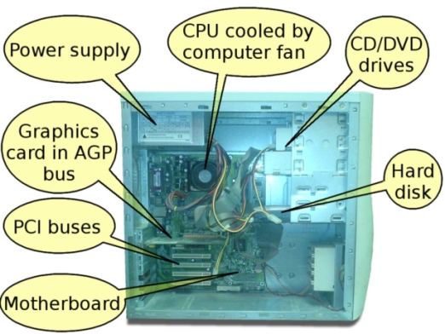Computer Hardware is the physical part of a computer, as distinguished from the [computer software](http://en.wikipedia.org/wiki/Computer_software) that executes or runs on the hardware. The hardware of a computer is infrequently changed, while software and data are modified frequently. The term soft refers to readily created, modified, or erased. These are unlike the physical components within the computer which are hard.

**What is Software?**

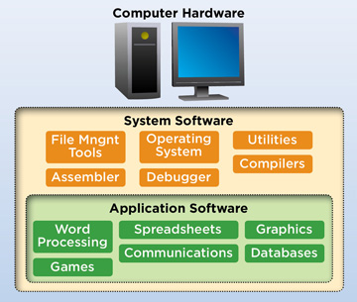Software is a program that enables a computer to perform a specific task, as opposed to the physical components of the system (hardware).This includes application software such as a word processor, which enables a user to perform a task, and system software such as an operating system, which enables other software to run properly, by interfacing with hardware and with other software.

**System Architecture and Functionality:-**

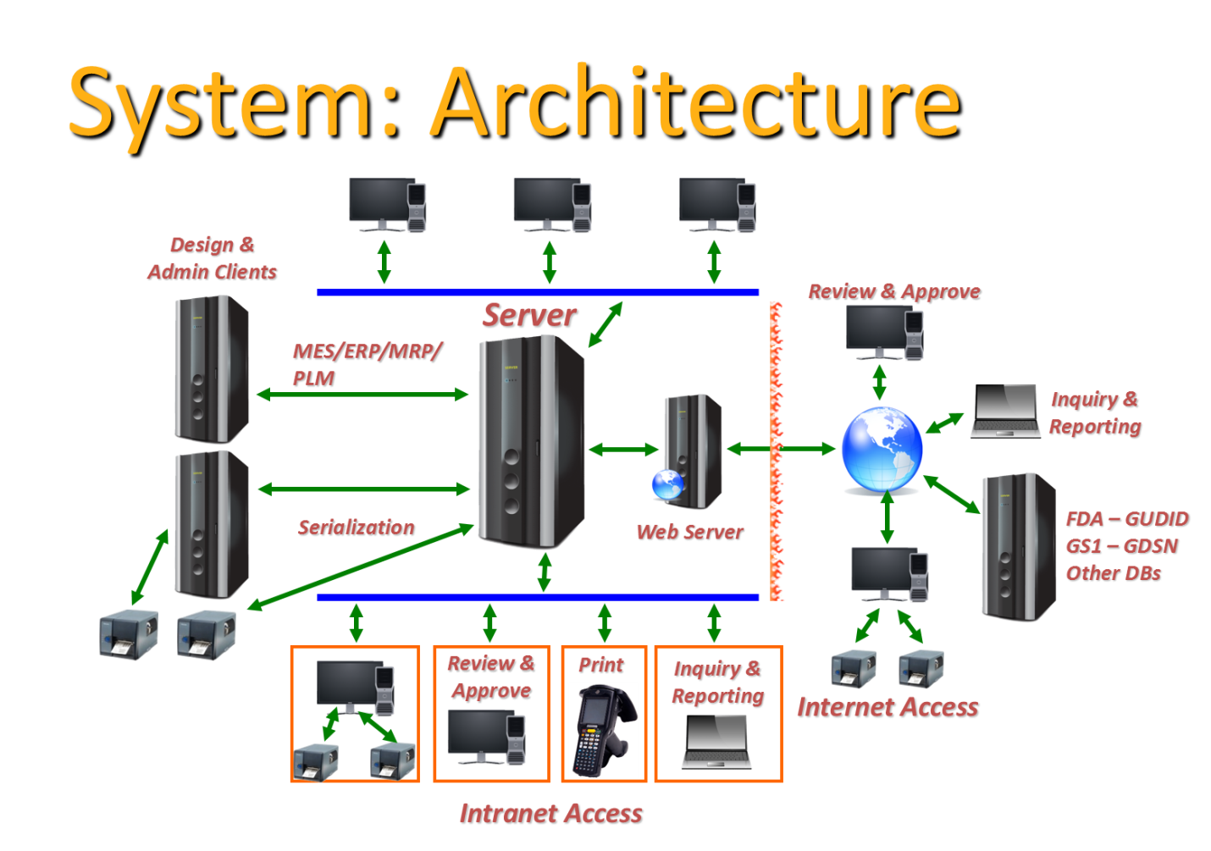

Systems Architecture is a generic discipline to handle objects (existing or to be created) called "systems", in a way that supports reasoning about the structural properties of these objects.  
Systems Architecture is a response to the conceptual and practical difficulties of the description and the design of complex systems.

**System Input Devices:-**

(Referral link :- <http://www.byte-notes.com/components-computer-system>)

(Referral link :- <https://www.computerhope.com/issues/ch001355.htm>)

(Referral link :- <http://people.bu.edu/baws/computer%20hardware.html>)

An input device feeds data to the computer system for processing.

Here is a list of input devices of a Computer System. We are going to discuss the most commonly used input devices in this article.

**Complete list of Input Devices:-**

* Keyboard
* Mouse
* Scanner
* Digital Camera , Camcorder
* Gamepad, Joystick, Steering wheel.
* Mic
* Barcode Reader
* Pen / Stylus
* Touch Screen
* Webcam
* Biometrics (Thumb impression / Face detection)

**System Output Devices:-**

Output devices display the processed form of data to the end user.

Common Output devices include;

* Monitor
* Printer
* Speaker

**System Unit Devices:-**

(Referral link: - <https://turbofuture.com/computers/Pcs-system-unit>)

(Referral link: - <https://www.quora.com/What-are-the-components-of-a-system-unit>)

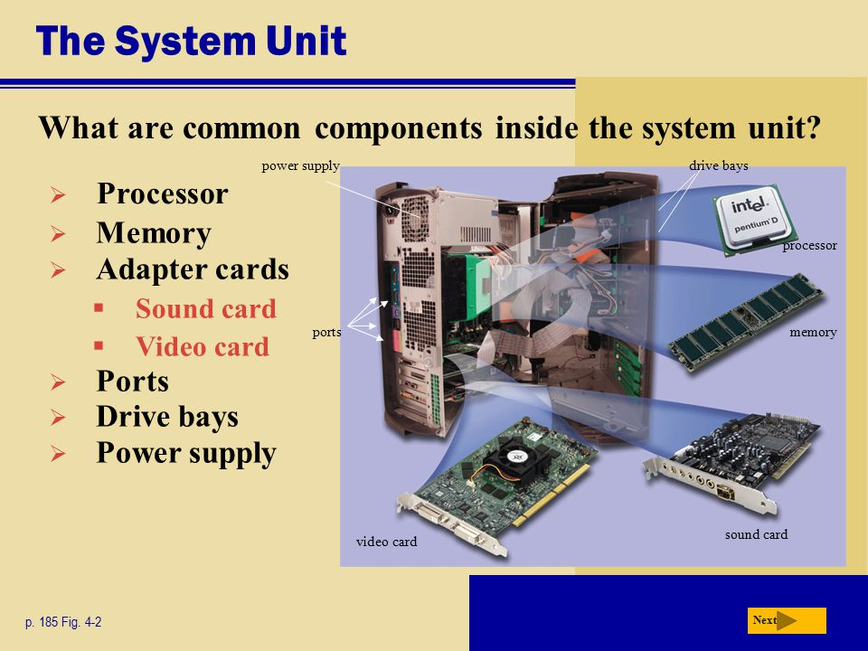

System unit (chassis) is a set of electronic components of a computer that provides the proper its operating. There are six main system unit components:

1. **Motherboard** – a system core. Actually, it is a heart of computer. Other system elements are connected to motherboard, and the whole system is managed and controlled by it. Motherboard contains special chips on which some ICs (Integrated circuits) are etched.
2. **Processor**– a computer engine, its brain. CPU (central processing unit) manages most of computer operations. Processors can be with pins or pin-less. It contains a control unit and a logic unit.
3. **RAM** (random access memory) – primarily memory. It storages all data processed by programs and apps on the computer. There are dynamic and static RAMs.
4. **Hard Drive**– a system memory that storages data in a form of archives. Here all our files, folders, operating system, programs, and applications are saved. Hard driver can be of two type: PATA (Parallel Attachment Packet Interface) and SATA (Serial Attachment Packet Interface).
5. **Video Card**(graphics adapter) – with its help the outputs from a computer are displayed on the screen. Modern video cards support HDMI (high-definition multimedia interface), VGA (video graphics array) and DVI (digital visual interface).
6. **Power Supply**– provides every part of PC with electrical power.

**Hard Disk Drive :-**

HDD: - It is stands for Hard Disk Drive. As per the structure of the HDD, there are three types.

1. IDE Hard Disk Drive
2. SATA Hard Disk Drive
3. SCSI Hard Disk Drive.

**IDE Hard Disk Drive: -** It stands for integrated drive electronic and there are 2 IDEs are presented on the motherboard.

Primary IDE or IDE0

Secondary IDE or IDE1

Each IDE is supporting two IDE devices.

IDE is having 40 pins.

Data Transfer Rate or Speed is 16.6 mbps.

RPM (Rotation per Minute) is 7200

Basically it is using for Desktop usage purpose.

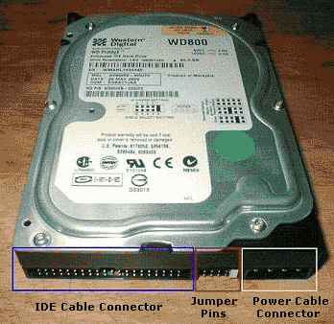

**SATA Hard Disk Drive: -** It stands for Serial ATA.

Each SATA port is supporting one hard disk.

SATA is having 7 pins

SATA hard disk is using for Desktop usage purpose.

Compare to IDE, SATA is more speed.

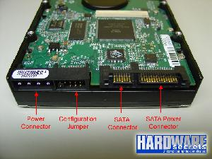

**SCSI Hard Disk Drive:-** SCSI stands for Small Computers Serial Interface or Small computers System Interface.

Each SCSI is supporting 16 hard disks.

SCSI is having 50 pins.

Data Transfer speed or Rate is 20 mbps.

RPM speed is 15000.

SCSI Hard disks are using for servers.

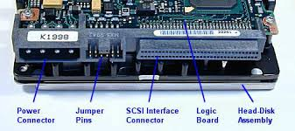

**System IO Bus:-**

There are two types of buses.

System bus/local bus/FSB (Front Side Bus):- System bus connects processors and RAM

I/O Bus: - I/O Bus connects CPU and other devices.

Types:-

PCI Slots

AGP Slots

CNR Slots

IDE Slots

RAM Slots

FDD Slots

SATA Ports /Slots

**PCI Slots: -** PCI Stands for Peripheral Component Interconnect. PCI Slots are mainly using for external card connections.

Ex: - NIC, Sound, VGA, TV Tuner etc.,

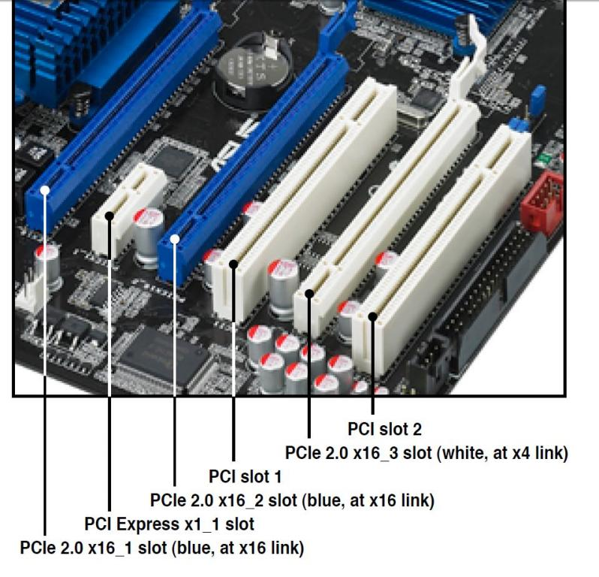

**AGP Slots: -** AGP Stands for “Accelerated Graphics Port” *AGP* is a type of expansion *slot* designed specifically for graphics cards.

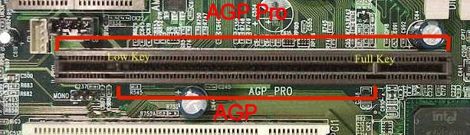

**CNR Slots: -** It stands for Communication Network Riser slot which is a hardware device that plugs into a motherboard and holds chips for functions like modems and audio devices and external LAN devices.

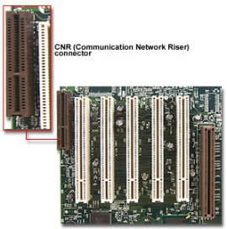

**IDE Slots:** - It stands for “Integrated Drive Electronic”. Integrated Drive Electronics (IDE) is a standard interface for connecting a motherboard to storage devices such as hard drives and CD-ROM/DVD drives.

IDE is having 40 pins.

**RAM Slot: -** A memory slot, memory socket, or RAM slot is what allows computer memory ([RAM](http://www.computerhope.com/jargon/r/ram.htm)) to be inserted into the computer.

There are two types of RAM Slots.

**SIMM:** - Stands for “Single Inline Memory Module”. Simm slots are having double notch. Simm slots are supporting only SD Rams. This slot is supporting only SD Rams.

SD stands for Synchronize Dynamic Ram. Simm slots having 168 pins and now it is outdated.

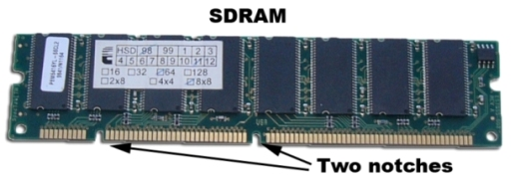

**DIMM Slots:-** It stands for “Duel Inline Memory Module” It is having single notch and supporting only DDR Rams.

DDR Stands for Double Data Rate.

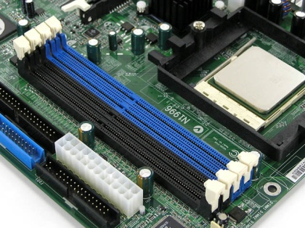

**FDD Slots: -** It is similar in function to the IDE connector. It is a 34 pin ribbon connector that carries data between the motherboard and any floppy drive installed in the PC.

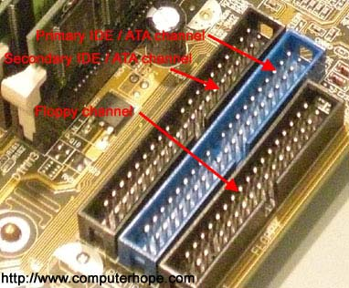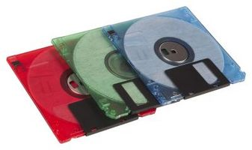

**SATA Slots: -** SATA stands for Serial ATA. The standard hardware interface for connecting hard disks and CD/DVD drives to the computer. SATA was introduced in 2002, and nearly all computers use SATA drives.

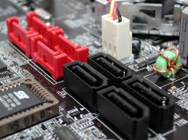

**System IO ports:-**

**Input/output Ports:-** Input/output port is what allows the software drivers to communicate with hardware devices on your computer.

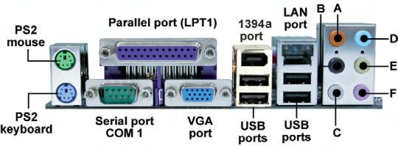

Below is power ports presented on motherboard.

1. **Power port:** It is for power supplying purpose. This one having three pins. With help of SMPS it supplies the power to motherboard.
2. **PS2 Keyboard port:** It is having 6 pin din female connector. This color is purple or blue.
3. **PS2 Mouse Port:** It looks like keyboard port but color is green.
4. **Serial Port:** It is having 9 pin male connectors. Here we can insert serial mouse and extended modems.
5. **Parallel Port:** It is a 25 pin female connector. By using this, we can insert inkjet or Dot Matrix printer. LPT stands for Line Print Terminal.
6. **VGA Port:** It stands for Video Graphic Adaptor. It is a 15 pin female connector. The vga port is used for connecting a computer to a monitor.
7. **USB Port:** Short for Universal Serial Bus, an [external bus](http://www.webopedia.com/TERM/E/external_bus.htm) standard that supports [data transfer rates](http://www.webopedia.com/TERM/D/data_transfer_rate.htm) of 12 [Mbps](http://www.webopedia.com/TERM/M/Mbps.htm). A single USB [port](http://www.webopedia.com/TERM/P/port.htm) can be used to connect up to 127 [peripheral devices](http://www.webopedia.com/TERM/P/peripheral_device.htm), such as [mice](http://www.webopedia.com/TERM/M/mouse.htm), [modems](http://www.webopedia.com/TERM/M/modem.htm), and [keyboards](http://www.webopedia.com/TERM/K/keyboard.htm). USB also supports [Plug-and-Play](http://www.webopedia.com/TERM/P/plug_and_play.htm) installation and [hot plugging](http://www.webopedia.com/TERM/H/hot_plugging.htm).
8. **1394a Port:** It is Fire wire port. It is a communications standard. It's used mainly for peripherals such as external hard drives or optical drives.
9. **LAN Port:** (**L**ocal **A**rea **N**etwork port) An RJ-45 Ethernet socket on a computer or network device such as a switch or router. It allows a computer to connect to a network using a wired connection.
10. **Audio Port:** Sound in, Sound out and Microphone ports.

**Server :-**

**A server** is a computer program that provides services to other computer programs (and their users) in the same or other computers. The computer that a server program runs in is also frequently referred to as a server

There are three types of servers

* **Rack Server**
* **Blade Server**
* **Tower Server**
* **Rack Server: -** A rack server, also referred to as a rack-mount server, is the standard size server used for mounting inside a data centre server cabinet or rack frame infrastructure. A single rack server is 19"w x 1.75"h. This is referred to as a 1U rack server which is short form for 1 unit.

**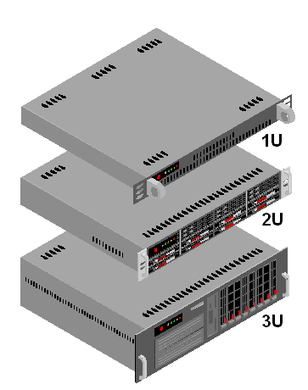**

Ex:- Dell PowerEdge R710, Dell PowerEdge R720, HP Proliant DL380 G7 and HP Proliant DL380 G8.

* Blade Server:-

A blade server is a compact, self-contained server that consists of core processing components that fit into an enclosure with other blade servers. A single blade may consist of hot-plug hard-drives, memory, network cards, input/output cards and integrated lights-out remote management. The modular design of the blade server helps to optimize server performance and reduce energy costs.

**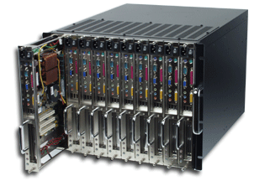**

Ex:- Dell PowerEdge M600, Dell PowerEdge M610 and HP Proliant BL495c and etc.,

* **Tower Servers: -** A tower server is a computer intended for use as a [server](http://whatis.techtarget.com/definition/server) and built in an upright cabinet that stands alone. The cabinet, called a tower, is similar in size and shape to the cabinet for a tower-style personal computer. This is in contrast to [rack server](http://whatis.techtarget.com/definition/rack-server-rack-mounted-server) s or [blade server](http://searchdatacenter.techtarget.com/definition/blade-server) s, which are designed to be [rack-mounted](http://whatis.techtarget.com/definition/rack-mounted).

**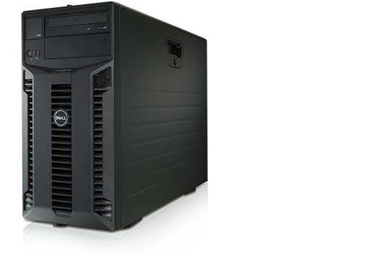**

Ex: - Dell PE T300, Dell PE 11G T610 and HP Proliant ML 350 G6 etc.,

**System Bios:-**

(Referral link :- <https://www.dell.com/support/article/in/en/indhs1/sln284433/what-is-bios-and-how-to-update-the-bios-on-your-dell-system?lang=en>)

(Referral link :- <https://computer.howstuffworks.com/bios.htm>)

**Commands for hardware information in Windows:-**

Referral link:- <http://www.simplehow.tips/a/44/how-to-view-system-information-on-windows10>

### View basic system information

Right click on "Start Menu" and click on "System" in pop-up menu to open "System" window.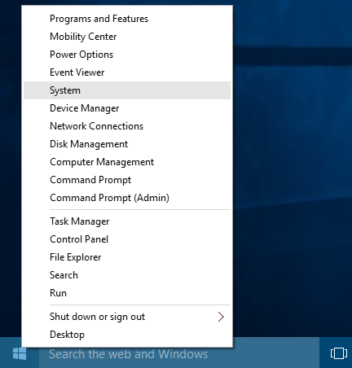

"System" window will show basic information about your computer like Windows edition, Processor type and speed, installed Memory(RAM) on your computer, system type, your computer name, domain or workgroup name and Windows activation status.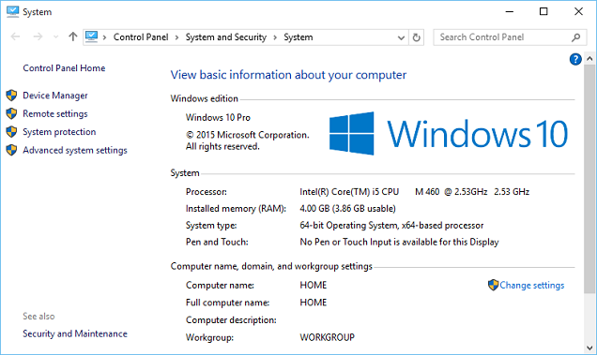

### View detailed system information

Type "System Information" in cortana search box, and select "System Information" from cortana search results.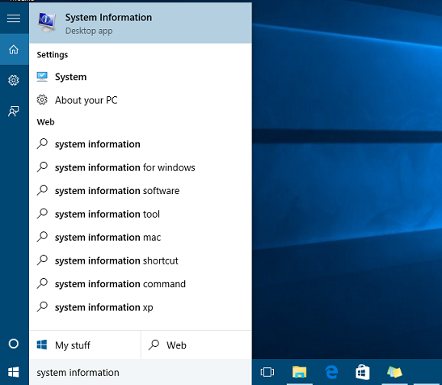

This will open "System Information" app where you can view detailed system summary, hardware resources, hardware devices on your computer and driver details.  
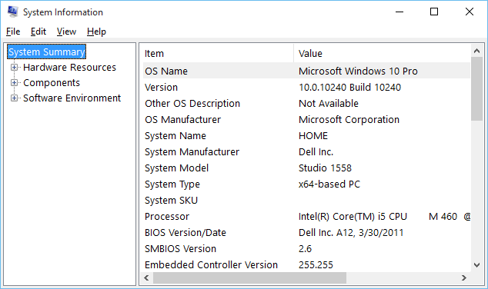You can also open "System information" by opening Windows Run dialog ("Windows key + R" shortcut or Right click on Start button and select "Run" from pop-up menu), type "msinfo32" in Run dialog, and click on OK button.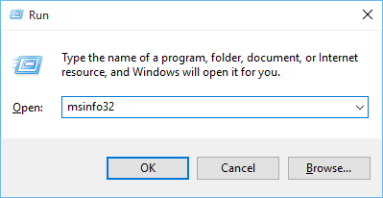

# Get CPU Information via Command Prompt in Windows:-

Referral link:- <https://winaero.com/blog/get-cpu-information-via-command-prompt-in-windows-10/>

wmic cpu get caption, deviceid, name, numberofcores, maxclockspeed, status

The command produces the following output:[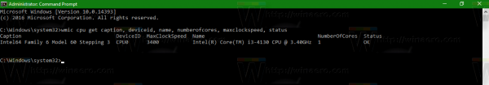](https://winaero.com/blog/wp-content/uploads/2016/10/cpu-wmic.png)

Press the Win + R hotkeys together on the keyboard and type the following command in your Run box:

msinfo32

Tip: See [the ultimate list of all Windows keyboard shortcuts with Win keys](https://winaero.com/blog/ultimate-list-of-all-windows-keyboard-shortcuts-with-win-keys/).[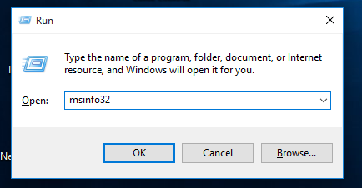](https://winaero.com/blog/wp-content/uploads/2015/10/Windows-10-msinfo32.png)[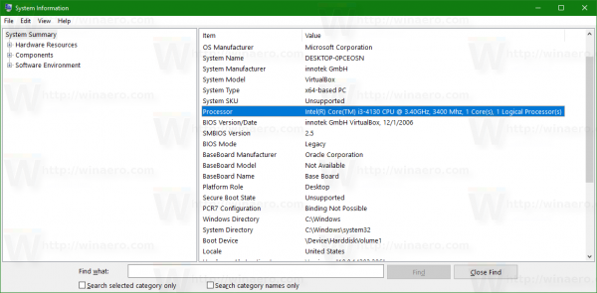](https://winaero.com/blog/wp-content/uploads/2016/10/cpu-info-msinfo32.png)

# Get MEMORY Information via Command Prompt in Windows:-

Referral link:- <https://www.tenforums.com/tutorials/66809-determine-system-memory-size-speed-type-windows-10-a.html>

**1.** Open [**Settings**](https://www.tenforums.com/tutorials/3326-settings-open-windows-10-a.html), and click/tap on the **System** icon.  
  
**2.** Click/tap on **About** on the left side, and look to see how much (ex: "32.0 GB") **Installed RAM** you have on the right side. (see screenshot below)  
  
[Click image for larger version. 

Name: Memory_size_Settings.png 
Views: 1111 
Size: 55.1 KB 
ID: 105828](https://www.tenforums.com/attachments/tutorials/105828d1476388173-determine-system-memory-size-speed-type-windows-10-a-memory_size_settings.png?s=a07e44131c9cf4bf64dda5de7192e1a9)

# Open the [Control Panel (icons view)](http://[b][url]https/www.tenforums.com/tutorials/3326-settings-open-windows-10-a.html%5b/url%5d%5b/B%5d), and click/tap on the System icon. 2. Look to see how much (ex: "32.0 GB") Installed memory (RAM) you have under the System section. (see screenshot below) [Click image for larger version.  Name: Memory_size_Control_Panel.png  Views: 872  Size: 42.6 KB  ID: 105827](https://www.tenforums.com/attachments/tutorials/105827d1476388173-determine-system-memory-size-speed-type-windows-10-a-memory_size_control_panel.png?s=a07e44131c9cf4bf64dda5de7192e1a9)

# Press the Win+R keys to open Run, type msinfo32 in the search box, and click/tap on OK. 2. Click/tap on System Summary on the left side, and look to see how much (ex: "32.0 GB") Installed Physical Memory (RAM) you have on the right side. [Click image for larger version.  Name: Memory_size_System_Information.png  Views: 2194  Size: 54.9 KB  ID: 105829](https://www.tenforums.com/attachments/tutorials/105829d1476388173-determine-system-memory-size-speed-type-windows-10-a-memory_size_system_information.png?s=a07e44131c9cf4bf64dda5de7192e1a9)

# Get BIOS Information via Command Prompt in Windows:-

Referral link: - <https://www.maketecheasier.com/get-bios-version-information-in-windows/>

Referral link: - <https://winaero.com/blog/get-bios-information-via-command-prompt-in-windows-10/>

wmic bios get smbiosbiosversion

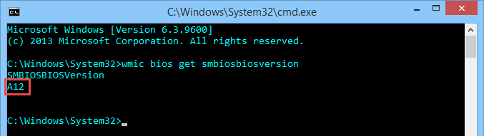

systeminfo | findstr /I /c:bios

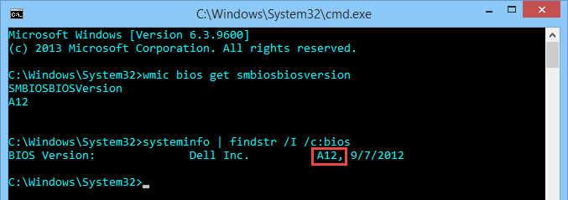

# Get HARD DISK Information via Command Prompt in Windows:-

**C:\Users\arunk> wmic logicaldisk get size,freespace,caption**

C:\Users\arunk>wmic logicaldisk

# Get PROCESS Information via Command Prompt in Windows:-

Referral link:- <https://support.kaspersky.com/6325#block2>

How to get PID using the command prompt

1. Run the command prompt.
2. Execute the **tasklist** command.
3. The list of active processes and their **identificators (PID)** will appear.

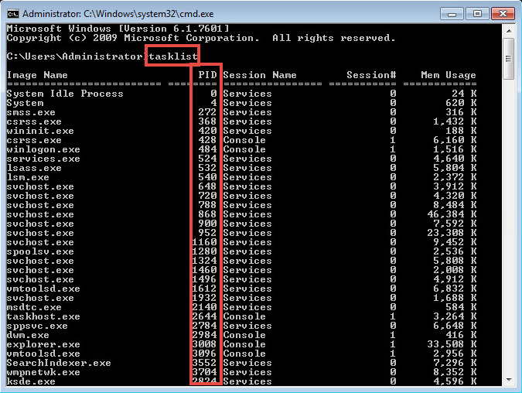

**Commands for hardware information in Linux / Linux Desktop:-**

Referral link:- <https://www.maketecheasier.com/check-hardware-information-linux/>

Referral link:- <https://poweruphosting.com/blog/linux-hardware-info/>

Referral link:- <https://www.binarytides.com/linux-commands-hardware-info/>

The lscpu command gives you information about the CPU and processing units. It does not have any other options or functionality.

lscpu

You will see the following output by running the above command.

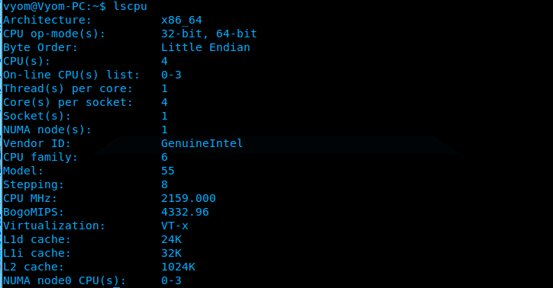

**lspci**

The lspci is another command line tool that lists all the PCI buses and details about the devices connected to them like VGA adapter, graphics card, network adapter, usb ports, SATA controller, etc.

**lspci**

You will see an output similar to the following image.

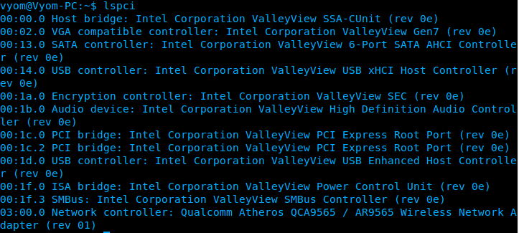

**lshw**

The lshw is a general purpose utility that reports detailed and brief information about multiple hardware units like CPU, memory, usb controller, disk, etc. Lshw extracts the information from different “/proc” files.

lshw -short

You will see the following information by running the above command.

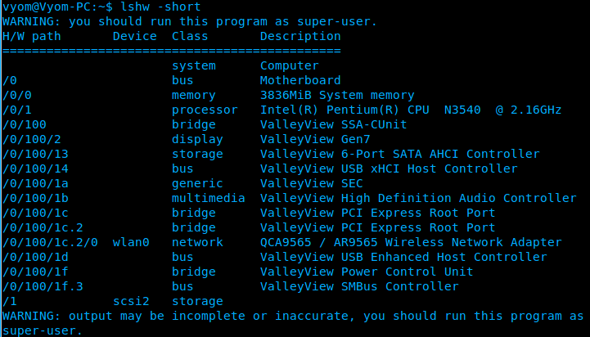

**df**

This command gives you brief information about various partitions, their mount points and the used and available space on each.  
You can run the df command with the -H parameter.

**df** -H

You will see the following output.



**Free**

You can check the amount of used, free and total amount of RAM on your system with the free command.

**free** -m

You will see the following output.

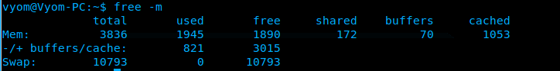

**Dmidecode**

The dmidecode command is different from all other commands. It extracts hardware information by reading data from the DMI tables.

To display information about the processor, run:

**sudo** dmidecode -t processor

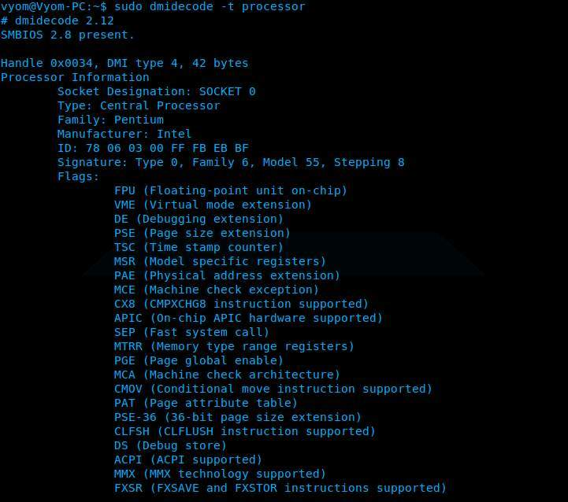

To display information about the memory, run:

**sudo** dmidecode -t memory

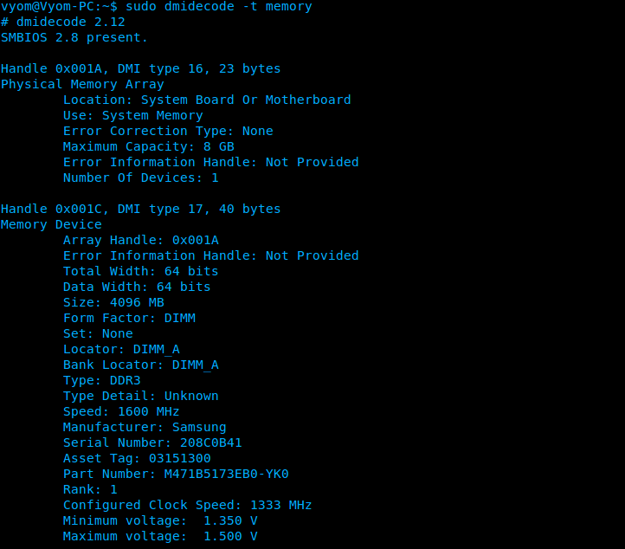

To display information about the bios, run:

**sudo** dmidecode -t bios

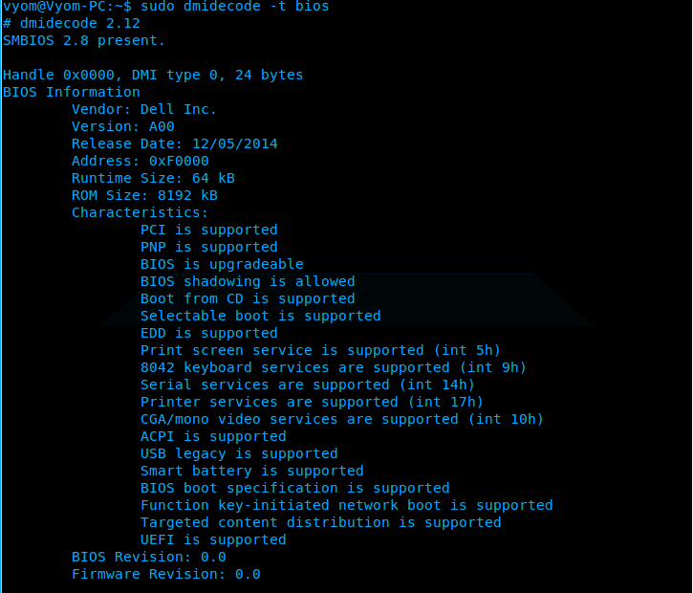

**Hdparm**

The hdparm command gives you information about sata devices like hard disks.

**sudo** hdparm

