Testing LEDs and Cablelength

LEDs tested:

RGB Smart NeoPixel
Flora NeoPixel
"in house" LEDs

Best luminoscity/color purity: Flora NeoPixel

Cablelength tested: 10m, LEDs still working.

Nearly noticable difference between single and double LEDs per compartment.

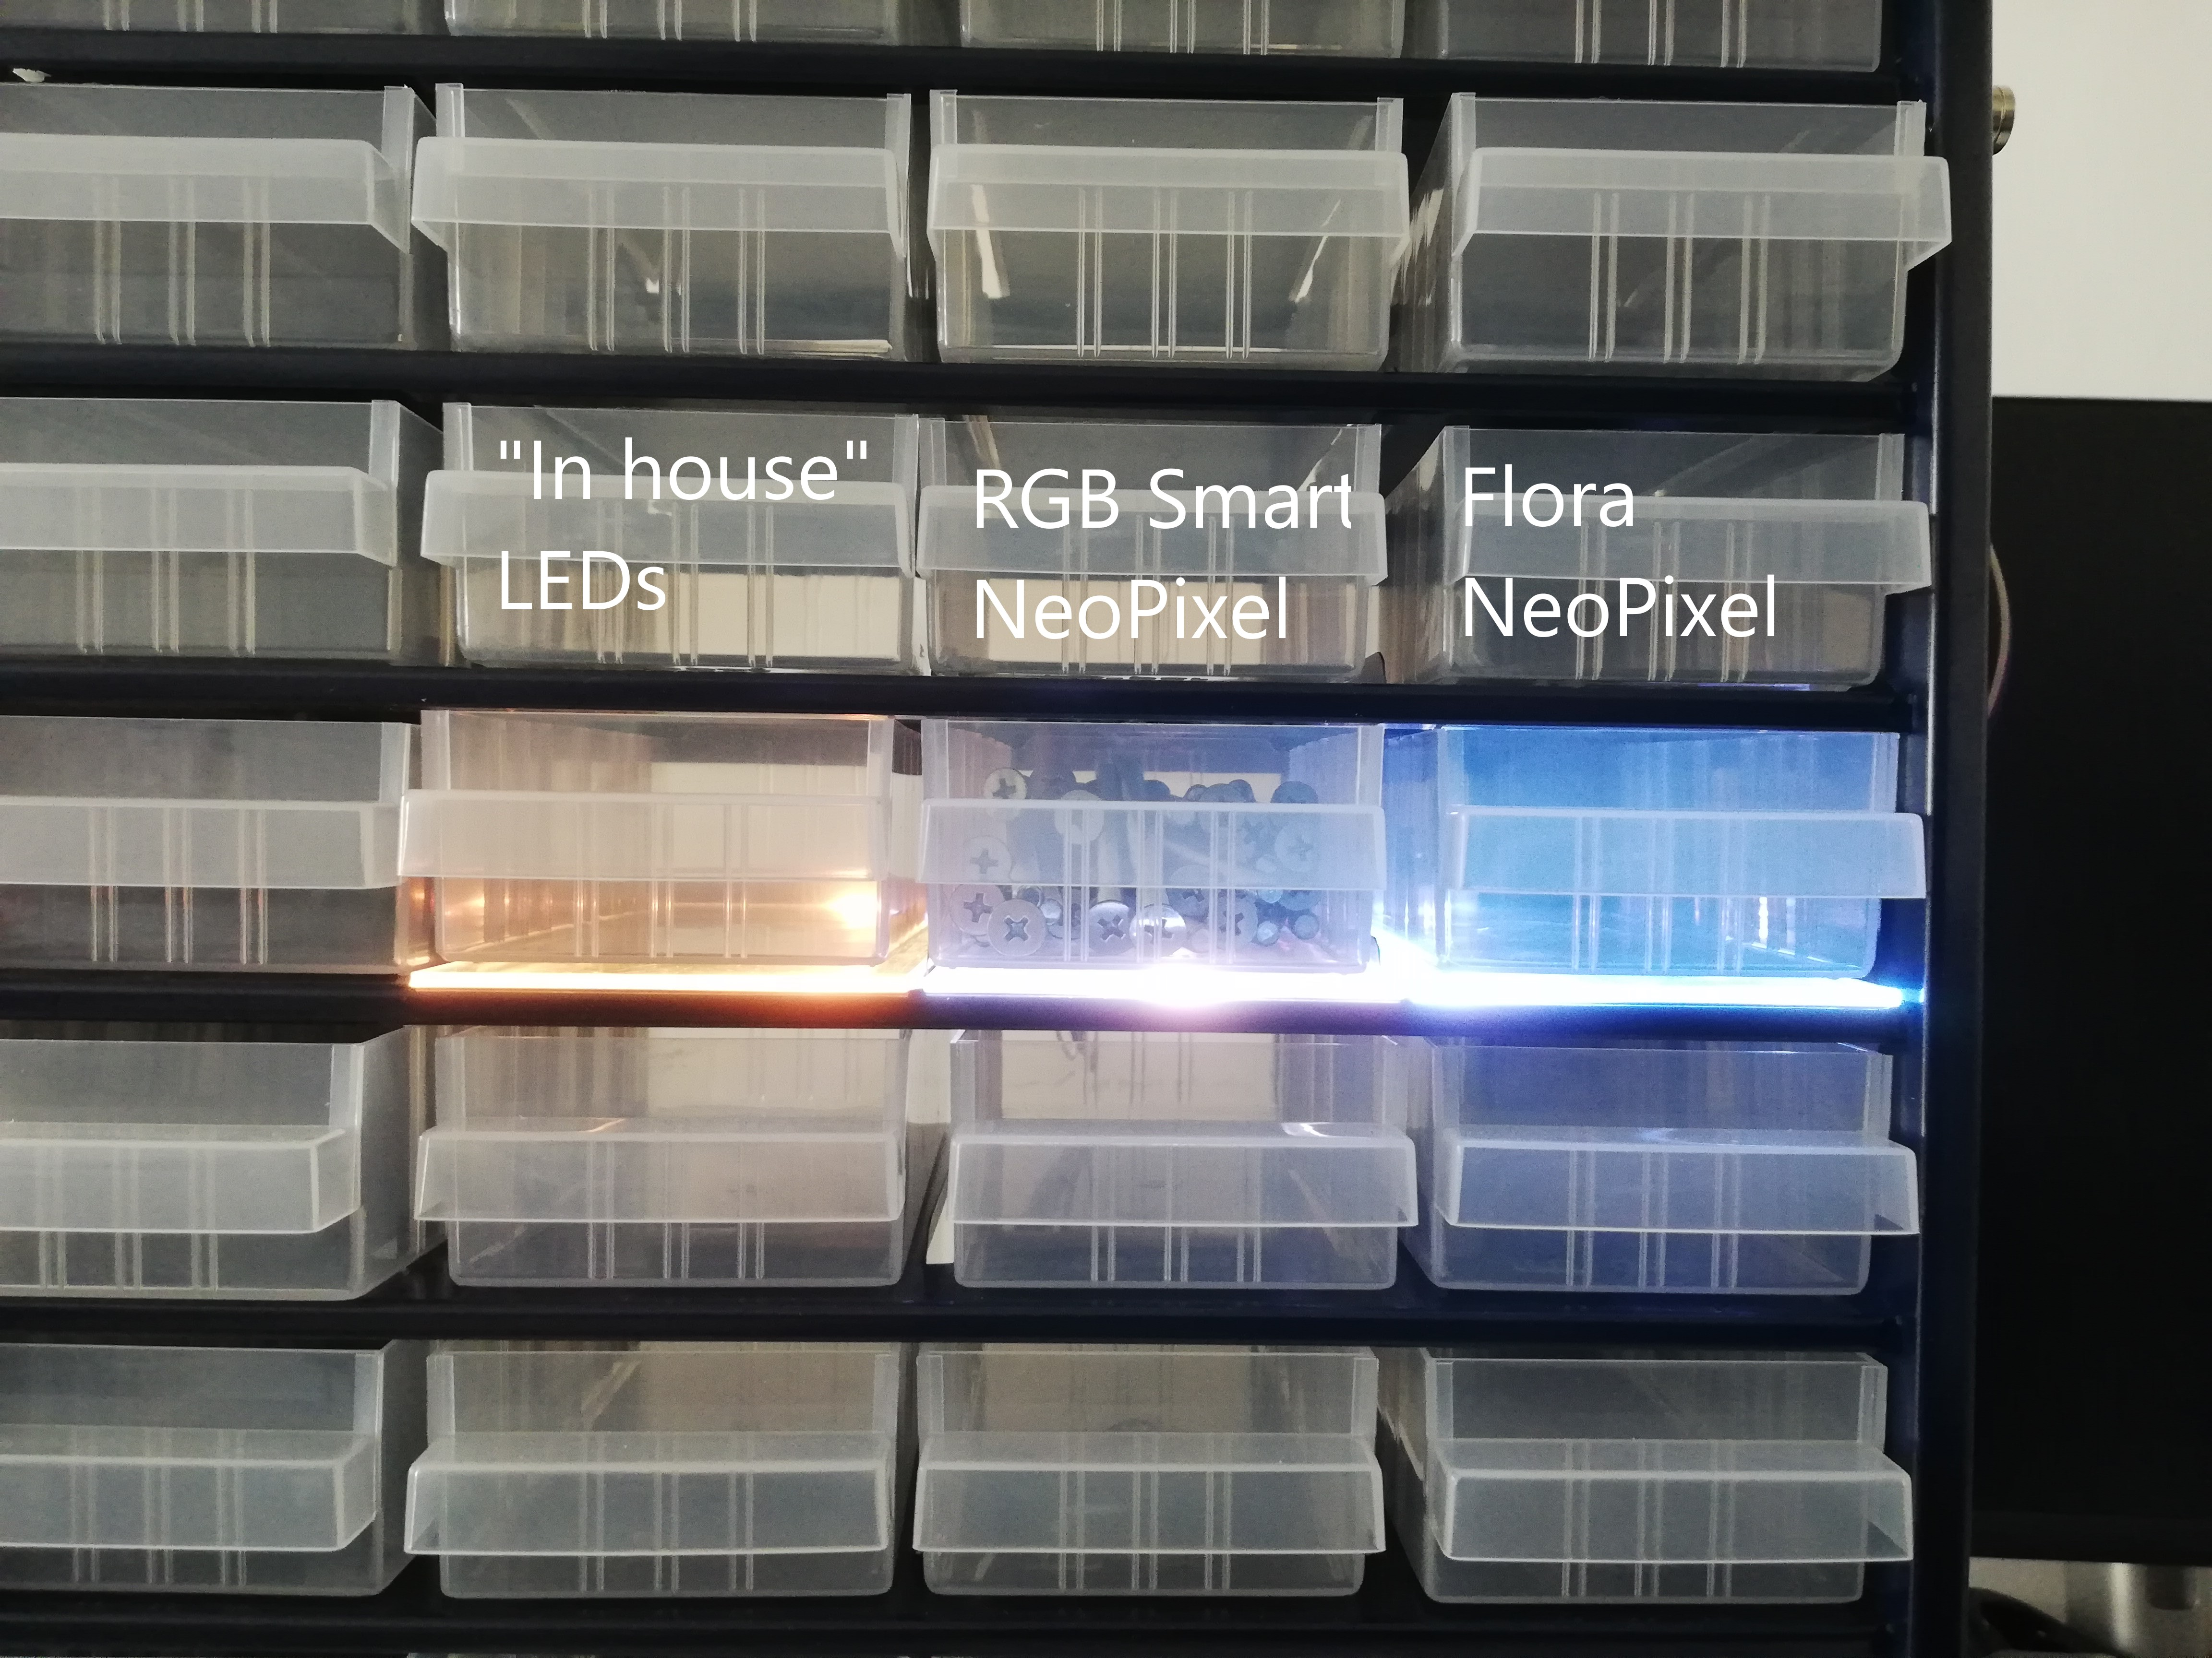
One LED per compartment:
(left LED is yellow, because the "in house" variant are two different LEDs, one without true white)

Two LEDs per compartment:


