PMC4321030
Total QTL tables: 6 (Table 3 and 4 are 2 times)
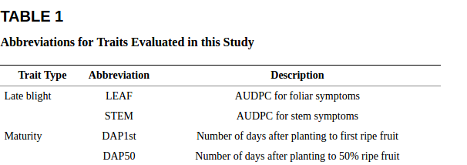
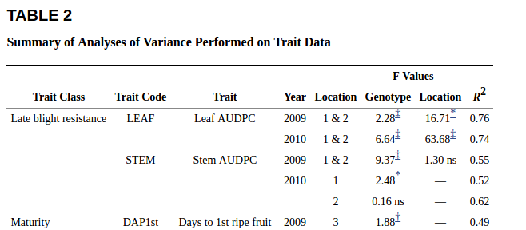
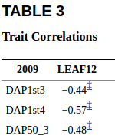
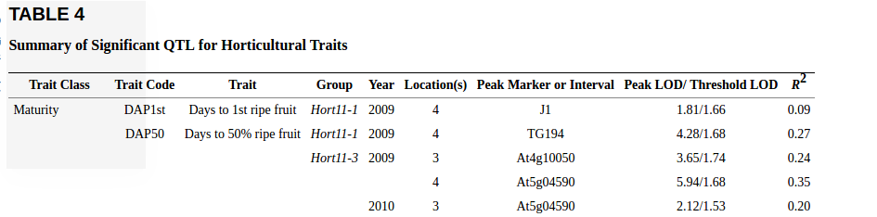

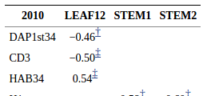
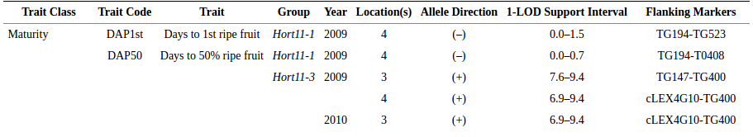

Table Number | QTL Descriptors | QTL Values | QTL Properties
1 | 1 |  | 2
2 | 3 | 2 | 3
3_0 | 0 | 0 | 4
3_1 | 0 | 0 | 4
4_0 | 3 | 2 | 4
4_1 | 3 | 2 | 4

QTL property terms added to vocab
Abbreviation | http://purl.bioontology.org/ontology/SNOMEDCT/398223008 | SNOWMED
Description | http://ncicb.nci.nih.gov/xml/owl/EVS/Thesaurus.owl#C25365 | NCIT
Location (Position in FALDO ) | http://biohackathon.org/resource/faldo#Position | FALDO
Genotype | http://www.ebi.ac.uk/efo/EFO_0000513 | EFO EBI
Group | http://ncicb.nci.nih.gov/xml/owl/EVS/Thesaurus.owl#C43359 | NCIT
Marker | http://purl.obolibrary.org/obo/SO_0001645 | SO
LOD | http://purl.bioontology.org/ontology/SNOMEDCT/58577001 | SNOWMED
QTLValue terms added to vocab
Year | http://www.ebi.ac.uk/efo/EFO_0001725

PMC

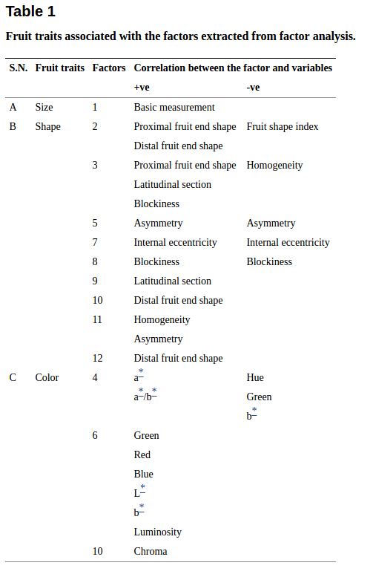

PMC4948827

