* Name

Idle Pirate Sailing

* Core concept

Sail your pirate ship across the seven seas while collecting loot, attacking merchant ships, and selling your loot at ports to buy ship upgrades.

* Design Pillars
  + 2D portrait mode autorunning casual gameplay
  + Idle progress
  + Fighting enemy ships
  + Upgrading and power increases
* Main Features and Mechanics

The game will be a 2D portrait mode game that automatically sails you forward. The player can sail left and right across the screen. There is floating debris and loot you can sail over to pick up and enemy ships you can sail next to and fire a broadside to destroy and loot them.

Your ship will also passively collect idle loot as time passes. The ship has a capacity for both passive and active loot and to turn it into gold you will need to stop off at a port along the side of the screen that appear regularly. There you will be able to sell your loot as well as purchase upgrades for your ship. The current list of upgrades is:  
Cannon range (The range left and right you can shoot an enemy  
Rudder (Left and right speed)  
Sails (Forward speed)  
Grappling hooks (Larger loot pick up range)  
Ship hold (Loot capacity. Possibly split into active and passive)

More upgrades can be added later.

* Interface and Controls

Mobile game style interface with displays for currency and buttons for opening menus and upgrade windows. The only controls I am planning at the moment are holding the left and right sides of the screen to move your ship left and right.

* Target platform and audience

Android only for the moment. The intended audience is casual players who want a simple mobile idle game

* Basic Story

You are the captain of a pirate ship heading off into the seven seas to gain riches and fame.

* Initial design sketches

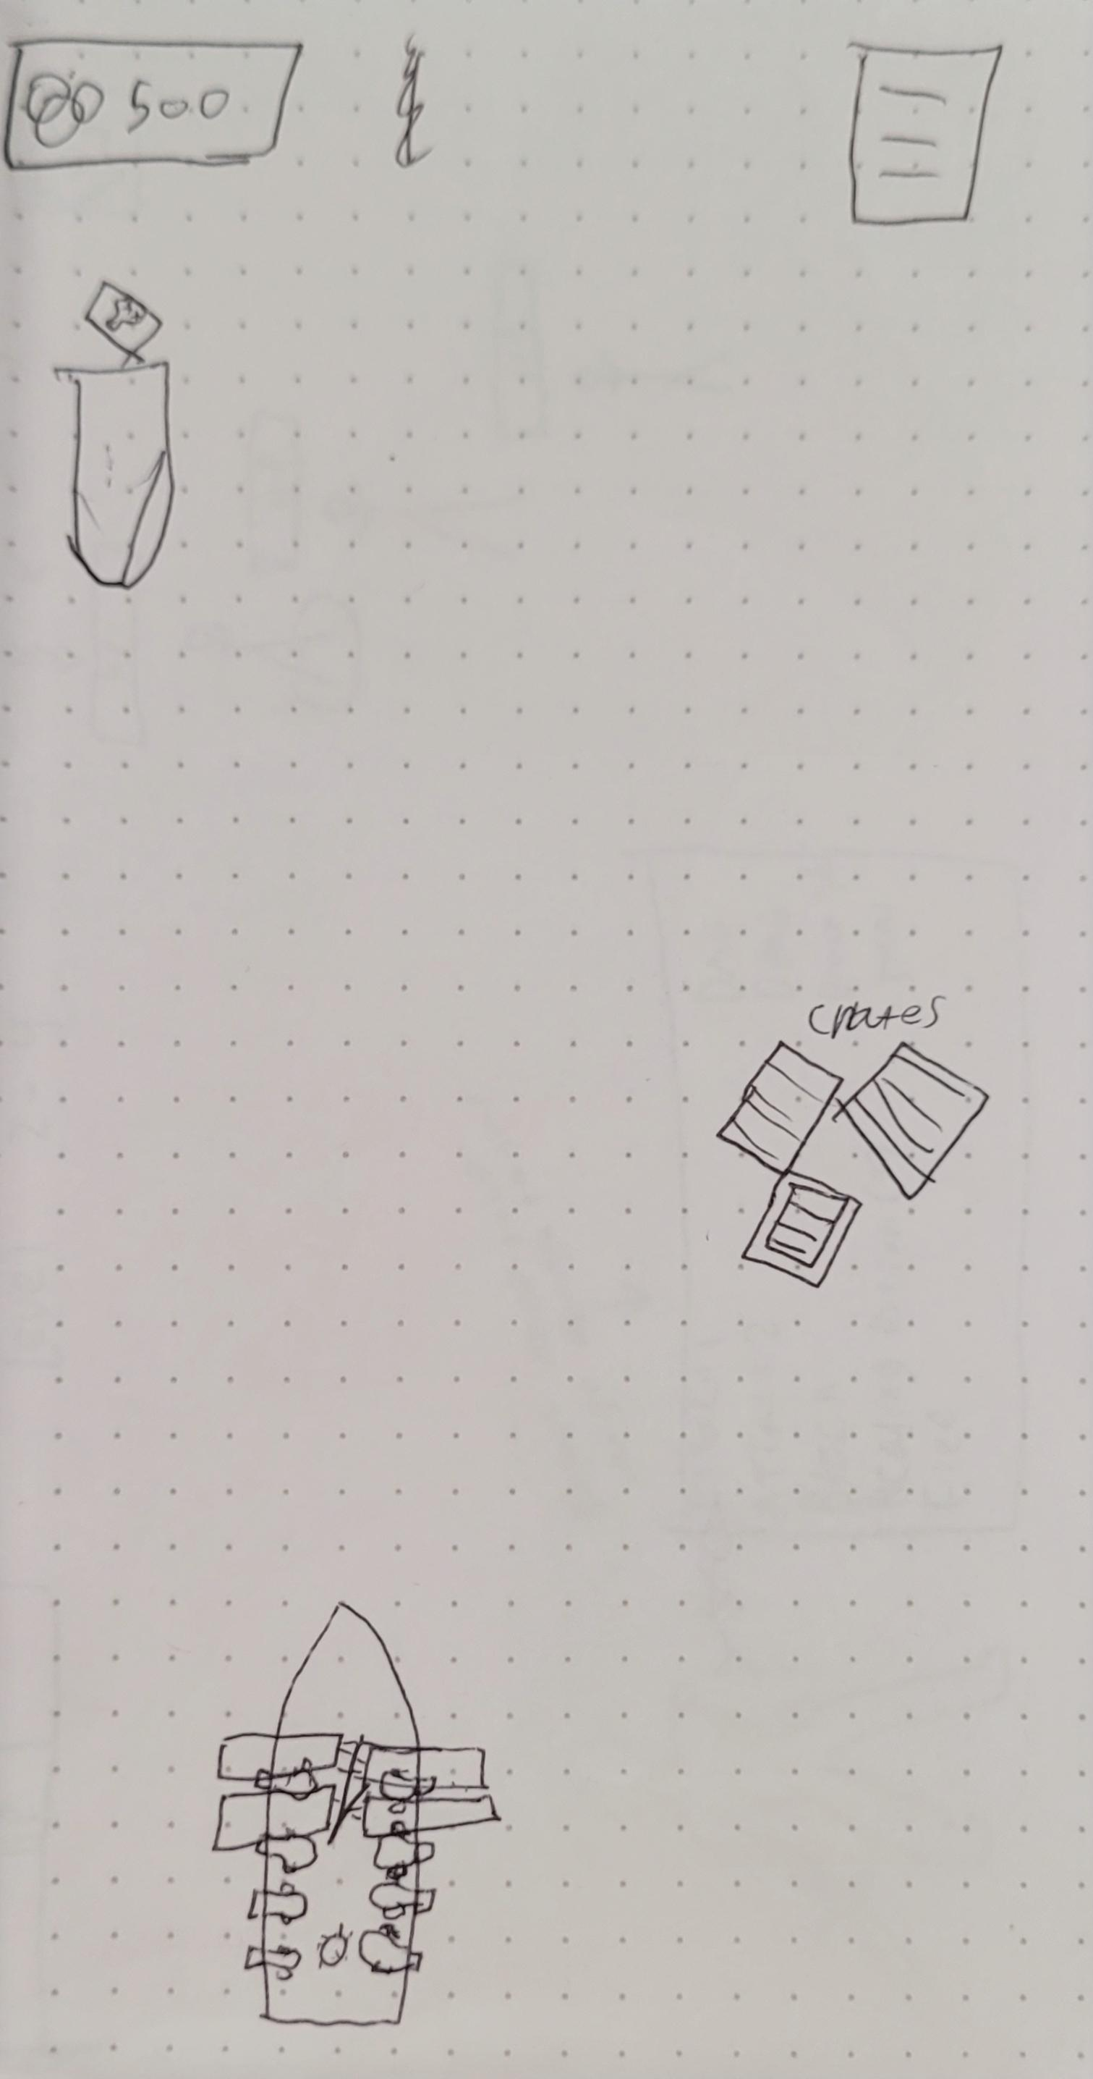

Initial sketch of the game

* Future improvement

There are a lot of potential improvements and additions for this type of mobile game. There can be more upgrades or more currencies. The biggest possible addition is some sort of “ascension” update where you reset all your coins and progress in exchange for some sort of meta progression upgrades.

* Audio Style

Basic and unobtrusive mobile game style soundtrack.

* Visual Style

I am going to be using this pack from the Unity store for the UI [2D Casual GUI - Play Light Games | 2D GUI | Unity Asset Store](https://assetstore.unity.com/packages/2d/gui/2d-casual-gui-play-light-games-233493)

The games style will be simple to make it easier to get art for the game, and if needed I can make anything I am missing. I am considering using this pack [Pirate Pack · Kenney](https://kenney.nl/assets/pirate-pack)

* Known issues and bugs