* **Name**

TBD

* **Core** **concept**

2D turn based combat fantasy game.

* **Inspiration** **games**

Turn based combat games such as the older Final Fantasy or Pokémon games.

* **Design Pillars**

Turn based combat. Speed stat and dice rolls determine turn order.

Themed levels. Several fights of similar enemies followed by a boss.

XP leveling. Three stats to improve: Attack, HP, Speed

* **Main** **Features and Mechanics**

The combat is turn based with selecting attacks, abilities, and items and selecting the target enemy. Not too difficult as it is a casual phone game.

The fights are in level sets with themed enemies and backgrounds. From fight 1-1 to 1-2 all the way to the end of the first level where there is a boss and then it becomes level 2-1. The screen scrolls with a player walking animation between fights.

There is a leveling system where you get XP from defeating enemies that will level you up. Leveling improves your stats. You can flee enemies and it will put you back at the start of the level so you can get more XP and levels to get stronger. XP granted will scale with enemy level so you cannot farm infinitely.

* **Interface and Controls**

Portrait mode. Controls are tapping on the options. No joystick. Possible option for playing with 4 arrows and a and select button to pick options? Interface has attack options, health, enemies, and the options menu. Minimal screen clutter is better.

* **Target platform and audience**

Android. Casual phone game for fans of the older Final Fantasy or Pokémon styles of gameplay

* **Basic Story**

Minimal story. A knight questing through different areas and fighting enemies.

* **Initial design sketches**

Sketch of the gameplay UI

Initial unity mockup

* **Future improvement**

More main characters with more abilities. A magic user.  
Multiple characters in the player’s party.  
More levels with different enemies.  
Improving the depth of the combat system.  
More items than just health potions  
~~Predatory microtransactions~~

* **Audio Style**

8bit style music and sound effects.

* **Visual Style**

The visual style is pixel art.

Some examples of characters and enemies

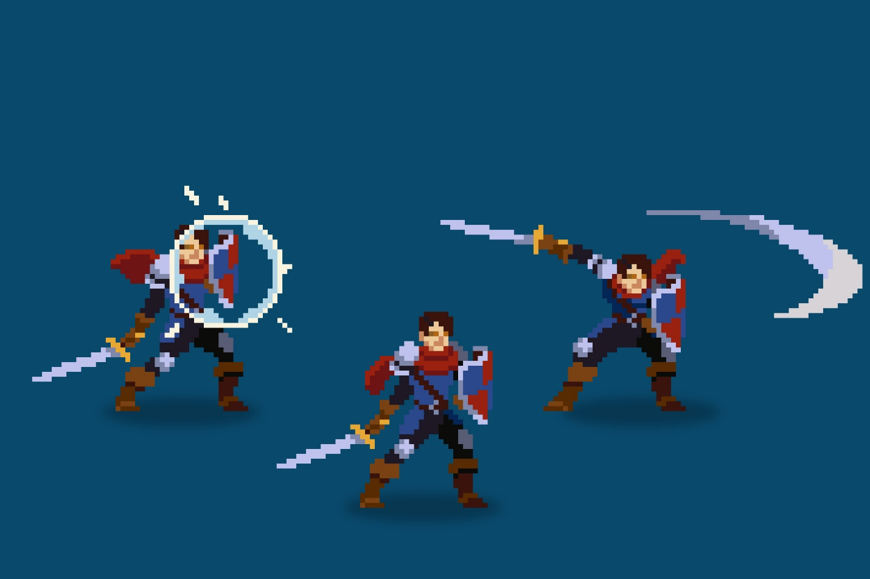

[Hero Knight - Pixel Art | 2D Characters | Unity Asset Store](https://assetstore.unity.com/packages/2d/characters/hero-knight-pixel-art-165188)

[Sven Thole - Asset Store (unity.com)](https://assetstore.unity.com/publishers/31468)

[Luiz Melo - Asset Store (unity.com)](https://assetstore.unity.com/publishers/34852)

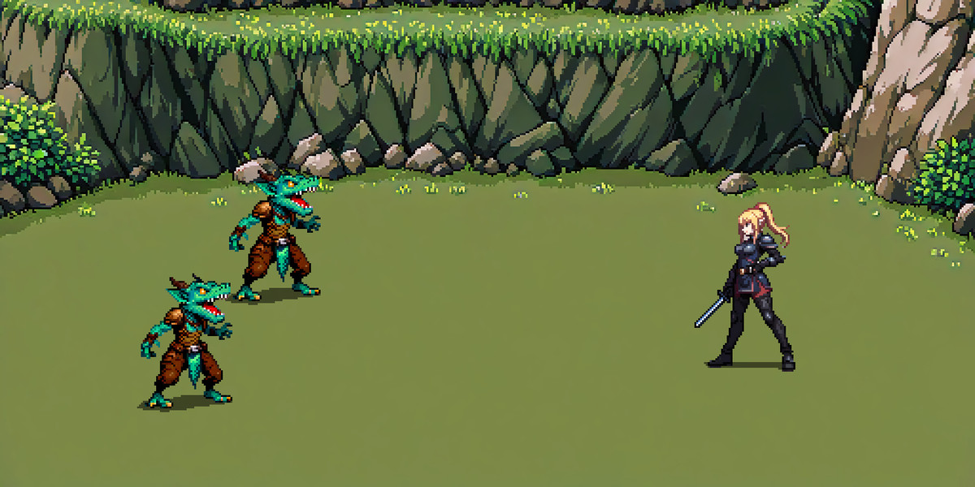

I am using this pack for backgrounds. The characters don’t have animations so likely not using them:

[Free Pixel Battle Backgrounds + Free Pixel Characters | 2D Environments | Unity Asset Store](https://assetstore.unity.com/packages/2d/environments/free-pixel-battle-backgrounds-free-pixel-characters-288309)

* **Known issues and bugs**
* **A URL to the games on Google Play Store or Apple App Store**
* **A URL to your presentation on your Microsoft OneDrive**