PayPal Cognitive AI Assistant — Official Java Project Documentation
Official technical documentation with Java architecture and screenshots.

1. Official Java Project Documentation
Project Name: PayPal Cognitive AI Assistant
Project Type: Java Spring Boot Web Application
Base Package: com.example.myaimproject
Main Class: MyaimprojectApplication
Server Port: 8081
Database: H2
Build Tool: Maven
IDE: Eclipse

2. Java Technologies Used
• Java 25
• Spring Boot 4.1.2
• Spring Web
• Spring Data JPA
• Hibernate ORM 7.4.13
• H2 Database
• Apache Tomcat 11.0.27
• Maven
• HTML, CSS, JavaScript

3. Main Class
MyaimprojectApplication is the main Spring Boot application class. It starts the embedded Tomcat server and initializes the Spring application context.

4. Controller Layer
AIController handles browser and chat requests. It receives the user message through the endpoint /api/ai-paypal/chat and sends the response back to the frontend.

5. Service Layer
AIService processes AI chat commands and creates payment orders. PayPalService generates sandbox-style PayPal order IDs and supports offline smart sandbox resilience.

6. Entity Layer
OrderEntity represents the paypal_orders database table. It stores order ID, amount, currency, status, and created time.

7. Repository Layer
OrderRepository extends JpaRepository<OrderEntity, Long>. It provides database operations such as save, findAll, findById, and delete.

8. Frontend Pages
index.html is the home page. dashboard.html displays transaction records, analytics, API sync status, and system health information.

9. Application URL
Home Page: http://localhost:8081
Dashboard: http://localhost:8081/dashboard.html
Chat AI: Available through the dashboard

10. Tested Commands
• hello
• Create a digital transaction order for 150 USD
• Transfer 500 INR to vendor
• Show transaction history
• Show system health status
• Open analytics dashboard

11. Test Output
The application successfully created a USD 150 order and an INR 500 order. Both orders were stored in transaction history. System health reported PayPal integration as Connected and transaction history entries as 2.

12. Conclusion
The Java Spring Boot PayPal Cognitive AI Assistant project is working successfully with AI chat, order creation, database storage, dashboard, and diagnostics features.

Screenshots
Screenshot 1: Application output / working screen
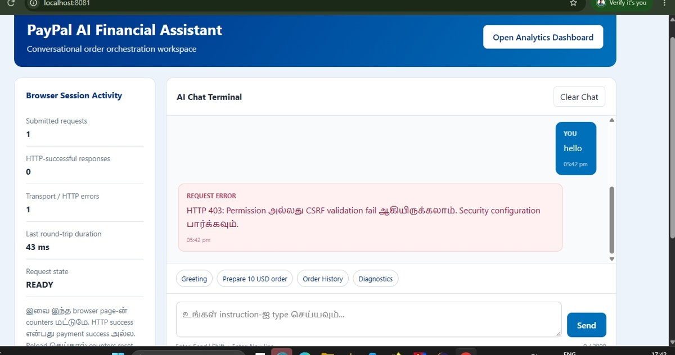

Screenshot 2: Application output / working screen

