# Version History

10/26/2025 Created.

# Goal

A program that uses the Laser system to clean mask resin on the Carousel part. The program focuses only on the outer and inner circumference of the pads, it does not attempt to clean resin from the radial areas between pads.

We found it difficult to clean the radial errors because the alignment of the laser to the pad edges needed to be << 0.1mm. Focusing on the circumferences only .1mm accuracy is needed and only translation errors need to be adjusted for, not rotation.

This process focuses on just cleaning the outer and inner circumferences which are the hardest to clean.

# Table of Contents

Version History 1

Table of Contents 1

Process Steps 1

Creation of the G-Code Files 1

Using the G-Code Files to Clean 6

#1 Connect and Set the working origin coordinates for the Laser 6

#2 Load the G-Code File 7

#3&4 Fine Alignment of the G-Code to the actual Carousel 8

#5 Running the Cleaning Process 10

# Process Steps

## Define the Paths to Clean

A dedicated program is used to generate G Code for cleaning of the masking resin off the Carousel part. This program focuses on cleaning the outer circumference and inner circumferences of the pads.

The size of the Carousel requires there be two cleaning steps, one for the top sectionof the Carousel and one for the bottom section. There can be overlap in the cleaning step if desired.

The fine alignment of the laser to the Carousel is done using the outer and inner grooves in areas between the masked pads. This avoids the resin from making the alignment difficult to see. Aligning the laser at low target power makes the glare off the aluminum less and aligning to the groove makes the laser change in intensity easier to spot.

Seven reference points are used to provide some averaging of the alignment errors. An analysis is done knowing the expected diameter of each outer and inner circle which will flag points with too much error and these can be remeasured.

When aligned the laser is turned on and run in full arcs from the starting to ending angles for each cleaning offset from the outer and inner groove. The laser is not shut off between pads as it will not damage the aluminum and this avoids needing precision rotational alignment of the laser to Carousel.

So two major simplifications:

* Using the outer and inner grooves to do the alignment which do not have masking in them and their small width provide finer alignement.
* Keeping the laser on for the fully arc, not trying to precisely fine each pad.

### Geometry Definition Tab

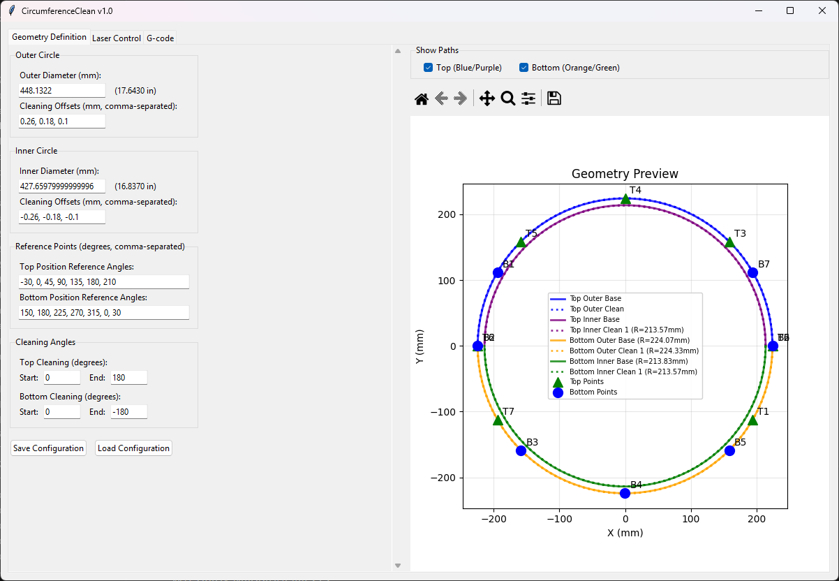

This view shows the initial screen. The data entry is done on the left side and the plot is shown on the right. The outer and inner diameters come from the CAD drawing. The offsets show the spacing from the center of the grooves.

The plot on the right shows both the top and bottom cleaning passes and the reference points. The check boxes at the top allow either the top, the bottom of both to be displayed. See below. For each view, the reference points that will be used for fine alignment are shown.

It is suggested to use 7 points, however, only 3 are strictly required. The angles picked should target locations that are free of resin to make alignment to the groove center earier. The exact X-Y location of these points is not critical, what matters is the laser must be aligned to the center of the groove as precisely as possible.

Note the pad offsets provide the ability to clean inwards or outwards. For example for the outer circumference you could have offsets of 0.1, 0.18, 0.26, which will clean outwards. However, you could also program 0.26, 0.18, 0.1 to have the laser start outside the pad and move inward towards the pad.

Zooming in on the plot shows the grooves as solid lines and the cleaning paths as dotted lines:

### G-Code Tab

The G-code tab shows the preamble, cleaning passes and postscript g-code that will be used. You can modify the code if needed, but it is not expected you will need to.

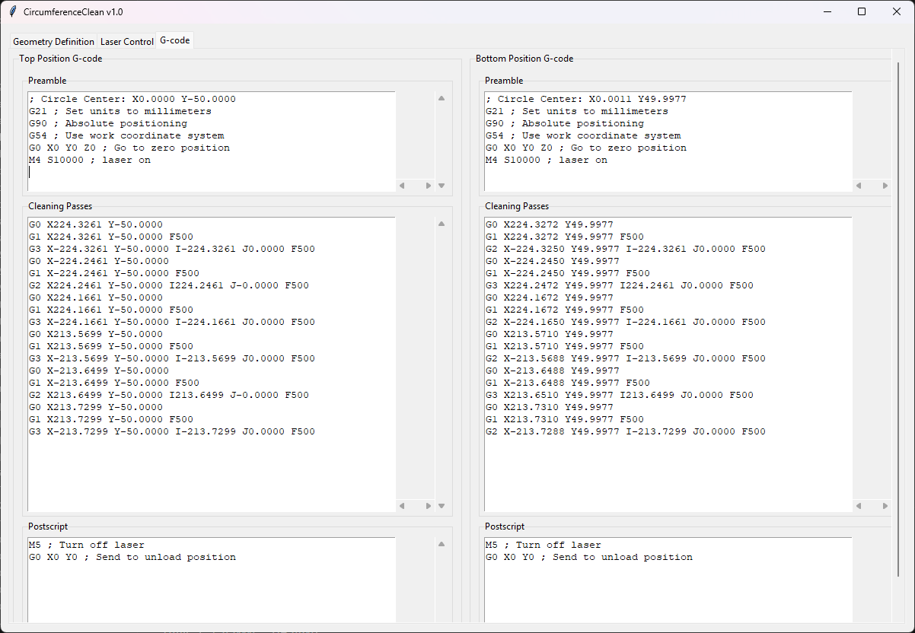

### Laser Control Tab

This tab is used to connect to the laser system, do the fine reference points alignment, adjust the g-code and run the cleaning.

The first step is to select either the bottom or top area to clean. Make sure the Carousel is oriented correctly on the fixture.

Next connect to the Laser system and you should see the status become connected and Idle.

Next set the origin for the workpiece. This can be done manually. For example for the bottom section; Home the Laser, set that as the origin, execute a G0 X320 Y200 Z-60.1 command and then set that as the origin. Or you can press the Bottom Origin button.

(note: we may want to fine tune these settings in the future to reduce the amount of laser jogging required for reference point calibration)

Now its time to do the fine alignment. There are 7 reference points that can be used for alignment. The system requires at least 3 points to do an alignment but 7 provides more accuracy. The process is to select the row of a point by clicking on it. Then press the ‘Goto’ button and the laser will move to that spot. Press the Laser On button, to toggle the laser on. Then jog the laser until it lines up with the OUTER groove of the Carousel near the point we just moved to. The key thing is to align the laser to the center of the groove as closely as possible. The specific reference point is just the area we want to be in but it is just the location of the OUTER groove in that area that matters. When the laser is centered in the groove, press the Set button to capture the X, Y values.

Do this for at least 3 points, do all 7 for more accuracy.

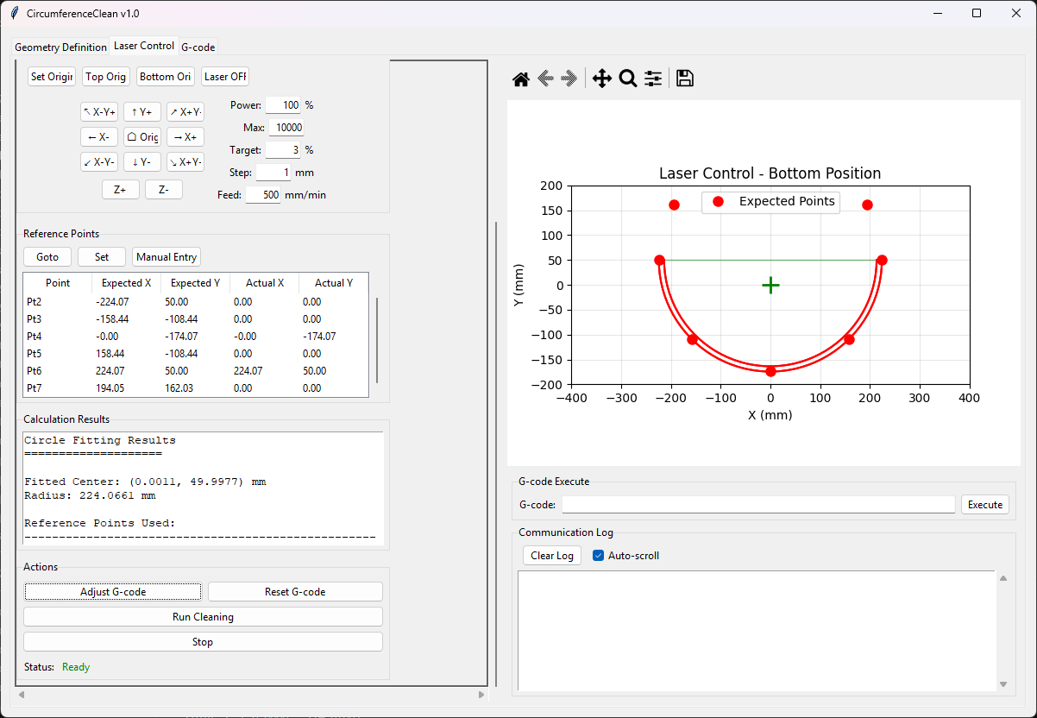

One at least 3 points have been aligned, press the Adjust G-code button. This will analyze the points and provide status in the Calculation results text box on the accuracy of the alignment. If the error is > 0.1mm see if you can correct the points with the largest error.

When the error is reasonable, make sure the laser googles are on and everyone without googles are safely away and press the Run Cleaning button. This will execute the g-code to perform the cleaning.

# Geometry of a Pad and the Cleaning Paths

## Geometry of the pad to the center of the grooves

The geometry of the pad comes from the outer and inner diameter of the circumference grooves at 17.643” and 16.837” from page 5 detail P of the dimension drawing. These translate to outer and inner radius in mm of 224.0661mm and 213.8299mm.

The sides come from the lines that intersect these arcs. The lines are defined on page 6 detail M, as the lines parallel to the X axis but offset +/-0.300” or +/-7.62mm.

To move the cleaning to the outer edges of the center of the grooves, the points need to be adjusted, outwards. The amount for the circumference grooves appears to be about 0.06mm.

Details P and N show the edge of the arc grooves from the center is 0.004” * tan(30) = 0.0023” or 0.059 mm. A very small amount.

