**Support tools to enhance participants retention in mental health clinical trials**

**Background:** The rising demand for mental health services necessitates timely interventions to prevent symptom deterioration and the need for specialised care. Such interventions are crucial not only to alleviate the strain on healthcare providers but also to enhance patient outcomes. To advance our understanding and treatment of mental health conditions, mental health clinical trials play a pivotal role. These trials explore new avenues for improving health, as well as detecting and treating various mental health conditions. However, the success of longitudinal studies in mental health is impeded by a significant challenge: loss to follow-up. One contributing factor to this issue is the limited interaction between participants and researchers throughout the study, which can result in a lack of engagement and support. For mental health trials to thrive, a supportive environment must be cultivated wherein individuals feel understood, valued, and informed about the study's impact on their health and well-being. To address the issue of retention in mental health research, it is crucial to establish a platform that fosters ongoing updates and interaction with participants. This platform should facilitate two-way communication, enabling participants to provide feedback while receiving regular updates on the study's progress.

In addition, it is worth noting that information regarding current mental health research and best practices in clinical trials is not readily accessible to individuals and healthcare professionals. There exists a significant variation among different centres in terms of their approaches to participant recruitment and retention in trials. By examining existing studies conducted across various centres, researchers can have an estimate of retention based on factors such as demographics of participants in relation to the centre’s case load. This platform can further support researchers in understanding the best practices for specific trial types. The development of machine learning and natural language processing (NLP) techniques can also contribute to the analysis of historical interactions between individuals and healthcare services, as well as online clinical and biomedical texts related to mental health. By leveraging these technologies, it becomes possible to identify individuals who are more likely to remain engaged in the study and customise trials to their specific needs. This personalised approach can significantly improve participant retention rates and enhance the overall effectiveness of mental health clinical trials.

**Our current prototype:** We have made the following progress in developing tools aimed at enhancing participant retention in mental health clinical trials:

**Retention Estimation Tool:** By analysing various research papers and clinical trials and discussing with our clinical member, we have identified several variables that commonly influence participant retention in clinical trials. These variables include demographics, utilisation of self-management techniques, availability of training resources, use of technology or mobile applications, and follow-up procedures (please refer to our repository for the current list). To assist researchers in designing clinical trials, we have created a simple User Interface (UI) where they can input their design choices. Learning machine learning models trained on simulated data, the tool provides an estimate of participant retention and offers suggestions for implementing best practices in the final solution.

**Web-Interface for joint research:** We have developed a simple UI, currently in its early stage, that aims to enable researchers to register their trial and volunteers to indicate their interest in participating in trials. This approach is inspired by a successful initiative in dementia research called Join Dementia Research (https://www.joindementiaresearch.nihr.ac.uk). This web-interface will offer several advantages, including facilitating interactions between researchers and participants, providing individuals with opportunities to engage in research and understand the significance of clinical trials, and offering training materials for both researchers and participants.

**Participant Platform:** We made a simple UI to show the objective of providing participants with access to information regarding the outcomes of the trial (as participants usually do not receive this information automatically) as well as allowing them to provide feedback.

The current view of UIs can be seen in Fig.1.

**Future Plans:** These tools collectively aim to address the challenges of participant retention in long-term mental health clinical trials by providing researchers with estimation and guidance, enabling seamless communication between researchers and participants, and empowering participants with information and resources to stay engaged in the trials. At this stage, we have laid the foundation for our final solution, but further research, collaboration, and allocation of resources are needed to fully develop and finalise the solutions. To achieve this, our solution will leverage adaptive and advanced machine learning approaches to extract patterns from existing clinical trials, published research, and available datasets, with the assistance of the clinical member of our team. We are committed to investing the required effort to ensure that our solution addresses the challenges discussed earlier and provides valuable tools for enhancing participant retention in mental health clinical trials.

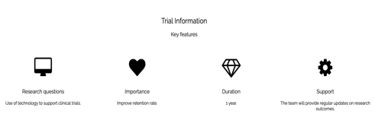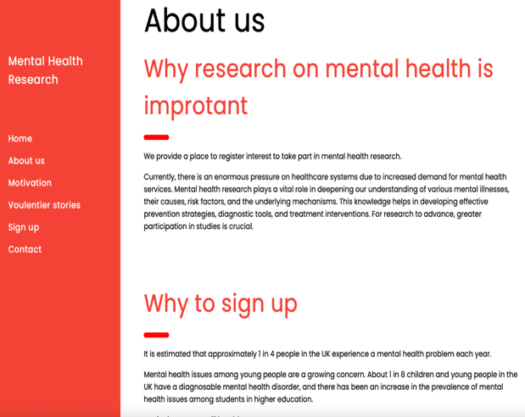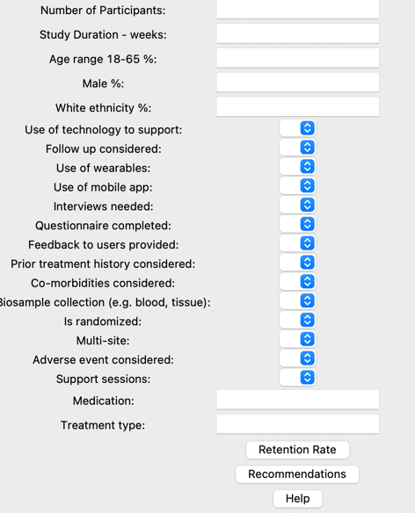

(c)

(a)

(b)

Figure 1 Schematic overview of our tools; (a) researcher support tool, (b) joint research platform and (c) participant support platform.

**Open and inclusive research:** The project is aligned with open data science by making code and knowledge available in publicly accessible repositories and support platforms, encouraging community engagement and collaboration, and prioritising reproducibility, transparency, accessibility, and actively seeking out and welcoming contributions from different communities to ensure a diverse and inclusive community. We will try to fill the gaps in mental health clinical research and develop tools that support a diverse community by providing effective communication and a sense of mutual support and engagement.

**Planned activities and timetable:**

Work Package 1 (WP1) - Co-design to understand and integrate users' requirements: In WP1, our primary focus is to engage various stakeholders, including researchers, adults with mental health illnesses, and healthy volunteers, in order to understand their requirements and integrate them into the development of our solution. To facilitate this process, we will collaborate with Surrey and Borders Partnership NHS Trust (SABP), which has access to trusted user groups and can support the organisation of workshops to engage with patients and the public.

Quarterly workshops will be organised, with the first workshop scheduled within the initial three months of the project's start. These workshops will provide a platform for ongoing engagement and input from participants, ensuring that their perspectives and needs are actively considered throughout the development process. We recognise that mental health issues disproportionately affect certain populations, including minority groups and individuals with lower socioeconomic status. Therefore, it is of utmost importance to us that the solution we develop is accessible and effective for all individuals, regardless of their background or circumstances.

In addition to gathering input during workshops, our web-interface will also incorporate option that allow users to provide feedback on different services. By incorporating iterative feedback loops throughout the development process, we can continuously improve the solution and ensure that it aligns with the evolving needs and expectations of end-users. Regular surveys and user testing sessions will be conducted to gather feedback and make necessary adjustments to the tools and other components of our solution.

Deliverables (D): D1.1 - Report on workshops and user-testing sessions (throughout the project).

WP2 - A machine learning-based portal to support clinical trial designs: In WP2, our objective is to develop a machine learning-based portal that will assist in the design of clinical trials, with a specific focus on enhancing participant retention. To achieve this, we will begin with an extensive literature search to build a comprehensive dataset that will serve as the baseline for our analysis. By analysing the collected data, we will update our variables that impact participant retention and incorporate them into our machine learning models. These models will be trained to estimate the retention rate for specific trial designs, enabling researchers to gain insights and make informed decisions. To extract information from current practices and enhance the accuracy of our models, we will develop specialised pre-trained language models (based on our current expertise in the area). The portal will serve as a valuable resource, equipping researchers with the necessary tool to optimise participant retention by providing accurate retention rate estimates and offering suggestions to enhance trial design. This can further be extended to provide a dynamic support system throughout long-term trials in which researchers can provide more granular information and receive regular suggestions and retention estimates. We will start with finalising our static solution as a preclinical trial support system and will seek partnership with research institutes and further funding application to design the dynamic version.

D2.1 – The portal for retention estimation and recommendation system [M5], D2.2 – List of important variables in designing clinical trials [M5].

WP3 – Interface to enable joint mental healthcare research: Currently, we have created a simple user interface (UI) as a representation of what the final interface will look like. The main objective of this work package is to further build and refine this interface.

The key purpose of this interface is to provide a platform where individuals with mental illnesses can register their interest in participating in research studies. Through this registration process, their interests will be connected to national portfolios of studies, enabling them to explore and potentially participate in relevant trials. To enhance the participant matching process, we will utilise machine learning techniques to recommend trials based on the suitability of interested participants. Additionally, the interface will offer researchers the ability to select participants based on their study requirements. Achieving the objectives of this work package requires regular co-design and partnership with different healthcare organisations.

It's important to note that the current funding enables us to build the main interface. However, we acknowledge that further funding will be sought to partnership with different research organisations and transform it into a live and operational interface. This demonstrates our commitment to ensuring the interface's availability for real-world usage and sustainability in the long term.

D3.1 – The final design and implementation of the web-based interface [M9].

WP4 – A participant support platform: This work package is dedicated to the development of a platform that facilitates two-way communication between the research team and participants in mental health clinical trials. The platform aims to create an interactive and supportive environment for both parties involved.

Researchers will have the ability to add participants to the platform, enabling them to easily share important information such as learning materials, step-by-step instructions, and trial results in layman's terms, making it easier for participants to comprehend and engage with. They will also monitor the number of times each participants login to the platform to ensure their engagement.

Participants, on the other hand, will have an active role in the communication process. They will be able to reach out to researchers, ask questions, provide feedback, and share their thoughts and experiences. This active engagement promotes a sense of ownership and empowerment among participants, making them feel valued and involved throughout the trial. Additionally, the platform will provide regular notifications to participants regarding upcoming follow-ups and self-management tips. These notifications serve as reminders, keeping participants informed and engaged in their own mental health journey. By establishing this platform, we aim to create a collaborative and transparent relationship between researchers and participants. This facilitates effective communication, ensures participants have access to relevant information, and fosters a sense of mutual support and engagement. Ultimately, the platform enhances the overall experience of participants in mental health clinical trials and contributes to improved research outcomes.

D4.1 – A participant platform system enabling two-way communication [M12].