MYSQL ASSIGNMENT 1

drop table if exists employee;

drop table if exists dept;

CREATE TABLE dept (

DEPARTMENT_ID double NOT NULL DEFAULT '1',

DEPARTMENT_NAME varchar(30) NOT NULL,

MANAGER_ID double DEFAULT NULL,

LOCATION_ID double DEFAULT NULL,

constraint pk_dept primary key (DEPARTMENT_ID)

);

INSERT INTO dept VALUES (90,'Administration',100,1700),

(100,'Marketing',108,1800),

(30,'Purchasing',114,1700),

(40,'Human Resources',203,2400),

(50,'Shipping',121,1500),

(60,'IT',103,1400);

CREATE TABLE employee(

EMPLOYEE_ID double NOT NULL DEFAULT '0',

FIRST_NAME varchar(20) DEFAULT NULL,

LAST_NAME varchar(25) NOT NULL,

EMAIL varchar(25) NOT NULL,

PHONE_NUMBER varchar(20) DEFAULT NULL,

HIRE_DATE date NOT NULL,

JOB_ID varchar(10) NOT NULL,

SALARY double DEFAULT NULL,

COMMISSION_PCT double DEFAULT NULL,

MANAGER_ID double DEFAULT NULL,

DEPARTMENT_ID double DEFAULT NULL,

constraint pk_emp primary key (EMPLOYEE_ID),

constraint fk_deptno foreign key (DEPARTMENT_ID) references dept (DEPARTMENT_ID)

);

INSERT INTO employee VALUES (100,'Steven','King','SKING','515.123.4567','1987-06-17','AD_PRES',24000.00,0.00,100,90),

(101,'Neena','Kochhar','NKOCHHAR','515.123.4568','1987-06-18','AD_VP',17000.00,0.00,100,90),

(102,'Lex','De Haan','LDEHAAN','515.123.4569','1987-06-19','AD_VP',17000.00,0.00,100,90),

(103,'Alexander','Hunold','AHUNOLD','590.423.4567','1987-06-20','IT_PROG',9000.00,0.00,103,60),

(104,'Bruce','Ernst','BERNST','590.423.4568','1987-06-21','IT_PROG',6000.00,0.00,103,60),

(105,'David','Austin','DAUSTIN','590.423.4569','1987-06-22','IT_PROG',4800.00,0.00,103,60),

(106,'Valli','Pataballa','VPATABAL','590.423.4560','1987-06-23','IT_PROG',4800.00,0.00,103,60),

(107,'Diana','Lorentz','DLORENTZ','590.423.5567','1987-06-24','IT_PROG',4200.00,0.00,103,60),

(108,'Nancy','Greenberg','NGREENBE','515.124.4569','1987-06-25','FI_MGR',12000.00,0.00,108,100),

(109,'Daniel','Faviet','DFAVIET','515.124.4169','1987-06-26','FI_ACCOUNT',9000.00,0.00,108,100),

(110,'John','Chen','JCHEN','515.124.4269','1987-06-27','FI_ACCOUNT',8200.00,0.00,108,100),

(111,'Ismael','Sciarra','ISCIARRA','515.124.4369','1987-06-28','FI_ACCOUNT',7700.00,0.00,108,100),

(112,'Jose Manuel','Urman','JMURMAN','515.124.4469','1987-06-29','FI_ACCOUNT',7800.00,0.00,108,100),

(113,'Luis','Popp','LPOPP','515.124.4567','1987-06-30','FI_ACCOUNT',6900.00,0.00,108,100),

(114,'Den','Raphaely','DRAPHEAL','515.127.4561','1987-07-01','PU_MAN',11000.00,0.00,114,30),

(115,'Alexander','Khoo','AKHOO','515.127.4562','1987-07-02','PU_CLERK',3100.00,0.00,114,30),

(116,'Shelli','Baida','SBAIDA','515.127.4563','1987-07-03','PU_CLERK',2900.00,0.00,114,30),

(117,'Sigal','Tobias','STOBIAS','515.127.4564','1987-07-04','PU_CLERK',2800.00,0.00,114,30),

(118,'Guy','Himuro','GHIMURO','515.127.4565','1987-07-05','PU_CLERK',2600.00,0.00,114,30),

(119,'Karen','Colmenares','KCOLMENA','515.127.4566','1987-07-06','PU_CLERK',2500.00,0.00,114,30),

(120,'Matthew','Weiss','MWEISS','650.123.1234','1987-07-07','ST_MAN',8000.00,0.00,121,50),

(121,'Adam','Fripp','AFRIPP','650.123.2234','1987-07-08','ST_MAN',8200.00,0.00,121,50),

(122,'Payam','Kaufling','PKAUFLIN','650.123.3234','1987-07-09','ST_MAN',7900.00,0.00,121,50),

(123,'Shanta','Vollman','SVOLLMAN','650.123.4234','1987-07-10','ST_MAN',6500.00,0.00,121,50),

(124,'Kevin','Mourgos','KMOURGOS','650.123.5234','1987-07-11','ST_MAN',5800.00,0.00,121,50),

(125,'Julia','Nayer','JNAYER','650.124.1214','1987-07-12','ST_CLERK',3200.00,0.00,121,50),

(126,'Irene','Mikkilineni','IMIKKILI','650.124.1224','1987-07-13','ST_CLERK',2700.00,0.00,121,50),

(127,'Vance','Jones','VJONES','650.501.4876','1987-09-20','SH_CLERK',2800.00,0.00,121,50);

commit;

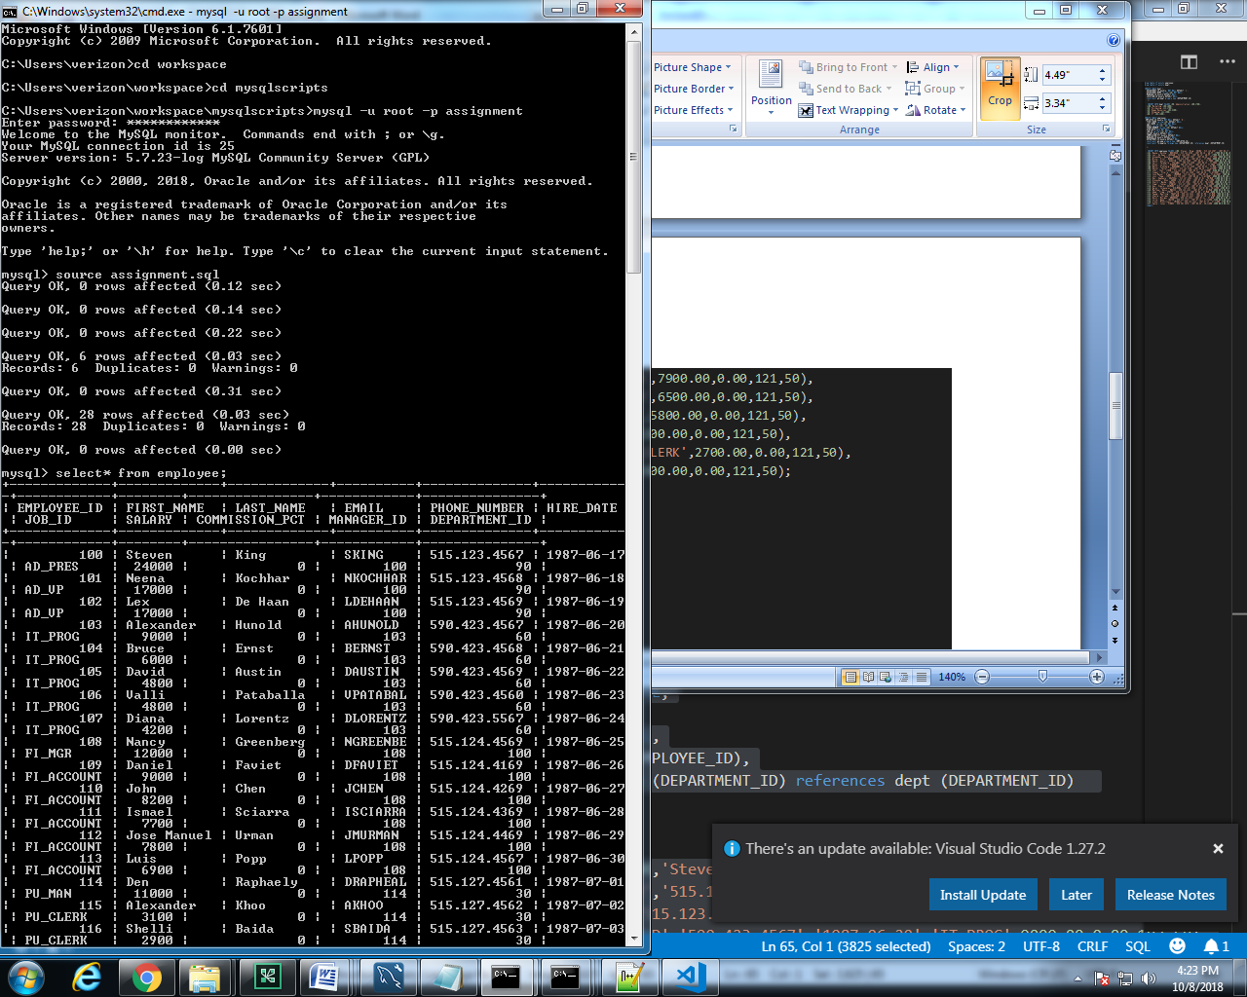

-----------------------------------------------------------

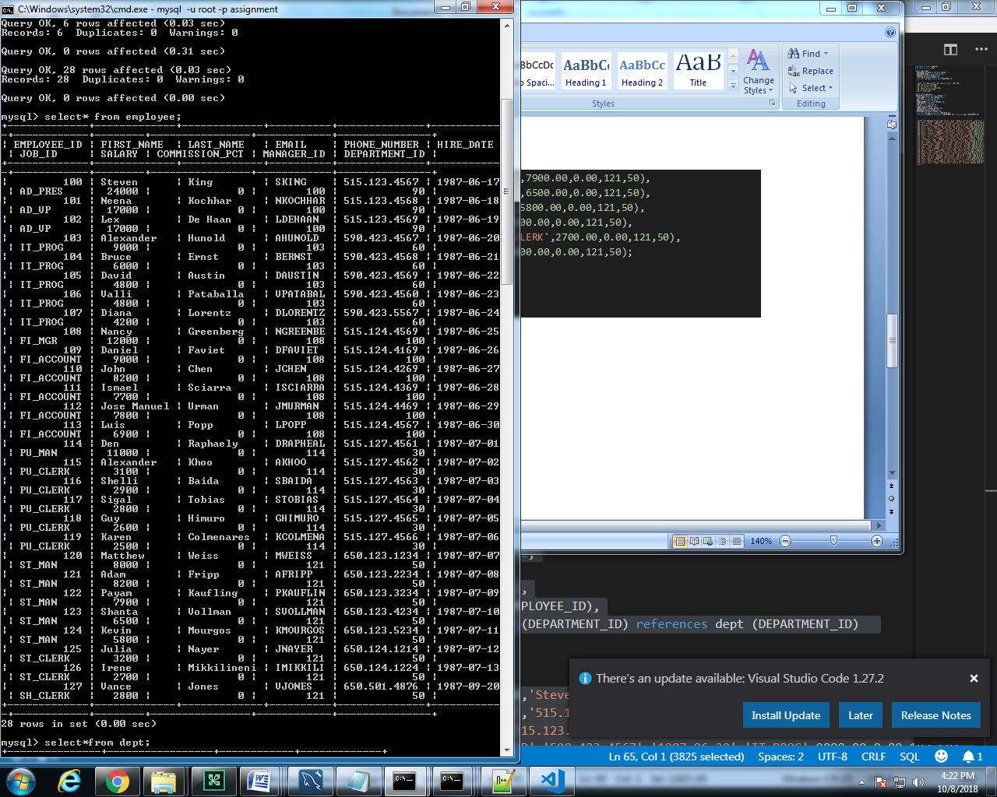

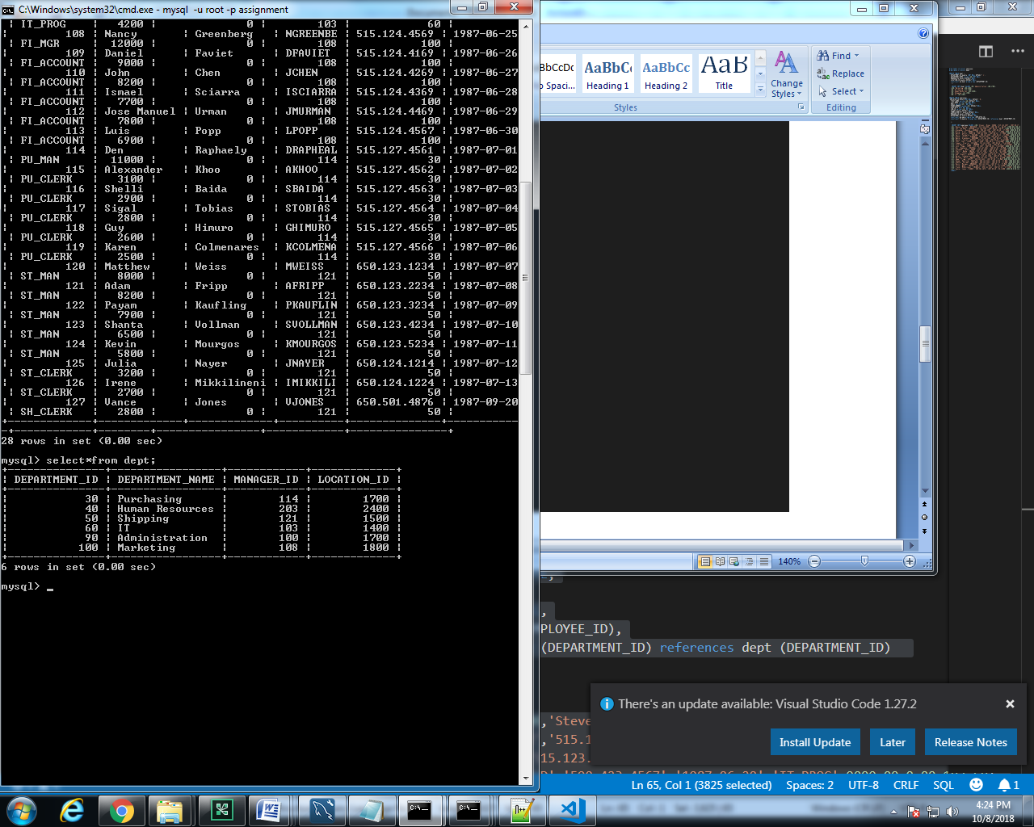

QUERIES:

1. select FIRST_NAME AS "first_name",LAST_NAME AS "last_name",from employee;

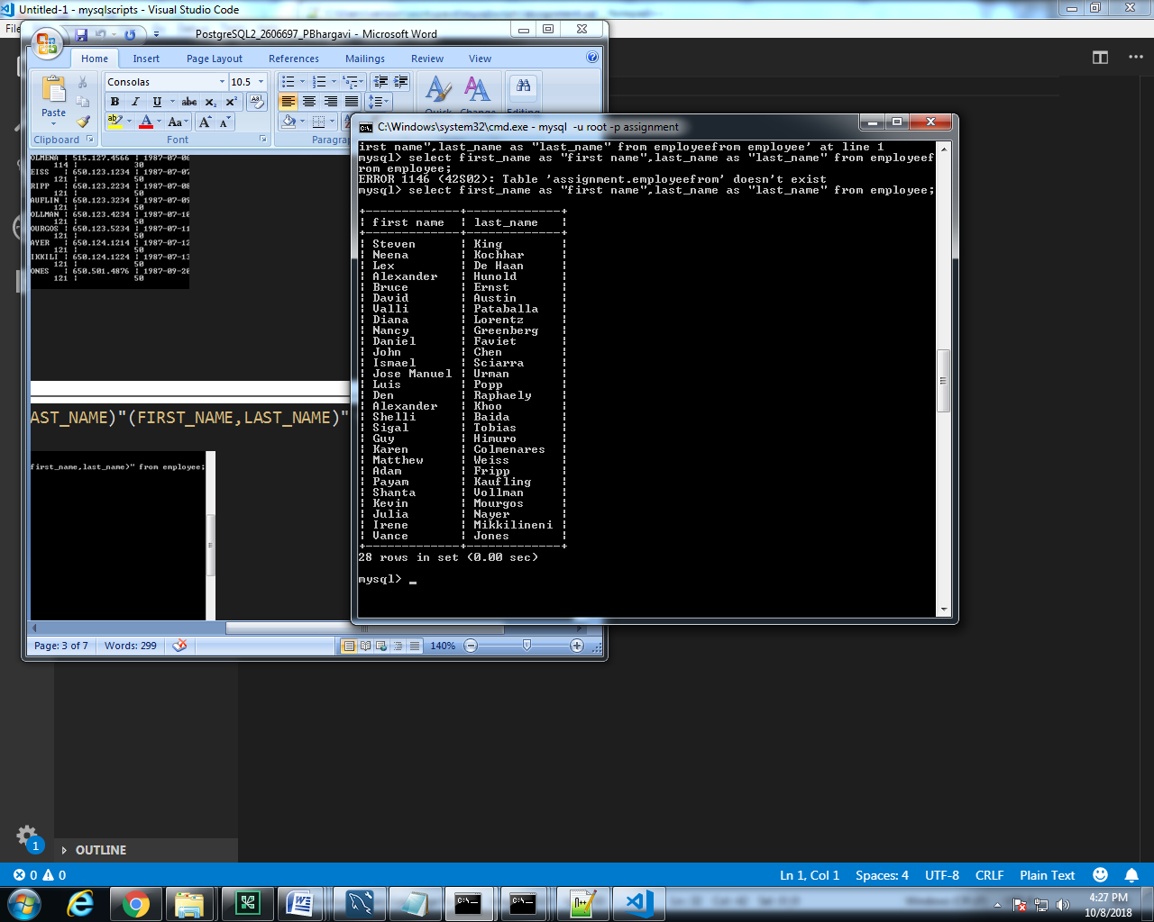

2. select distinct department_id from employee;

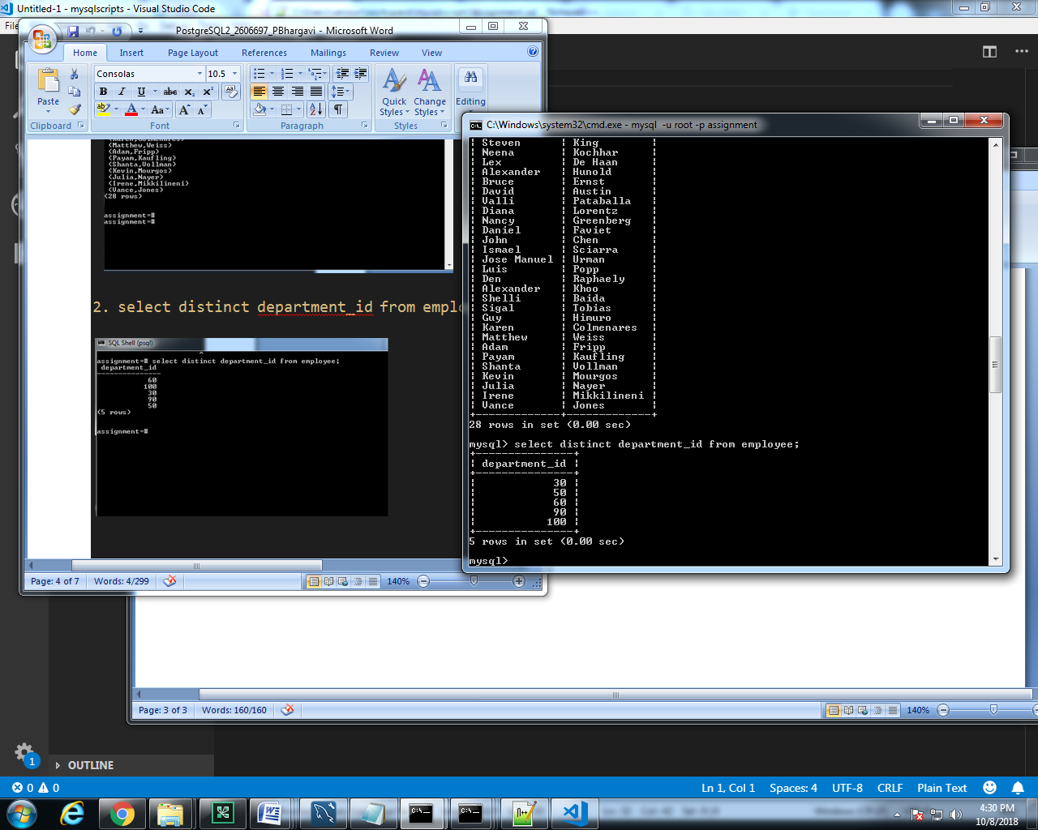

3. select FIRST_NAME AS "first_name",LAST_NAME AS "last_name",0.15*salary "PF" from employee;

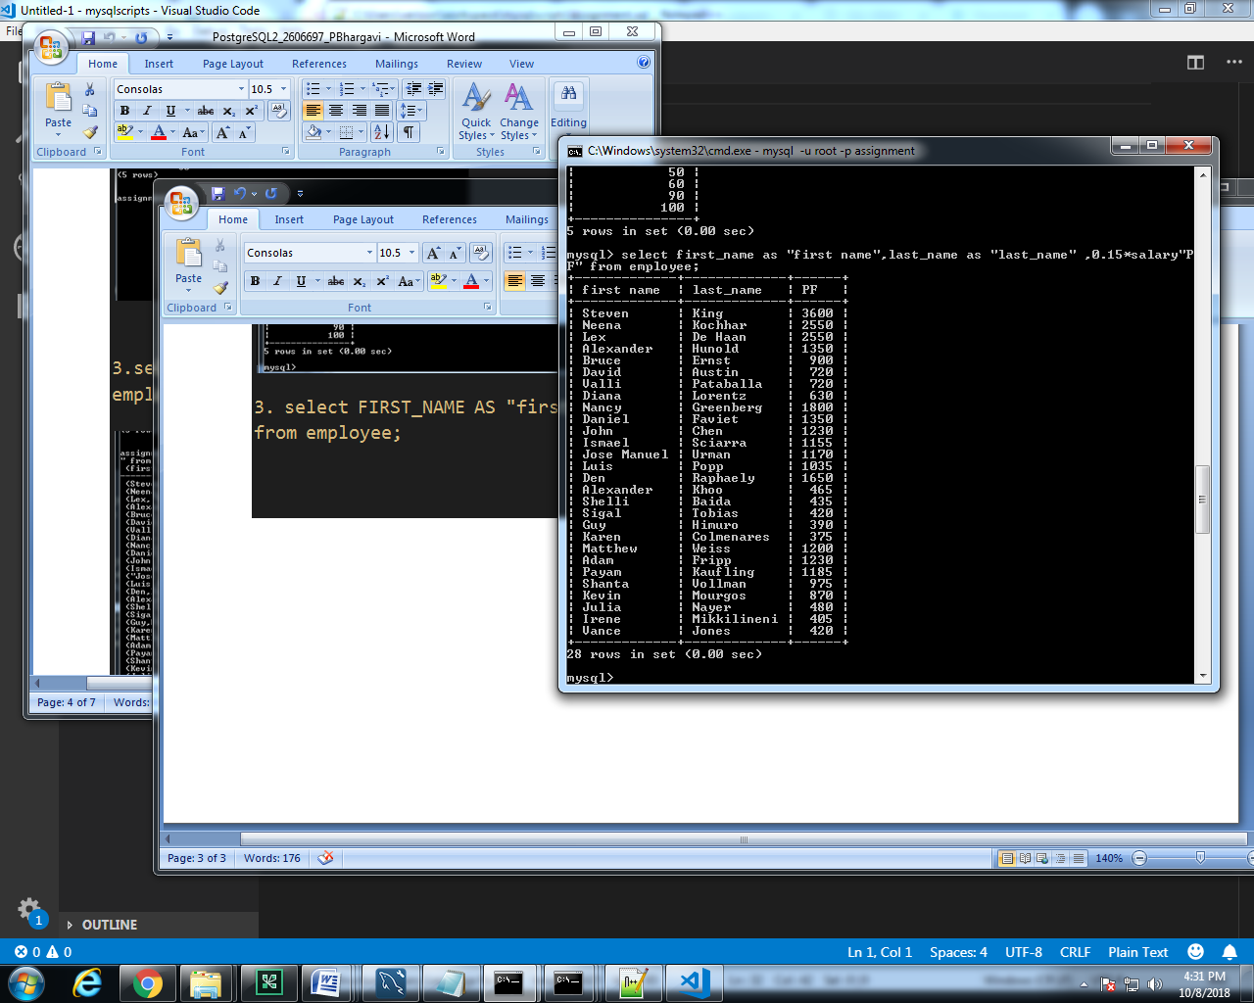

4. select FIRST_NAME AS "first_name",LAST_NAME AS "last_name",salary from employee where salary=(select min(salary) from employee) or salary=(select max(salary) from employee);

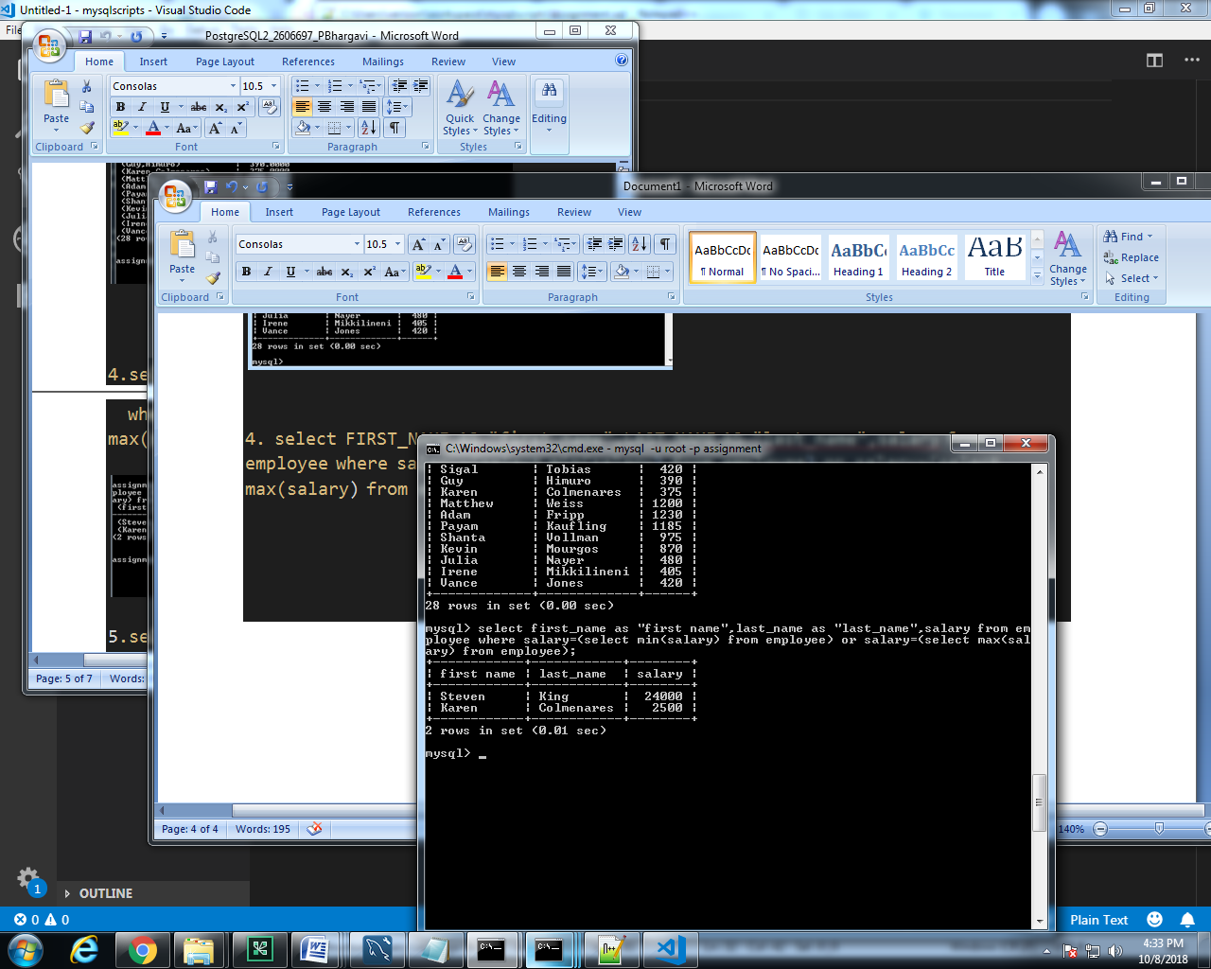

5.select FIRST_NAME AS "first_name",LAST_NAME AS "last_name",d.department_id "dept id",d.department_name "dept name"

from employee e INNER JOIN dept d ON e.department_id= d.department_id;

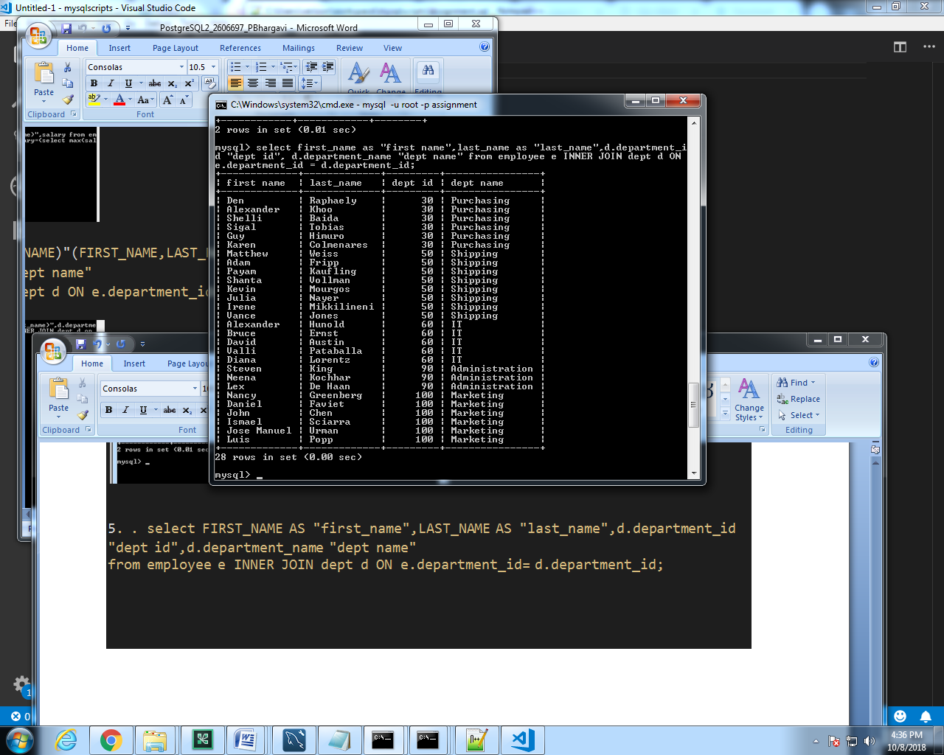

6.SELECT a.employee_id AS "Employee ID",a.last_name AS "Employee Last Name",

    b.Manager_ID AS "Manager ID",b.last_name AS "Manager last Name"

    FROM employee a, employee b

    WHERE a.employee_id = b.Manager_ID;

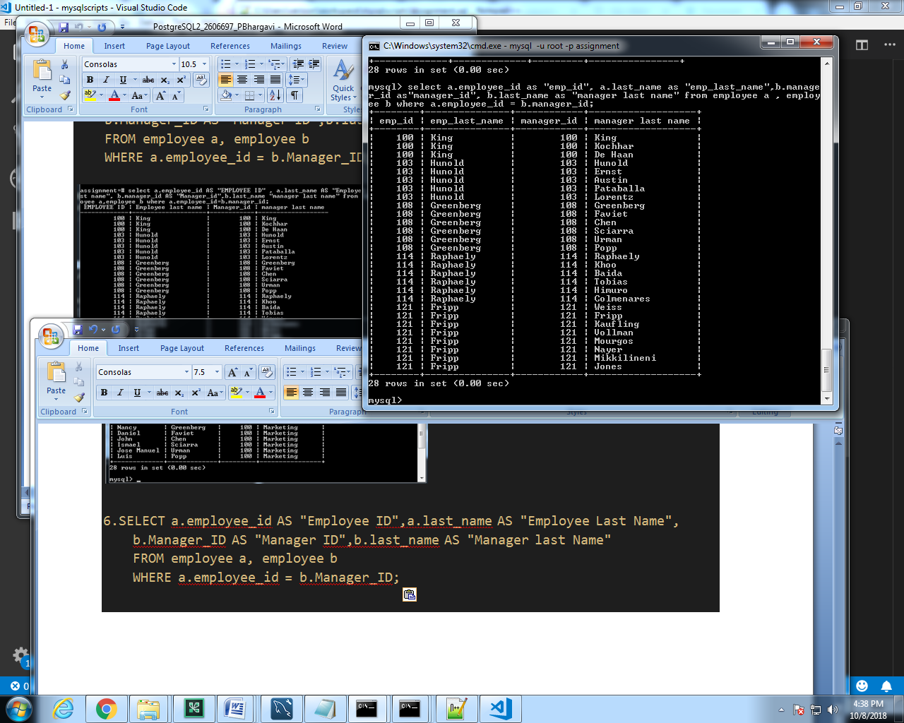

7.select e.employee_id,e.last_name as "Employee", e.hire_date from employee e INNER JOIN (select * from employee where last_name='Jones' ) e1 on e.hire_date <e1.hire_date;

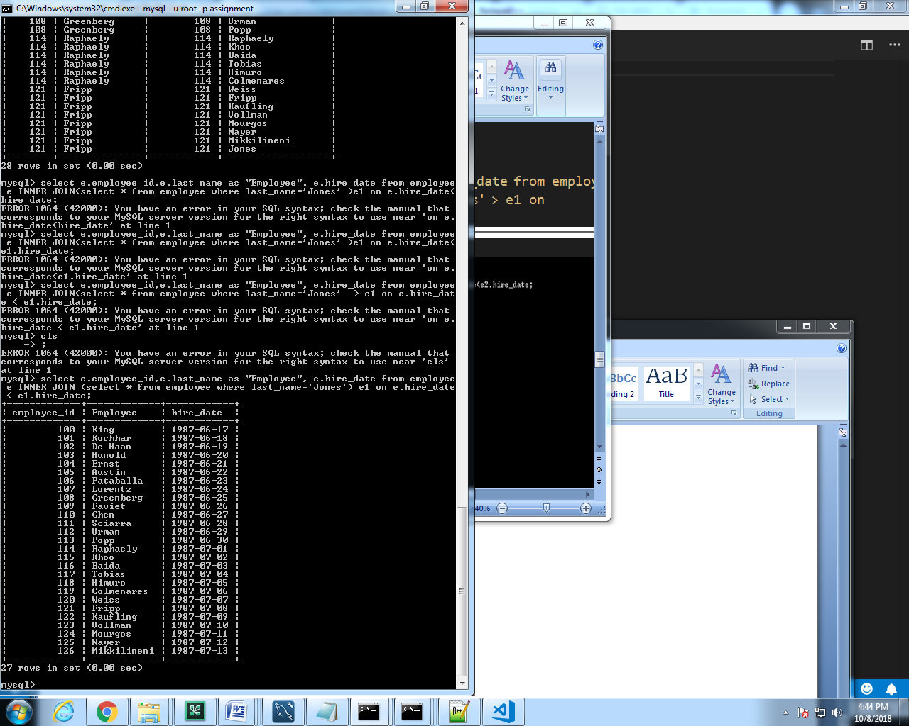

8.select d.department_name "dept name”, count(e.department_id)

from (employee e INNER JOIN dept d ON e.department_id =d.department_id)

group by d.department_name

having count(e.department_id)>0;

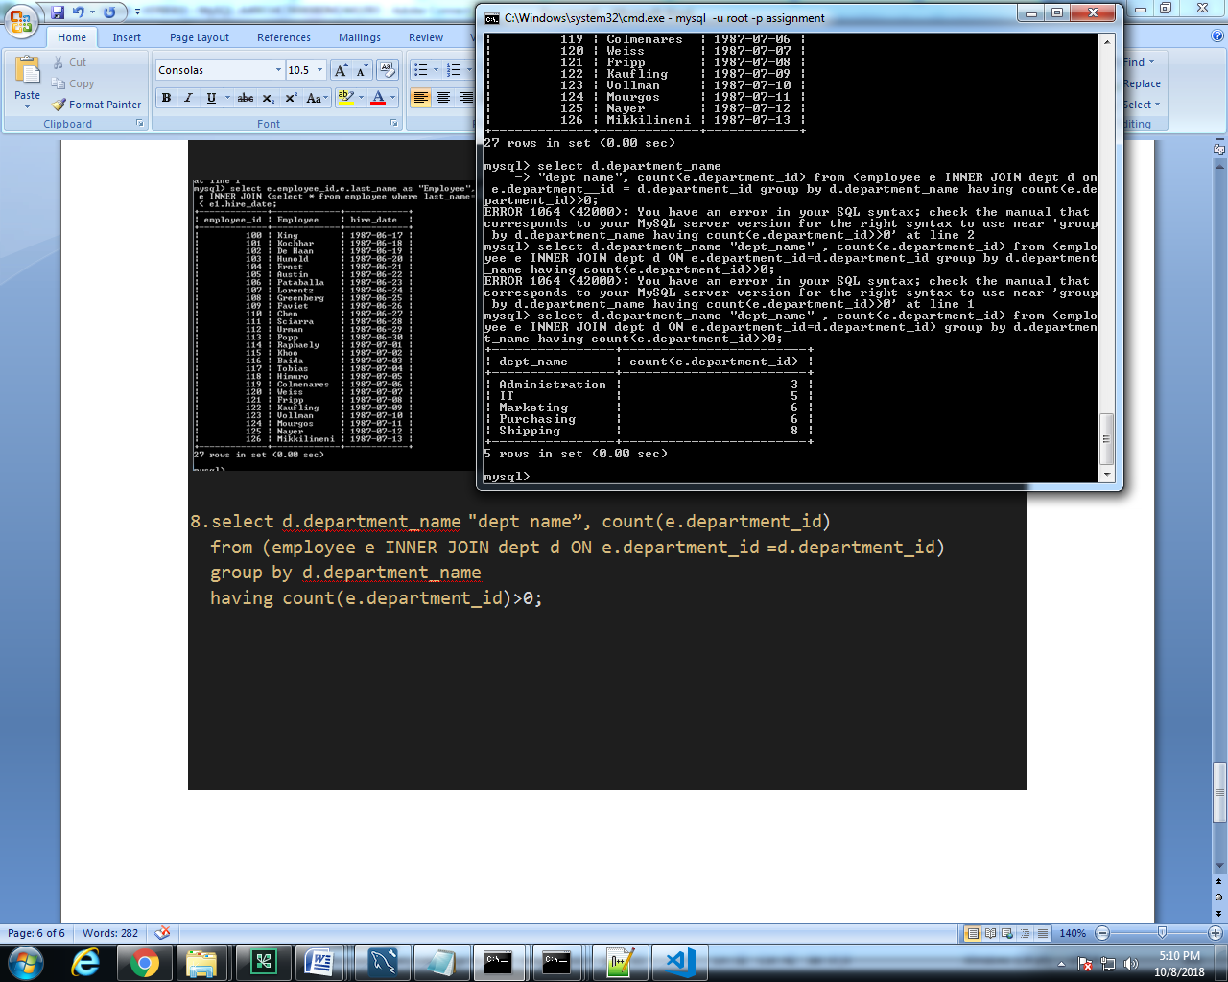

9.select e.employee_id,e.job_id,current_date-hiredate"working days" from employee e INNER JOIN dept d ON e.department_id =d.department_id where d. d.department_id =90;

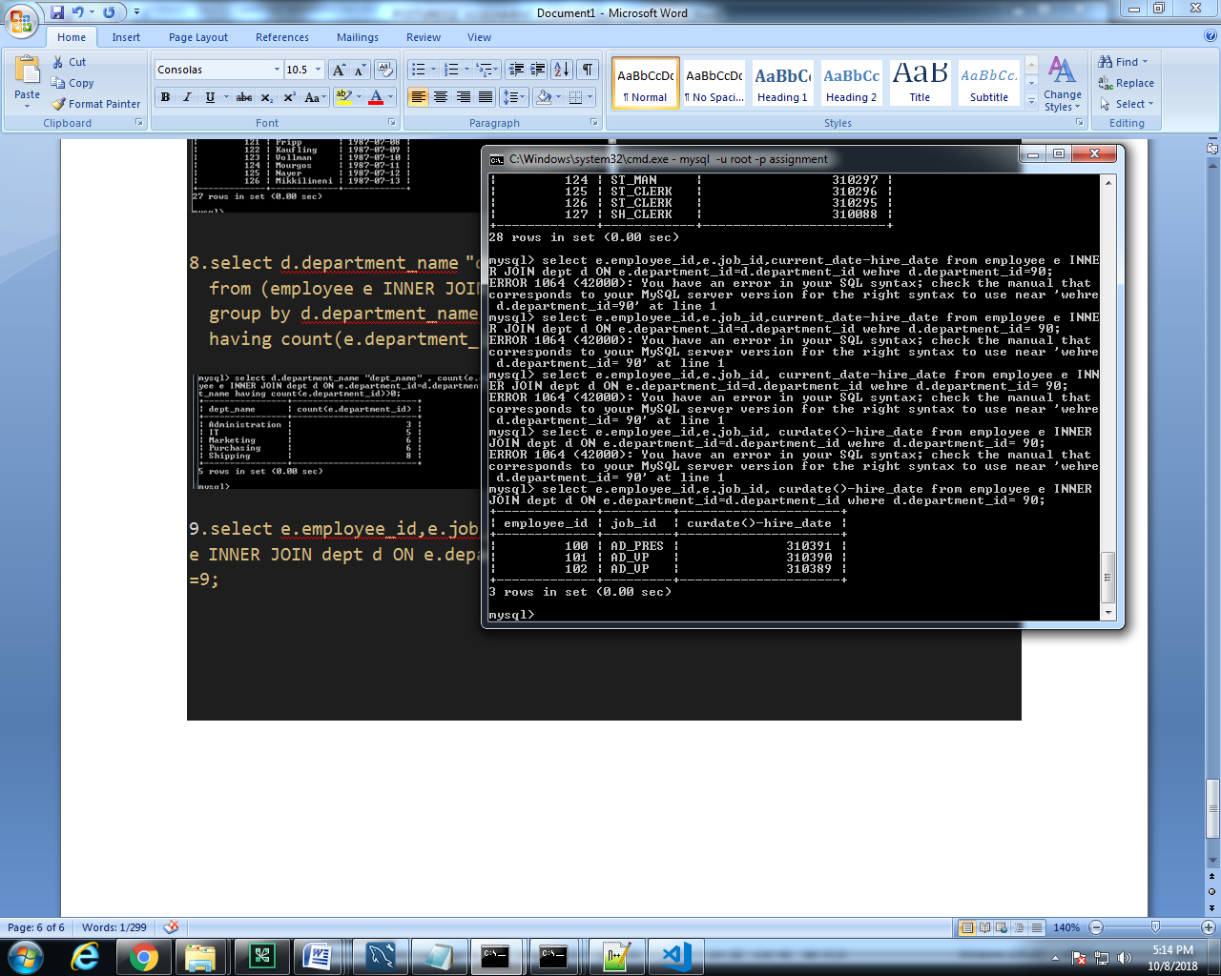

10.select d.department_name "dept name" ,(e.FIRST_NAME,e.LAST_NAME)"(FIRST_NAME,LAST_NAME)",e.hire_date,e.salary

from employee e INNER JOIN dept d ON e.department_id=d.department_id

where (year(curdate())-year(hire_date))>15 and e.employee_id=e.manager_id;

