EEEM030 Assignment 1
Assessment: 15% of module
Linear Predictive Speech Synthesizer
Task Description

To download a male and a female vowel sound from a given set of sample sound recordings to perform the following operations on the signal.

- Estimation: We are required to estimate formant frequencies by determining the LPC coefficients of the chosen sample. Evaluation of the different AR models by using different MATLAB functions like LPC, and ARCOV for estimating the LPC coefficients and experimenting with different model orders to get better accuracy with the resulting formants.

- Synthesis: Generating the impulse train model by using the pitch frequency and LPC coefficients obtained during the Estimation task to produce a simulated periodic source for voiced sounds. We are then required to filter the pulse train using the LPC filter. This will synthesize a speech signal that can be used for assessment of the speech quality and experiments with various AR model orders and segment lengths.

TABLE OF CONTENTS

1. Selection and loading of vowel phenome samples 3
2. LPC Coefficient Estimation 3
2.1. Plot signal spectrogram to identify voiced segments for analysis 3
2.2. Segment Extraction 4
2.3. Estimate LPC coefficients 4
3. Filter response and Speech amplitude spectrum plots 5
4. Formant Frequency Estimation 6
5. Mean Fundamental Frequency Estimation 6
6. Periodic Impulse train generation and Speech synthesis 7
7. Evaluations on different AR orders and segment lengths 8
7.1. Evaluation with the same AR order and different segment lengths: 8
7.2. Evaluation with different AR order and same segment lengths 9
8. Results and Findings 11

9. MATLAB CODE .............................................................................................................................................................. 13
References ................................................................................................................................................................................. 15

Selection and loading of vowel phenome samples

From the given set of sample signals hid_f.wav (female sound) and hid_m.wav (male sound) files have been used for analysis and speech Synthesis in this report. I have used audioread function from MATLAB to upload vowel sound files in .wav format for further coding in MATLAB.

LPC Coefficient Estimation

Linear Predictive Coding (LPC) is used to predict the polynomial roots utilized to calculate formant frequencies of the vowel segment.

Plot signal spectrogram to identify voiced segments for analysis.

MATLAB function spectrogram() is used to calculate the spectrogram of a signal by first dividing the signal into overlapping segments and then computing the spectrum using the Fast Fourier Transform (FFT). The high-frequency components in the spectrogram plot are likely to be associated with the formants of the speech signal, while the low-frequency components are likely associated with the fundamental frequency.

A spectrogram shows time on the X-axis and frequency on the Y-axis. For this assignment, I have tried to predict the start and end of the required vowel segment by analysing the spectrogram plot. Based on the study of the spectrogram, a vowel can be identified as several dark horizontal stripes across the Spectrogram. When the spectrogram is lighter and doesn’t show clear stripes, it can probably be a consonant. This criterion alone can be a bit confusing. Therefore, I have experimented with different vowel segments and used the original audio sound to listen in slow motion and get accurate signal segments.

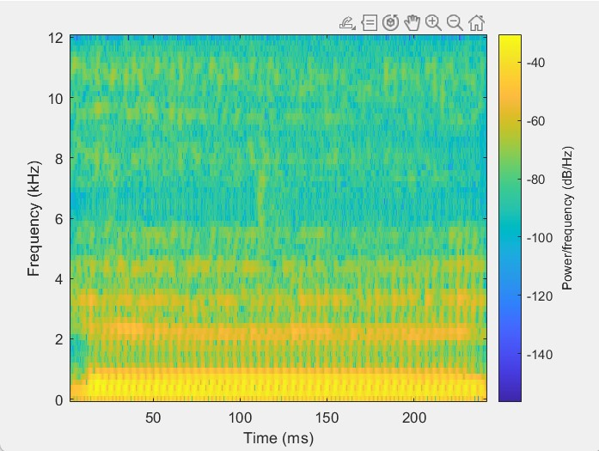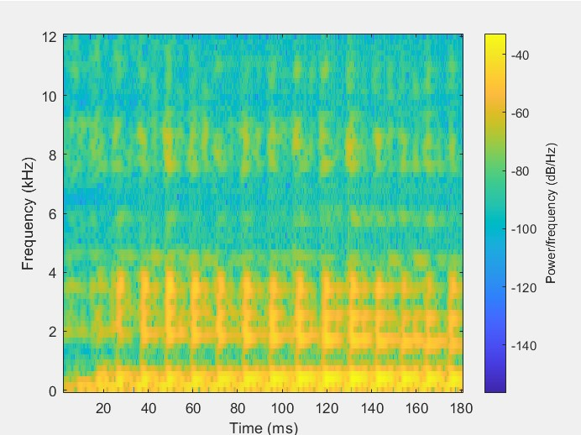
Figure 1: Spectrogram of hid_f.wav Figure 2: Spectrogram of hid_m.wav

The spectrogram of the hid_f signal reveals that the first formant is located around 500 Hz, represented by darker yellow shades. Additionally, the second and third formants are found around 2000 Hz and 3000 Hz, respectively. Similarly, the spectrogram of the hid_m signal indicates that the first three formants are located around 300 Hz, 1800 Hz, and 2500 Hz, respectively.

Segment Extraction

The required indices of the time interval T0 to Tend can be extracted by calculating the sampling period(dt) by dividing T0 and Tend by dt.
Consider:
I0 = Starting index Iend = Ending index
dt = 1/fs
I0 =round(T0/dt) ,
Iend=round(Tend/dt)

Following T0 and Tend in seconds have been considered for the assignment: a. hid_f.wav:
T0=0.0255 , Tend = 0.218

b. hid_m.wav:
T0=0.0255, Tend= 0.157

Estimate LPC coefficients

a= lpc(x, p) function of MATLAB has been used to obtain LPC coefficients of pth order. This function
uses the autocorrelation method to find the LPC coefficient ‘a’.
x - processed sound signal

The LPCs are the coefficients of a linear filter that can be used to predict the current value of the signal x from its past values.

Plots of Filter response and Speech amplitude spectrum

- The first plot shows the speech amplitude spectrum. The speech amplitude spectrum is a measure of the magnitude of the signal at different frequencies.
- The second plot shows the LPC filter response. The LPC filter response is a measure of how the filter amplifies or attenuates different frequencies.

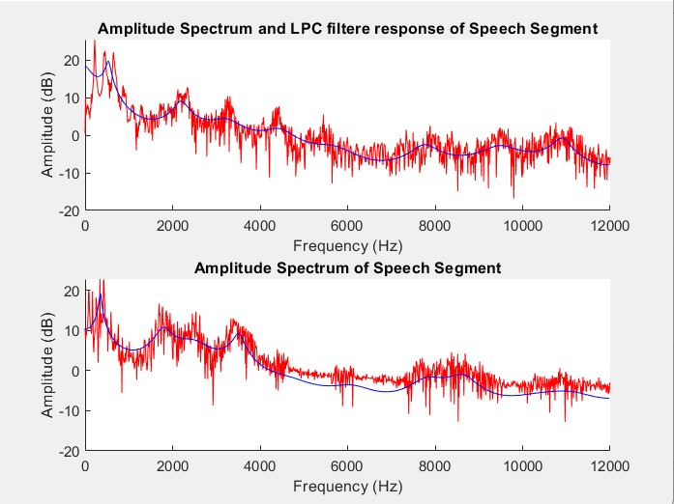
Figure 3 : Amplitude spectrum and LPC filter response of hid_f and hid_m signal, order=20, AR model=lpc, segment length = 100ms

Formant Frequency Estimation

Since LPC coefficients are real-valued functions roots of this will be in complex conjugate pairs. We will be separating the real and imaginary parts of the roots. After retaining the roots with only one sign in the imaginary part calculate the angle corresponding to the imaginary part.

Angular frequencies in rad/sample is converted to hertz and the bandwidth of the formants is Calculated. Finally, the criterion is that formant frequencies should be greater than 90 Hz with bandwidths less than 400 Hz to predict formant frequencies.
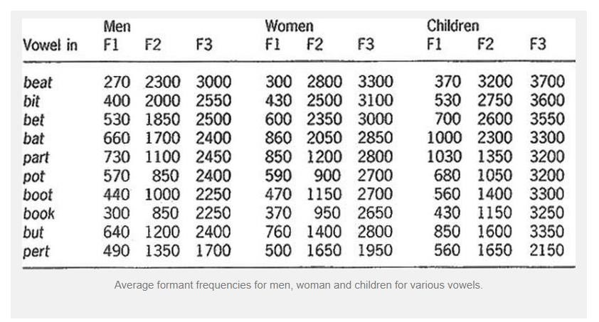
Figure 4: Formant frequency range for Men, women, and children.

Mean Fundamental Frequency Estimation

The fundamental frequency is also known as the pitch of the waveform. It is the lowest frequency component of the waveform, and the waveform repeats itself at this frequency.

MATLAB function pitch(signal, fs) is used to calculate the fundamental frequencies of the chosen male and female sounds. The mean fundamental frequency is then calculated by simply taking the mean of the fundamental frequencies obtained.

Following are the fundamental frequency ranges for some different sounds:
- Male voice: 85-155 Hz
- Female voice:165-255 Hz
- Middle C on a piano: 261.6 Hz
- A4(tuning fork) : 440 Hz

Periodic Impulse train generation and Speech synthesis

A periodic impulse train is a signal that consists of a series of impulses spaced at regular intervals. This signal is then used to model the excitation signal of the vocal tract, which is the source of sound in speech production.

A periodic impulse train of roughly 1 second is generated using previously estimated mean fundamental frequency. The interval between the impulses is calculated by dividing the mean fundamental frequency(fm) by the Sampling rate(Fs).

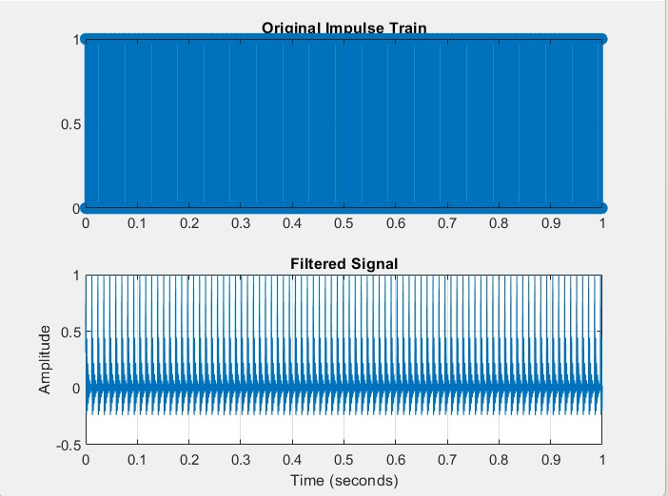
Figure 5: Plots of impulse train and filtered signal of hidden female

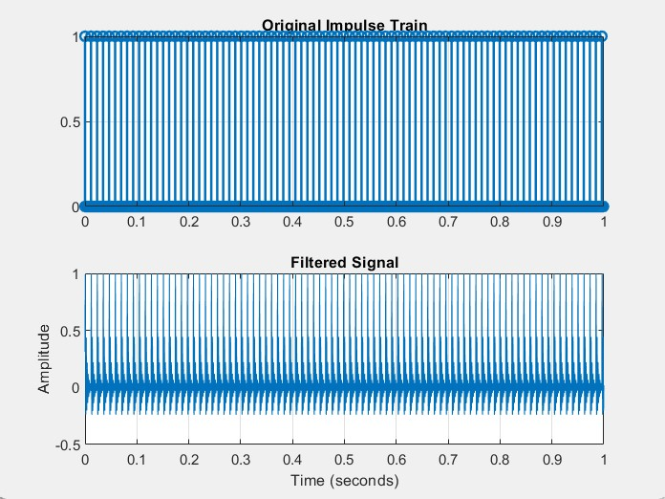
Figure 6: Plots of impulse train and filtered signal of hidden male

Evaluations on different AR orders and segment lengths

Evaluation with the same AR order and different segment lengths:
- Hid female
AR Order | Segment length(ms) | F1(Hz) | F2(Hz) | F3(Hz) | F0(Hz)
18 | 80 | 524.55 | 2238.53 | 3333.29 | 216.13
18 | 100 | 532.56 | 2226.9 | 3344.12 | 216.16
18 | 120 | 536.92 | 2223.58 | 3350.74 | 216.13

- Hid male
AR Order | Segment length(ms) | F1(Hz) | F2(Hz) | F3(Hz) | F0(Hz)
18 | 80 | 342.14 | 1923.92 | 3029.53 | 86.46
18 | 100 | 353.54 | 1891.89 | 2905.08 | 86.46
18 | 120 | 353.72 | 1871.5 | 2883.06 | 86.46

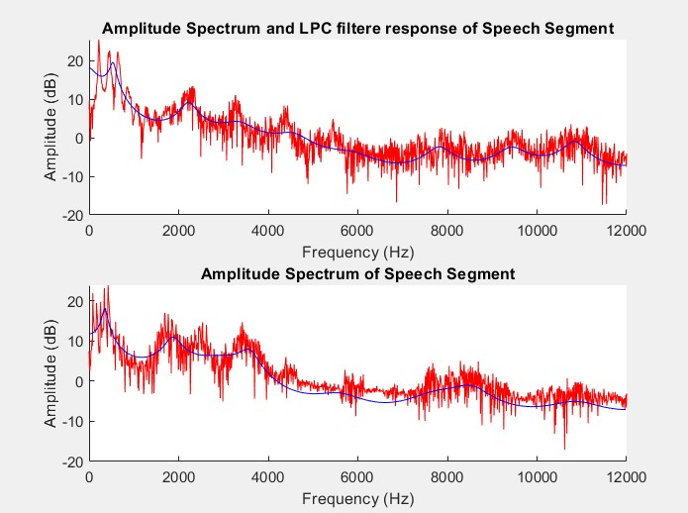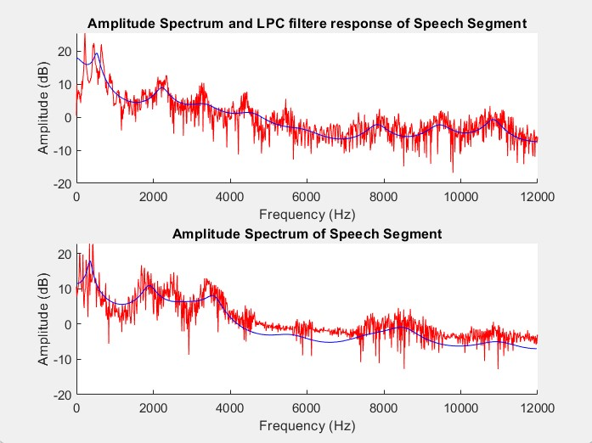

Segment Length = 80ms Segment Length = 100ms
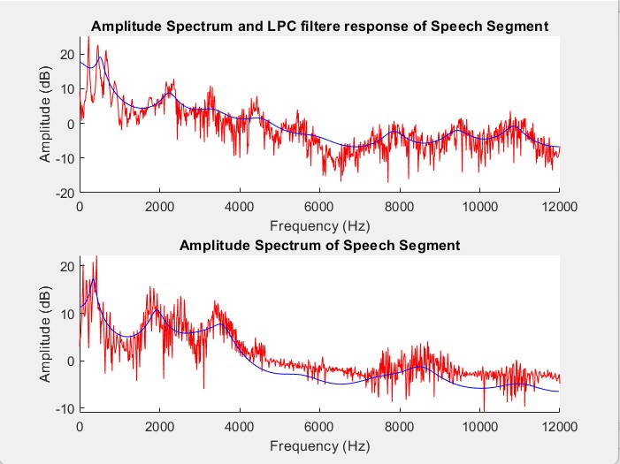
Segment length =120ms
Figure 7: LPC filter response and amplitude spectrum with AR Order =18 and different segment length,AR model=lpc
From the above formant frequencies and LPC filter response, we can observe that changing the segment length from 80ms to 120ms did not give much difference in formant frequency values, but some differences can be observed in plots which indicates further experimenting with these values might provide better fit and better output values. Plots with 120ms segment length are better coinciding among the 3 given experiments.

Evaluation with different AR order and same segment lengths

- Hid female

AR Order | Segment length(ms) | F1(Hz) | F2(Hz) | F3(Hz) | F0(Hz)
20 | 100 | 534.48 | 2196.23 | 3248.57 | 216.13
22 | 100 | 309.99 | 619.25 | 2225.72 | 216.16
24 | 100 | 309.35 | 609.43 | 2227.45 | 216.13
30 | 100 | 280.66 | 634.44 | 1972.6 | 216.13
40 | 100 | 283.92 | 637.92 | 1878.54 | 216.13
- Hid male

AR Order | Segment length(ms) | F1(Hz) | F2(Hz) | F3(Hz) | F0(Hz)
20 | 100 | 349.01 | 1783.53 | 2504.92 | 86.46
22 | 100 | 350.85 | 1801.29 | 2566.77 | 86.46
24 | 100 | 367.14 | 1798.23 | 2547.14 | 86.46
30 | 100 | 401.14 | 1764.75 | 2447.15 | 86.46
40 | 100 | 85.3 | 410.05 | 1727.54 | 86.46

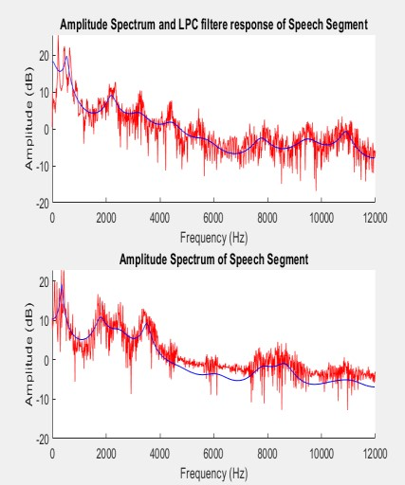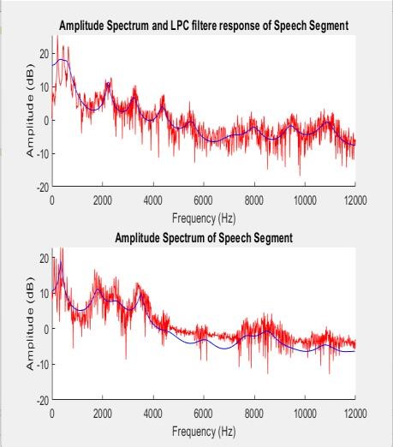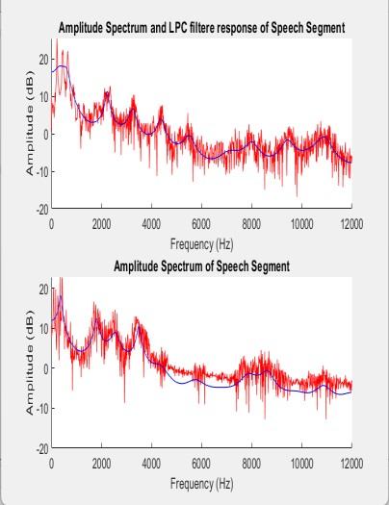

AR Order=20 AR Order=22 AR Order=24

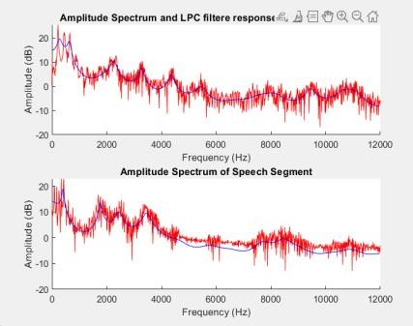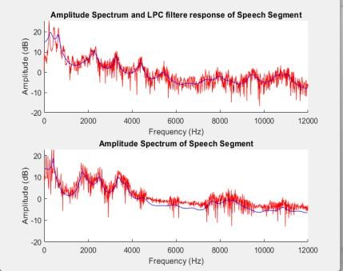
AR Order=30 AR Order=40

Figure 8: LPC filter response and amplitude spectrum with different AR Order and segment length =100ms, AR model=lpc

The above experiments on different AR model order shows that sudden drop or changes can be observed in formant frequency F1 and F2 by increasing the model orders. Usually, by increasing the order number more information is captured and hence it gives better results than lower. However, sometimes results can degrade due to various reasons like overfitting, Noise, and computational complexity. Therefore, we should be careful while selecting the appropriate model order by carefully considering LPC plots and formant frequencies.

Results and Findings

Final Results, frequency values and plots after each step of estimation and generation of hid female and male vowel segments are as follows:

Step 1:
Audio signal 1 (sig1) is hid_f.wav and audio signal 2 (sig2) is given by hid_m.wav. Both with sampling fs = 24000 Hz are used to extract vowel segment ‘i’ from female and male hid sound signals. Both the extracted segments are 100 ms in length with different starting and end indices.

Step 2:
The LPC coefficients were calculated using a segment length of 100 milliseconds and an AR model order of 20 for the female hid vowel segment and an AR model order of 18 for the male hid vowel segment.

Step 3:
Formant Estimation
First three formant frequencies of hid female vowel segment with lpc AR model: Model order = 20 formant 1: 534.48 formant 2: 2196.23 formant 3: 3248.57

First three formant frequencies of hid male vowel segment with lpc AR model: Model order = 18 formant 1: 331.90 formant 2: 1916.85 formant 3: 2878.02

Step 4:
LPC filter response and amplitude spectrum plot female and male vowel segment respectively.

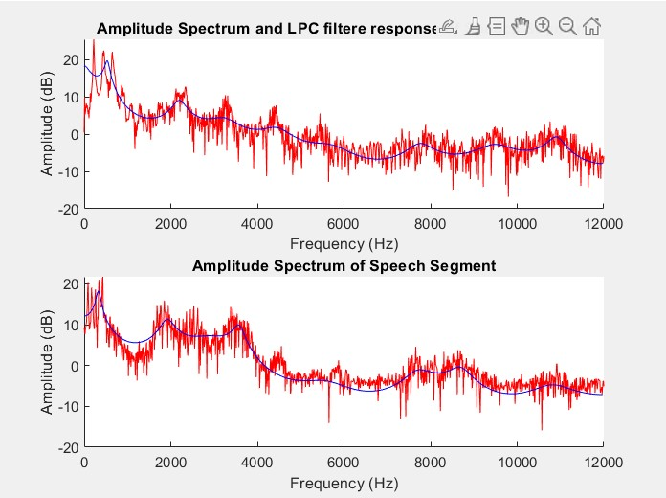
Step 5:
Fundamental frequency estimation
Mean fundamental frequency values obtained after taking the mean of fundamental frequencies :

hid female(fm1): 216.13 Hz
hid male(fm2): 86.46 Hz

Step 6:
Synthesize speech signal :
- To examine synthesized speech, I have tried to plot the spectrogram of the synthesized sound and compared it with the original signal spectrogram for both male and female vowel segments which looked almost similar with a similar formant frequency range. The fundamental frequency estimated for the synthesized sound is also as same as the mean fundamental frequency of the original signal i.e., 216 Hz and 86 Hz for female and male segments respectively.

- Alternatively, I have used the Praat application which uses a better algorithm for estimation to cross-validate my output values.
Praat application output:

Hid female vowel segment:
Time_s | F1_Hz | F2_Hz | F3_Hz | F4_Hz
0.02488 | 528.027716 | 2297.679985 | 3230.8754 | 4448.62483

Hid male vowel segment:
Time_s | F1_Hz | F2_Hz | F3_Hz | F4_Hz
0.025896 | 402.284025 | 2130.275033 | 2909.5282 | 3569.51835

Even though the values obtained are not the same as the Praat values, there is minor difference between the values and they vary based on the orders and segment length chosen.

- Synthesized vowel segment has similar formant and fundamental frequency values as the original, but due to lack of noise and delay signals the produced sound is not the same as the original. I believe the quality of speech synthesized is not up to the mark. We can further try to use deep learning models and spectrogram-based models for speech production.

9. MATLAB CODE

close all; clear all;

[sig1, fs1]= audioread('hid_f.wav'); [sig2, fs2]= audioread('hid_m.wav'); fprintf('Signal duration: %.2f seconds\n', length(sig1) / fs1); fprintf('Signal duration: %.2f seconds\n', length(sig2) / fs2); segmentlen = 100; noverlap = 90;
NFFT = 128;
%Spectrogram of the signal
%spectrogram(sig1,segmentlen,noverlap,NFFT,fs1,'yaxis') %spectrogram(sig2,segmentlen,noverlap,NFFT,fs2,'yaxis')
%Segmentation of signal
x = sig1(round(0.024 * fs1):round((0.024+0.1) *fs1)); y = sig2(round(0.025 * fs2):round((0.025+0.1) *fs2));
%Estimate lpc coefficient
A = lpc(x,20); B = lpc(y,18); rts1 = roots(A); rts1 = rts1(imag(rts1)>0); rts2 = roots(B); rts2 = rts2(imag(rts2)>0);
angz1 = atan2(imag(rts1),real(rts1)); angz2 = atan2(imag(rts2),real(rts2));
[frqs1,indices1] = sort(angz1.*(fs1 / (2*pi))); for i=1:3
fprintf('formant %d:%.2f\n',i,frqs1(i)) end

[frqs2,indices2] = sort(angz2.*(fs2 / (2*pi))); for i=1:3
fprintf('formant %d:%.2f\n',i,frqs2(i)) end num1=1; num2=1; spectrum1 = fft(x); spectrum2 = fft(y);

% Frequency vector for plotting the spectrum f_vec1 = linspace(0, fs1/2, length(spectrum1)/2); f_vec2 = linspace(0, fs2/2, length(spectrum2)/2);
% Calculate the amplitude spectrum (in dB) amplitudeSpectrum1 = 10 * log10(abs(spectrum1)); amplitudeSpectrum2 = 10 * log10(abs(spectrum2));
% Compute the LPC filter response
13

num = 1; den1 = A; den2 = B;

[h1, f1] = freqz(num, den1,512, fs1);
[h2, f2] = freqz(num, den2,512, fs2);
% Mean fundamental frequency f01 = pitch(sig1,fs1); f02 = pitch(sig2,fs2); fm1=mean(f01); fm2=mean(f02);

% Define parameters
Fs = 24000; % Sampling rate
duration = 1; % Duration of the excitation signal in seconds F01 = fm1; % Fundamental frequency (adjust as needed) F02 = fm2;

% Calculate the number of samples num_samples = round(Fs * duration);
% Calculate the interval between impulses impulse_interval1 = round(Fs / F01); impulse_interval2 = round(Fs / F02);

% Initialize the impulse train signal impulse_train1 = zeros(1, num_samples); impulse_train2 = zeros(1, num_samples);
% Set impulse amplitudes to 1 at appropriate intervals impulse_train1(1:impulse_interval1:end) = 1; impulse_train2(1:impulse_interval2:end) = 1;

% Filter the impulse train using the LPC filter filtered_signal1 = filter(1, A, impulse_train1);
filtered_signal1 = filtered_signal1 / max(abs(filtered_signal1));

filtered_signal2 = filter(1, A, impulse_train2);
filtered_signal2 = filtered_signal2 / max(abs(filtered_signal2));
% Play the filtered signal %sound(filtered_signal1, Fs) sound(filtered_signal1(1:0.1*Fs),Fs); sound(filtered_signal2(1:0.1*Fs),Fs);

% Use the audiowrite function to save the filtered signal to a .wav file filename1 = 'hid_fout2.wav'; filename2 = 'hid_mout2.wav';
audiowrite(filename1, filtered_signal1, Fs); audiowrite(filename2, filtered_signal2, Fs);

% plot (the amplitude spectrum in dB);
14

figure('Name', 'Figure 3'); subplot(2,1,1);
hold on;
plot(f_vec1, amplitudeSpectrum1(1:length(f_vec1)),'r'); plot(f1,10*log10(abs(h1)),'b'); hold off; xlabel('Frequency (Hz)'); ylabel('Amplitude (dB)');
title('Amplitude Spectrum and LPC filter response of Speech Segment');

subplot(2,1,2);
hold on;
plot(f_vec2, amplitudeSpectrum2(1:length(f_vec2)),'r'); plot(f2,10*log10(abs(h2)),'b'); hold off; xlabel('Frequency (Hz)'); ylabel('Amplitude (dB)');
title('Amplitude Spectrum of Speech Segment');
%Plot the original impulse train and the filtered signal figure('Name','figure 6 '); t = (0:num_samples-1) / Fs; subplot(2, 1, 1);
stem(t, impulse_train1, 'marker', 'o', 'lineWidth', 1.5); title('Original Impulse Train'); grid on;
subplot(2, 1, 2); plot(t, filtered_signal2); title('Filtered Signal'); xlabel('Time (seconds)'); ylabel('Amplitude'); grid on;

% Play the filtered signal after segmentation
sound(filtered_signal1(1:0.1*Fs),Fs);
sound(filtered_signal2(1:0.1*Fs),Fs);

References

http://musicweb.ucsd.edu/~trsmyth/analysis/analysis_4up.pdf

https://synsinger.wordpress.com/2016/11/24/men-woman-and-children/

https://www.mathworks.com/help/audio/ref/pitch.html

https://www.ee.columbia.edu/~dpwe/e4896/lectures/E4896-L06.pdf

https://core.ac.uk/download/pdf/47086396.pdf

15

