Sentinel IAM — Team Guide
  - Team Bastion · IBM SkillsBuild AI Experiential Learning Lab · Oct 21, 2026

Start here
Sentinel IAM is one AI agent that helps a bank security analyst handle a suspicious login in about a minute instead of about an hour. A human approves every action, and Sentinel never acts on its own.
The problem. When a bank sees a suspicious login, an analyst checks several things by hand: Is the location normal? Is the device known? Is the IP on a threat list? Is there an active attack campaign? An alert waits about 55 minutes before someone picks it up, and a full investigation takes about 75 minutes. Attackers need about 29 minutes to break out.
Our solution. You give Sentinel a login alert. It:
- decides which tools to call to gather evidence,
- explains the risk in plain language (Low, Medium, High or Critical),
- ranks the possible responses best to worst, each with a reason,
- waits for a human analyst to approve, reject or pick another option.
Who this guide is for. New team members who need to know where to start, and reviewers who want to understand the project quickly. Read it once top to bottom (about 15 minutes). After that, use the section headings as a reference.
The program. IBM SkillsBuild AI Experiential Learning Lab, Fall 2026, Banking and Financial Services track. We must build with IBM Bob, and the agent runs on IBM watsonx Orchestrate. Submission is due Nov 22, 2026.
Related documents (same folder): Setup and Coding Standards, Backend Guide, Tools Guide, Agent Guide, Frontend Guide, Testing and Troubleshooting.
Repo: https://github.com/PC-DigitalSolutions/IBM-Sentinel-IAM

Where things stand
The design, the first tool and a working prototype are done. Everything that runs in watsonx Orchestrate is still to do, starting with Tasks 03 and 03b this week. The live tracker is the Team Guide document on claude.ai; this file is a snapshot.
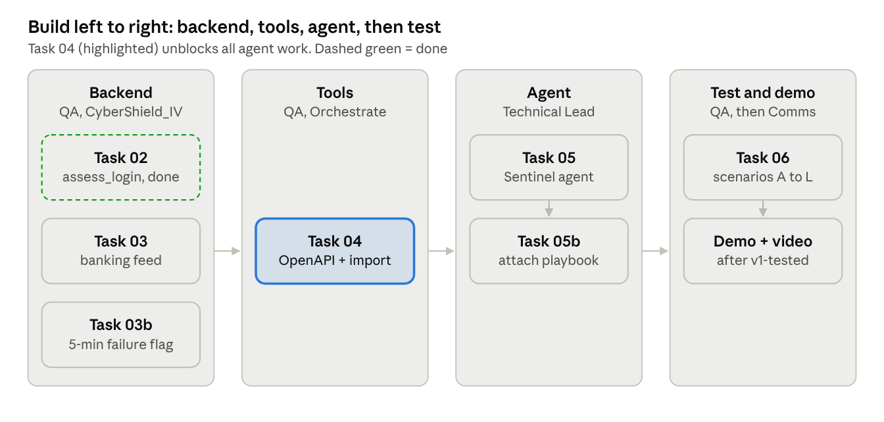
Build order: backend, tools, agent, then test

Build tasks
# | Task | Repo | Owner | Target | Status
01 | Repo scaffold and AGENTS.md | Sentinel IAM | Aldo | Sep 30 | Done
02 | assess_login endpoint and tests (6/6 pass, live on Render) | CyberShield_IV | Aldo | Oct 3 | Done
— | Local Python prototype of the whole agent (21/21 tests pass) | Sentinel IAM | Aldo | Oct 4 | Done
03 | Re-point the threat feed to banking threats | CyberShield_IV | Technical Support / QA | Oct 21 | Not started
03b | 5-minute failure flag inside assess_login (backend and prototype) | Both | Technical Support / QA | Oct 22 | Not started
04 | Import the 3 tools into Orchestrate (blocks Task 05) | Sentinel IAM | Technical Support / QA | Oct 23 | Not started
05 | Build the Sentinel agent in Orchestrate | Sentinel IAM | Technical Lead | Oct 27 | Not started
— | Audit log record format | Sentinel IAM | Technical Lead | Oct 29 | Not started
05b | Attach the response playbook as a knowledge base | Sentinel IAM | Technical Lead | Oct 29 | Not started
06 | Run scenarios A to L, fix, tag v1-tested | Sentinel IAM | Technical Support / QA | Nov 1 | Not started
— | Baseline timing: manual vs Sentinel | — | Technical Support / QA | Nov 4 | Not started

Deliverables
Deliverable | Owner | Draft | Final | Status
Demo script | Communications & Demo Lead | Oct 23 | — | Not started
Oct 25 checkpoint deck | Communications & Demo Lead | Oct 24 | Oct 25 | Not started
3 to 5 analyst interviews | Research & Documentation Lead | Start Oct 21 | Nov 1 | Not started
Persona and as-is journey, updated with interviews | Research & Documentation Lead | — | Nov 3 | Not started
White paper and procedure manual | Research & Documentation Lead | Nov 8 | Nov 20 | Not started
Technology statement | Research Lead with Technical Lead | Nov 8 | Nov 20 | Not started
Written problem, solution and prototype link | Research & Documentation Lead | Nov 8 | Nov 20 | Not started
3-minute video (record only after v1-tested) | Communications & Demo Lead | Nov 8 | Nov 20 | Not started
Bob session screenshots from every member | Everyone, QA checks | Ongoing | Nov 21 | In progress

Known issues
- The prototype still uses the retired 15-minute, 4-failure rule. Fix in Task 03b.
- The prototype ranks “Block session” above step-up MFA for Medium cases. The rule is Medium means step-up MFA first. Fix in Task 03b.
- Some older docs describe 4 agents, 3 members or a 15-minute window. Don’t build from them (see “Where everything lives”).
- No analyst interviews yet, and the “about an hour down to about a minute” claim is not yet measured by us.

Your first two days
Follow these steps in order. Tick each one when its “done when” check is true.

Day 1: understand the project (about 1 hour)
- Read this guide top to bottom. Done when you can explain in one sentence what Sentinel does and why a human must approve.
- Read the technical spec, docs/build-spec.md sections 1 to 3 and 6. Done when you can name the three tools and what each is for.
- Read the agent’s instructions, agents/sentinel.instructions.md. This text is what the agent receives in Orchestrate, and it decides how Sentinel behaves.
- Skim the test cases in docs/testing/test-sheet.md. Each scenario, A to L, is one fake alert with the answer we expect.

Day 1: set up your machine (about 30 minutes)
- Install Git and Python 3.10 or newer.
- Get the code and run the prototype. On Windows use py; on Mac or Linux use python3. Done when you see a risk level, ranked actions and an approval block, then “21 passed”.
git clone https://github.com/PC-DigitalSolutions/IBM-Sentinel-IAM.git
cd IBM-Sentinel-IAM
py -m pip install pytest
py sample_run.py
py -m pytest tests -q
- Backend work only (Tasks 02, 03, 03b): also clone https://github.com/PC-DigitalSolutions/CyberShield_IV next to it.
- Set up IBM Bob. Install it, sign in with your SkillsBuild account, and open the repo folder. Bob reads AGENTS.md automatically. Don’t start a session until you have a written task.
- Optional: check the backend by opening https://cybershield-iv.onrender.com/status. The free tier sleeps, so the first load can take a minute.
Use pytest tests, not plain pytest. A stray nested copy of the project in some local folders makes plain pytest fail with “import file mismatch”.

Day 2: start contributing
- Put your name next to your role in the Team roles section.
- Read your role’s document (table below).
- Pick your first task from the Build tasks table and follow the task loop in How we work.
Your role | Read these
Technical Lead | Agent Guide, Frontend Guide, docs/team/team-playbook.md section 4
Technical Support / QA | Backend Guide, Tools Guide, Testing and Troubleshooting, docs/team/team-playbook.md section 5
Research & Documentation Lead | docs/research/research-evidence.md, docs/research/analyst-interview-guide.md, docs/knowledge/sentinel-response-playbook.md, docs/team/team-playbook.md section 6
Communications & Demo Lead | Frontend Guide (demo section), docs/testing/test-sheet.md, docs/research/research-evidence.md, docs/team/team-playbook.md section 7
The team playbook predates Oct 15. Where it says 15 minutes or 4+ failures, the current rule is 2 failures in 5 minutes.

Program requirements for everyone
- Finish all 6 IBM SkillsBuild courses and upload the W6 deliverable by Sun Oct 25
- Attend the Thursday sessions or watch the recordings
- Run at least one real Bob session and save its screenshot in bob_sessions/. Without screenshots from every member, the project can’t be judged

How Sentinel works
Sentinel is one agent with three tools and one knowledge base. It gathers only the evidence a case needs, then hands a ranked recommendation to a human.
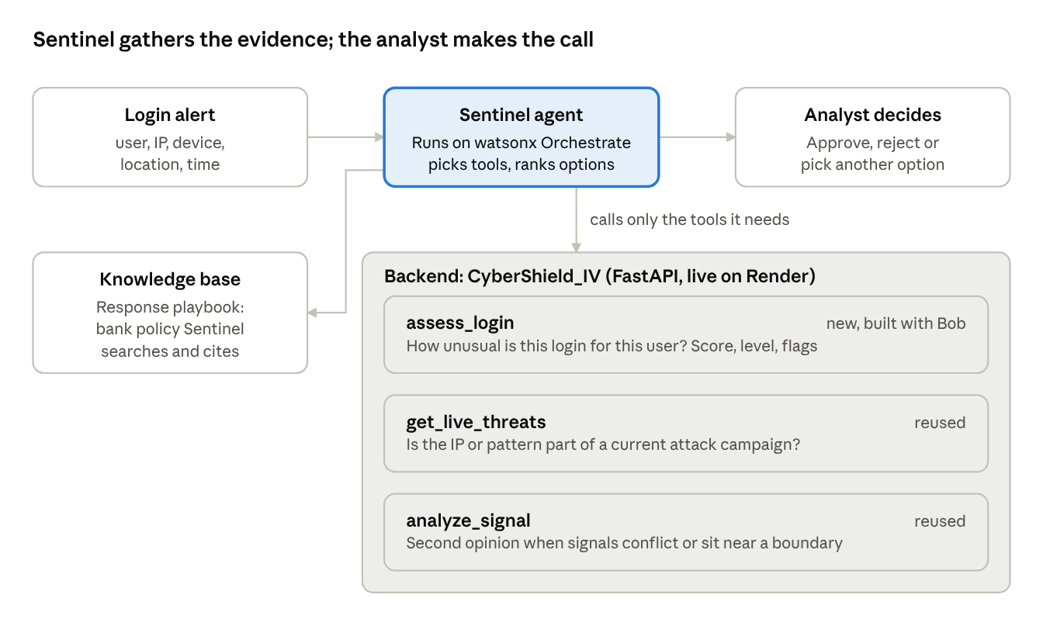
Sentinel gathers the evidence; the analyst makes the call
The analyst’s approval is the only way anything happens. After approval, the bank’s own team carries out the action, and the case is logged with executed: false for Sentinel.

The parts
Part | Where it lives | What it does
Sentinel agent | watsonx Orchestrate; behavior set by agents/sentinel.instructions.md | After each tool result it writes what it learned and what is still unknown, then calls another tool or stops. No fixed script
assess_login | Backend, POST /iam/assess-login | Scores the login 0 to 100 against the user’s normal behavior. No AI, no database. After Task 03b it also counts failed logins in the last 5 minutes
get_live_threats | Backend, GET /threats/live | Checks the IP or pattern against current threats. Task 03 points it at banking threats
analyze_signal | Backend, GET /analyze | AI second opinion for close calls. Needs CYBERSHIELD_API_KEY on the backend
Response playbook | docs/knowledge/sentinel-response-playbook.md | Bank policy the agent searches and cites. Restates settled rules, adds none
Local prototype | sentinel_iam/ and sample_run.py in this repo | Plain-Python imitation of the whole loop. A reference and a backup demo, not the submitted agent

How the score works
Each warning sign adds points, capped at 100: impossible travel +35, IP on the threat list +30, new device +25, outside usual hours +10.
Score | Level | Default first recommendation
0 to 24 | Low | No action, keep monitoring
25 to 49 | Medium | Step-up MFA
50 to 79 | High | Revoke the active session
80 to 100 | Critical | Revoke the session and force a password reset
The score is evidence, not the decision. Sentinel starts from the default and explains any difference.
Failure rule: 2 or more failed logins for the account within 5 minutes flags the case. A flagged case with a Low score ranks step-up MFA first.

Guardrails
- Recommend, never execute. One breach fails the test.
- Rank every option with a reason, best first.
- Be decisive. No hedging words such as “probably” or “most likely”.
- Fictional data only. IPs only from 203.0.113.x, 198.51.100.x and 192.0.2.x.

Team roles
The team has 5 members: one advisor and four roles that own the build and the deliverables. Add your name when you claim a role.
Role | Name | Owns
Team Lead / Advisor | Aldo | Answers questions, signs off on design changes and the final package. Not assigned build or writing tasks
Technical Lead |  | The agent in Orchestrate (Tasks 05, 05b), the audit log, the agent freeze on Nov 8, technical input to the technology statement
Technical Support / QA |  | Banking threat feed and failure flag (03, 03b), tools in Orchestrate (04), test pass and v1-tested tag (06), baseline timing, checking bob_sessions/ for the whole team
Research & Documentation Lead |  | Analyst interviews, white paper and procedure manual, written problem and solution, technology statement final text
Communications & Demo Lead |  | Demo script, checkpoint deck, 3-minute video, showcase, weekly Slack status post, final packaging

Who to ask
Question about | Ask
Design, thresholds, guardrails, “is this allowed?” | Aldo, in Slack
Program rules, deadlines, Bob access | The coach, in Slack
A task someone else owns | That role’s owner
If you’re stuck for 30 minutes, post the task number, what you tried and the exact error. Don’t spend Bobcoins trying to work around a blocker.

Handoffs between roles
- QA to Technical Lead (Oct 23): working tools in Orchestrate, request and response shapes, known issues.
- Technical Lead to QA (next day): any confusing tool behavior, with the exact input.
- QA to Communications: v1-tested confirmation before any recording, plus scenario results.
- QA to Research: the test sheet and timing numbers.
- Research and Communications: one shared storyline so the paper and the video match.

How we work
Every task follows the same loop: write the task, run one Bob session, check it yourself, save the evidence, update the tracker, commit, and post in Slack. Full rules are in the Setup and Coding Standards document.
- Pick your task in the Build tasks table and set it to In progress.
- Read its prompt in docs/bob-tasks/ and only the files it names.
- Run one Bob session. The prompt names the files to read, what to build and when to stop.
- Stop when the task’s “Done when” condition is met.
- Check it yourself. Run the tests or the scenario.
- Save evidence. Bob screenshot to bob_sessions/<name>-task-<nn>-<yyyy-mm-dd>.png, plus the test output.
- Update the Build tasks table to Done.
- Commit with the task number first.
- Post a Slack status update: Done, Next, Blocked, Bobcoins left.

Timeline and submission checklist
The next hard deadline is the Oct 25 checkpoint. The agent freezes on Nov 8 and the project is submitted on Nov 22.
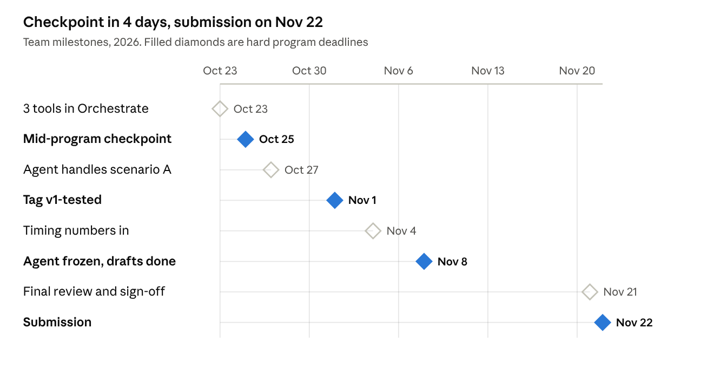
Milestones Oct 23 to Nov 22, 2026
Oct 25 is also the deadline for every member’s 6 SkillsBuild courses and W6 deliverable. At the checkpoint, demo the Orchestrate agent if it’s ready; otherwise demo the prototype and say so.

Before we submit on Nov 22
- The 3-minute video is under 3 minutes and shows the full flow: alert, tool calls, ranked recommendation, analyst approval
- Written problem, solution and prototype link are complete
- Technology statement is complete
- Test sheet with every scenario run is attached
- bob_sessions/ has screenshots from every member
- Every statistic has a source, or is labeled as our own measurement
- No real data appears anywhere
- Every member has finished the courses and credential requirements
- Aldo has signed off on the final package

Where everything lives

Two repos, one project
Repo | What lives there | Tasks that change it
IBM-Sentinel-IAM | The agent: instructions, Bob task prompts, test scenarios, local prototype, docs, and the graded bob_sessions/ folder | 04, 05, 05b, 06
CyberShield_IV | The backend the agent calls (FastAPI). Live at cybershield-iv.onrender.com | 02, 03, 03b

Which file wins when two disagree
- docs/build-spec.md and agents/sentinel.instructions.md
- tests/scenarios.json and docs/testing/test-sheet.md
- These guides
- Everything else

Words you’ll see a lot
Term | Meaning
SOC or IAM analyst | The bank security person who handles the alert. Our user
Step-up MFA | Ask for an extra verification code only because the login looks risky
Revoke session | Log the user out right now
Reset credential | Force a new password
Impossible travel | Two logins too far apart to travel between in the time elapsed
Tool | An API the agent can choose to call for information
Knowledge base | A document the agent can search, here the response playbook. Not a tool
IBM Bob | IBM’s AI coding assistant. We must build with it. Its credits are Bobcoins
watsonx Orchestrate | IBM’s platform where the agent runs
v1-tested | The git tag added once every scenario passes

For reviewers: a 5-minute tour
- What and why: Start here, then docs/build-spec.md sections 1 to 3.
- The agent’s behavior: agents/sentinel.instructions.md (goal, guardrails, reply format).
- How we prove it works: tests/scenarios.json and docs/testing/test-sheet.md, 12 scenarios from normal logins to account takeover.
- Evidence that IBM Bob built it: bob_sessions/.
- Where the numbers come from: docs/research/research-evidence.md.
- What’s done and what’s left: Where things stand, above.

