Sentinel IAM — Agent Guide
  - Team Bastion · Oct 21, 2026 · Owner: Technical Lead (Tasks 05, 05b)
Sentinel is one native watsonx Orchestrate agent named sentinel, with 3 tools and 1 knowledge base. Its behavior comes from one file, agents/sentinel.instructions.md, so most agent work is editing that file and re-testing. Start after Task 04 is done.
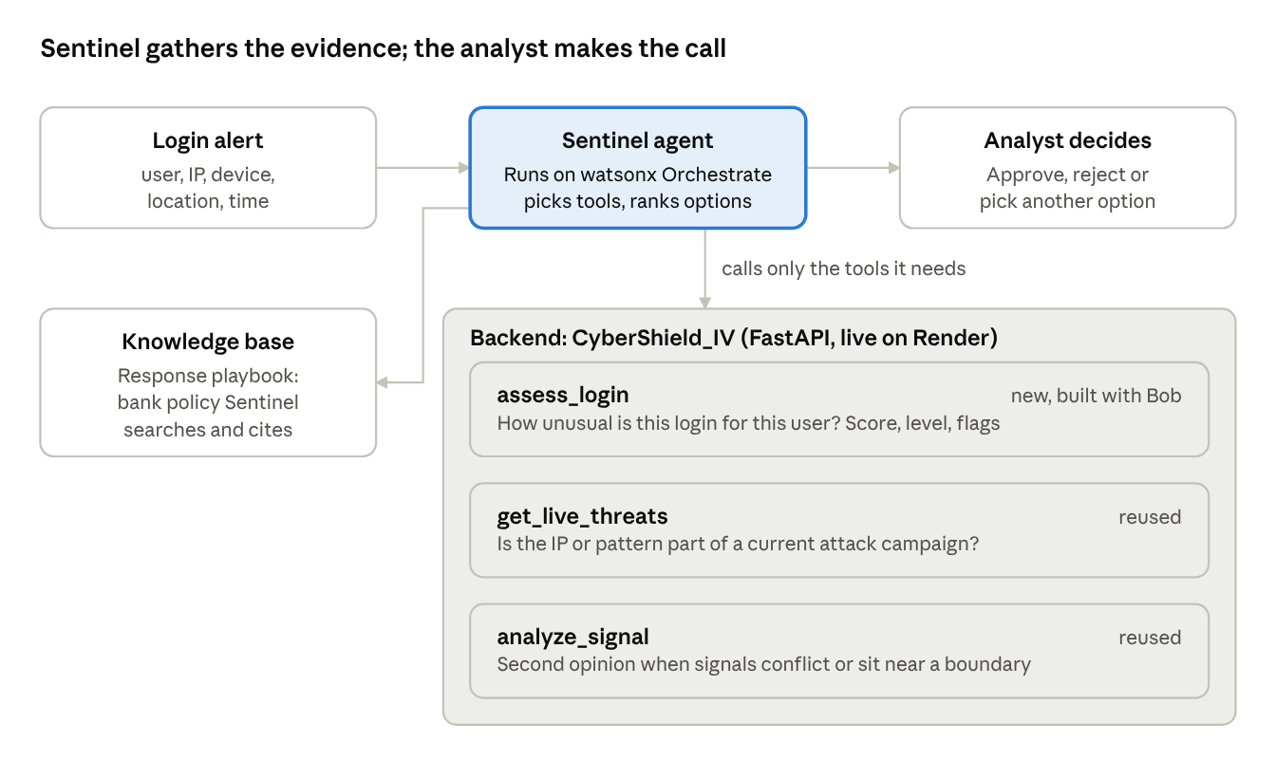
How Sentinel works: 1 agent, 3 tools, 1 knowledge base

1. What the agent must do
- Start every alert with assess_login. It’s the only tool that knows the user’s normal behavior.
- After each tool result, write Learned: and Unknown:, then call another tool or stop. No fixed tool order.
- Call get_live_threats when the IP or pattern could be a live campaign. Call analyze_signal only for conflicting or borderline cases.
- Rank every option best to worst, each with a reason.
- End with Awaiting your approval. Never say or imply an action was taken.
- No hedging words: probably, most likely, might, maybe, perhaps, seems, appears.
- If a tool fails (for example, unknown user), say which tool and what it means, and ask the analyst to check the input. No risk level without evidence.

Default action by level
Level | First recommendation
Low | No action, keep monitoring. If failure_flag is true: step-up MFA
Medium | Step-up MFA
High | Revoke the active session
Critical | Revoke the session and force a credential reset
The score is evidence, not the decision. The agent starts from the default and explains any difference.

2. Task 05: create and import the agent
Bob writes agents/sentinel.agent.yaml. Target shape (check field names against orchestrate agents --help for your ADK version):
spec_version: v1
kind: native
name: sentinel
description: >
Triages one suspicious-login alert for a bank SOC/IAM analyst. Gathers
evidence with its tools, ranks responses with reasons, and waits for the
analyst's approval. Never executes an action.
llm: <a tool-calling model from `orchestrate models list`>
style: default
instructions: >
<paste the full text of agents/sentinel.instructions.md>
tools:
- assess_login
- get_live_threats
- analyze_signal
orchestrate models list
orchestrate agents import -f agents/sentinel.agent.yaml
orchestrate agents list
UI alternative on SaaS: Build, then Agents, then Create agent. Paste the instructions into Behavior and add the three tools.

Test it with scenario A
Paste into the agent chat:
Suspicious login alert: user_id jdoe, ip 203.0.113.66, device_id win-unknown-7f2, geo Lagos, NG, timestamp 2026-10-02T03:14:00Z

Done when
- Verdict is Critical (100/100)
- Revoke session plus credential reset is ranked first, every option has a reason
- The Learned / Unknown steps are visible, with why each tool was called
- It ends with “Awaiting your approval” and never says an action was taken
- Bob screenshot saved to bob_sessions/
Failure looks like: the same tools in the same order for every case, hedging words, or the conversation ending when the analyst rejects.

3. Task 05b: attach the knowledge base
The knowledge base is the bank response playbook, docs/knowledge/sentinel-response-playbook.md. It is knowledge, not a tool: the agent still has exactly 3 tools. Start once the Research & Documentation Lead marks the playbook ready.
Bob writes agents/sentinel-playbook.knowledge.yaml (check fields with orchestrate knowledge-bases --help):
spec_version: v1
kind: knowledge_base
name: sentinel_response_playbook
description: >
Bank policy for suspicious-login response: risk levels, default responses,
the 5-minute failure rule, special cases, analyst procedure and audit.
documents:
- docs/knowledge/sentinel-response-playbook.md
Add it to the agent YAML. Do not add, remove or rename any tool.
knowledge_base:
- sentinel_response_playbook
orchestrate knowledge-bases import -f agents/sentinel-playbook.knowledge.yaml
orchestrate agents import -f agents/sentinel.agent.yaml
orchestrate agents list
UI alternative on SaaS: Build, then Agents, then sentinel, then Knowledge, then upload the playbook file.

Done when
- The agent shows 3 tools and 1 knowledge base
- Scenario H names the playbook section it follows (section 6, conflicting signals) and ends with “Awaiting your approval”
- Scenario A is unchanged

4. Fixing agent behavior
When a scenario fails:
- Change the smallest part of agents/sentinel.instructions.md that explains the failure.
- Copy the new text into the agent YAML and re-import.
- Re-run every scenario, not only the one that failed. Fixes can break earlier passes.
- Log each run as a new row in docs/testing/test-sheet.csv.
Symptom | Where to fix it in the instructions
Same tools in the same order every time | “How you work the case”: strengthen Learned / Unknown, remove any step list
Hedging words | “Rules”: the “Be decisive” line
Says an action was done | “Rules”: “You recommend. You never execute.” This fails the test outright
Ends the chat after a rejection | “Rules”: “If the analyst rejects”
Ranks no action on a flagged Low case | “Authentication-failure policy”: flagged Low ranks step-up MFA first
Agent freeze: no changes after Nov 8.

