Part 1

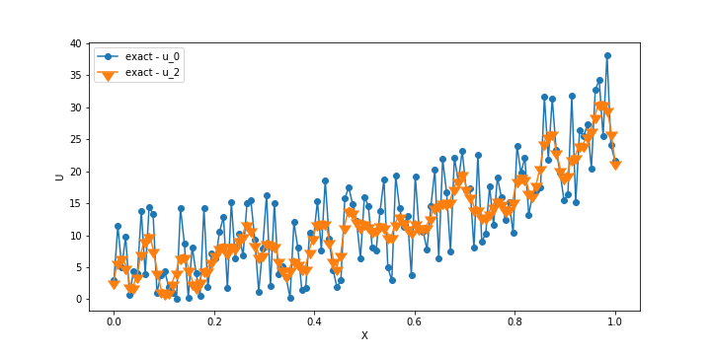

With Increase in Number of iteration, the high frequency residual has damped huge as compared to low frequency residual as expected.

Part 2

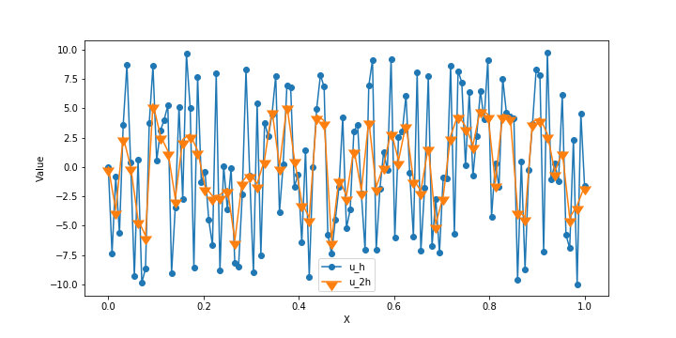

Part 3

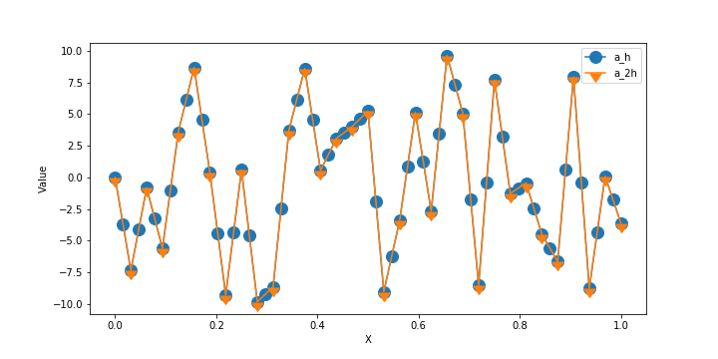

Part 4

Solution of Ax = B, is

X = [1,1,1,1,1,1,1,1,1,1]

Part 5

For 2000 Jacobi and 1000 Grid Iteration

Note both the plots has created from using the same initial guess. (value 109.872), but at first iteration the value of Multigrid norm shot’s up, that’s why they appear to generated from different guess.

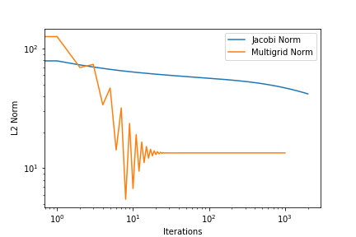

For 20000 Jacobi and 10000 Grid Iteration

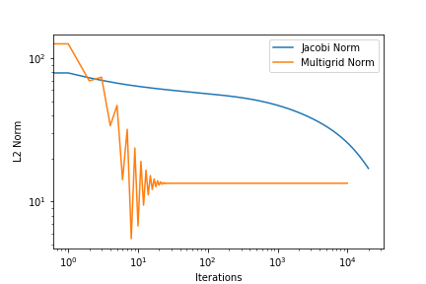

For 200000 Jacobi and 100000 Grid Iteration

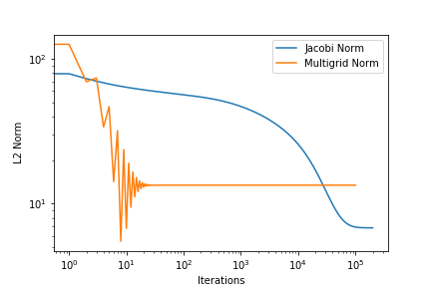

For 2000000 Jacobi and 1000000 Grid Iteration

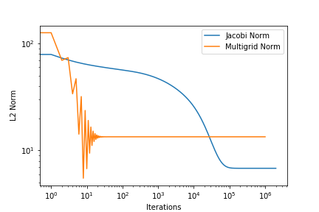

Both solver Jacobi and multigrid reach a plateau where the error doesn’t go down further. I changed the number of grid point to 64, and still got the same result. Since the error plateau at norm ~ 1-10, my code can’t reach the tolerance for next problem. I doubled check my Thomas solver using linpack solver of armadillo and it work’s fine. I couldn’t figure out the problem why it don’t converge.

To compile I used the command:-

g++ main.cpp -O2 -larmadillo && ./a.out