**Problem 1**

x_coord : [0.0, 0.25, 0.5, 0.75, 1.0]

Nodes : [(1, 0, 1), (2, 1, 2), (3, 2, 3), (4, 3, 4)]

Quad_point : [0.125, 0.375, 0.625, 0.875]

Quad_weight : [0.25, 0.25, 0.25, 0.25]

Note the last two value of Nodes return the global index for Phi. Unknown is trivial and is equal to first element of each tuple in Nodes. x_coord is equispaced x point between 0,1. Quad_Point is Quadrature Point Calculated by MID-POINT formula. Quad Weight is the respective weight for Quadrature.

## Problem 2

Value of basis function phi_2 at x : 0.125 is 0 and Derivative : 0

Value of basis function phi_2 at x : 0.375 is 0.5 and Derivative : -4.0

Value of basis function phi_2 at x : 0.5 is 1.0 and Derivative : 4.0

Value of basis function phi_2 at x : 0.675 is 0.2999999999999998 and Derivative : 4.0

Value of basis function phi_2 at x : 0.8 is 0 and Derivative : 0

## Problem 3

Mass Matrix

[[0. 0. 0. 0. 0. 0. 0. 0. 0. 0. 0. 0. 0. 0. 0.]

[0. 0. 0. 0. 0. 0. 0. 0. 0. 0. 0. 0. 0. 0. 0.]

[0. 0. 0. 0. 0. 0. 0. 0. 0. 0. 0. 0. 0. 0. 0.]

[0. 0. 0. 0. 0. 0. 0. 0. 0. 0. 0. 0. 0. 0. 0.]

[0. 0. 0. 0. 0. 0. 0. 0. 0. 0. 0. 0. 0. 0. 0.]

[0. 0. 0. 0. 0. 0. 0. 0. 0. 0. 0. 0. 0. 0. 0.]

[0. 0. 0. 0. 0. 0. 0. 0. 0. 0. 0. 0. 0. 0. 0.]

[0. 0. 0. 0. 0. 0. 0. 0. 0. 0. 0. 0. 0. 0. 0.]

[0. 0. 0. 0. 0. 0. 0. 0. 0. 0. 0. 0. 0. 0. 0.]

[0. 0. 0. 0. 0. 0. 0. 0. 0. 0. 0. 0. 0. 0. 0.]

[0. 0. 0. 0. 0. 0. 0. 0. 0. 0. 0. 0. 0. 0. 0.]

[0. 0. 0. 0. 0. 0. 0. 0. 0. 0. 0. 0. 0. 0. 0.]

[0. 0. 0. 0. 0. 0. 0. 0. 0. 0. 0. 0. 0. 0. 0.]

[0. 0. 0. 0. 0. 0. 0. 0. 0. 0. 0. 0. 0. 0. 0.]

[0. 0. 0. 0. 0. 0. 0. 0. 0. 0. 0. 0. 0. 0. 0.]]

Stiffness Matrix

[[ 32. -16. 0. 0. 0. 0. 0. 0. 0. 0. 0. 0. 0. 0.

0.]

[-16. 32. -16. 0. 0. 0. 0. 0. 0. 0. 0. 0. 0. 0.

0.]

[ 0. -16. 32. -16. 0. 0. 0. 0. 0. 0. 0. 0. 0. 0.

0.]

[ 0. 0. -16. 32. -16. 0. 0. 0. 0. 0. 0. 0. 0. 0.

0.]

[ 0. 0. 0. -16. 32. -16. 0. 0. 0. 0. 0. 0. 0. 0.

0.]

[ 0. 0. 0. 0. -16. 32. -16. 0. 0. 0. 0. 0. 0. 0.

0.]

[ 0. 0. 0. 0. 0. -16. 32. -16. 0. 0. 0. 0. 0. 0.

0.]

[ 0. 0. 0. 0. 0. 0. -16. 32. -16. 0. 0. 0. 0. 0.

0.]

[ 0. 0. 0. 0. 0. 0. 0. -16. 32. -16. 0. 0. 0. 0.

0.]

[ 0. 0. 0. 0. 0. 0. 0. 0. -16. 32. -16. 0. 0. 0.

0.]

[ 0. 0. 0. 0. 0. 0. 0. 0. 0. -16. 32. -16. 0. 0.

0.]

[ 0. 0. 0. 0. 0. 0. 0. 0. 0. 0. -16. 32. -16. 0.

0.]

[ 0. 0. 0. 0. 0. 0. 0. 0. 0. 0. 0. -16. 32. -16.

0.]

[ 0. 0. 0. 0. 0. 0. 0. 0. 0. 0. 0. 0. -16. 32.

-16.]

[ 0. 0. 0. 0. 0. 0. 0. 0. 0. 0. 0. 0. 0. -16.

32.]]

Matrix F

[[0.11976204]

[0.23492169]

[0.34105344]

[0.43407869]

[0.51042254]

[0.56715114]

[0.60208444]

[0.61387997]

[0.60208444]

[0.56715114]

[0.51042254]

[0.43407869]

[0.34105344]

[0.23492169]

[0.11976204]]

## Problem 4

Part 1

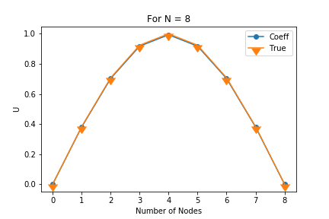

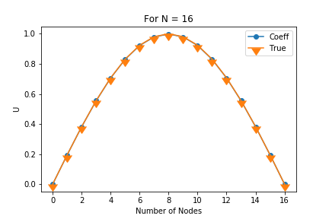

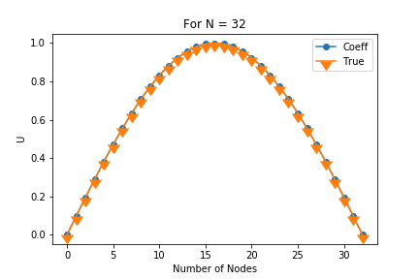

Part 2

