Problem 1,

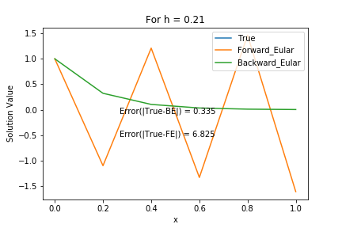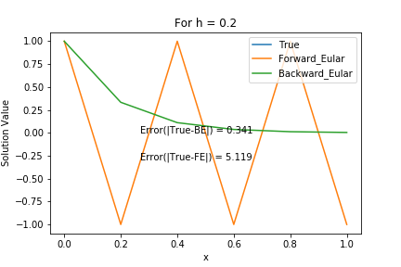

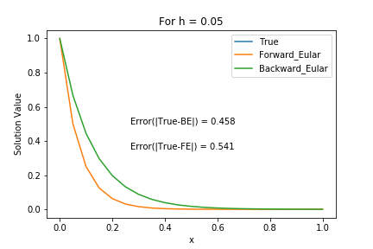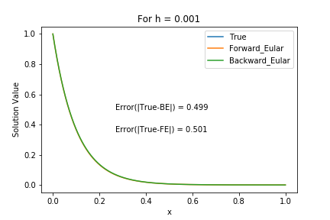

For FE, the solution is stable only when , and for this problem k=-10.

For 1st case, h=0.21, the condition define above doesn’t hold, and hence we can see that for h=0.21, the solution is diverging. For h=0.20, the solution is stable but not converging, and for h=0.05 and h=0.001, z lie’s well within range of 1, and hence the solution is stable and converging.

For BE, the solution is unconditionally stable as we can see from the figures.

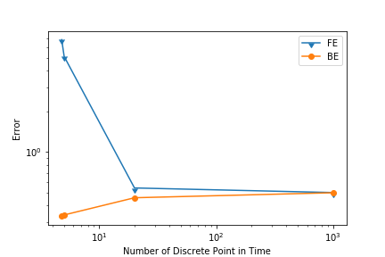

For FE, the error decrease as h increase, but for BE they are somewhat same. Every graph reported above has the error value. With increase in h, error for both BE and FE become of same order. For FE, when h increase from 5 to 20, the error decrease should decrease by a factor of 8, and from our study it decreases by a factor of ~9.5.

Problem 2:

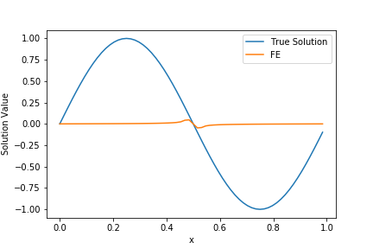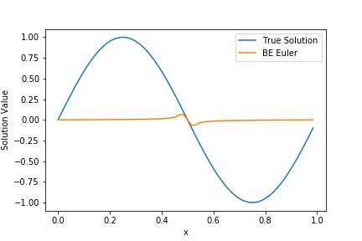

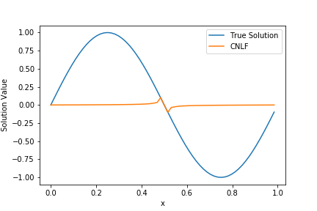

We can see that all solution show stable solution. The solution is reported above is build using 64 discrete point in space and 100-time steps.

For FE:-

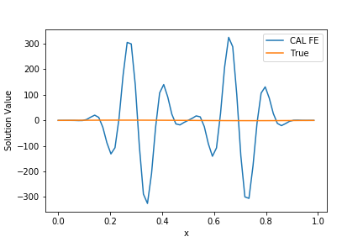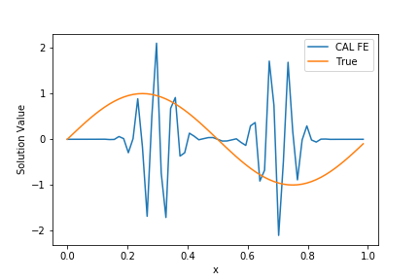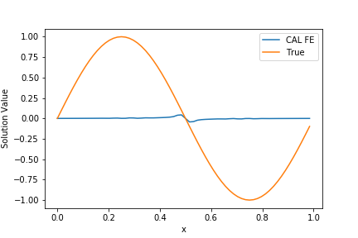

Nt=10 Nt=50 Nt=70

Here Nt represent the number of time step, so for FE the largest time step that produce stable solution is 0.0143 (1/70).

For BE:-

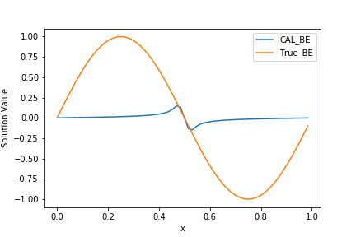 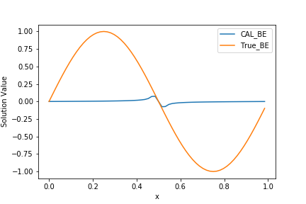 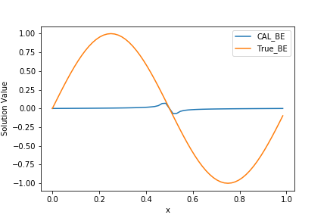

Nt=10 Nt=50 Nt=70

BE is unconditionally stable.

For CNLF:-

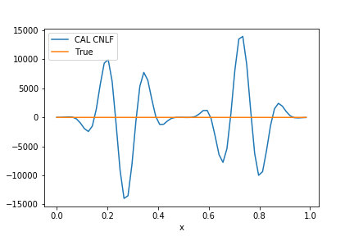 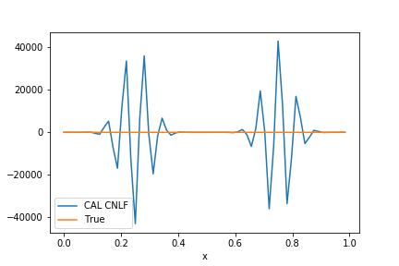 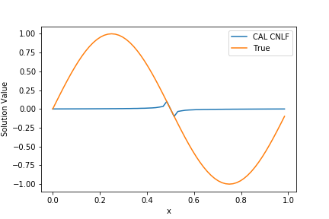

Nt=10 Nt=50 Nt=70

For CNLF the largest time step that produce stable solution is 0.0143 (1/70).What I observed is that it’s not unconditional stable.