**For Problem 1, Part 1**

For 1st dataset

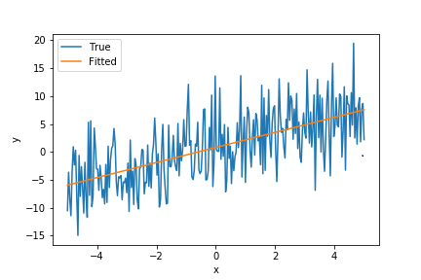

For 2nd Dataset

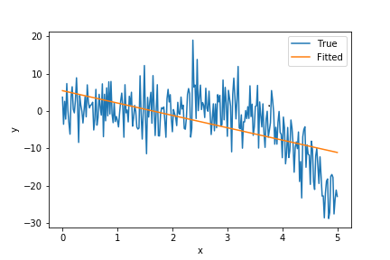

#### Problem 1,Part 2

For 1st dataset

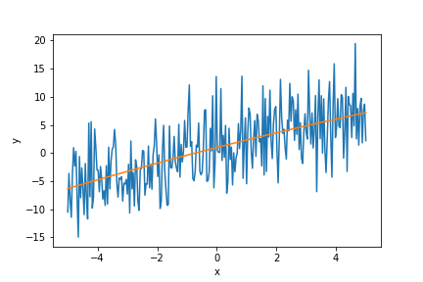

For 2nd Dataset

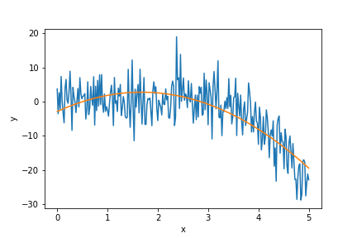

Problem 1,Part 3

For Problem 1.1 :

For File 1, Value of beta0: 0.802313 and Value of beta_1: 1.35011 Value of R2 is = 0.394645

For Problem 1.1 :

For File 2, Value of beta0: 5.44423 and Value of beta1: -3.30736 Value of R2 is = 0.363543

As we know greater the R2 value better is the fitting. For a fit of order 1 we have obtained R2~0.4 which show that there is some room for improvement in first order regression. However, dataset1 is fitted somewhat fine.

For Problem 1.2

For File 0 Value of beta0: 0.986694, Value of beta_1: 1.35011, Value of beta_2: -0.0219535 Value of R2 is = 0.395733

For Problem 1.2

For File 1 Value of beta_0 : -2.90445, Value of beta_1 :6.75049, Value of beta_2 :-2.01157 Value of R2 is = 0.587317

Changing the order to 2, result in same predications for dataset1, but our prediction on dataset2 increase significantly. My intrusion is that because of the variations in data1, the data can’t fit more better than this, unless we go to higher order where overfitting starts to occur. For dataset2 we saw a good fit of data for order 2.

So first dataset can be fitted using order 1, and second dataset can be fitted by using order 2.

#### Problem 2

Correlation between Solar Radiation and rain is : -0.00307215, and Between Solar radiation and Temperature is: 0.0005541

There is negative correlation between solar radiation and rain, which makes senses as the sunlight is less when it’s raining. Similarly, on a day when temperature is high there is more chance that radiation is high which is proven by positive correlation between radiation and temperature.

However, for both the case correlation is weak.