Results:

For steepest Descent

Number of Iteration : 132

Time (in ms) :0.1689

Value of X(x1,x2) : 0.999998,0.999999

For Newton's Method

Number of Iteration : 98

Time (in ms) :0.0631

Value of X(x1,x2) : 1,1

For BFGS Method

Number of Iteration : 76

Time (in ms) : 0.349

Value of X(x1,x2) : 1,1

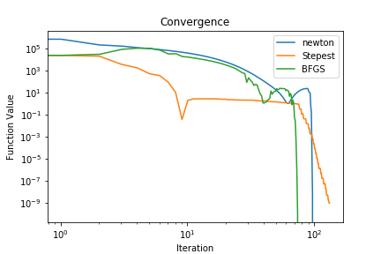

In terms of Number of Iteration BFGS outperformed Newton and Steepest Descent method. However in terms of run time newton was the quickest. The Worst time performance of BFGS arises because of the calculation of matrix product in Morrison’s formula. The newton method seems to be a wise choice for solving this problem because of small number of iterations and quick performance.

Inverse Comparison for BFGS:

By using Exact Form:

1st 2nd 3rd

0.0002 -0.0012 0.0004 -0.0012 0.0016 -0.0075

-0.0012 0.0119 -0.0012 0.0086 -0.0075 0.0399

By using Morrison’s Formula:

1st 2nd 3rd

1 0 0.0137 -0.1160 0.0004 -0.0019

0 1 -0.1160 0.9887 -0.0019 0.0132

The sign for all the terms seems to agree in both the expression and as we can see that terms of 3rd iteration compares better than terms of 2nd iterations. It suggest that as iterations increase the result from both the expression will be more or less similar.

Note:- I used gamma_1 = 0.01 and rho = 0.1 to get the value of alpha.

To compile : g++ -fopenmp main.cpp -O2 -larmadillo && ./a.out