Problem 1:

To visualize the Semi-Lagrangian method I have attached a video “Advection.mp4” which show the propagation of wave In time without diffusion.

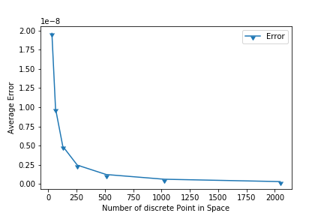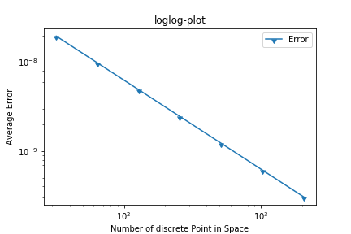

From the loglog plot it is evident that the relationship between grid size and error is of linear type. As grid size if shrink by half, the error also diminishes by half. It suggest that the method is first order accurate.

Problem 2:

To visualize the Semi-Lagrangian method I have attached a video “Advection and diffusion.mp4” which show the propagation of wave In time with diffusion.

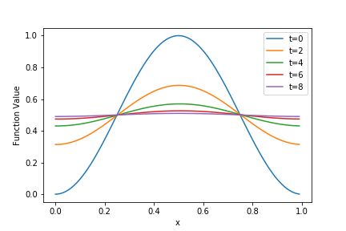

Above figure represent the evolution of wave with time. With time, the amplitude of wave decreases due to diffusion and eventually dies out for t=8.