**Problem 1**

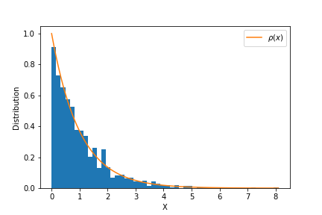

The result of Inverse sampling produce exponential distribution as suspected. To validate the results one can use QQ-plot or KS-test, which can validate the generated distribution.

# Problem 2

probability of acceptence,Uniform (Problem 2,part 1): 0.167661

Theoretical mean and variance : 1.253, 0.429204

Calculated mean and variance : 1.24775, 0.420909

probability of acceptence,Piecewise(Problem 2,part 2) : 0.312725

Theoretical mean and variance : 1.253, 0.429204

Calculated mean and variance : 1.25385, 0.429029

# Problem 3

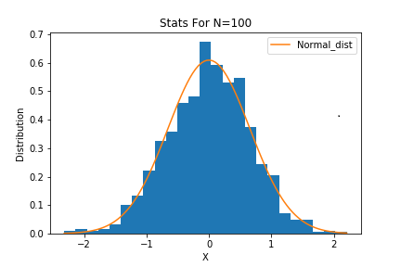

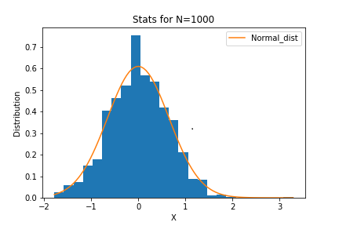

As the number of observation increase from N=100 to N=1000, the generated distribution becomes more like Normal. This can also be achieved If we Increase the number of iterations for a given N.