Polygonal Element
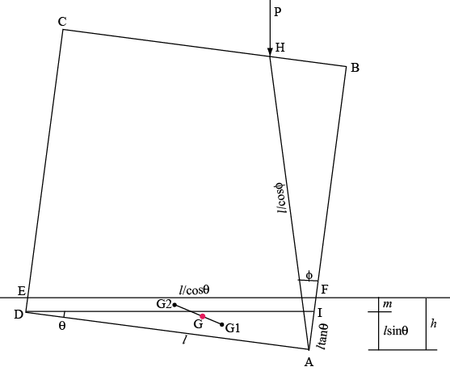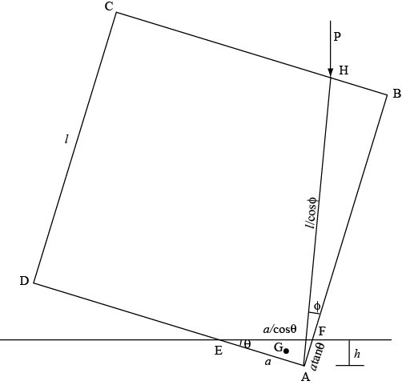
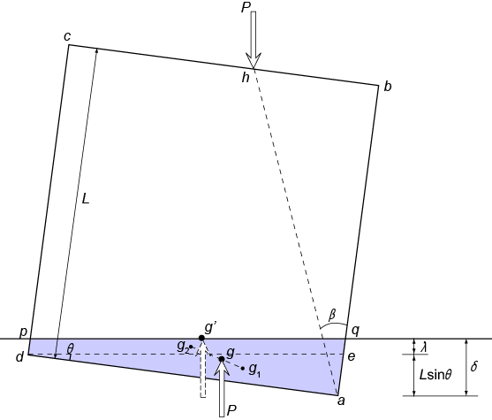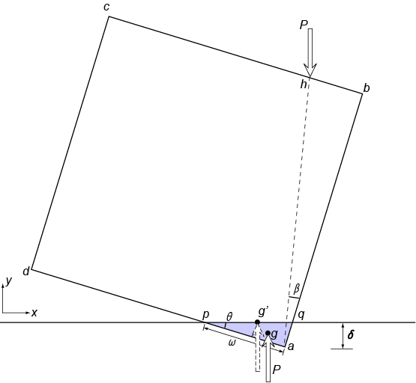
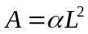
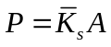
Critical rotation
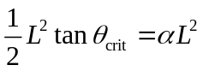
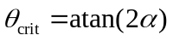
For 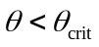, the overlapping area is a trapezoid
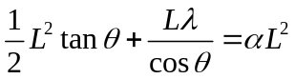
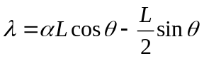
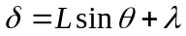
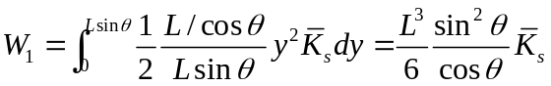
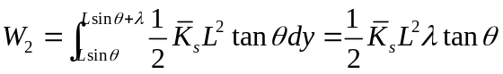
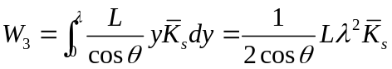
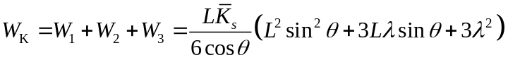
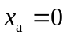, 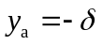
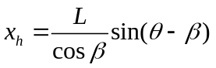, 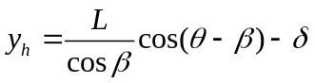
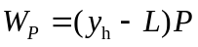
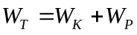
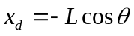, 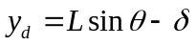
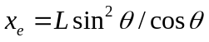, 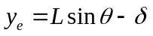
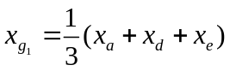, 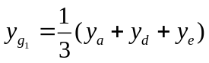
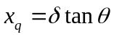, 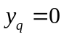
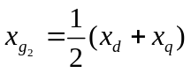, 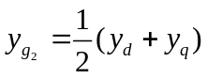
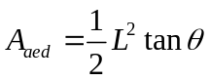, 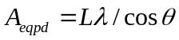
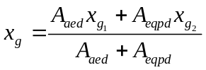, 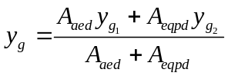
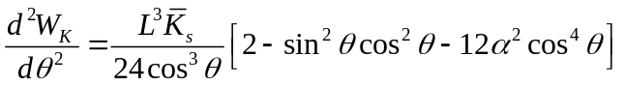
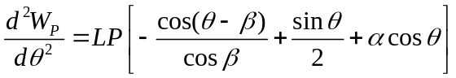

For 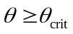, the overlapping area is a triangle
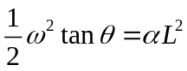, 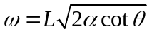， 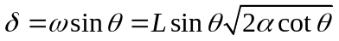
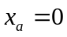, 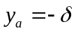
,
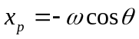, 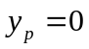
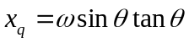,
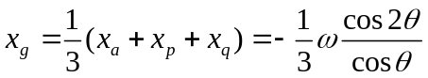, 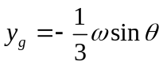
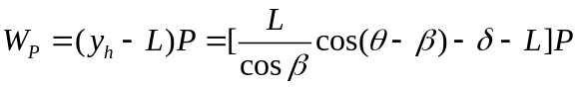
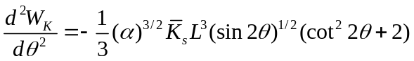
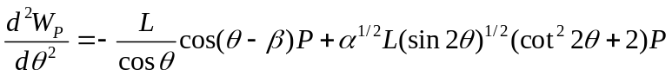
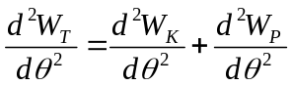
Polyarc Element

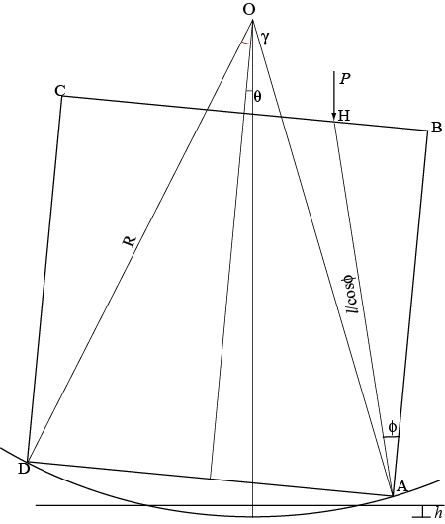

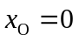, 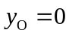
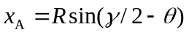, 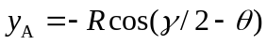
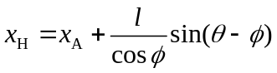, 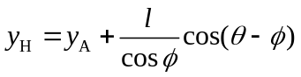
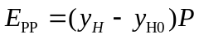
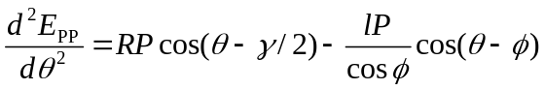
Feng’s model

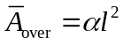 when θ=0
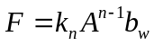
Critical rotation
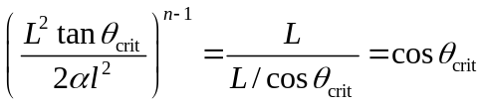, 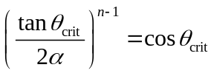
No close form solution for θ_{crit}
For , the overlapping area is a trapezoid
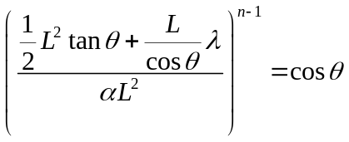
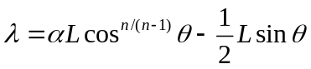
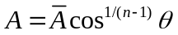
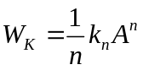
, 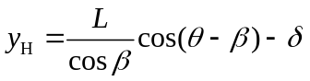
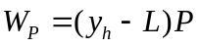
,
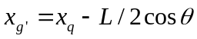
For , the overlapping area is a triangle

