A array of geometry parameters is as shown below.
Parameter | Interpretation | Value range
PG1 | Lower limit of the minor-major axis ratio | 0~1
PG2 | Distribution factor of minor-major axis ratio  minor_axis=major_axis * (1-rand()^PG2*(1-PG1))  If PG2=1, then minor axis length has a uniform distribution between PG1 and 1.  The smaller the value of PG2, the shorter minor axis. The bigger PG2, the longer minor axis. | 0~??
PG3 | Upper limit of 2*dAi/(360/nV) | 0~1
PG4 | Distribution factor of dAi  dAi=±360/nV/2*PG3*rand()^PG4 | 0~??

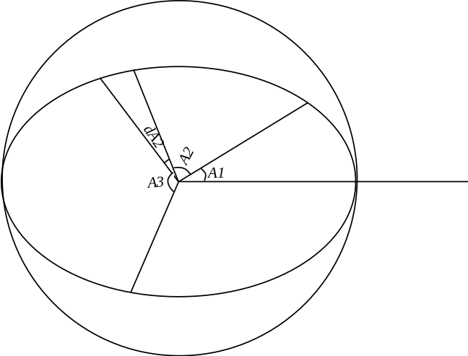

Definition of gradation curve
BinSize(nBin+1) |  | Bin(nBin,8)
Size Bin |  | Total num. of ele. in this bin  Bin(nBin,8) | Num. of ele. of each shape
Min | Max | (non-normalized) | 2 | 3 | 4 | 5 | 6 | 7 | 8
0.001 | 0.002 | 1000 | 800 | 200 | 0 | 0 | 0 | 0 | 0
0.002 | 0.004 | 400 | 300 | 80 | 20 | 0 | 0 | 0 | 0
0.004 | 0.008 | 150 | 30 | 40 | 40 | 40 | 0 | 0 | 0
0.008 | 0.016 | 80 | 10 | 30 | 20 | 15 | 5 | 0 | 0
0.016 | 0.032 | 30 | 3 | 10 | 10 | 5 | 1 | 1 | 0

