Each element has two mass values:
mInert: Inertial mass, which is normalized to have approximately equal critical time interval for big and small elements.
mGrav: Gravitational mass, to calculate gravity force.
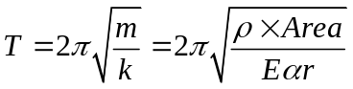
is a coefficient determined by 1) kinematic energy and 2) particle stiffness, should be smaller than unity.
Inertial mass should have such a value that
