**Assignment-1**

**PROJECT 1:**

1. Created a Windows instance using AMI: 2019 base
2. Launched the instance using RDP

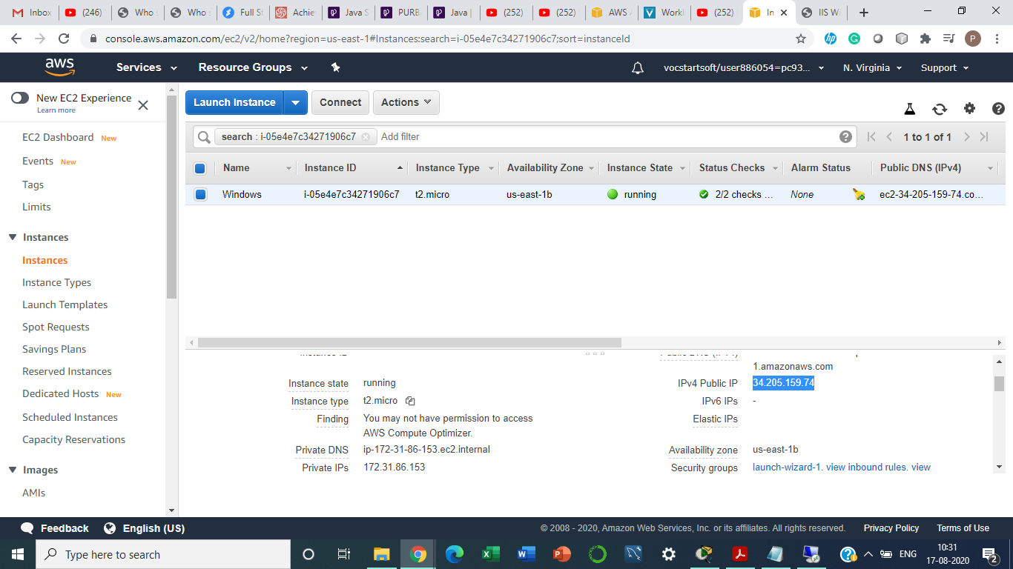

1. Installed IIS Web Server using PowerShell ISE
2. Successful installation of IIS Web Server verified.

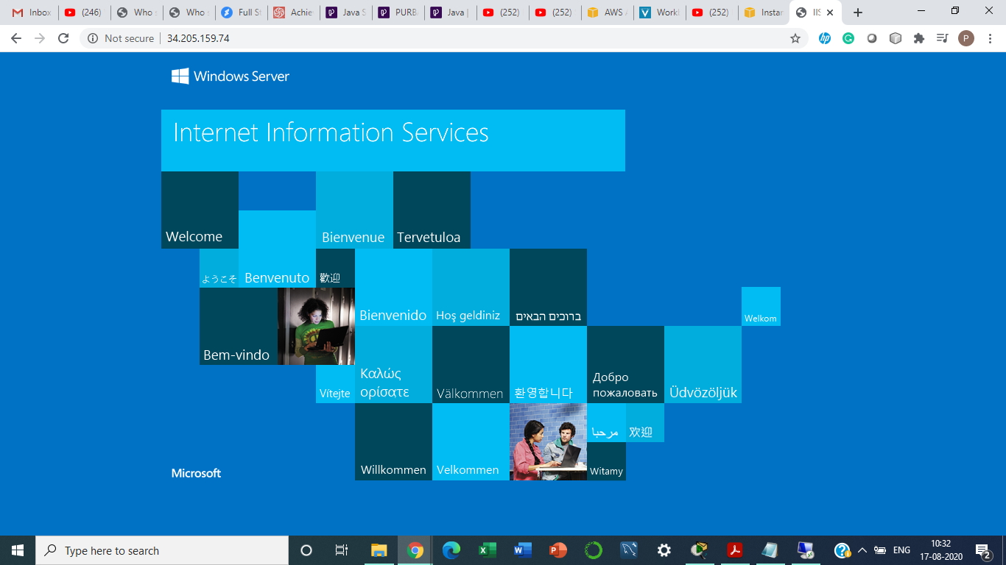

**PROJECT 2:**

1. Created a Windows instance using AMI: Ubuntu 18.04 LTS(HVM)
2. Ubuntu instance launched using SSH.

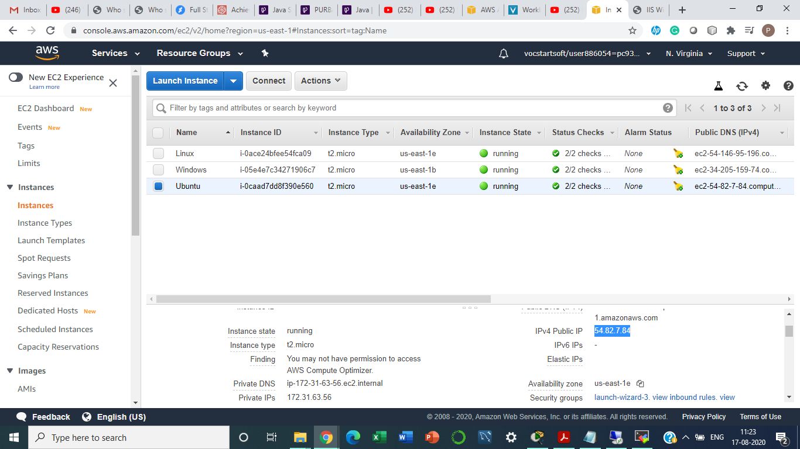

1. Nginx web server launched using bash.
2. Successful installation of nginx verified.

