**Assignment-2**

**Step1: Create two Linux instances, Use the first free Linux AMI**

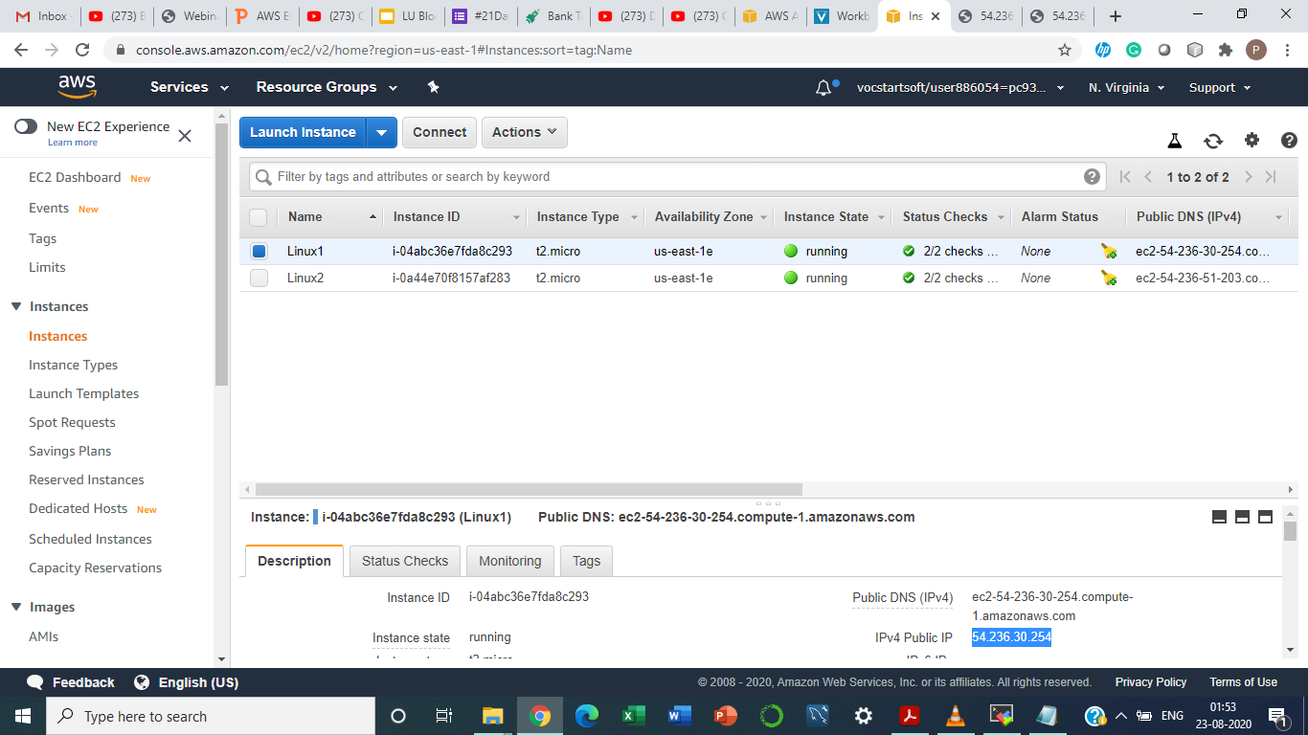

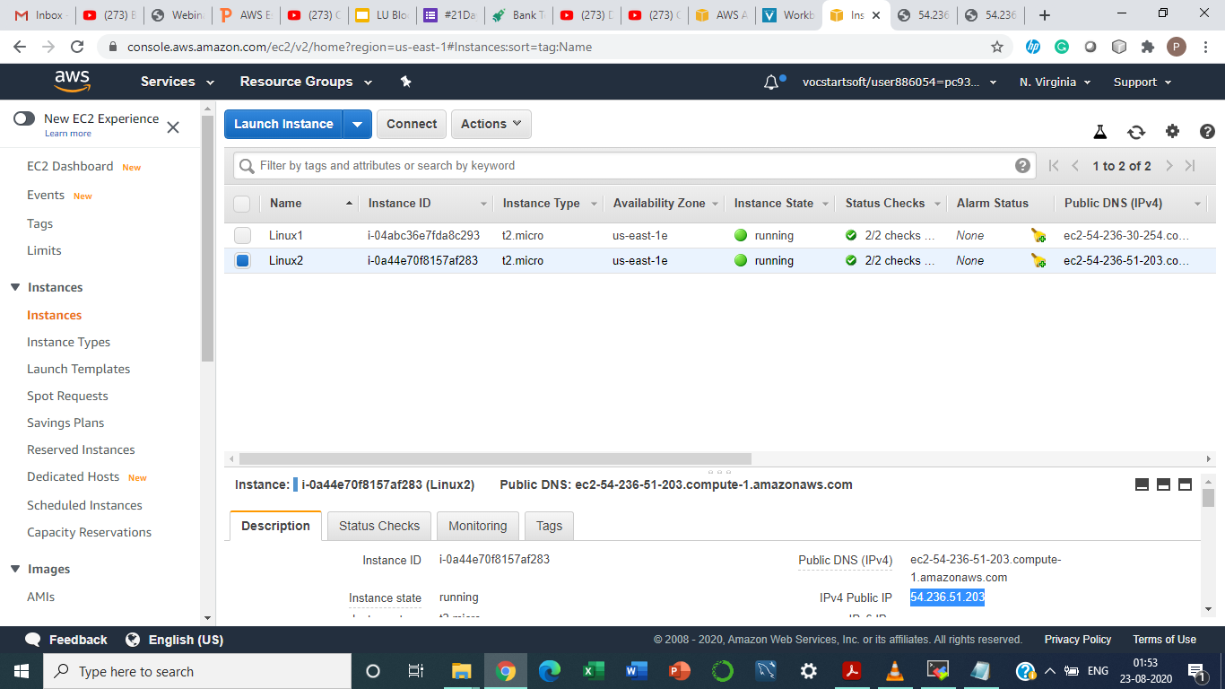

**Step2: Launch both instances using Mobaxterm**

**Step4: Host html login webpage on both servers**

**Step5: Check is application is deployed on both servers by copy pasting the public ip of the servers into the browser.**

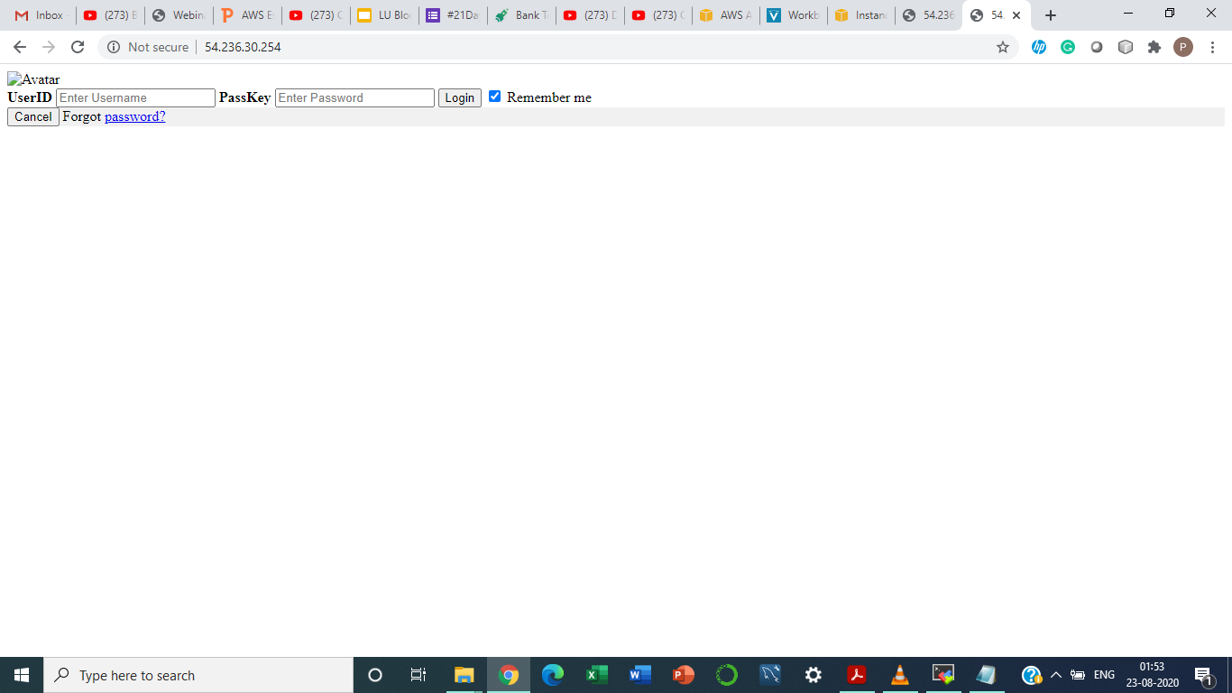

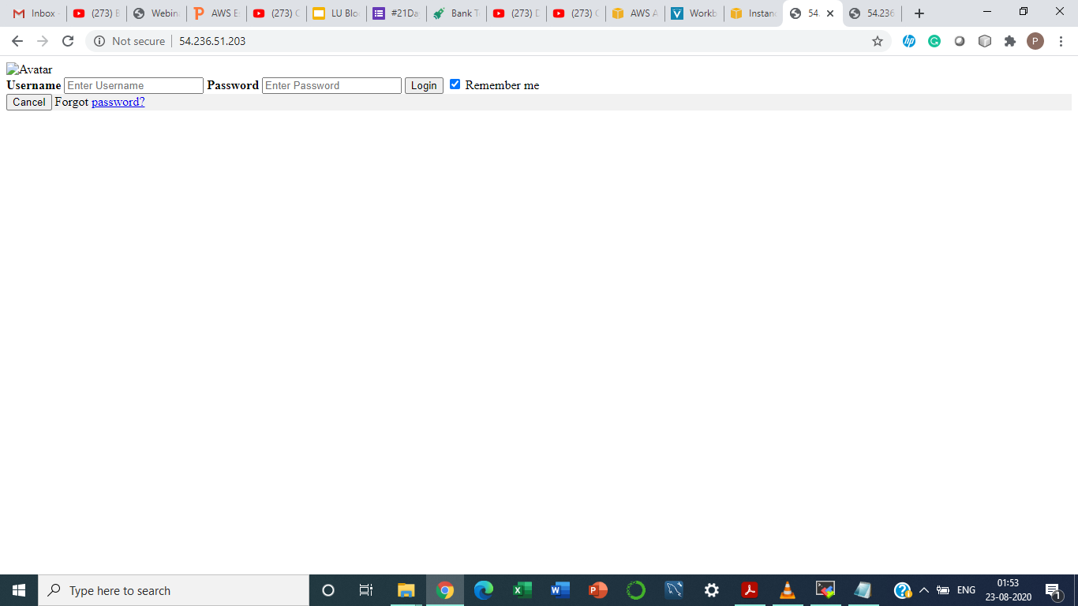

**Step6: Create an application Load balancer with the above two instances as targets**

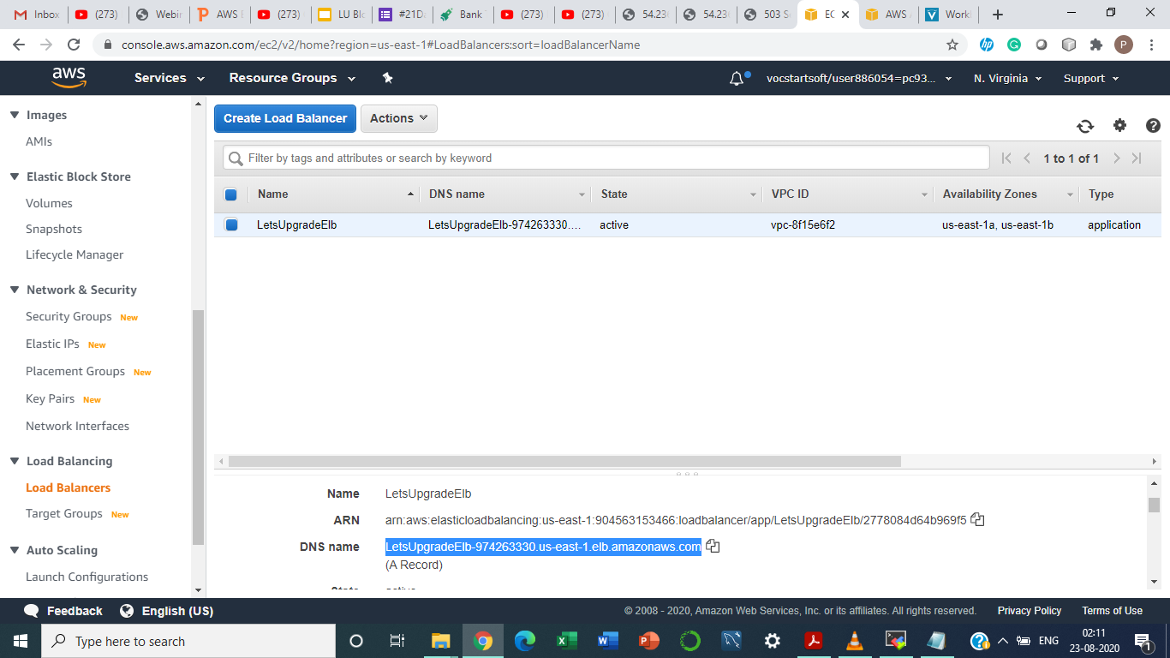

**Step7: Check the functioning of ELB**

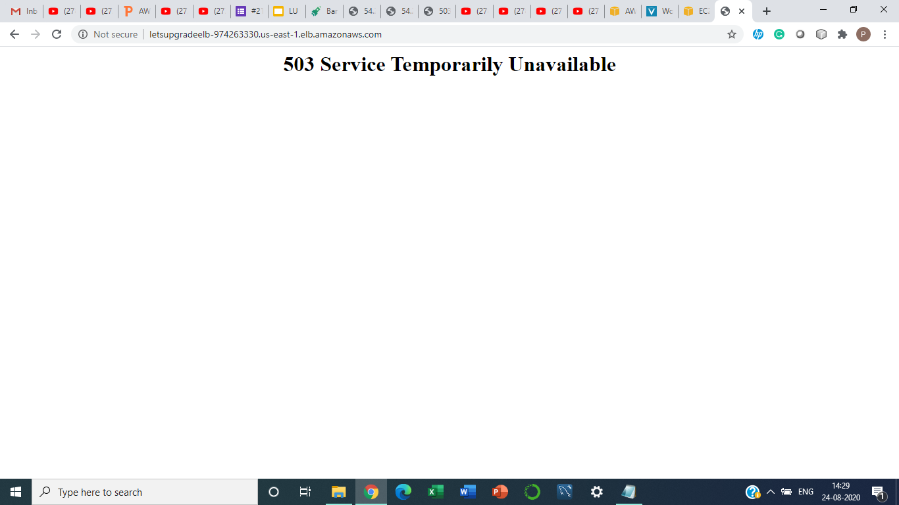

**## N.B. I couldn’t get the load balancer up and running even after following given steps and having waited more than 24 hours (can be verified from the time stamp at the bottom right corner)**