**DATABASE ENGINEERING**

**(EC-240)**

LAB MANUAL # 07

**Course Instructor:** Prof Dr Farooque Azam / Assoc Prof Dr Wasi Haider Butt

**Lab Engineer:** Engineer Kashaf Raheem

AMINA QADEER

**Student Name: _______________________________________________**

**Degree/ Syndicate: _______CE-42-A_____________________________________**

**Lab#07: Normalization**

**Lab Objective:**

To help students know the basics of normalization, functional dependencies and decomposition of a relation using normalization to remove anomalies and ambiguities in relations (if any).

**Lab Description:**

Normalization is a process in which we systematically examine relations for anomalies and, when detected, remove those anomalies by splitting up the relation to produce smaller, well-structured relations. Normalization is an important part of the database development process: Often during normalization, the database designers get their first real look into how the data are going to interact in the database. Normalizing a relation reduces data redundancy but introduces the need for joins when all of the data is required by an application such as a report query.

### Functional Dependency:

A constraint between two attributes in which the value of one attribute is determined by the value of another attribute.

For any relation R, attribute B is functionally dependent on attribute A if, for every valid instance of A, that value of A uniquely determines the value of B (Dutka and Hanson, 1989). The functional dependency of B on A is represented by an arrow, as follows: A → B. A functional dependency is not a mathematical dependency: B cannot be computed from A.

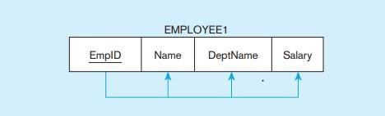

### Modification Anomalies:

Once our E-R model has been converted into relations, we may find that some relations are not properly specified. There can be a number of problems:

* **Deletion Anomaly:** Deleting one fact or data point from a relation results in other information being lost.
* **Insertion Anomaly:** Inserting a new fact or tuple into a relation requires we have information from two or more entities – this situation might not be feasible.
* **Update Anomaly:** Updating one fact in a relation requires us to update multiple tuples.

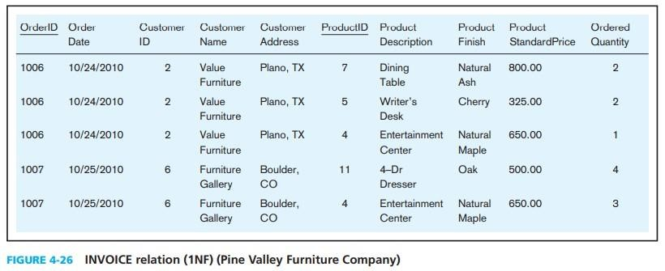

### Steps In Normalization:

Normalization can be accomplished and understood in stages, each of which corresponds to a normal form. A normal form is a state of a relation that requires that certain rules regarding relationships between attributes (or functional dependencies) are satisfied.

### First normal form (1NF): A relation that has a primary key and in which there are no repeating groups (remove any multivalued attribute, so there is a single value (possibly null) at the intersection of each row and column of the table).

* **Second normal form (2NF):** A relation is in second normal form (2NF) if it is in first normal form and contains no partial functional dependencies (remove any partial functional dependencies i.e., non-key attributes are identified by the whole primary key). Partial functional dependency is a functional dependency in which one or more non-key attributes are functionally dependent on part (but not all) of the primary key.

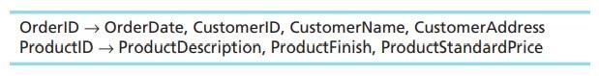

### Third normal form (3NF): A relation that is in second normal form and has no transitive dependencies. Transitive dependency is a functional dependency between the primary key and one or more non-key attributes that are dependent on the primary key via another non-key attribute.

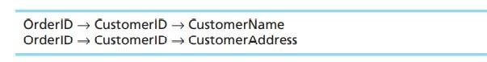

**Lab Tasks:**

1. **For each of the following relations, indicate the normal form for that relation. If the relation is not in third normal form, decompose it into 3NF relations. Functional dependencies (other than those implied by the primary key) are shown where appropriate.**

* CLASS (CourseNo, SectionNo)
* CLASS (CourseNo, SectionNo, Room)
* CLASS (CourseNo, SectionNo, Room, Capacity) [FD: Room → Capacity]
* CLASS (CourseNo, SectionNo, CourseName, Room, Capacity) [FD: CourseNo → CourseName; FD: Room → Capacity]

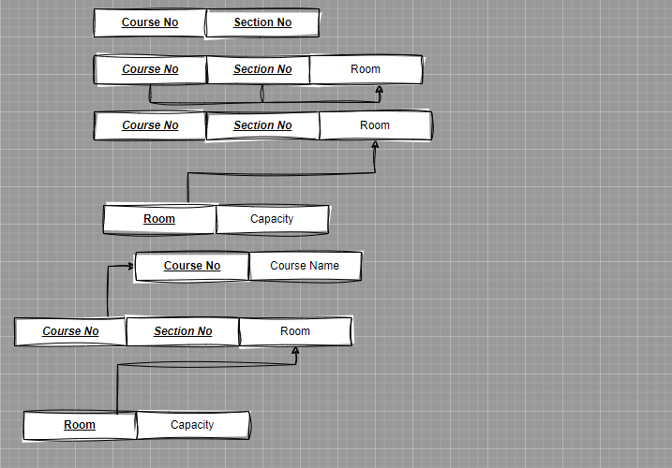

1. **Figure shows an EER diagram for a simplified credit card environment. There are two types of card accounts: debit cards and credit cards. Credit card accounts accumulate charges with merchants. Each charge is identified by the date and time of the charge as well as the primary keys of merchant and credit card.** 
   * Develop a relational schema.
   * Show the functional dependencies.
   * Develop a set of 3NF relations.

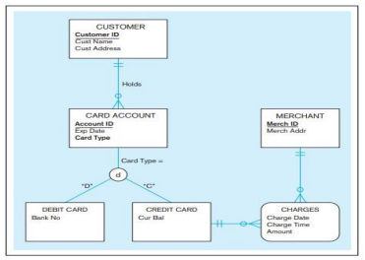

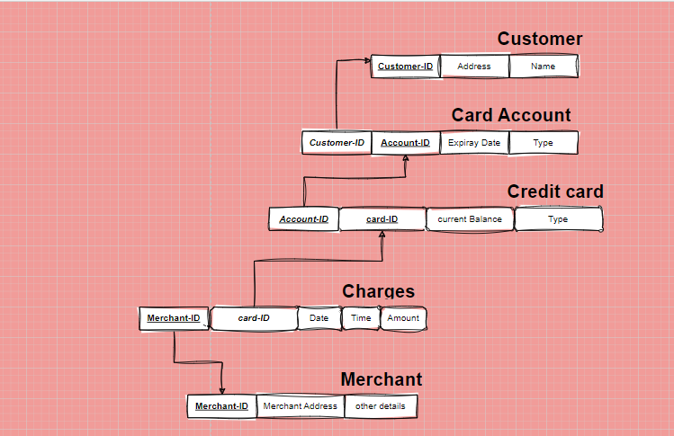

1. **Figure includes an EER diagram describing a car racing league. You have already transformed the diagram into a relational schema in lab-06. Verify that the resulting relations are in 3NF.**

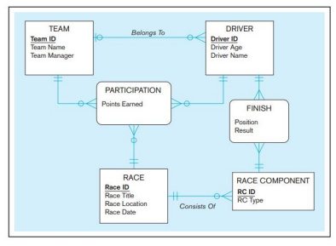

1. **The following attributes form a relation that includes information about individual computers, their vendors, software packages running on the computers, computer users, and user authorizations. Users are authorized to use a specific software package on a specific computer during a specific timeframe (characterized with attributes UserAuthorization Starts and UserAuthorizationEnds and secured with UserAuthorizationPassword). Software is licensed to be used on specific computers (potentially multiple software packages at the same time) until an expiration time (SoftwareLicenceExpires) at a specific price. Computers are sold by vendors, and each vendor has a support person with an ID, name, and phone extension. Each individual computer has a specific purchase price. The attributes are as follows:**

ComputerSerialNbr, VendorID, VendorName, VendorPhone, VendorSupportID, VendorSupportName, VendorSupportExtension, SoftwareID, SoftwareName, SoftwareVendor, SoftwareLicenceExpires, SoftwareLicencePrice, UserID, UserName, UserAuthorizationStarts, UserAuthorizationEnds, UserAuthorizationPassword, PurchasePrice

**Based on this information,**

* Identify the functional dependencies between the attributes.
* Identify the reasons why this relation is not in 3NF.
* Present the attributes organized so that the resulting relations are in 3NF.