 | Informationstechnische Projekte  Höhere Technische Bundeslehranstalt Krems, 3500, Alauntalstraße 29A  mit Expositur Zwettl, 3910, Hammerweg 1

Projekt |  | Team
Nr | 17/18-4AHIT-HAUL-1 |  | Paul Camerloher  Dominik Arnstorfer  Bernhard Hackl
Name | passIn |  | Paul Camerloher  Dominik Arnstorfer  Bernhard Hackl
Dokument |  |  | Paul Camerloher  Dominik Arnstorfer  Bernhard Hackl
Nr | D_01 |  | Paul Camerloher  Dominik Arnstorfer  Bernhard Hackl
Name | Fachliche Planung |  | Paul Camerloher  Dominik Arnstorfer  Bernhard Hackl

Versionsgeschichte
Version | Datum | Autor/in | Änderungen
1.0 | 31.10.2017 | Bernhard Hackl | Erstellung

Inhaltsverzeichnis
1. Mockups 2
2. API – Design 6
Database: 6
passCategoryRoutes 6
passEntryRoutes 6
settingRoutes 6
userRoutes 7
3. Klassendiagramm 8

- Mockups
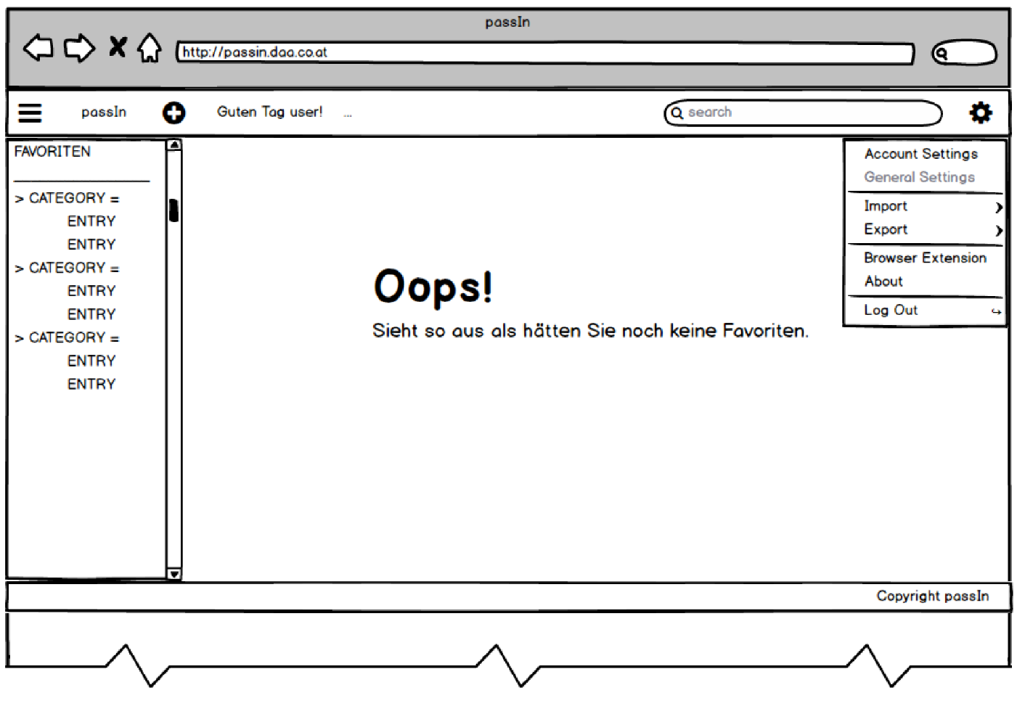
Main Page
Body
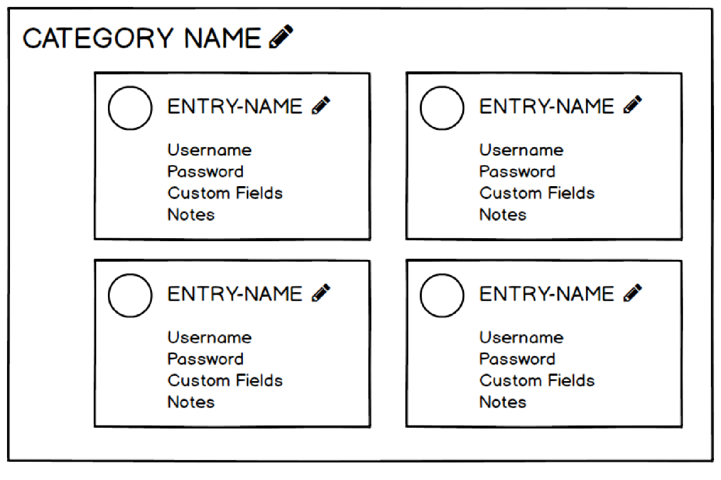

Account Settings
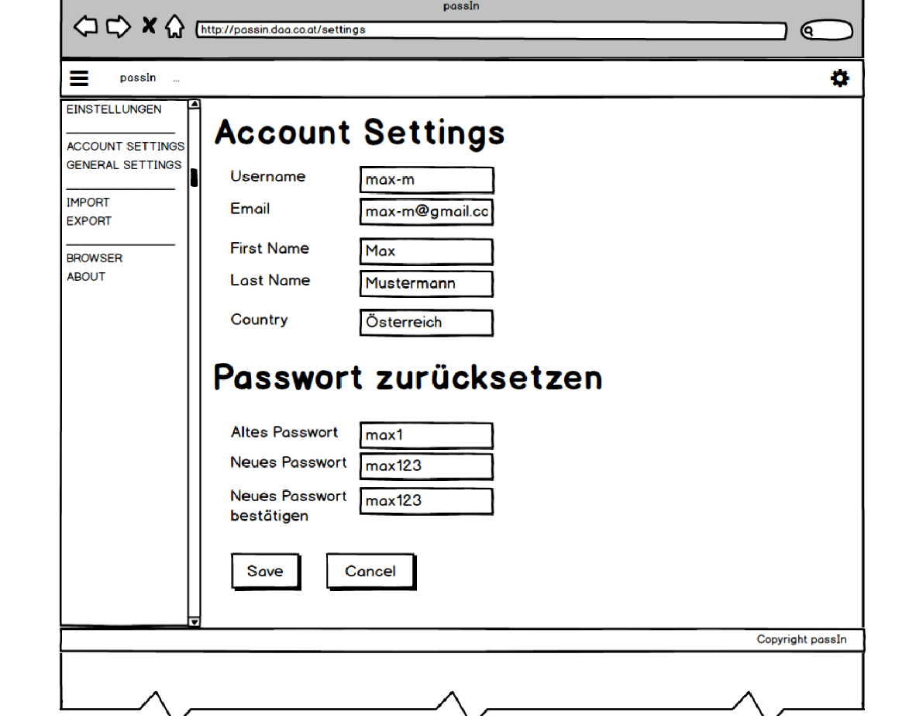

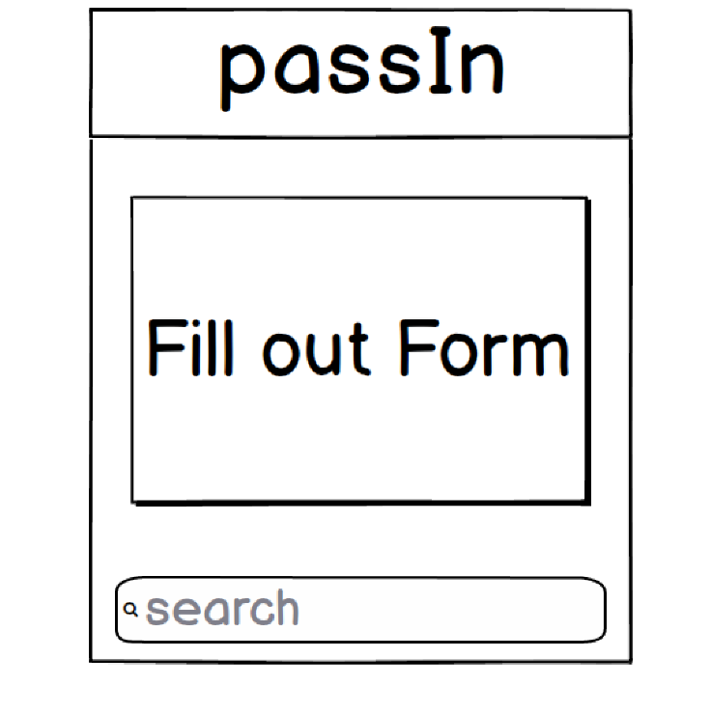
Browser Extension
Edit Category
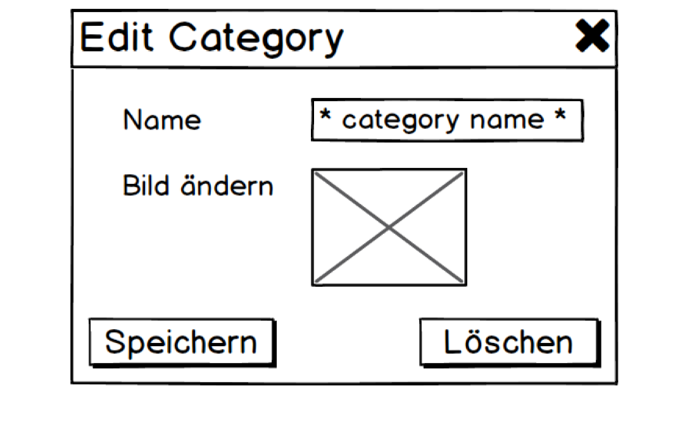

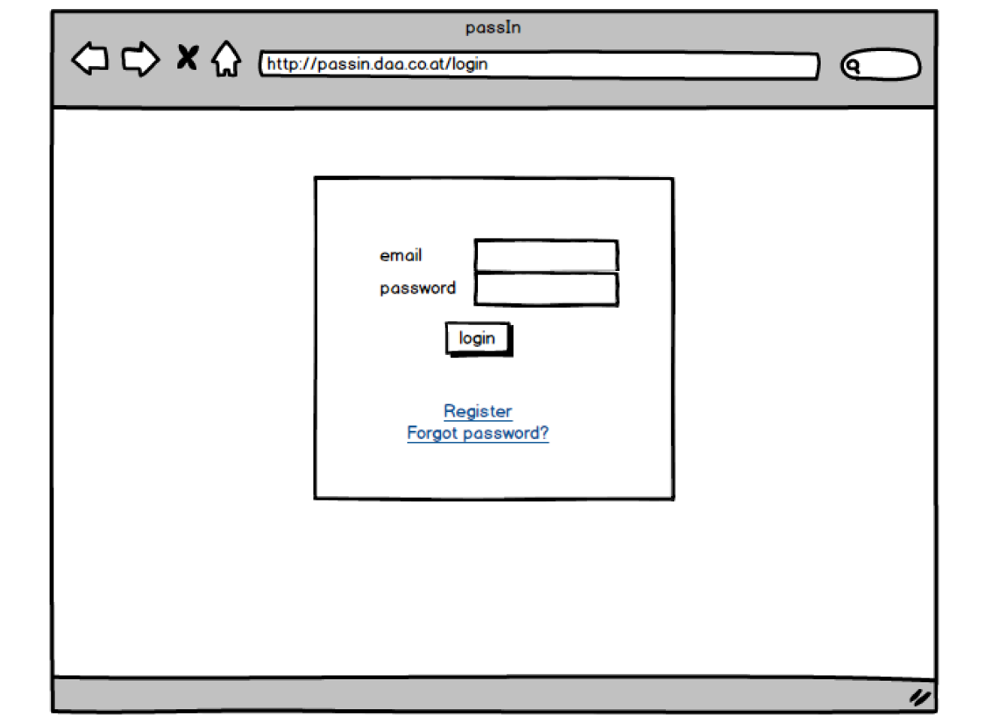
Login - Site

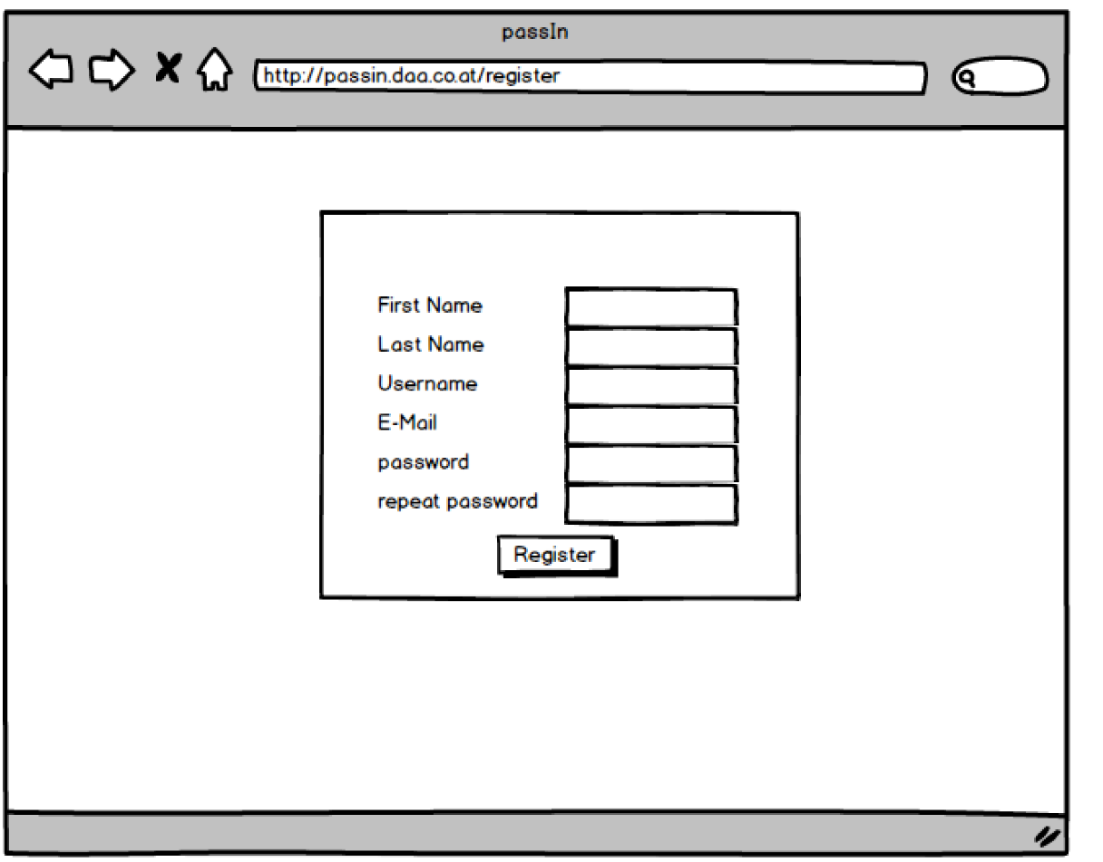
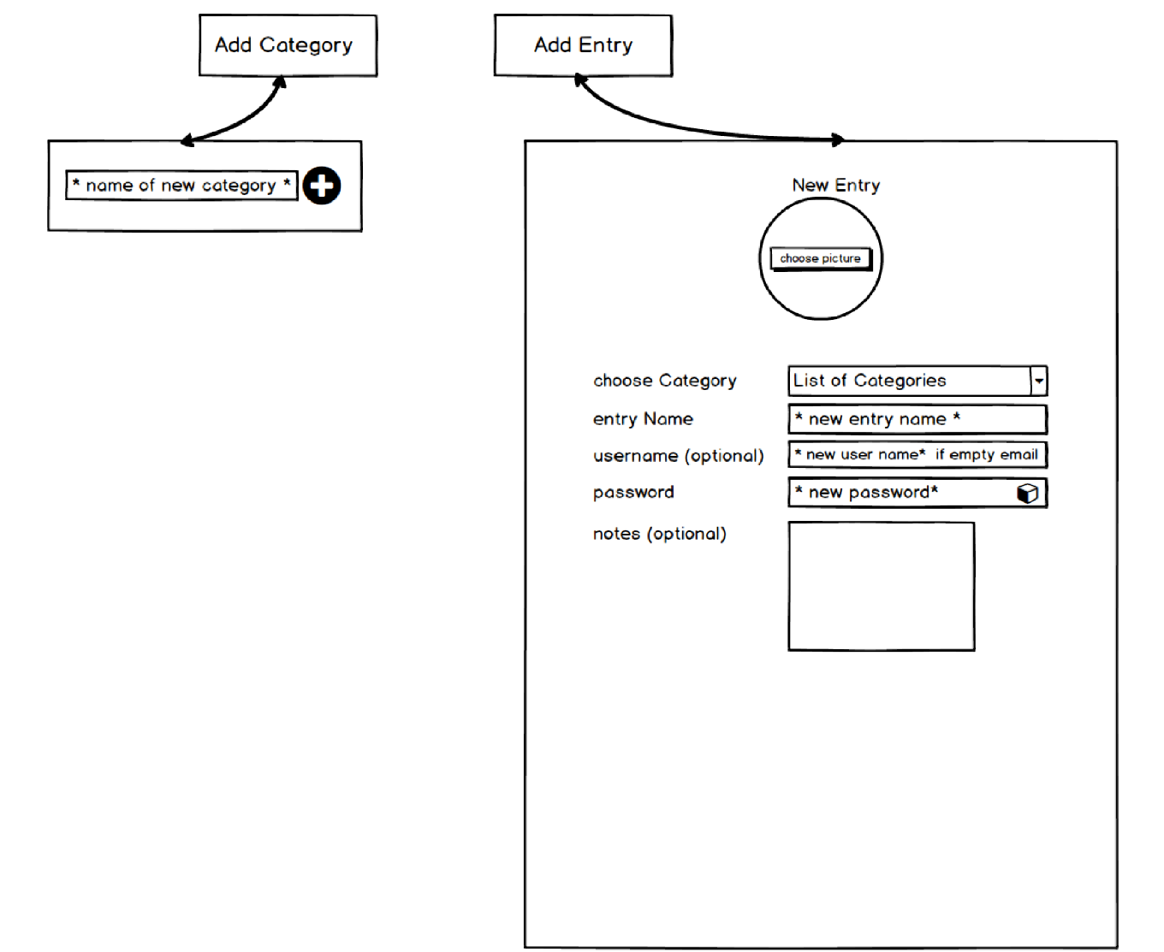
Register - Site

Add Modal

- API – Design

Database:
User:
email, username, password, firstName, lastName, settings, dateJoined, country
PassCategory:
name, color, childs
PassEntry:
name, color, link, image, username, password, notes, custom fields
settings:
colorschema, PassCategory order

passCategoryRoutes
/category
get/ -> get all categories
post/ -> create category
delete/ -> delete category
put/ -> update category

passEntryRoutes
/passentry
get/ -> get entry information
post/ -> create new entry
delete/ -> delete passEntry
put/ -> update passEntry

settingRoutes
/settings
get/ -> get settings
put/ -> update settings

userRoutes
/user
get/ -> get user info without password
post/ -> create user
delete/ -> delete user
put/ -> update user

- Klassendiagramm

