AI-Powered Plant Disease Recognition Assistant
with Explainable Visual Analysis
CDS6334 Visual Information Processing Final Project
Project Track: Intelligent Visual Application Track
Trimester 2610 | Group 08
Group member | Student ID | Main responsibility
Saw Qi Rui | 241UC240KV | Transfer-learning model development
Jayy Wong Jun Vun | 241UC24178 | Grad-CAM explainability and Streamlit application
Lee Yi Yang | 242UC2451A | Dataset preparation and class selection
Goh Pei Chung | 241UC240J2 | Simple CNN baseline and evaluation

Abstract
This project develops a plant disease recognition assistant that classifies selected tomato, potato and corn leaf disease images and provides visual explanation using Grad-CAM. The dataset used is the Kaggle New Plant Diseases Dataset (Augmented), which contains approximately 87,000 RGB leaf images across 38 classes. To keep the coursework scope manageable, eight selected disease classes were used. The provided training folder was used as the training set, while the provided validation folder was split into validation and final labelled test subsets using stratified sampling. A Simple CNN was implemented as the baseline model, and MobileNetV2 was implemented as the main transfer-learning model. A fine-tuned MobileNetV2 model was also evaluated after the first transfer-learning model was completed. The models were compared using accuracy, macro precision, macro recall, macro F1-score, weighted F1-score, confusion matrix, model size and average inference time per image. Based on the saved evaluation outputs, the fine-tuned MobileNetV2 achieved the best result with 96.49% accuracy and 96.44% macro F1-score. The final Streamlit application allows users to upload a leaf image, view the predicted disease class, confidence score, top-three predictions, inference time and Grad-CAM overlay. The system is intended as an educational prototype and preliminary screening tool, not as a replacement for expert agricultural diagnosis.

Table of Contents
- 1. Introduction
- 2. Problem Statement and Objectives
- 3. Related Work
- 4. Project Folder and Implementation Overview
- 5. Dataset Preparation
- 6. Model Development
- 7. Experimental Setup
- 8. Quantitative Results
- 9. Grad-CAM Qualitative Analysis
- 10. Streamlit Application
- 11. Notebook and Reproducibility
- 12. Limitations
- 13. Task Distribution
- 14. Conclusion and Future Work
- 15. References
- 16. Main Project Files Produced
- 17. Academic Integrity Note

1. Introduction
Plant diseases can reduce crop quality and yield when symptoms are not recognised early. Many symptoms appear visually on leaves, such as spots, blight marks, colour changes and texture damage. This makes plant disease recognition a relevant application of visual information processing.
Manual inspection is useful, but it depends on the observer's experience. Some diseases have similar visual symptoms, so a non-expert may find it difficult to identify them confidently. A computer vision model can assist by learning disease-related visual patterns from labelled images and producing a preliminary prediction.
This project is built as a complete student-level visual application rather than only a model training experiment. It includes dataset preparation, baseline modelling, transfer learning, evaluation, Grad-CAM visual explanation and a Streamlit user interface.

2. Problem Statement and Objectives
A prediction label alone is not enough for a visual application. Users should also know whether the model is looking at relevant leaf symptom regions or unrelated background. This project therefore combines classification performance with explainable visual analysis.
- Prepare and preprocess selected tomato, potato and corn plant disease classes.
- Develop a Simple CNN baseline model.
- Develop a MobileNetV2 transfer-learning model.
- Evaluate models using quantitative metrics and confusion matrices.
- Generate Grad-CAM heatmaps for qualitative visual analysis.
- Build a Streamlit prototype for image upload, prediction display and Grad-CAM overlay.

3. Related Work
CNN-based models are commonly used for image classification because convolution layers can learn spatial patterns from images. In plant disease detection, these patterns may include lesions, leaf spots, damaged texture and colour differences. Mohanty et al. demonstrated that deep learning can classify plant diseases from leaf images, showing the value of image-based diagnosis in agriculture.
Transfer learning is useful for student projects because pretrained models reduce the need to train a deep architecture from the beginning. MobileNetV2 is a lightweight CNN architecture designed for efficient image classification, making it suitable for a Streamlit prototype and coursework demonstration.
EfficientNetB0 was considered as an optional extension, but the completed implementation focuses on the required Simple CNN and MobileNetV2 models, plus fine-tuned MobileNetV2 after the core models were working. Grad-CAM is used for qualitative visual explanation, not as exact disease segmentation.

4. Project Folder and Implementation Overview
The project is organised into separate folders so that the dataset pipeline, model scripts, app, reports and results can be understood clearly.
Folder or file | Purpose
src/ | Dataset audit, split preparation, model training, evaluation and Grad-CAM scripts.
app/streamlit-app.py | Final Streamlit application for upload, prediction and Grad-CAM display.
app/sample_images/ | Packaged images for deployed app testing without the full dataset.
outputs/models/ | Saved trained Keras models and class names.
outputs/reports/ | Evaluation reports, split summaries and model comparison tables.
outputs/figures/ | Training curves, confusion matrices, class distribution and Grad-CAM examples.
notebooks/CDS6334_Plant_Disease_Recognition_Project.ipynb | One clean notebook that presents the full workflow for lecturer review.
README.md | Installation and run instructions.

The scripts are kept as Python files because they are easier to run repeatedly and connect to Streamlit. The notebook is used as a review version of the workflow, not as a replacement for the source scripts.

5. Dataset Preparation
The dataset used is the Kaggle New Plant Diseases Dataset (Augmented). It is already augmented and organised into training and validation folders. The project uses selected classes only, not all 38 classes.
The selected training folder was used directly as the training set. The selected validation folder was split into validation and final test subsets using stratified sampling. The small Kaggle prediction/test folder was not used as the official evaluation test set.
Class | Train | Validation | Test
Corn (maize) - Cercospora leaf spot / Gray leaf spot | 1,642 | 205 | 205
Corn (maize) - Common rust | 1,907 | 238 | 239
Corn (maize) - Northern Leaf Blight | 1,908 | 238 | 239
Potato - Early blight | 1,939 | 243 | 242
Potato - Late blight | 1,939 | 243 | 242
Tomato - Bacterial spot | 1,702 | 212 | 213
Tomato - Early blight | 1,920 | 240 | 240
Tomato - Late blight | 1,851 | 232 | 231
Total | 14,808 | 1,851 | 1,851

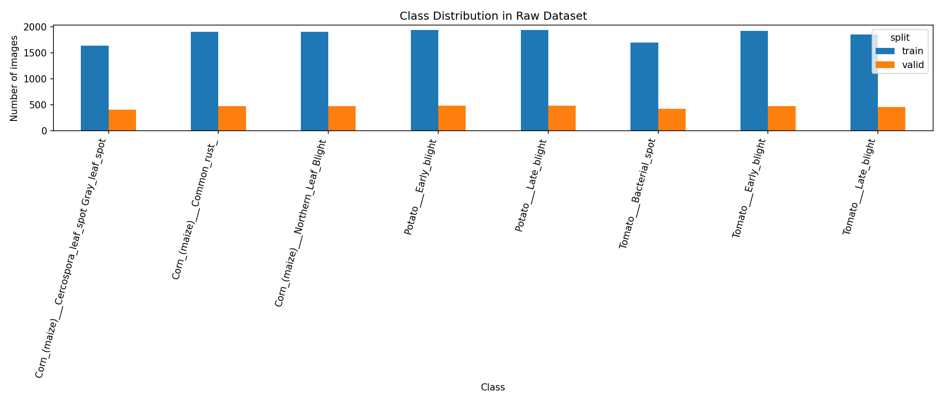
Figure 1. Class distribution for the selected plant disease subset.

6. Model Development

6.1 Simple CNN Baseline
The Simple CNN was developed as the baseline model. It contains convolution layers, ReLU activations, max pooling, global average pooling, dropout and a dense softmax output layer. The purpose of this model is to provide a simple comparison point before using transfer learning.

6.2 MobileNetV2 Transfer Learning
MobileNetV2 was used as the main transfer-learning model. The pretrained ImageNet feature extractor was used with a new classification head for the eight selected plant disease classes. This allows the model to reuse general visual features learned from a large image dataset.

6.3 Fine-Tuned MobileNetV2
After the first MobileNetV2 model was trained, fine-tuning was applied to improve adaptation to the plant disease dataset. This model achieved the best final test performance in the saved evaluation outputs.

6.4 EfficientNetB0
EfficientNetB0 was considered as an optional extension, but no completed EfficientNetB0 result is included in the current project outputs. Therefore, it is reported only as future work and no EfficientNetB0 result is invented.

7. Experimental Setup
- Image size: 224 x 224 pixels.
- Training set: selected images from the Kaggle training folder.
- Validation and final test sets: stratified split from the Kaggle validation folder.
- Training augmentation: limited online augmentation only, because the dataset is already augmented.
- Validation and test augmentation: none.
- Frameworks: TensorFlow/Keras, Pillow/OpenCV, scikit-learn, matplotlib and Streamlit.
- Evaluation metrics: accuracy, macro precision, macro recall, macro F1-score, weighted F1-score, confusion matrix, model size and average inference time per image.
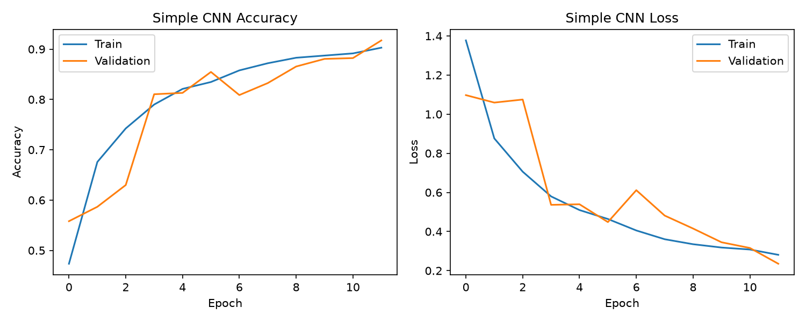
Figure 2. Simple CNN training accuracy and loss curves.
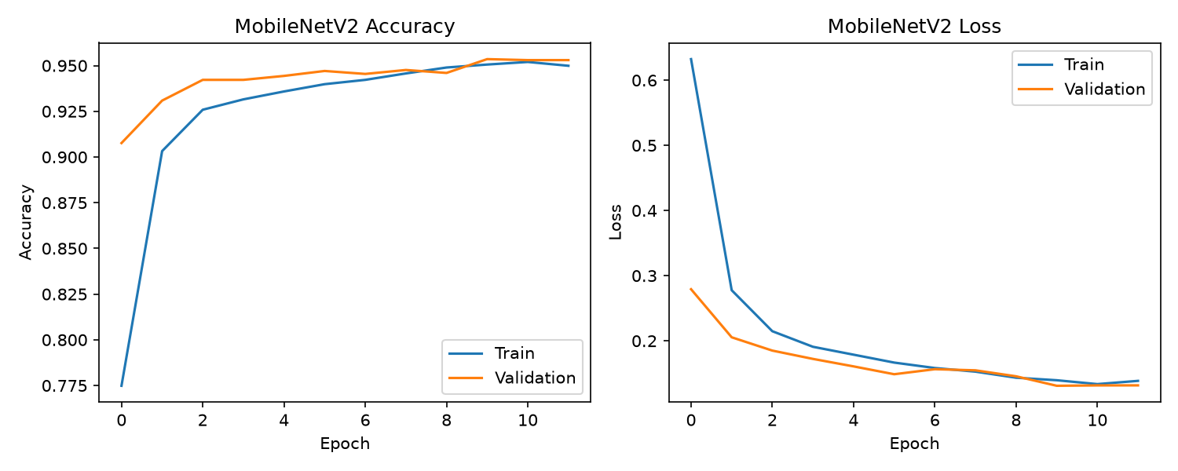
Figure 3. MobileNetV2 training accuracy and loss curves.
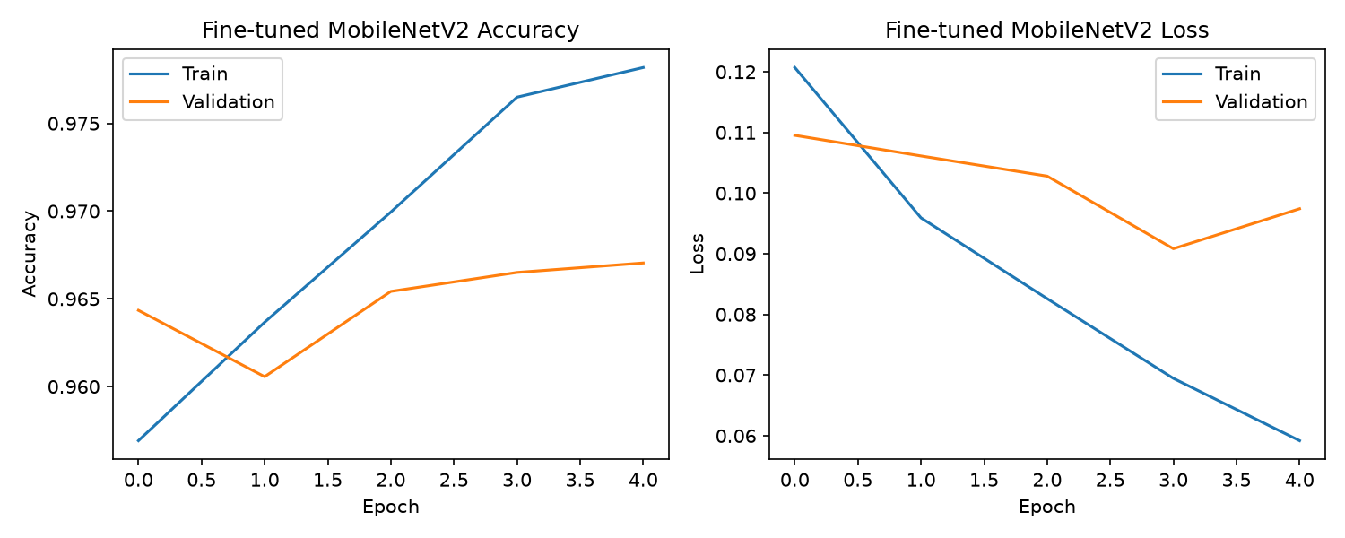
Figure 4. Fine-tuned MobileNetV2 training accuracy and loss curves.

8. Quantitative Results
All values in this section are loaded from saved project output files. The main comparison table is stored in outputs/reports/model_comparison.csv.
Model | Accuracy | Macro precision | Macro recall | Macro F1 | Weighted F1 | Size | Avg inference
Simple CNN | 91.84% | 92.62% | 91.54% | 91.66% | 91.75% | 1.33 MB | 0.0012 s
MobileNetV2 | 95.30% | 95.26% | 95.27% | 95.22% | 95.26% | 9.31 MB | 0.0021 s
MobileNetV2 fine-tuned | 96.49% | 96.62% | 96.48% | 96.44% | 96.47% | 20.84 MB | 0.0021 s

The Simple CNN achieved 91.84% accuracy and 91.66% macro F1-score. MobileNetV2 improved the result to 95.30% accuracy and 95.22% macro F1-score. The fine-tuned MobileNetV2 achieved the strongest result with 96.49% accuracy and 96.44% macro F1-score.
Although the Simple CNN is smaller and slightly faster, the fine-tuned MobileNetV2 is selected as the main model because it gives the best final test performance while still being practical for the Streamlit application.
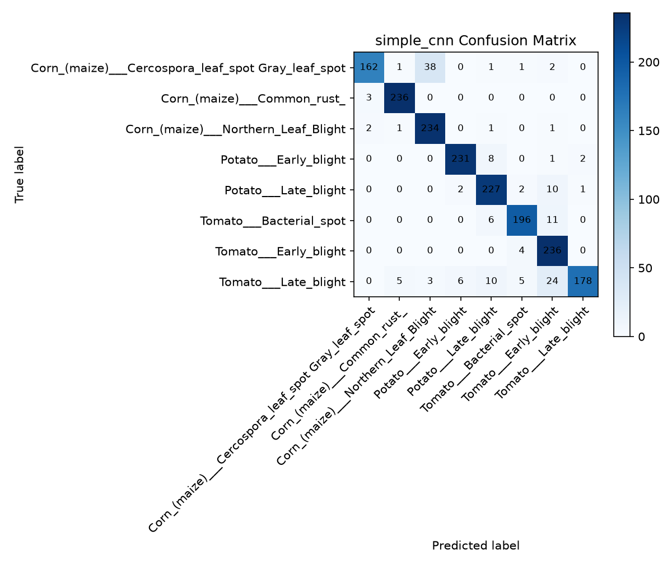
Figure 5. Confusion matrix for the Simple CNN baseline.
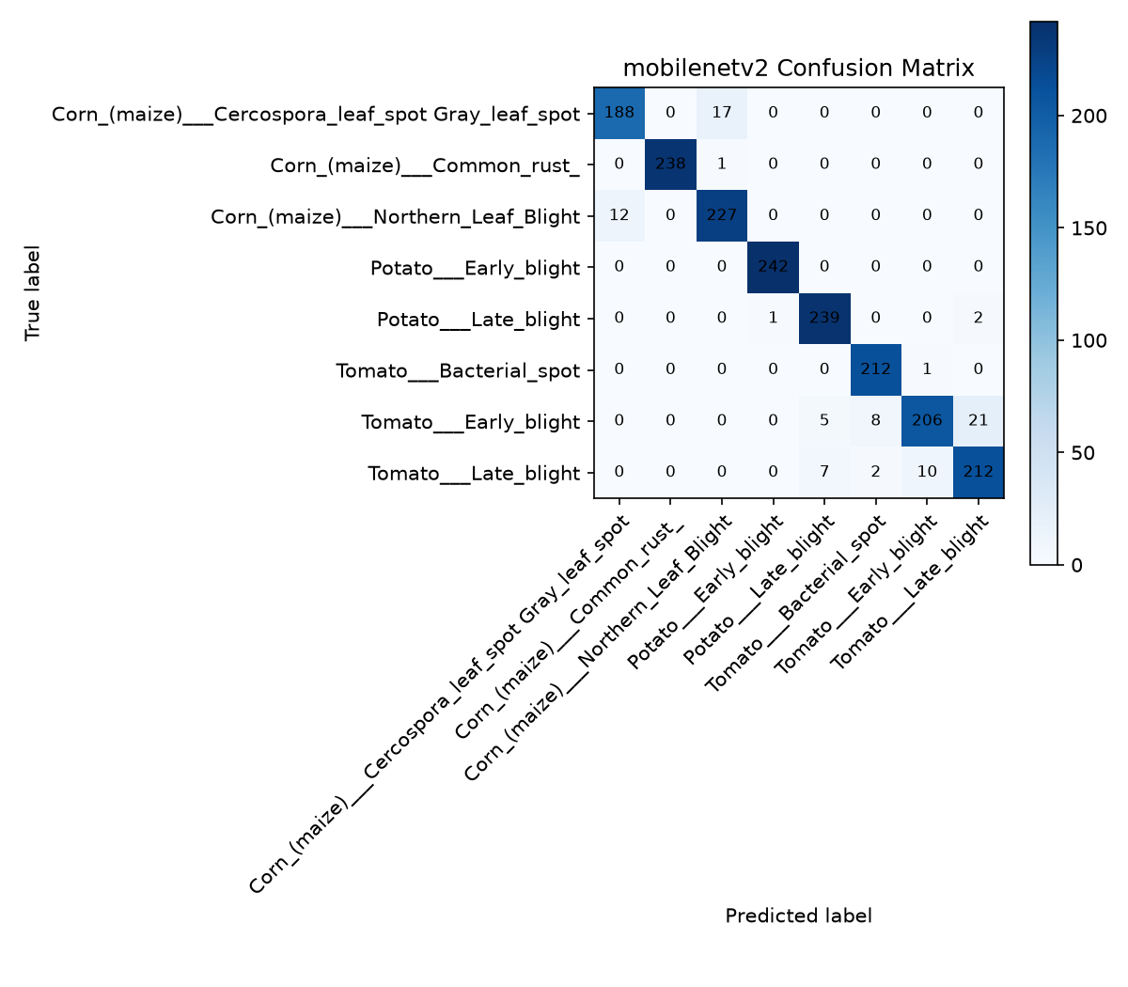
Figure 6. Confusion matrix for MobileNetV2.
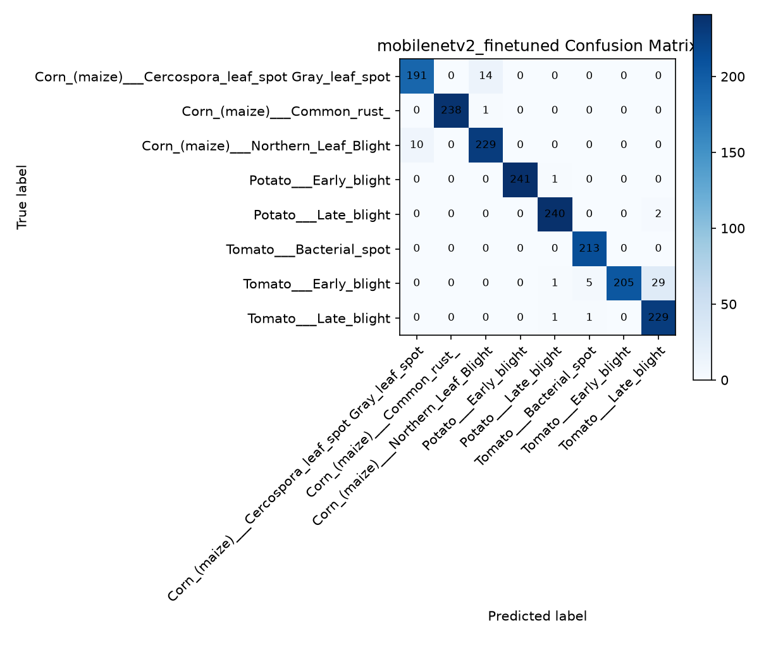
Figure 7. Confusion matrix for fine-tuned MobileNetV2.

9. Grad-CAM Qualitative Analysis
Grad-CAM was used to inspect which image regions influenced the model prediction. Correct and incorrect examples were saved where possible. The saved incorrect examples mainly show confusion between corn gray leaf spot and northern leaf blight.
A Grad-CAM heatmap is not the same as disease segmentation. If the heatmap activates partly outside the leaf, it means the model may be influenced by background, leaf edge shape or image context. This is an important limitation to discuss honestly.
Example type | True class | Predicted class | Confidence
Correct 1 | Corn (maize) - Cercospora leaf spot / Gray leaf spot | Corn (maize) - Cercospora leaf spot / Gray leaf spot | 99.96%
Incorrect 1 | Corn (maize) - Cercospora leaf spot / Gray leaf spot | Corn (maize) - Northern Leaf Blight | 86.87%

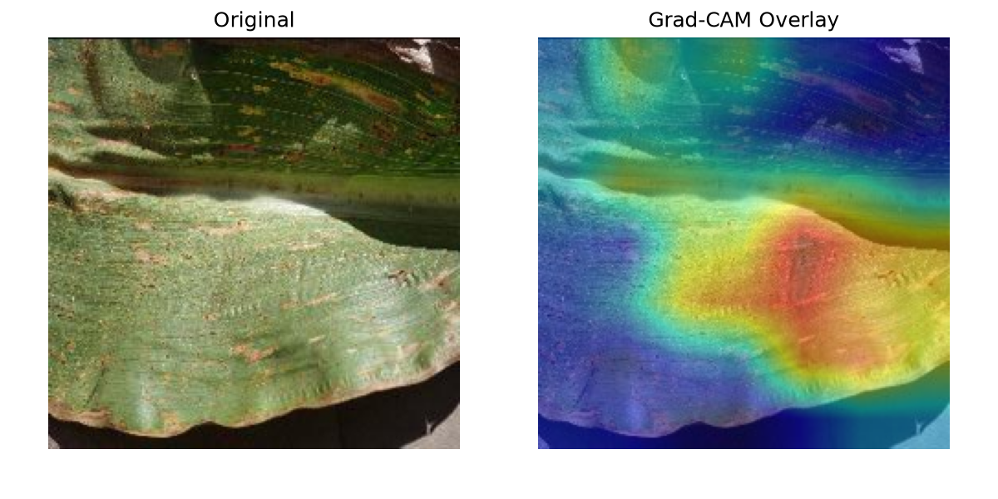
Figure 8. Correct prediction Grad-CAM example.
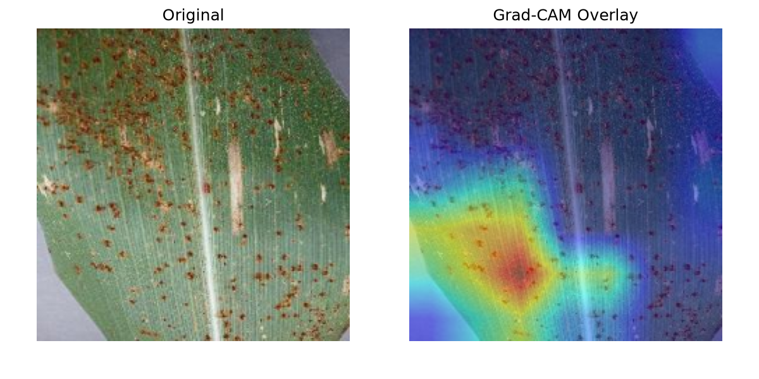
Figure 9. Incorrect prediction Grad-CAM example.
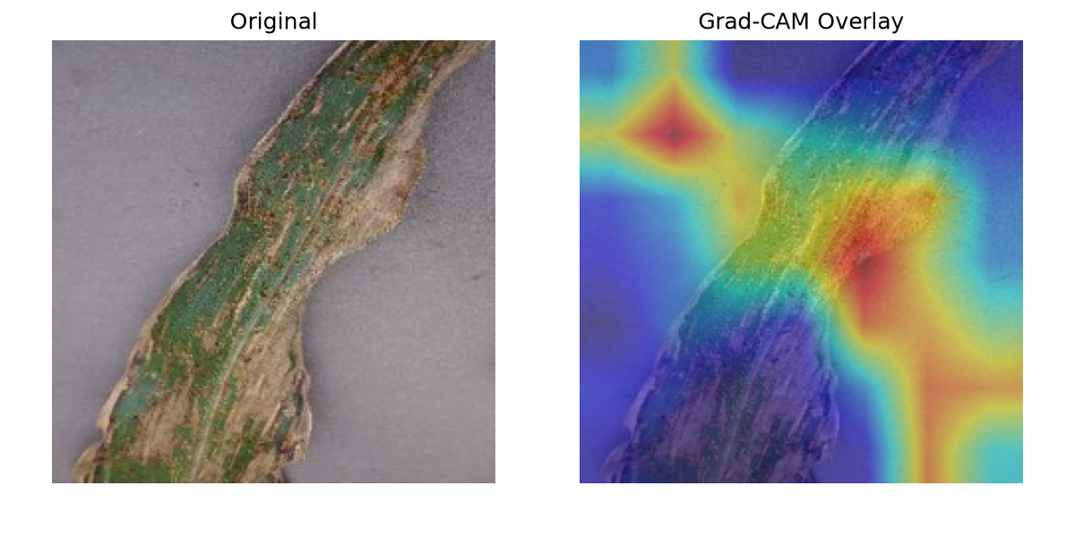
Figure 10. Additional incorrect Grad-CAM example showing class confusion.

10. Streamlit Application
A Streamlit application was developed as the final visual application demo. The application file is app/streamlit-app.py. This part is important because the project track is the Intelligent Visual Application Track, so the system should be usable beyond command-line model training.
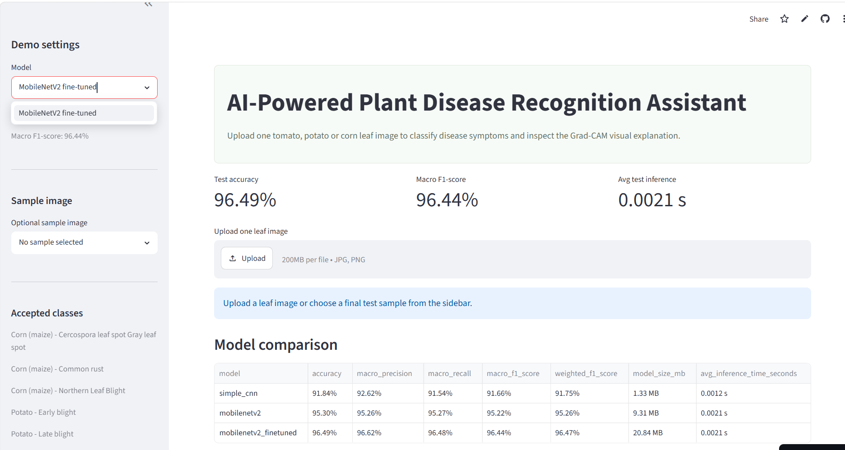
Figure 11. Streamlit application interface showing model selection, final test metrics, image upload and model comparison.

10.1 Application Features
- Upload one tomato, potato or corn leaf image.
- Display the uploaded or selected sample image.
- Choose between Simple CNN, MobileNetV2 and fine-tuned MobileNetV2.
- Show predicted disease class, crop name, condition name and confidence score.
- Show the top-three predicted classes using a chart and table.
- Show inference time for the uploaded image.
- Show Grad-CAM overlay beside the original image.
- Show accepted classes and final test model metrics in the sidebar.
- Include packaged sample images so the deployed app can be tested without downloading the full dataset.
- Display the educational disclaimer required by the project scope.

10.2 Application Workflow
- The app loads class_names.json and the selected trained model.
- The user uploads an image or selects a packaged sample image.
- The image is resized to 224 x 224 pixels.
- The model predicts probabilities for the eight selected classes.
- The app displays the top prediction, confidence score and top-three probabilities.
- Grad-CAM is generated for the predicted class and displayed as an overlay.

10.3 Deployment and Testing
The app is designed to run locally with the command streamlit run app/streamlit-app.py. It can also be deployed to Streamlit Community Cloud because the repository contains the app file, requirements.txt, runtime.txt, class names, trained model files and packaged sample images.
The deployed prototype is useful for demonstration because users can open the web link, choose a sample image or upload a leaf image, and view the prediction and Grad-CAM explanation without cloning the repository. Figure 11 shows the main interface of the deployed Streamlit app.
Disclaimer shown in the app: This prototype is for educational and preliminary screening purposes only and does not replace expert agricultural diagnosis.

11. Notebook and Reproducibility
A single clean notebook was prepared for lecturer review: notebooks/CDS6334_Plant_Disease_Recognition_Project.ipynb. The notebook presents the full workflow, displays saved outputs and avoids duplicating too much script code.
The formal implementation remains in Python scripts under src/. This is more reproducible for training, evaluation and app deployment. The notebook acts as a readable walkthrough for presentation and review.
python src/extract_selected_from_zip.py
python src/dataset_audit.py
python src/select_subset.py
python src/prepare_splits.py
python src/train_simple_cnn.py
python src/train_mobilenetv2.py
python src/fine_tune_mobilenetv2.py
python src/evaluate_models.py
python src/gradcam.py
streamlit run app/streamlit-app.py

12. Limitations
- The dataset images are controlled leaf images and may not represent real field conditions.
- Real images may include complex backgrounds, shadows, multiple leaves and poor lighting.
- Only eight selected disease classes are used, so the system does not cover all plant diseases.
- The current selected subset does not include healthy leaf classes.
- Grad-CAM is a qualitative explanation method, not proof of correct diagnosis.
- The prototype should not replace expert agricultural diagnosis.

13. Task Distribution
Member | Role | Technical contribution
Lee Yi Yang | Dataset lead | Dataset download workflow, selected classes, audit and split checking.
Goh Pei Chung | Baseline and evaluation lead | Simple CNN baseline, evaluation metrics, classification reports and comparison table.
Saw Qi Rui | Transfer-learning lead | MobileNetV2 training, fine-tuning workflow and transfer-learning explanation.
Jayy Wong Jun Vun | Explainability and application lead | Grad-CAM examples, qualitative analysis and Streamlit app workflow.

14. Conclusion and Future Work
This project completed a full visual information processing application pipeline for selected plant disease recognition. It includes dataset preparation, Simple CNN baseline training, MobileNetV2 transfer learning, fine-tuning, quantitative evaluation, Grad-CAM explanation and a Streamlit application.
The fine-tuned MobileNetV2 achieved the best final result and is suitable as the main model for the prototype. Grad-CAM improves interpretability by showing the regions that influence model predictions, while the app demonstrates how the model can be used in a simple visual interface.
Future work can include adding healthy leaf classes, testing with real field images, improving background robustness, adding EfficientNetB0 as another comparison model and collecting user feedback on the Streamlit interface.

15. References
[1] S. P. Mohanty, D. P. Hughes, and M. Salathe, "Using deep learning for image-based plant disease detection," Frontiers in Plant Science, vol. 7, 2016.
[2] M. Sandler, A. Howard, M. Zhu, A. Zhmoginov, and L.-C. Chen, "MobileNetV2: Inverted residuals and linear bottlenecks," in Proceedings of the IEEE Conference on Computer Vision and Pattern Recognition, 2018, pp. 4510-4520.
[3] M. Tan and Q. V. Le, "EfficientNet: Rethinking model scaling for convolutional neural networks," in Proceedings of the International Conference on Machine Learning, 2019, pp. 6105-6114.
[4] R. R. Selvaraju, M. Cogswell, A. Das, R. Vedantam, D. Parikh, and D. Batra, "Grad-CAM: Visual explanations from deep networks via gradient-based localization," in Proceedings of the IEEE International Conference on Computer Vision, 2017, pp. 618-626.
[5] Kaggle, "New Plant Diseases Dataset (Augmented)," Kaggle Dataset. Available: https://www.kaggle.com/datasets/vipoooool/new-plant-diseases-dataset.
[6] TensorFlow, "TensorFlow: An end-to-end machine learning platform." Available: https://www.tensorflow.org/.

16. Main Project Files Produced
File | Purpose
app/streamlit-app.py | Streamlit visual application demo.
src/train_simple_cnn.py | Simple CNN baseline training script.
src/train_mobilenetv2.py | MobileNetV2 transfer-learning training script.
src/fine_tune_mobilenetv2.py | Fine-tuning script for MobileNetV2.
src/evaluate_models.py | Final test evaluation script.
src/gradcam.py | Grad-CAM generation script.
outputs/models/*.keras | Saved trained Keras models.
outputs/reports/model_comparison.csv | Main model comparison metrics.
outputs/figures/ | Training curves, confusion matrices and Grad-CAM figures.
notebooks/CDS6334_Plant_Disease_Recognition_Project.ipynb | Single clean notebook for review.

17. Academic Integrity Note
The project uses public datasets, pretrained ImageNet weights and open-source Python libraries. The reported numbers and figures are generated from the saved project scripts and output files. Any writing or coding assistance was used only to support organisation, debugging and drafting; the final project implementation, outputs and discussion were checked against the actual project files.

