INTERNSHIP WORK DOCUMENTATION
Machine Learning and Computer Vision

Internship at IIT Bhilai
Prepared by
Mohit Choudhary

Primary Areas | lunar image annotation, FPGA-based object detection, SystemVerilog analysis, QGIS annotation, python fundamentals
FPGA Work | Study of an existing CNN/object-detection accelerator architecture and its 18-module processing flow
GIS Work | Moon South Pole annotation using QuickMap and QGIS with geographic coordinate annotations and map-layout elements
Purpose | Documentation of internship work and technical learning.

1. Internship Overview
During the internship at IIT Bhilai, the work was carried out in the area of Machine Learning (ML), Computer Vision (CV), FPGA-based acceleration, and geospatial image annotation. The internship progressed from foundational Python learning to practical annotation work on lunar images and then to analysis of an existing FPGA object-detection implementation. In the later part of the internship, additional work was performed in QGIS to create precise lunar map annotations with coordinate labels and standard cartographic elements.
The work was primarily analytical and implementation-oriented: understanding an already functioning hardware design, tracing the data flow through its SystemVerilog modules, documenting the architecture, investigating Vivado project-simulation limitations, examining registers and buses, and producing a generalized architecture diagram. The geospatial work involved both QuickMap and QGIS workflows and emphasized reproducible annotation procedures.

2. Objectives of the Internship
- Build a basic working foundation in Python for subsequent ML/CV-related tasks.
- Understand practical lunar image annotation workflows using open-source tools.
- Study the architecture and processing flow of an FPGA-based object-detection/CNN accelerator.
- Trace the functions of the 18 principal SystemVerilog modules from top-level integration through output frame writing.
- Analyze register and bus usage at module level and understand the relationship between data movement and processing.
- Investigate Vivado simulation/build problems caused by unavailable project artifacts such as Block Design (.bd) and Design Checkpoint (.dcp) files.
- Learn QGIS-based lunar image annotation with geographic coordinates, legends, scale bar, north arrow, map overview, and export workflows.

3. Work Performed – Summary
Work Area | Major Activities | Outcome / Learning
Python | Studied Python from scratch for approximately one week using W3Schools; practiced basic language concepts. | Established a basic programming foundation for ML/CV work.
QuickMap | Annotated the Moon South Pole on 15 TIFF files using an open-source QuickMap workflow. | Hands-on experience with lunar image interpretation and annotation.
FPGA/CNN | Studied an already-working object-detection project, its 18-module SystemVerilog pipeline, and its data/control structure. | Understood the accelerator architecture, module sequence, and processing stages.
Vivado Troubleshooting | Attempted simulation/build work and investigated missing .bd and .dcp project artifacts. | Understood project-dependency issues and documented the technical limitation.
Register/Bus Analysis | Reviewed register and bus usage across all 18 listed modules. | Developed understanding of internal state, data paths, AXI/DDR interfaces, and pipeline registers.
QGIS | Performed precise lunar annotation with coordinates and cartographic elements. | Produced research-style annotated map layouts and learned a repeatable QGIS workflow.

4. Python Fundamentals
At the beginning of the internship, Python was studied from the basics for approximately one week using the W3Schools website. The objective was not to build a large application but to establish the programming foundation needed for later ML/CV activities and for understanding Python-based workflows used in technical projects.

Topics Practiced
- Basic Python syntax and program structure
- Variables and data types
- Operators and expressions, Conditional statements
- Loops, Functions
- Lists, tuples, sets, and dictionaries
- Basic input/output and simple data handling
- General programming problem-solving using Python
- NumPy, Pandas, SciPy, Django
- Python JSON, RegEX, Math
This initial phase provided the programming background required to follow later technical work involving computer vision, image annotation, and hardware/software integration.

5. Moon South Pole Annotation Using QuickMap
After the initial Python learning phase, practical work was carried out on lunar data. The Moon South Pole was annotated for 15 different TIFF files using the open-source QuickMap platform. The activity involved working with lunar surface imagery and identifying/annotating relevant regions in the provided datasets.

Main Activities
- Worked with 15 TIFF image files covering the Moon South Pole region.
- Used QuickMap as the open-source annotation environment.
- Inspected lunar surface imagery and performed image-based annotation.
- Handled repeated annotation tasks across multiple datasets to build consistency and familiarity with the lunar region.
This phase provided direct experience with lunar image datasets and helped bridge the gap between theoretical computer-vision concepts and practical image annotation work.

6. FPGA-Based Object Detection Project
The next major internship assignment involved an existing FPGA-based object-detection project. The implementation was already functional when the work began, and the main responsibility was to understand its architecture, follow the signal/data flow through the design, and document the processing stages. The design was studied at SystemVerilog module level, with the architecture beginning at the design wrapper and progressing through image/data preparation, CNN computation, post-processing, and final frame writing.

6.1 Overall 18-Module Processing Flow
- design_1_wrapper.sv
- pixel2half.sv
- ddr_manager.sv
- ddr_if.sv
- neuron_machine.sv
- networkunit.sv
- recep_shiter.sv
- receptor.sv
- synapse_unit.sv
- mul_half2ints2316.v
- adder_tree.sv
- dendrite_unit.sv
- du_tip.sv
- soma_unit.sv
- my_half_adder.sv
- bbox_n_softmax.sv
- nms.sv
- frame_writer.sv

6.2 Generalized Architecture and Functional Categorization
A generalized block diagram was prepared to organize the 18 modules according to their functional roles. The categorization groups the design into memory interface/management, control and configuration, CNN computation pipeline, and output post-processing. The diagram also shows the high-level data flow from DDR memory through the neural processing stages and then to post-processing and frame output.
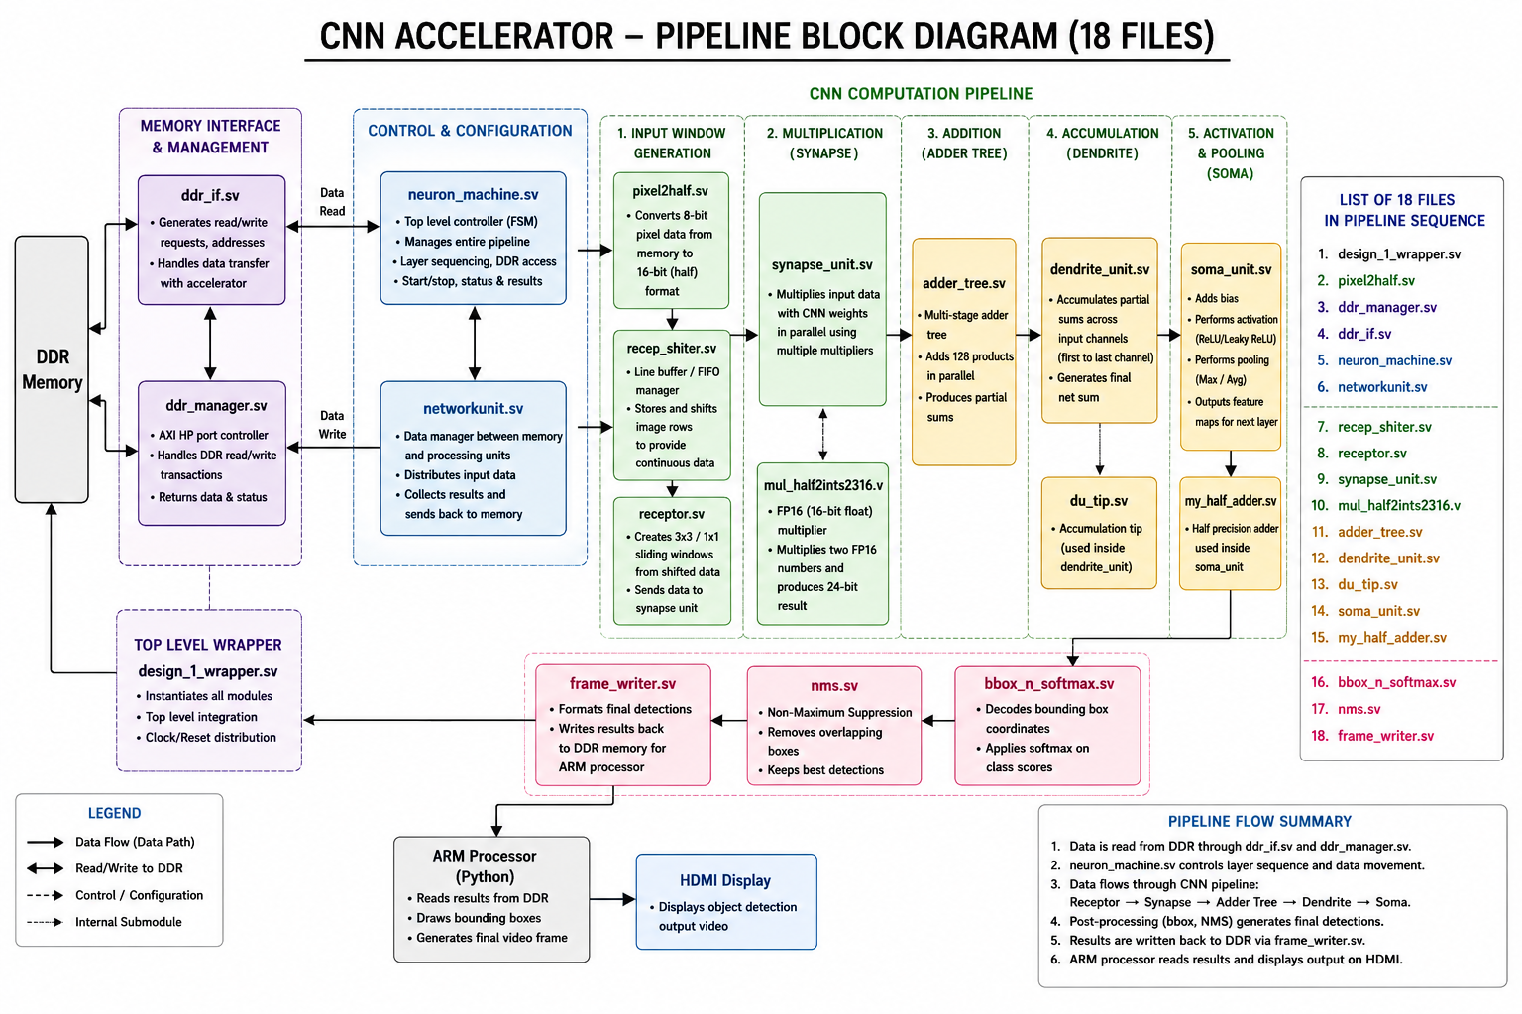Figure 1. Generalized block diagram of the 18-module FPGA CNN/object-detection pipeline prepared during the internship.

6.3 Functional Description of the Pipeline
Memory Interface & Management: ddr_if.sv generates/handles DDR read/write requests and address/data transfer; ddr_manager.sv manages AXI high-performance port control, DDR transactions, and returns data/status.
Top-Level & Control: design_1_wrapper.sv provides top-level integration and clock/reset distribution. neuron_machine.sv acts as the main control/FSM block, managing pipeline sequencing, DDR access, start/stop operation, status, and results. networkunit.sv manages data movement between memory and processing units and distributes input data.
Input Window Generation: pixel2half.sv converts incoming 8-bit pixel data to FP16/half format. recep_shiter.sv provides line-buffer/FIFO-based storage and shifting for continuous image-row data. receptor.sv creates the 3x3/1x1 sliding windows used by the convolution computation.
Multiplication: synapse_unit.sv performs parallel input/weight multiplication, with mul_half2ints2316.v providing FP16 multiplication and a 24-bit product result.
Addition & Accumulation: adder_tree.sv combines parallel products into partial sums. dendrite_unit.sv accumulates partial sums across input channels, while du_tip.sv provides the accumulation tip used inside dendrite_unit.
Activation & Pooling: soma_unit.sv adds bias, performs activation (e.g., ReLU/Leaky ReLU), and supports pooling. my_half_adder.sv provides the half-precision addition used in soma_unit.
Post-Processing: bbox_n_softmax.sv decodes bounding-box coordinates and applies softmax to class scores. nms.sv applies Non-Maximum Suppression to remove overlapping boxes and retain the strongest detections. frame_writer.sv formats the final detections and writes the results back to DDR for the processor side.

6.4 Module-by-Module Functional Table
# | Module | Observed / Documented Role
1 | design_1_wrapper.sv | Top-level integration of the project modules; clock/reset and system interconnection.
2 | pixel2half.sv | Converts 8-bit pixel data into FP16/half-precision representation for processing.
3 | ddr_manager.sv | Controls DDR transactions through the AXI HP interface and manages data/status.
4 | ddr_if.sv | Implements/handles DDR read-write interface signals, addresses, and data transfer.
5 | neuron_machine.sv | Main control FSM; manages pipeline sequence, data movement, layer sequencing, and DDR access.
6 | networkunit.sv | Data manager between memory and processing units; distributes input and returns results.
7 | recep_shiter.sv | Line-buffer/FIFO-based shifting and storage of image rows for continuous data supply.
8 | receptor.sv | Generates sliding convolution windows (3x3/1x1) and forwards them to the synapse stage.
9 | synapse_unit.sv | Parallel multiplication of input values and CNN weights.
10 | mul_half2ints2316.v | FP16 multiplication; two half-precision operands produce a wider product result.
11 | adder_tree.sv | Multi-stage addition of parallel products to create partial sums.
12 | dendrite_unit.sv | Accumulates partial sums across input channels and generates the final net sum.
13 | du_tip.sv | Accumulation tip used inside dendrite_unit.
14 | soma_unit.sv | Bias addition, activation, and pooling/output feature-map operations.
15 | my_half_adder.sv | Half-precision addition used within soma processing.
16 | bbox_n_softmax.sv | Bounding-box decoding and class-score softmax post-processing.
17 | nms.sv | Non-Maximum Suppression to remove overlapping detections and retain best boxes.
18 | frame_writer.sv | Formats final detections and writes results back to DDR for processor-side use.

7. Vivado Simulation Challenges and Troubleshooting
To proceed from architectural understanding toward gate-level and implementation-level analysis, the FPGA project needed to be opened and processed in Xilinx Vivado. The project encountered critical missing-file errors that prevented successful restoration/execution of the expected design context.

7.1 Missing Block Design (.bd) Files
The project referenced a Block Design file that was not available in the recovered project contents. The Block Design is important because it defines the system-level integration of IPs and interconnects used by the design. In the Vivado project view, the referenced block design was shown as unavailable.
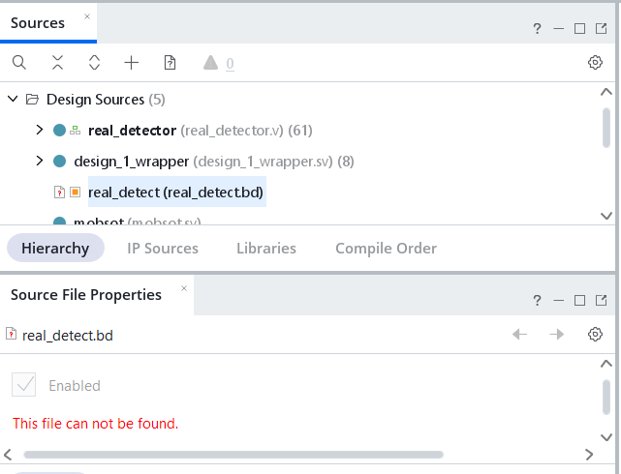
Figure 2. Vivado project view showing a missing Block Design file.

7.2 Missing Design Checkpoint (.dcp) Files
The project also referenced a Design Checkpoint (.dcp) file that was not available. A DCP stores a synthesized or implemented state that can be restored by Vivado. Without the required checkpoint, the exact previously compiled design state could not be recovered.
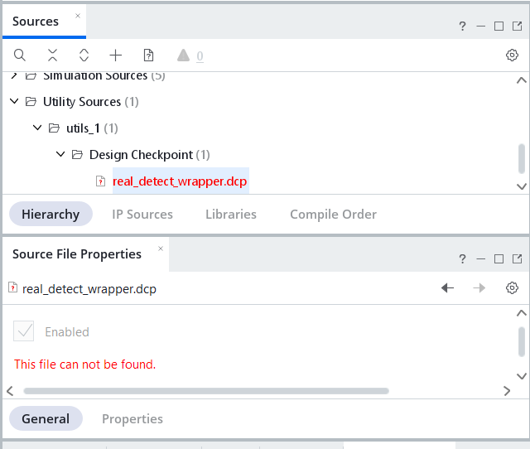
Figure 3. Vivado project view showing a missing Design Checkpoint (.dcp) file.

7.3 Result of Troubleshooting
Multiple attempts were made to retrieve or recover the missing project artifacts, but the required files remained inaccessible. Consequently, the work could not proceed to a complete reproduction of the original Vivado simulation/build flow. Instead, effort was redirected toward source-level analysis of the available SystemVerilog files, functional documentation of the 18-module pipeline, and analysis of registers, buses, and data rates.

8. Register and Bus-Level Analysis of SystemVerilog Modules
The available SystemVerilog source files were examined to determine where registers and buses are used and what role they serve in the architecture. The following table summarizes the module-level understanding developed during the internship.
Module | Registers Used? / Bus Used? | Purpose
design_1_wrapper.sv | Yes / Yes | Top-level interconnection, including AXI/DDR/HDMI-related buses.
pixel2half.sv | Yes / Yes | Stores pixel data and converts 8-bit input to FP16.
ddr_if.sv | Yes / Yes | AXI DDR interface signals and address/data buses.
ddr_manager.sv | Yes / Yes | DDR transaction control and AXI buses.
neuron_machine.sv | Yes / Yes | FSM state registers and control/data buses.
networkunit.sv | Yes / Yes | Feature-map routing and internal data buses.
recep_shiter.sv | Yes / Yes | FIFO registers and pixel buses.
receptor.sv | Yes / Yes | Sliding-window registers and feature buses.
synapse_unit.sv | Yes / Yes | Weight registers and multiplication buses.
mul_half2ints2316.v | Yes / Yes | FP16 operand buses and product bus.
adder_tree.sv | Yes / Yes | Pipeline registers and accumulation buses.
dendrite_unit.sv | Yes / Yes | Partial-sum registers and output buses.
du_tip.sv | Yes / Yes | Accumulation registers.
soma_unit.sv | Yes / Yes | Bias/activation registers.
my_half_adder.sv | Yes / Yes | FP16 adder registers.
bbox_n_softmax.sv | Yes / Yes | Bounding-box and class-score buses.
nms.sv | Yes / Yes | Bounding-box comparison registers.
frame_writer.sv | Yes / Yes | Output-buffer registers and DDR write bus.

9. HDMI Output Data-Rate Analysis
An HDMI output-side data-rate calculation was also examined using the project information available during the internship. The working notes referenced a frame rate of 6.67 FPS, RGB565 output, and a 74.25 MHz pixel-clock / 742.5 Mbps per-lane TMDS assumption. The resulting figures are shown below together with an important consistency check.
Quantity | Working Value | Interpretation
Raw Pixel Data Rate | 1.188 Gbps (148 MB/s) | Corresponds to 1280x720 active pixels, RGB565, at 74.25 MHz pixel rate.
Pixel Clock | 74.25 MHz | Typical timing value associated with 1280x720@60 Hz video timing.
TMDS Rate per Lane | 742.5 Mbps (92.81 MB/s) | 10x the pixel-clock rate, as used in the working HDMI/TMDS calculation.
Total TMDS Rate | 2.2275 Gbps (278.44 MB/s) | Sum across three TMDS data lanes under that assumption.

9.1 Technical Consistency Check
There is a mismatch between the stated 6.67 FPS and the 74.25 MHz pixel-clock assumption. For 1280x720 RGB565 active-pixel payload, the data rate at 6.67 FPS is approximately 98.1 Mbps (about 12.3 MB/s), whereas 1.188 Gbps is obtained by using a 74.25 MHz pixel rate. Therefore, the original working table mixes two different assumptions: the 6.67 FPS processing rate and a 60 Hz-style HDMI timing rate. This distinction is important when documenting the design because processing FPS and display timing are not necessarily the same quantity.
This analysis was performed to understand the data-rate implications rather than to claim a new measured HDMI throughput for the hardware.

10. QGIS-Based Moon Annotation
After the FPGA work, additional training was carried out on QGIS using open-source learning material. The lunar South Pole imagery was annotated with geographic coordinates and standard map-layout elements. The objective was to produce a precise, publication-style map presentation rather than only a raw image annotation.

10.1 Main QGIS Tasks Completed
- Loaded TIFF imagery into QGIS.
- Removed/controlled the black background using the Identify Feature tool and raster transparency settings.
- Created a new print layout and added a main map.
- Created a second, zoomed map focused on a selected crater/area of interest.
- Created a map overview rectangle linking the zoomed map to its location on the main map.
- Added latitude and longitude annotations using the Moon Geographic coordinate reference system.
- Configured degree-minute coordinate display with suffixes.
- Added map frame styling and configured the grid to show frame/annotations without drawing internal grid lines.
- Added a connecting arrow between the main map and zoomed map.
- Added a north arrow, legend, and scale bar.
- Saved the layout/project and exported the final annotation as an image.
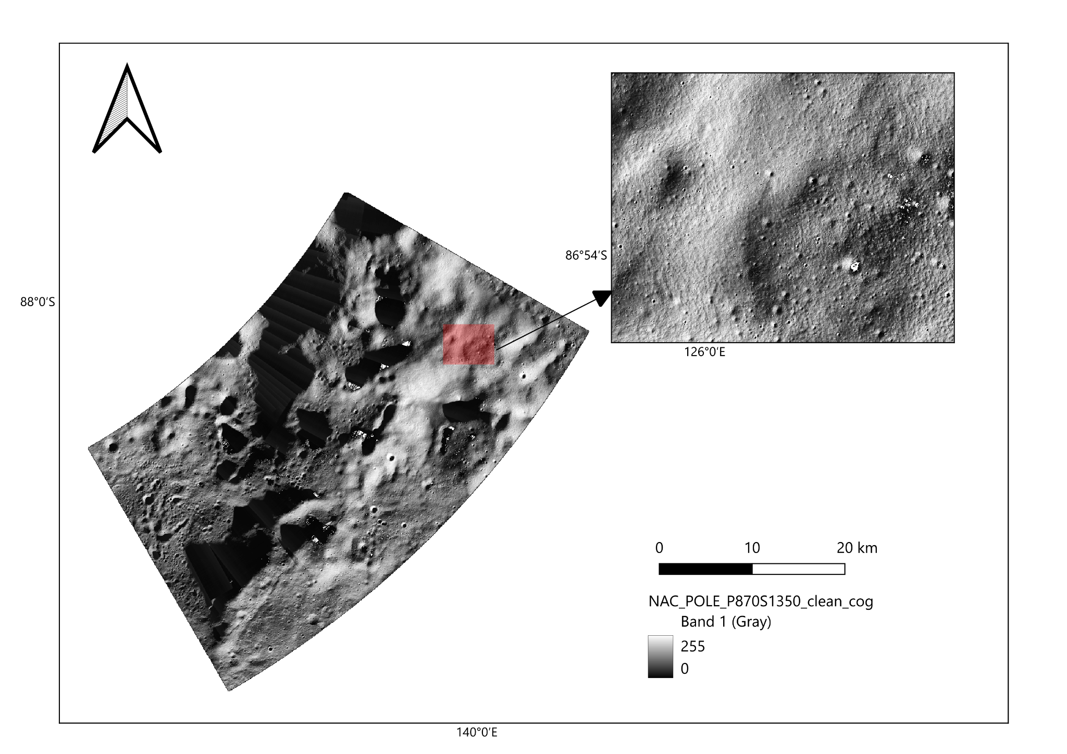
Figure 4. Annotated Moon South Pole map prepared in QGIS, including coordinates, zoomed region, north arrow, scale bar, and legend.

10.2 QGIS Annotation Procedure
Step | Procedure
1 | ('Open QGIS.', '')
2 | ('Add the TIFF file by dragging it from the file manager into the QGIS interface.', '')
3 | ('Remove the black background by identifying the background value with Identify Feature and adding the value to Raster Properties > Transparency > Transparent pixel list.', '')
4 | ('Create a new print layout using Project > New Print Layout.', '')
5 | ('Add the main map using Add Item > Add Map.', '')
6 | ('Add a second smaller map for the zoomed region, then use Move Item Content to zoom and pan only inside the small map.', '')
7 | ('For the zoom-area rectangle, select the main map and use Item Properties > Overviews > Add > Map 2.', '')
8 | ('For latitude and longitude, select the map and use Item Properties > Grids > Add Grid; set the CRS to Moon Geographic, set the required intervals, enable coordinate drawing, and use Degree, Minute with suffix formatting.', '')
9 | ('Configure the frame as a line border (nautical) style and use Frame/Annotations only when internal grid lines are not required.', '')
10 | ('Set coordinate visibility so latitude/Y is shown on the left and longitude/X is shown at the bottom, with top/right disabled.', '')
11 | ('Add an arrow to connect the main map and zoomed map.', '')
12 | ('Add a north arrow, legend, and scale bar.', '')
13 | Save the layout/project and export the result as an image.

11. Technical Skills and Learning Outcomes
- Basic Python programming and technical self-learning using online documentation/tutorials.
- Practical image annotation and handling of lunar TIFF datasets.
- Understanding of FPGA design hierarchy and the role of a top-level wrapper.
- SystemVerilog source-code reading and module-level functional tracing.
- Understanding of CNN accelerator stages: receptive-window generation, multiplication, addition, accumulation, activation, pooling, and detection post-processing.
- Basic understanding of DDR/AXI data movement and hardware data-path/control-path organization.
- Recognition of Vivado project dependencies such as .bd and .dcp artifacts.
- Module-level register and bus analysis.
- Basic HDMI/TMDS throughput reasoning and distinction between processing FPS and display timing.
- QGIS map composition, coordinate annotation, overview mapping, and export.

12. Internship Outcomes
The internship provided exposure to three complementary technical layers. First, Python established the basic programming foundation required for ML/CV work. Second, lunar annotation work in QuickMap and QGIS provided practical experience with image-based interpretation and geospatial visualization. Third, the FPGA assignment provided hands-on exposure to hardware acceleration, SystemVerilog modules, memory interfaces, CNN pipeline organization, and the limitations that can arise when an inherited Vivado project is missing essential build artifacts.
Although the unavailable .bd and .dcp files prevented full reproduction of the original Vivado simulation environment, the source-level analysis still enabled a detailed understanding of the 18-module architecture and its data flow. The generalized block diagram, register/bus analysis, and HDMI data-rate study served as technical documentation of that understanding.

13. Conclusion
The internship at IIT Bhilai resulted in practical learning across Machine Learning/Computer Vision support tasks, FPGA-based object detection, and geospatial image annotation. The work progressed from Python fundamentals to repeated lunar annotation, followed by analysis of an existing FPGA object-detection/CNN accelerator and finally detailed QGIS-based annotation of lunar imagery. The internship strengthened the ability to read technical source code, understand system-level data flow, investigate project failures, document hardware architecture, and produce precise technical visualizations.
This document records the work completed and the technical understanding developed during the internship period for internship completion and certification purposes.
End of Internship Work Documentation

