INTERNSHIP WORK REPORT
Machine Learning,
Computer Vision &
FPGA Architecture Analysis
Indian Institute of Technology Bhilai | MANAS Lab

INTERN | Mohit Choudhary
RESEARCH SUPERVISOR | Dr. Nitin Khanna
HOST ORGANIZATION | Indian Institute of Technology Bhilai
INTERNSHIP DURATION | 08 June 2026 – 08 August 2026

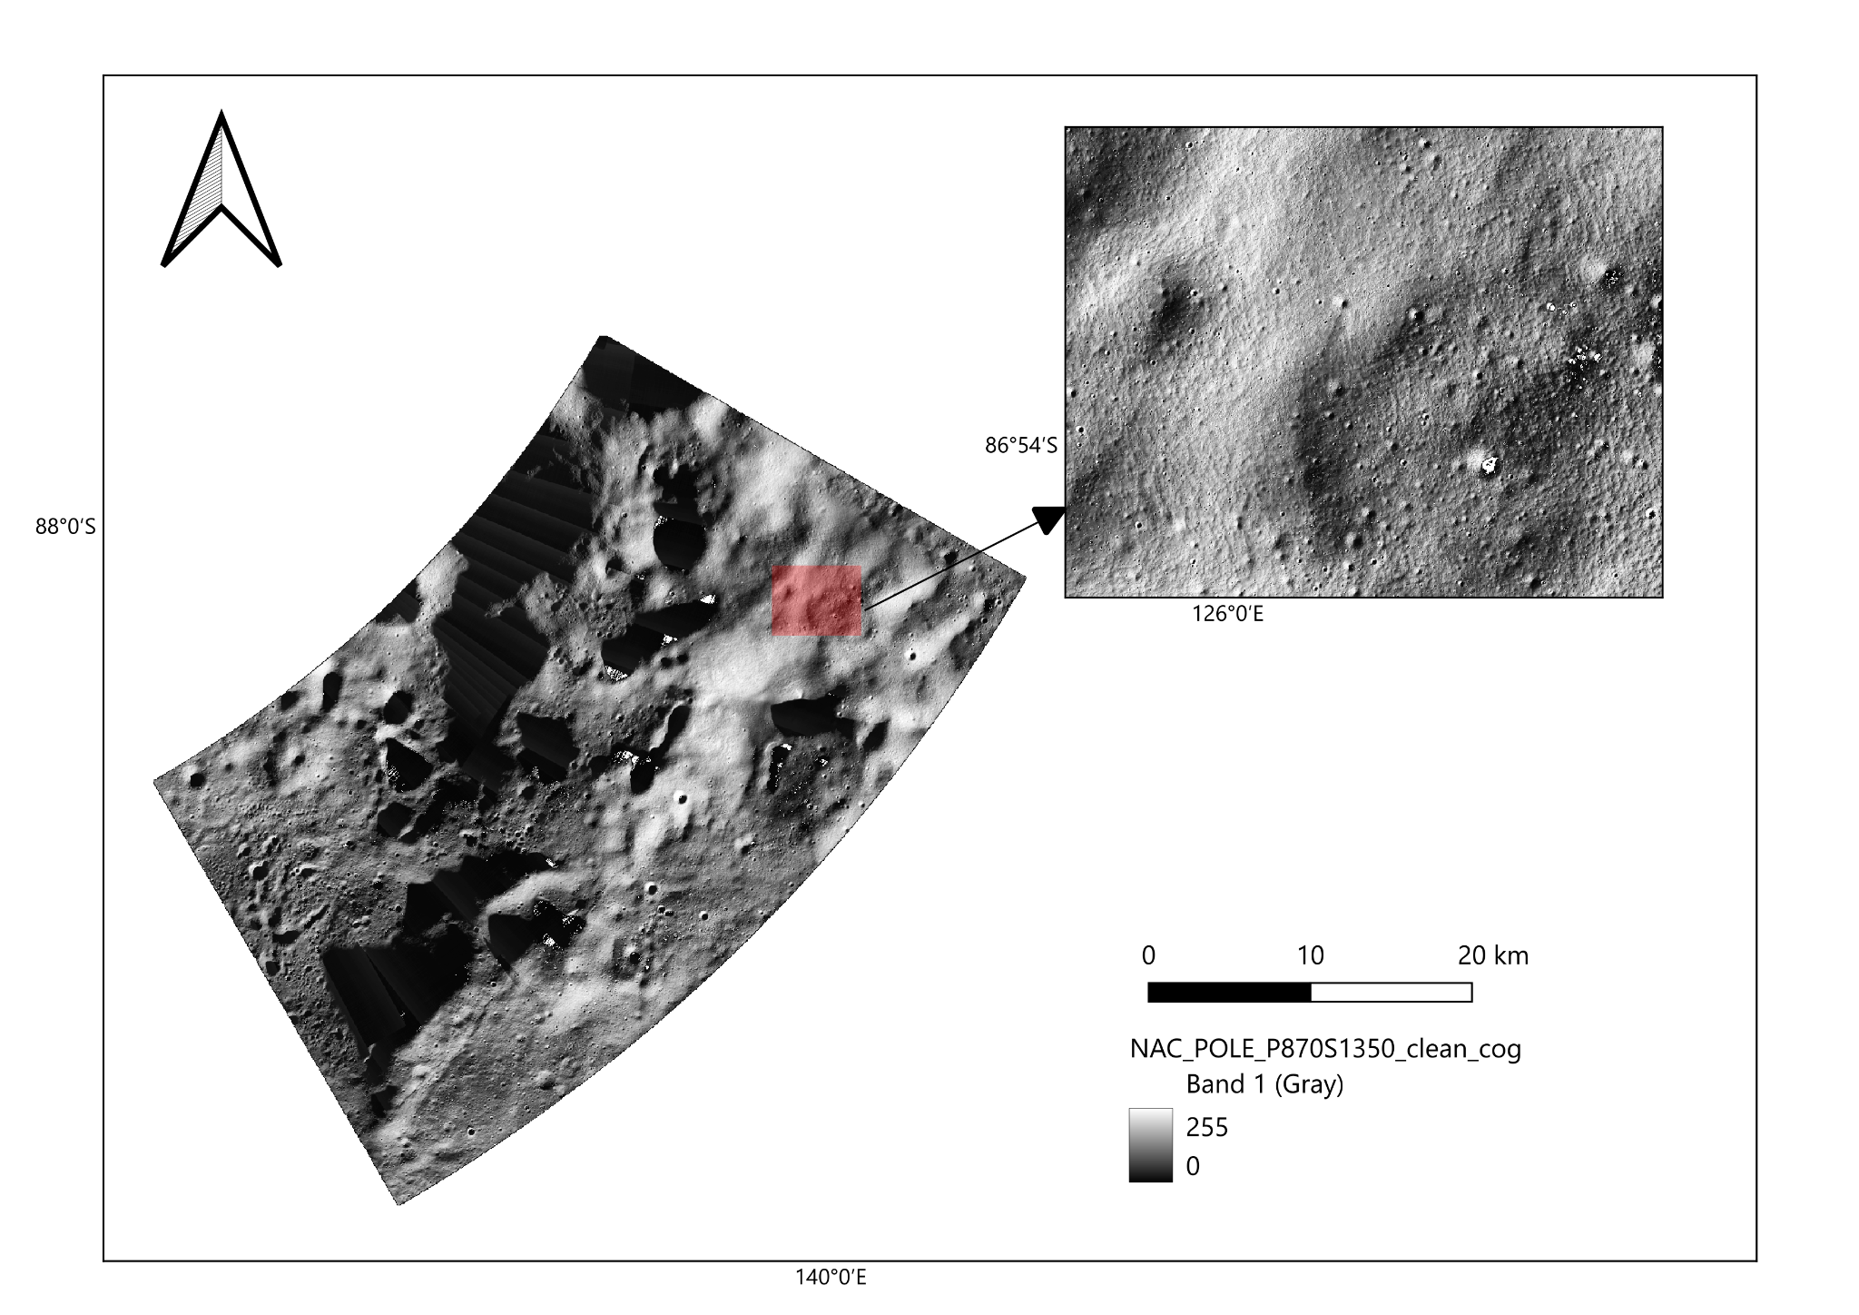

Report at a Glance
This report records the work carried out during the internship at the Indian Institute of Technology Bhilai from 08 June 2026 to 08 August 2026. The activities covered introductory Python learning, lunar image annotation using QuickMap and QGIS, architectural analysis of an FPGA-based CNN object-detection pipeline, SystemVerilog register/bus review, and preliminary HDMI data-rate calculations.

Contents
- 1. Internship Overview and Objectives
- 2. Learning Python Fundamentals
- 3. Lunar South Pole Annotation using QuickMap
- 4. FPGA-Based CNN Object-Detection Pipeline
- 5. SystemVerilog Module and Register/Bus Analysis
- 6. Vivado Simulation and Project-Recovery Challenges
- 7. HDMI Output Data-Rate Assessment
- 8. Lunar Annotation using QGIS
- 9. Skills Acquired, Outcomes and Limitations
- 10. Conclusion
- Appendix A. QGIS Annotation Procedure
- Appendix B. Sources and Technical Notes
Scope and accuracy note
The FPGA work documented here was an analysis of an existing object-detection design and its RTL structure. A completed gate-level implementation, synthesis report, or measured resource-utilization result is not claimed because the referenced Vivado block-design and checkpoint files were unavailable. Technical estimates are identified as estimates where applicable.

1. Internship Overview and Objectives
The internship was undertaken at the Indian Institute of Technology (IIT) Bhilai under the guidance of Dr. Nitin Khanna, Associate Professor. The work was associated with the Multimedia Analysis and Security (MANAS) Lab. The lab’s publicly described interests include signal, image and video processing, multimedia security, satellite-image analysis and machine learning. These areas provide relevant context for the internship’s image-processing and computer-vision activities.
Particular | Details
Intern | Mohit Choudhary
Host organization | Indian Institute of Technology Bhilai, Chhattisgarh
Research group / lab | MANAS Lab — Multimedia Analysis and Security
Research supervisor | Dr. Nitin Khanna
Internship area | Machine Learning (ML), Computer Vision (CV), FPGA architecture analysis and lunar image annotation
Duration | 08 June 2026 to 08 August 2026 (two months)

1.1 Objectives
- Build an introductory understanding of Python programming and basic programming concepts.
- Carry out lunar South Pole image annotation using QuickMap and QGIS tools.
- Understand the organization and data flow of an existing FPGA-based CNN object-detection design.
- Categorize the 18 RTL modules and prepare a generalized pipeline block diagram.
- Review the use of registers and buses across the SystemVerilog/Verilog modules.
- Investigate the project structure in Xilinx Vivado and identify the reasons the original design could not be restored for simulation and implementation analysis.
- Estimate the output-side data rates associated with the reported RGB565 and HDMI timing values.

2. Learning Python Fundamentals
At the beginning of the internship, approximately one week was devoted to learning Python from the basics. The W3Schools online Python tutorial was used as the introductory learning resource. The focus was on understanding Python syntax and basic programming concepts before moving to the image-processing and hardware-architecture activities.

2.1 Learning approach
- Used the W3Schools Python learning material for self-paced study.
- Started with introductory syntax and basic programming concepts.
- Built a foundation for reading and discussing software-oriented parts of the computer-vision workflow.
Learning record
The internship notes describe this as one week of learning Python from scratch. They do not record a completed Python application or a formal assessment; this section therefore documents introductory learning rather than claiming software-development proficiency.

3. Lunar South Pole Annotation using QuickMap
After the introductory Python learning, an image-annotation task was assigned using QuickMap, an open-source lunar mapping website. The task involved working with 12 different TIFF image files covering the lunar South Pole. The work provided practical exposure to lunar surface imagery, raster data, image interpretation and annotation in a geospatial context.

3.1 Work carried out
- Opened and examined the supplied lunar TIFF datasets in QuickMap.
- Worked through 12 separate TIFF files covering the Moon’s South Polar region.
- Performed annotation of features in the available lunar imagery as part of the assigned task.
- Used this task to become familiar with the visual characteristics and challenges of high-latitude lunar terrain imagery.

3.2 Relevance to the internship
The QuickMap activity connected the introductory computer-vision learning with practical work on scientific image data. It also provided experience working with raster imagery and spatially meaningful surface features before the later QGIS mapping work.

4. FPGA-Based CNN Object-Detection Pipeline
The next major assignment involved an existing FPGA-based object-detection project for which the RTL source code was provided. The project was already described as operational in its original environment. The assigned work was to study the FPGA project architecture, understand the purpose and sequence of its 18 RTL modules, and prepare a generalized block diagram showing the modules grouped by function.

4.1 Architecture understanding
The architecture was studied from the top-level wrapper and its system integration through the processing stages and final frame-writing stage. The work focused on understanding how image data is presented to the CNN pipeline, how the neural-network computation is organized, how detection outputs are post-processed, and how results are returned for display.

4.2 Functional grouping of the modules
Functional group | Modules included | Role in the generalized pipeline
Top-level integration and memory interface | design_1_wrapper.sv; ddr_manager.sv; ddr_if.sv | Top-level module integration and DDR/AXI data-transfer interfaces.
Control and data routing | neuron_machine.sv; networkunit.sv | Pipeline control, sequencing and movement of data between processing stages.
Input conversion and window generation | pixel2half.sv; recep_shiter.sv; receptor.sv | Pixel-format conversion, buffering/shifting and generation of sliding input windows.
CNN computation | synapse_unit.sv; mul_half2ints*; adder_tree.sv; dendrite_unit.sv; du_tip.sv; soma_unit.sv; my_half_adder.sv | Multiplication, partial-sum generation, accumulation, bias/activation and pooling-related processing.
Detection post-processing and output | bbox_n_softmax.sv; nms.sv; frame_writer.sv | Bounding-box/class-score processing, non-maximum suppression and writing final detection results.

4.3 Generalized CNN pipeline flow
The block diagram groups the RTL files into memory management, control/configuration, input-window generation, multiplication, addition, accumulation, activation/pooling and detection post-processing. It is a conceptual map of the flow based on the source files and the internship analysis; it is not a Vivado-generated netlist or timing-accurate implementation diagram.

Figure 1. Generalized 18-Module CNN Accelerator Pipeline
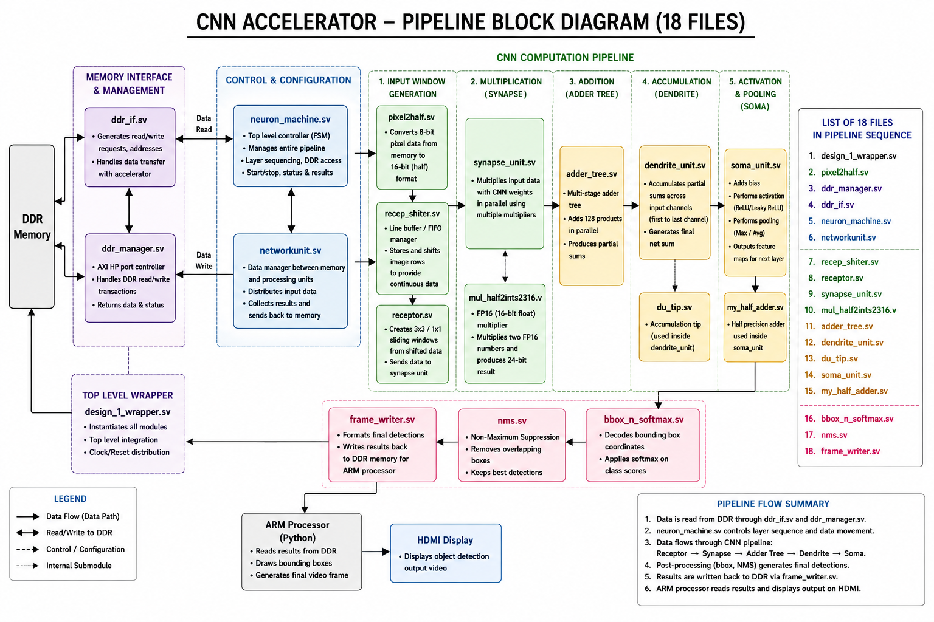
Intern-prepared generalized block diagram showing functional groups, data flow, DDR interaction, post-processing and the listed 18 RTL files.

4.4 RTL module sequence and purpose
# | RTL file name (as recorded) | Purpose / observed role | Group
1 | design_1_wrapper.sv | Top-level wrapper; instantiates/integrates modules and distributes clock/reset. | Top-level integration
2 | pixel2half.sv | Converts 8-bit pixel values into a 16-bit half-precision representation. | Input conversion
3 | Ddr_manager.sv / ddr_manager.sv | DDR transaction management and coordination of read/write activity. | Memory management
4 | ddr_if.sv | DDR/AXI interface signals and data/address transfer interface. | Memory interface
5 | neuron_machine.sv | Top-level processing controller, including FSM and layer/operation sequencing. | Control
6 | networkunit.sv | Routes data between memory and processing units and collects results. | Data routing
7 | recep_shiter.sv | Line buffer/FIFO-style shifting of image rows for continuous input data. | Input window support
8 | receptor.sv | Creates sliding windows (described as 3×3 / 1×1) and supplies data to the synapse unit. | Window generation
9 | synapse_unit.sv | Performs input/weight multiplication using parallel multipliers. | Multiply
10 | mul_half2ints.sv / mul_half2ints2316.v | FP16 multiplication datapath; the notes describe FP16 operands and a 24-bit result. | Arithmetic submodule
11 | adder_tree.sv | Multi-stage adder tree that combines products into partial sums. | Addition
12 | dendrite_unit.sv | Accumulates partial sums across input channels and generates a net sum. | Accumulation
13 | du_tip.sv | Accumulation-tip submodule used inside dendrite_unit. | Arithmetic submodule
14 | soma_unit.sv | Adds bias and performs activation/pooling-related processing. | Activation / pooling
15 | my_half_adder.sv | Half-precision adder submodule used inside soma_unit. | Arithmetic submodule
16 | bbox_n_softmax.sv | Decodes bounding-box coordinates and applies softmax to class scores. | Detection output
17 | nms.sv | Non-Maximum Suppression: removes overlapping boxes and retains stronger detections. | Post-processing
18 | frame_writer.sv | Formats final detections and writes results back to DDR for ARM-side processing. | Output / memory write

5. SystemVerilog Register and Bus Analysis
A module-wise review was prepared to identify whether registers and buses were used and to record their apparent purpose. The internship analysis marked both registers and buses as present for all 18 modules. The purpose column below preserves the functions recorded in the supplied analysis notes.
Module | Registers? | Bus? | Recorded purpose
design_1_wrapper.sv | Yes | Yes | Top-level interconnection; AXI, DDR and HDMI buses.
pixel2half.sv | Yes | Yes | Pixel data storage and 8-bit to FP16 conversion.
ddr_if.sv | Yes | Yes | AXI DDR interface signals and address/data buses.
ddr_manager.sv | Yes | Yes | DDR transaction control and AXI buses.
neuron_machine.sv | Yes | Yes | FSM state registers and control buses.
networkunit.sv | Yes | Yes | Feature-map routing and internal data buses.
recep_shiter.sv | Yes | Yes | FIFO registers and pixel buses.
receptor.sv | Yes | Yes | Sliding-window registers and feature buses.
synapse_unit.sv | Yes | Yes | Weight registers and multiplication buses.
mul_half2ints2316.v* | Yes | Yes | FP16 operand buses and product bus.
adder_tree.sv | Yes | Yes | Pipeline registers and accumulation buses.
dendrite_unit.sv | Yes | Yes | Partial-sum registers and output buses.
du_tip.sv | Yes | Yes | Accumulation registers.
soma_unit.sv | Yes | Yes | Bias/activation registers.
my_half_adder.sv | Yes | Yes | FP16 adder registers.
bbox_n_softmax.sv | Yes | Yes | Bounding-box and class-score buses.
nms.sv | Yes | Yes | Bounding-box comparison registers.
frame_writer.sv | Yes | Yes | Output buffer registers and DDR write bus.

*The multiplier filename is shown as it appears in the register/bus analysis table; see Appendix B.3.
Interpretation
This is a source-review summary from the internship work, not a substitute for a signal-level audit of the RTL. Exact register widths, bus widths, handshake behavior, clock domains and synthesis-inferred resources would require the complete source hierarchy and a successful elaboration/synthesis run.

6. Vivado Simulation and Project-Recovery Challenges
The next planned task was to inspect the design in Xilinx Vivado and progress toward gate-level circuitry and logic-mapping information. During the hardware-simulation/project-restoration phase, Vivado reported that referenced project files could not be found. Two screenshots from the project Sources view show the missing dependencies.

6.1 Missing project dependencies
Missing item | Role in the project | Impact observed
.bd — Block Design | Stores the IP-integrator design structure, IP connections and interconnect configuration used by the system. | The design hierarchy and integration context could not be fully restored from the available project files.
.dcp — Design Checkpoint | Stores a checkpoint of a synthesized or implemented design state. | The prior compiled design state could not be reopened from the missing checkpoint.

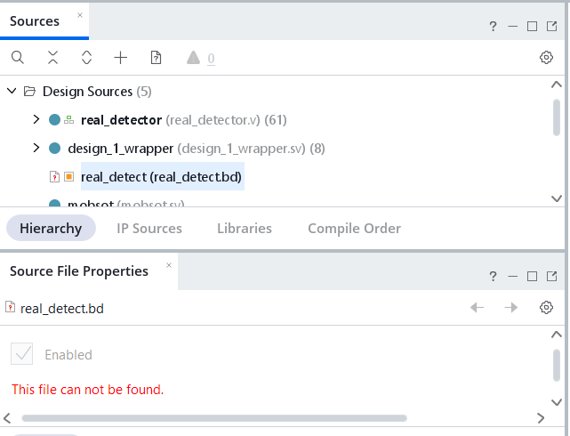  Missing project file shown in Vivado | 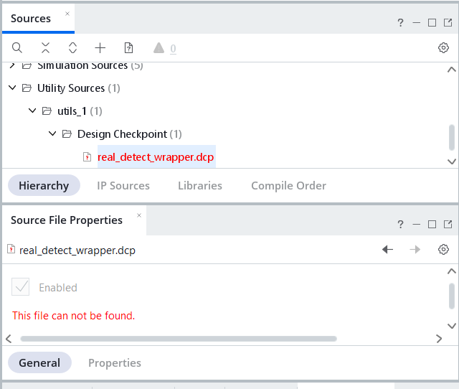  Missing project file shown in Vivado
Figure 2. Vivado Sources screenshots: the real_detect.bd block design and real_detect_wrapper.dcp checkpoint are reported as not found.

6.2 Troubleshooting outcome
- Multiple attempts were made to retrieve or recover the referenced files, but the files remained inaccessible during the internship.
- The exact original Vivado project state could therefore not be reconstructed from the available materials.
- The register/bus review and the generalized block diagram were completed as documentation-based architecture analysis.
- The planned gate-level mapping and extraction of implementation statistics could not be completed or independently verified.
Important technical distinction
A .dcp checkpoint is a saved synthesis/implementation state and can often be regenerated when the full RTL, constraints, IP definitions and build settings are available. The missing .bd and associated IP-integrator configuration can be a more fundamental reconstruction issue. This report records the observed missing files and the resulting limitation; it does not claim that every Vivado project with a missing .dcp is unrecoverable.

7. HDMI Output Data-Rate Assessment
An output-side data-rate assessment was attempted using the project’s reported processing speed of 6.67 frames per second (FPS), RGB565 format and HDMI timing values. The values recorded during the internship are reproduced below, followed by the calculation assumptions that must be checked before treating them as measured project specifications.
Quantity | Meaning | Recorded estimate
Raw pixel data rate | Pixel payload represented as RGB565. | 1.188 Gbps (approximately 148.5 MB/s)
Pixel clock | Pixel timing clock used for the HDMI calculation. | 74.25 MHz
TMDS rate per lane | Serial rate on one of the three HDMI data lanes. | 742.5 Mbps (approximately 92.81 MB/s)
Total TMDS rate | Combined rate across the three data lanes. | 2.2275 Gbps (approximately 278.44 MB/s)

7.1 Formula and consistency check
For RGB565, the nominal pixel payload rate is calculated from active image dimensions and frame rate:
Rpixel = image width × image height × FPS × 16 bits/pixel
The recorded 1.188 Gbps value is consistent with 74.25 million pixel periods per second multiplied by 16 bits per pixel: 74.25 MHz × 16 = 1.188 Gbps. It is therefore a clock-based estimate. It cannot be derived from 6.67 FPS alone without the active image width and height, and it may include assumptions about the video timing clock.
The recorded TMDS figures are arithmetically consistent with a 10-bit TMDS symbol rate per data lane: 74.25 MHz × 10 = 742.5 Mbps per lane; across three lanes, 3 × 742.5 Mbps = 2.2275 Gbps.
Validation required before using these as final specifications
The 6.67 FPS value appears to describe object-detection processing throughput, while 74.25 MHz is a video pixel-timing clock. These are different quantities and should not be presented as interchangeable. Confirm the active resolution, actual pixel clock, HDMI transmitter/serializer configuration, color depth, blanking intervals and whether RGB565 is expanded or otherwise mapped before publishing the rates as measured hardware output.

8. Lunar Annotation using QGIS
After the FPGA architecture study, QGIS was learned through open-source lectures. The lunar South Pole raster data was then prepared in QGIS and presented as annotated map layouts. The work included geographic coordinate annotations, a main map with a zoomed inset, a locator rectangle, a connecting arrow, a north arrow, a legend and a scale bar. QGIS annotation work continued until the end of the internship.

8.1 Map elements included
- Main map showing the lunar South Pole raster/TIFF dataset.
- Zoomed inset map focused on a selected crater or region of interest.
- Overview rectangle on the main map identifying the area shown in the inset.
- Moon Geographic coordinate reference system and latitude/longitude labels in degree-minute format with suffixes.
- Map frame, north arrow, legend, scale bar and a connector arrow between the overview and inset maps.
- Exported map layout saved as an image, with the QGIS project saved for further editing.
Figure 3. Lunar South Pole QGIS layout prepared during the internship, showing the main raster, zoomed inset, coordinate annotations, scale bar, grayscale legend and north arrow.

8.2 Annotation procedure
The detailed procedure below is based on the three-page QGIS step document supplied with the internship materials. It is grouped for readability while preserving the sequence and settings recorded in that document.

9. Skills Acquired, Outcomes and Limitations

9.1 Skills and tools
Area | Exposure / outcome
Python | Introductory learning from scratch using W3Schools over approximately one week.
QuickMap | Annotation work on 12 lunar South Pole TIFF datasets.
FPGA architecture | Understanding of an existing CNN object-detection RTL architecture and its module-level data flow.
SystemVerilog / Verilog | Module categorization and register/bus usage review across the 18-file pipeline.
Xilinx Vivado | Project-source inspection and troubleshooting of unavailable block-design/checkpoint references.
HDMI / RGB565 | Preliminary pixel-payload and TMDS-rate calculations with timing assumptions identified.
QGIS | Lunar raster visualization, Moon Geographic coordinate annotation, print layout composition and image export.

9.2 Work products completed
- A generalized block diagram categorizing the 18 RTL modules in the CNN object-detection pipeline.
- A module-wise record of the purpose of each RTL file.
- A register and bus usage table covering the 18 modules.
- A record of Vivado project-recovery issues supported by screenshots of the missing .bd and .dcp files.
- A preliminary HDMI output data-rate assessment with caveats about the assumptions.
- QuickMap annotation work covering 12 lunar South Pole TIFF files.
- QGIS annotated lunar map layout(s) including coordinates, inset, legend, scale bar and north arrow.
- A written step-by-step QGIS annotation procedure.

9.3 Limitations and unfinished items
- The exact missing Vivado block design and checkpoint files could not be recovered during the internship.
- Because the original design could not be fully restored, gate-level mapping, synthesized logic-gate/resource counts and implementation reports were not completed.
- The HDMI data-rate values require confirmation against actual timing and interface configuration before being treated as measured results.
- The exact multiplier RTL filename should be checked in the original source tree because the internship notes contain two variants.

10. Conclusion
The two-month internship provided practical exposure to introductory Python, lunar raster annotation, geospatial mapping and FPGA-based CNN architecture analysis. The completed outputs include QuickMap annotation across 12 lunar South Pole TIFF datasets, a generalized 18-module CNN pipeline diagram, a module-wise register/bus review and QGIS map layouts with coordinate annotations and standard cartographic elements. Vivado gate-level mapping remained incomplete because the referenced .bd and .dcp project files were unavailable. The HDMI figures remain preliminary and require confirmation against the actual video timing and interface configuration. This report is prepared for review by the host supervisor as supporting documentation for internship-completion verification.

Appendix A. QGIS Annotation Procedure

A.1 Load raster and prepare transparency
- Open QGIS.
- Drag the TIFF file from the file manager into the QGIS interface.
- To remove the black background, use Identify Feature (Ctrl + Shift + I or the identify icon) to note the black-pixel value, then open Raster Properties → Transparency → Transparent pixel list and add that value using the plus (+) control.

A.2 Create the print layout and maps
- Choose Project → New Print Layout, enter a layout name and create it.
- When the new layout window opens, choose Add Item → Add Map and draw the main map in the blank layout area.
- Choose Add Item → Add Map again and draw a smaller rectangle for the zoomed inset map.
- Choose Move Item Content (hand icon), click inside the small map, zoom with the mouse wheel and pan to the crater. This changes the inset map while leaving the large map unchanged.
- To show the zoom extent on the main map, select the main map → Item Properties → Overviews → plus (+) → Add Map 2.

A.3 Configure latitude/longitude annotations and frame
- Select the map → Item Properties → Grids → plus (+). Set the CRS to Moon Geographic.
- Enable Draw Coordinates and set the coordinate format to Degree, Minute with suffix.
- To set the frame, open the grid Frame options and select a line-border style (recorded as “nautical” in the supplied notes).
- To remove internal grid lines, set Grid Type to “Frame and annotations only”.
- The supplied notes record grid intervals of X = 12 and Y = 1 in the coordinate-grid setup, and later record X = 20 and Y = 2 under the appearance interval setting. Confirm the final interval from the saved QGIS project before reproducing the exact layout.
- Under Draw Coordinates, disable the right and top labels; show latitude/Y only on the left and longitude/X only at the bottom.

A.4 Add map furniture and export
- To connect the maps, choose Add Item → Add Arrow.
- To add a north arrow, choose Add Item → Add North Arrow.
- To add a legend, choose Add Item → Add Legend.
- To add a scale bar, choose Add Item → Add Scale Bar.
- Save the project using Layout → Save Project and specify the location.
- Export the layout using Layout → Export as Image and specify the output location.
Reproducibility note
The source procedure contains two grid-interval settings at separate steps. This report keeps both as recorded rather than silently selecting one. The interval used in the final annotated map should be confirmed from the actual QGIS project/layout.

Appendix B. Sources and Technical Notes
The internship activity descriptions, module list, analysis tables, HDMI figures, screenshots and QGIS workflow are derived from the information and files supplied by the intern. Public institutional context is included only to identify the host organization and research group.

B.1 Public institutional sources
MANAS Lab — Multimedia Analysis and Security, IIT Bhilai. Lab profile and research interests
IIT Bhilai faculty profile — Dr. Nitin Khanna. Official faculty profile
IIT Bhilai — official institute website. Institute website
W3Schools — Python Tutorial. Learning resource
IIT Bhilai Student Mentorship Programme brochure 2025–26. Official brochure PDF

B.2 Intern-supplied material
- CNN accelerator 18-module pipeline block diagram.
- Vivado Sources screenshots showing the missing real_detect.bd and real_detect_wrapper.dcp references.
- Annotated lunar South Pole QGIS map image.
- “Steps to make annotation file” — three-page procedure supplied by Mohit Choudhary.

B.3 Important interpretation notes
- The 18-module register/bus table is documented as the intern’s code-review record; detailed signal widths and synthesized mappings were not independently verified in this report.
- The reported 6.67 FPS is kept separate from the 74.25 MHz HDMI pixel timing clock. Resolution and actual HDMI configuration are required to establish a measured pixel payload rate.
- The two multiplier filenames and two QGIS grid-interval settings are both preserved as recorded in the supplied notes and should be checked against the original project files/layout.

