HMIS API 0.0.1 Schema

Here is a matchup of the Schema field names from HMIS API-0.0.1 with the HUD HMIS Data Standards:

https://anypoint.mulesoft.com/apiplatform/hmis-api/#/portals/organizations/1d2d1eb1-46af-4ee8-aa04-bd79ed2764a3/apis/7105/versions/7150#clients_client_id_enrollments_enroll_id_disabilities

Universal Data Elements

3.1 Name

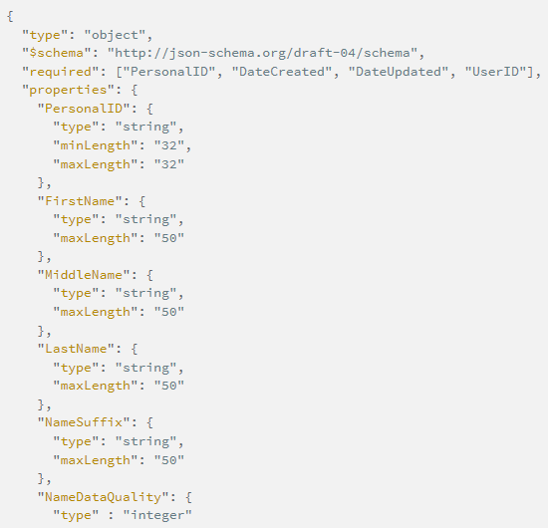

3.2 SSN

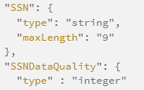

3.3 DOB

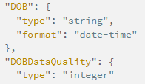

3.4 Race

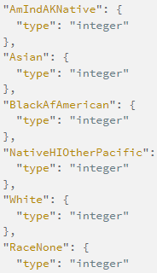

3.5 Ethnicity



3.6 Gender

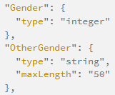

3.7 Veteran Status

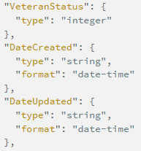

3.8 Disabling Condition



3.9 Residence Prior to Project Entry

3.10 Project Entry Date

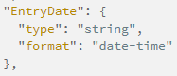

3.11 Project Exit Date

3.12 Destination

3.13 Personal ID

From Enrollment Schema

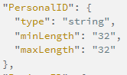

3.14 Houshold ID

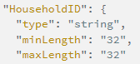

3.15 Relationship to Head of Household



3.16 Client Location

3.17 Length of Time on Street

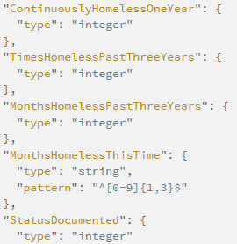

API User ID

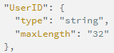

Date Deleted

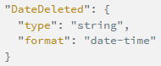

Program Specific Data Elements

4.1 Housing Status



4.13 Date of Engagement

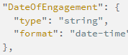

4.17 Residentioal Move-in Date

