Advanced Regression Assignment

Question 1

What is the optimal value of alpha for ridge and lasso regression? What will be the changes in the model if you choose double the value of alpha for both ridge and lasso? What will be the most important predictor variables after the change is implemented?

Optimal Value for Ridge regression is 8 and Lasso Regression is 0.0002.
Alpha values for below results: Ridge Regression is 8 and Lasso regression is 0.0002
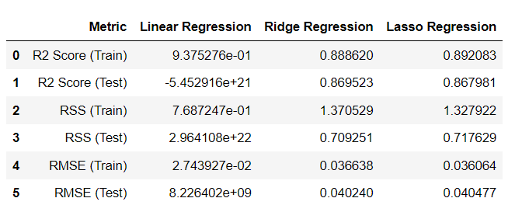
After doubling the Ridge and Lasso coefficients
Ridge = 16, Lasso = 0.0004
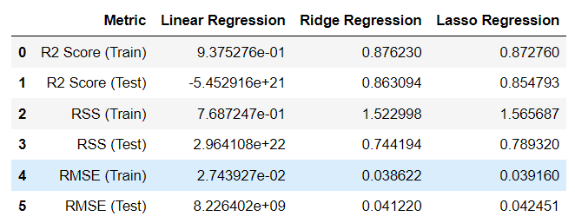
After doubling the alphas it can be seen that the R2 score has reduced in both the cases. Also it can been seen that the training as well as test errors have increased. This is in accordance Bias-Variance tradeoff. As the alphas increase it shrinks the coefficients to make the model simpler, hence increasing the bias (error). Also the number of variables having non-zero coefficients in case of Lasso regression gets reduced from 75 to 42.

Most important predictor variables with optimum alpha
Ridge: Lasso:
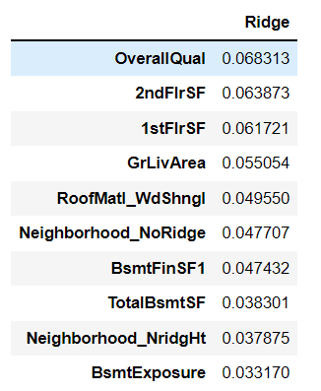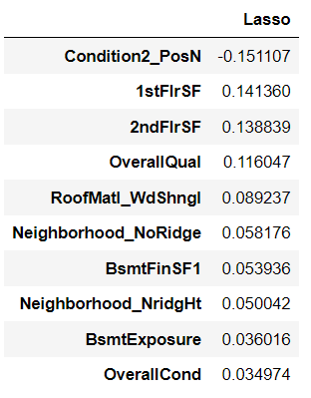

Most important predictor variables after doubling the alpha
Ridge: Lasso:
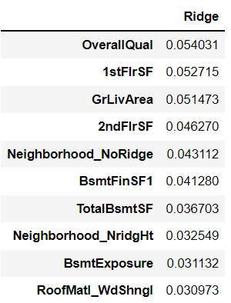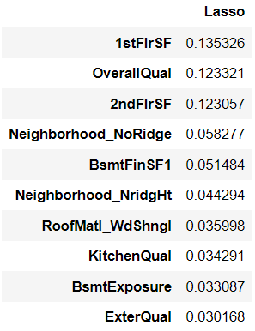

Question 2
You have determined the optimal value of lambda for ridge and lasso regression during the assignment. Now, which one will you choose to apply and why?

From the performance metrics it seems that both the regression models’ performance is similar. But as we see in Lasso Regression model the model has reduced the number of variables to 75. This is substantial reduction and considering that there are highly correlated variables involved in the dataset. Hence we should choose Lasso to apply here or we can consider Ridge with RFE.

Question 3
After building the model, you realised that the five most important predictor variables in the lasso model are not available in the incoming data. You will now have to create another model excluding the five most important predictor variables. Which are the five most important predictor variables now?
After deleting the 5 most important predictor variables, now the five most important predictor variables in Lasso model are as shown below.

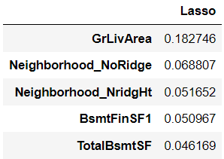

Question 4
How can you make sure that a model is robust and generalisable? What are the implications of the same for the accuracy of the model and why?

