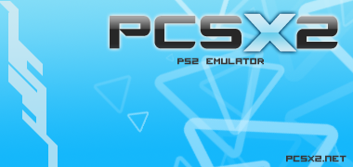

Overview

PCSX2 is a PlayStation 2 emulator for Windows and Linux, started by the same team that brought you PCSX (a Sony PlayStation 1 emulator).
The PCSX2 project attempts to allow PS2 code to be executed on your computer, thus meaning you can put a PS2 DVD or CD into your computers drive, and boot it up!
The project has been running for nearly 10 years now, and since its initial release has grown in compatibility. From initially just being able to run a few public domain demos, its current state enables many games to boot and actually go in game, such as the 'famous' Final Fantasy X, Devil May Cry 3 and God of War. You can always visit the PCSX2 homepage to check the latest compatibility status of games with more than 2000 titles tested.

Following our new release scheme as described here, v1.0.0 is an official, stable release.

What’s new in 1.0.0?
GUI:
- New, threaded GUI using wxWidgets.
- New menus, for improved usability and faster configuration.
- Convenient Memory Card editor.
- On the fly pause and resume, perfectly stable, safe and fast.
- On the fly setting switching and even plugin switching.
- Powerful new configuration that is more user friendly with its first time wizard, reset to default buttons and a global presets system.
- A plethora of new options that make playing games more fun!
- All options have tooltips explaining what each of them do.
- Comes translated, with many languages to select from.
- Compatible with Aero Glass and Windows eye candy.
- Looks and works great on Linux, too!
Core:
- Entire emulation core has been overhauled. Many components are rewritten.
- Countless code generation and runtime execution bugs fixed.
- Added microVU, an improved VU0/VU1/COP2 recompiler.
- New VIF recompiler
- Multi-threaded GS rewrite: Faster and more stable than in 0.9.6.
- Better BIOS splash screen skip method, better ELF support, host fs support.
- New Game database detects the game you run, displays compatibility info, and auto applies special game fixes/patches if needed.
Plugins:
- GSdx is faster, more stable and has more configuration options than ever before.
- SPU2-X is the preferred SPU2 plugin now.
It has matured into almost completely emulating all the SPU2 quirks, making many more games work!
(And it sounds nice, too :) )

Known issues in release 1.0.0

- GSdx DX9 Hardware mode lacks various features that DX10 mode has.
- Game database not complete (it's an ongoing wip).
- Patches browser is not implemented yet.
- Interpreters are somewhat unstable.

Configuration

A very detailed guide is available on the PCSX2 homepage which is already translated in several languages!
You can consult it here.

Status

PCSX2 has come a long way since its starting point back in 2001. Current features include:

- Separate recompilers for Emotion Engine (EE) , Vector Unit 0 (VU0) and Vector Unit 1 (VU1).
- Dual core support, with the Graphics Synthesizer (GS) running on a second thread.
- Usage of MMX,SSE1,SSE2,SSSE3 and SSE4 extensions.
- Proper SPU2 emulation featuring Time Scaling and Reverb.
- Full gamepad support featuring Dual Shock 2,analog controls and even supporting analog movement over keyboard (using some external plugins).
- Many more :)

Sections that still need work:

- Dev9, FireWire and USB are all just partially supported.
- Image Processing Unit (IPU) emulation (which is responsible for the FMV playback) is slow and not completely fixed yet.
- MIPS cache could be properly implemented, but currently only one title is known to rely on it.
- The complex timing between PS2 components is an on-going work in progress.

How can you help

As most of you are aware, the PCSX2 team is working on this project at the expense of their free time and provide it without charging the program’s use.
If you want to show your appreciation to these people and motivate them, you can donate any amount of money you feel is right to the team’s PayPal account found on the official site.
These funds will be used for the team members to get new, more modern hardware in order to test and debug more efficiently and even implement new features (just like dual core support for example).

If you are a programmer and you are interested in helping the PCSX2 team by making additions or corrections to the code, you are free to browse through the public Google Code repository here after taking into account PCSX2 is under the GNU General Public Licence (GPL) v3
The Coding Team

Below you can see 3 tables, showing the current team members who are actively coding at the present time, the current team members who have been inactive for some time and the older team members who for some reason quit along the way, which include the previous project leader Linuzappz, and our last “semi project leader” Jake Stine, to both of which we send our best regards ☺

Current active team members:

Nickname | Real Name | Place | Comments
refraction | Alex Brown | England | General Coding DMA/VIF etc
arcum42 |  | USA | Linux compatibility and porting
gregory |  | France | Linux compatibility, translation
cottonvibes |  | USA | FPU and VU recompilers, general coding
drkIIRaziel |  | Greece | Memory management, emulation theory, recompiler design
gigaherz |  | Spain | General coding, spu2ghz (later SPU2-X), cdvdGigaherz
pseudonym |  | England | EE recompiler, GSdx renovations
rama |  | Germany | Resident hacker, general coding, testing
Gabest |  | Hungary | GSdx creator, recompiler optimizations
avih |  | Israel | GUI coding, Memory Card editor

Current inactive team members:

Nickname | Real Name | Place | Comments
florin | Florin Sasu | Romania | Master of HLE. Master of cd code and bios HLE..
Nachnbrenner |  | Germany | patch freak :P
aumatt |  | Australia | a bit of everything mostly handles CDVD cmds
saqib |  | Pakistan | Project leader, fixing bugs around (FPU, Interpreter, VUs..)
Shadow | George Moralis | Greece | Project founder, master of cpu, master of bugs, general coding…
Goldfinger |  | Brazil | MMI,FPU and general stuff
loser |  | Australia | obscure cdvd related stuff
zerofrog |  | USA | Recompilers, ZeroGS, x86-64, linux, optimizations, general fixes and new features

Ex team members:

Nickname | Real Name | Place | Comments
Linuzappz |  | Argentina | Project founder, master of The GS emulation and so many others..
basara |  |  | Recompiler programmer. general coding
Jake Stine |  | USA | wxGUI, MTGS,counters, general coding,SPU2-X, x86 emitter
[TyRaNiD] |  |  | GS programmer.General coding
Roor |  |  | General coding
tmkk |  | Japan | VUs, recompilers, x86asm

Additional coding and help:
F|RES, fumofumo, Nneeve, Nocomp, Pofis, _Riff_, Shadow Lady
The Beta Tester Team

Beta testers are people (slaves/mindless grunts :P) who constantly test new PCSX2 beta builds to report any new bugs, regressions or improvements. While this might sound simple to most, what many people do not know is that testers also debug with the coders, maintain the huge game compatibility list, create dumps and logs for the coders and so much more. As above, active, inactive and ex members are listed alphabetically.

Current active members:

Bositman, Falcon4Ever, GeneralPlot, Prafull, Shadow Lady

Current inactive team members:

Belmont, CKemu, Crushtest, Knuckles, Krakatos. Raziel, RudyX, Parotaku

Ex team members:

Chaoscode, CpUMasteR, EFX , Elly, JegHegy, Razorblade, RPGWizard, Seta San, Snake875

Release date chart

Here’s a little something we made after careful and time consuming searching over archived news about PCSX2 releases! It’s a timeline chart showing the PCSX2 release dates since 0.1.Thanks to gigaherz for creating the chart :)

PCSX2 Releases 0.1 – 0.9.8

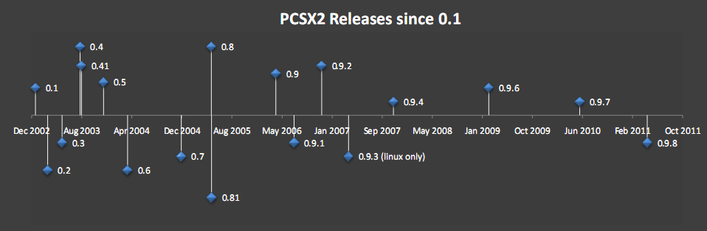

And here are the actual release dates for those of you who are curious:

0.026: 23 March 2002
0.031: 14 April 2002
0.036: 17 June 2002
0.038: 7 July 2002
0.042: 11 September 2002
0.1: 20 December 2002
0.2: 19 February 2003
0.3: 2 May 2003
0.4: 31 July 2003
0.41: 7 August 2003
0.5: 25 November 2003
0.6: 24 March 2004
0.7: 17 December 2004
0.8: 16 May 2005
0.81: 17 May 2005
0.9: 3 April 2006
0.9.1: 3 July 2006
0.9.2: 18 November 2006
0.9.3 (Linux only) 1 April 2007
0.9.4: 11 November 2007
0.9.6: 1 March 2009
0.9.7 (beta): 29 May 2010
0.9.8: 1 May 2011

Additional thanks and credits

Duke of NAPALM: For “3D stars”. The first demo that worked in PCSX2 :)
Tony Saveski (dreamtime): For his great ps2tutorials!!
F|res: Author of dolphin, a big thanks from shadow..
Now3d: The guy that helped shadow at his first steps..
Keith: Who believed in us..
Bobbi & Thorgal: For hosting us, for the old page design and so many other things
Sjeep: Help and info
BGnome: Help testing stuff
Dixon: Design of the old pcsx2 page, and the pcsx2.net domain
Bositman: PCSX2 beta tester :) (gia sou bositman pare ta credits sou )
No-Reccess: Nice guy and great demo coder :)
NSX2 team: For their help with VU ;)
Razorblade: For the old PCSX2 logo & icon.
Snake: He knows what for :P
Ector: Awesome emu :)
Zezu: A good guy. Good luck with your emu :P
Hiryu & Sjeep: For their libcdvd (iso parsing and filesystem driver code)
Sjeep: For the SjDATA filesystem driver
F|res: For the original DECI2 implementation
libmpeg2: For the mpeg2 decoding routines
Aumatt: For applying fixes to pcsx2
Microsoft: For VC.Net 2003, 2005, 2008 and now 2010.
NASM team: For nasm
CKemu: Logos/design

and probably to a few more..

Special Shadow's thanks go to...

My friends: Dimitris, James, Thodoris, Thanasis and probably to a few more..and of course to a lady somewhere out there....

Updated for v1.0.0 by rama.

