Question 2:
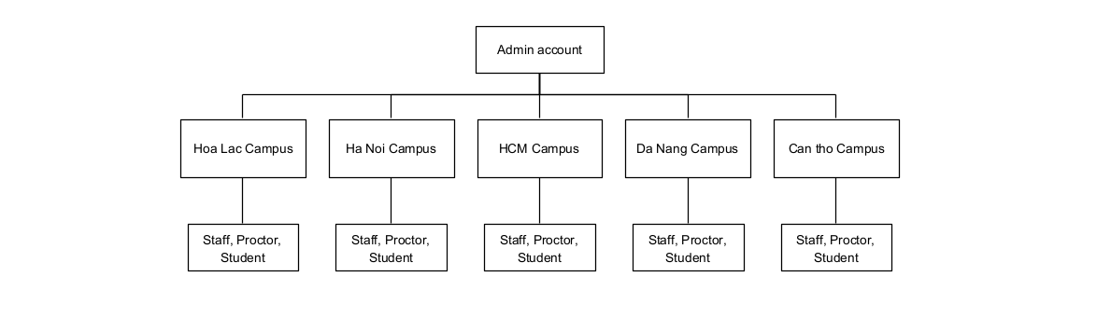

Question 3:
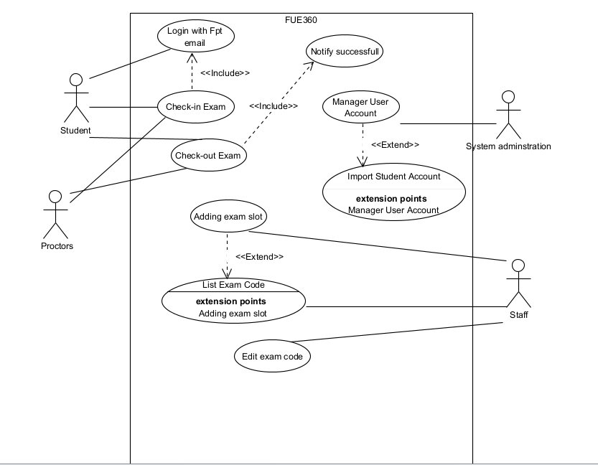

Question 4

Use case ID : UC-01
Use case name : Add Exam Slot
Primary actor : Staff of Examination Department
Secondary actor : Student
Precondition : The staff member is logged in with account email of FPT university and has permission .
Post condition : A new exam slot is created and student and check in, check out that exam
MainFlow :
- Staff open and login FUE360
- Staff select and open Exam Slot Management
- Staff select Add exam Slot
- Staff enter information of Exam
- System validated information of Exam
- System show Exam Slot detail
- System create the new exam slot
- System notify a success message

Alternative Flow: At step 1. If the Account is invalid with FUE360 system
- System notify account is invalid
- Staff cannot log into the FUE306 system
Alternative Flow: At step 5. If the information of Exam is invalid
- System notify the information of exam is invalid
- System notify staff enter the information of exam again
Business Rules : Exam-slot date and time must be inside the official final-exam period for the selected semester.

Question 5 :
- Security : All requests to view, add, edit, or delete exam slots, exam codes, student accounts, and student-count reports must require an authenticated email account of FPTU and a mapped FU Exam360 role.
- Role-based authorization must prevent Staff accounts from managing exam slots outside their assigned campus.

