DƯƠNG NGUYỄN ĐÌNH THẮNG-SE192688
Question 1: Complete all part of the first page of the software requirement
Question 2: The organization chart below shows the authorization/user structure with more than three levels and multiple FU campuses.
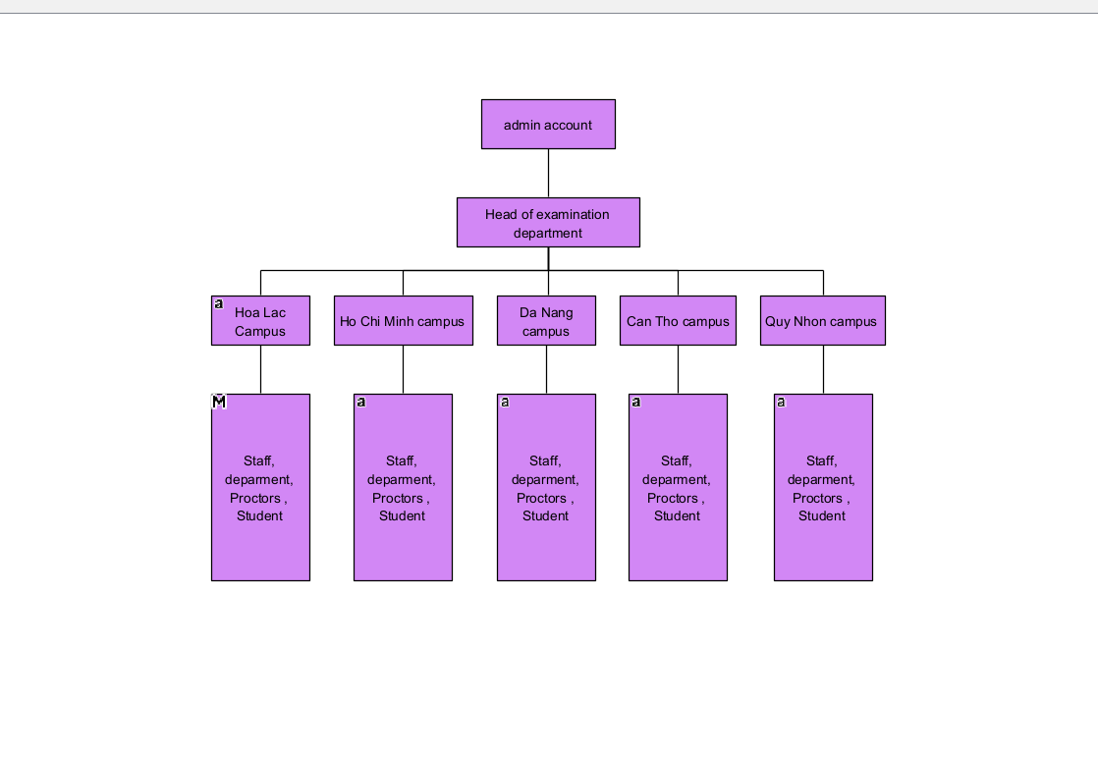
Question 3:Use case diagram
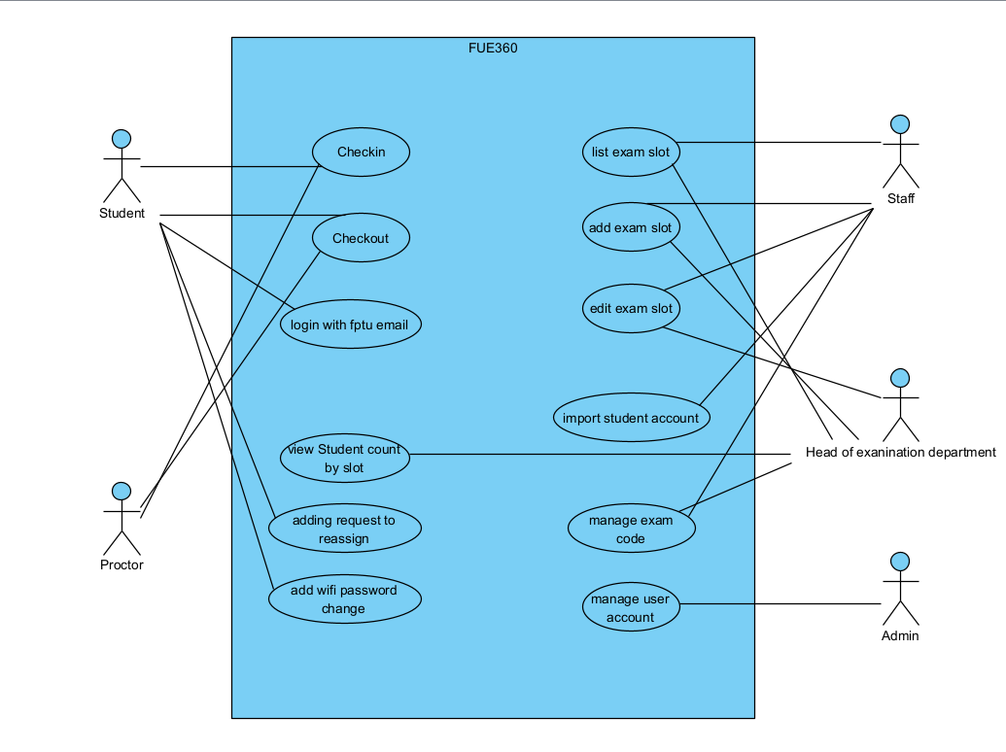
Question 4: writing in detail one use case Add exam slot in template provided.
Use case ID: UC-01
Use case name: add exam slot
scope: FU Exam360 website
Level User-goal
Primary actor: Staff of Examination Department
Preconditions: The staff member is logged in with an active @fpt.edu.vn account and has selected campus, semester, and course.
Preconditions: Required master data such as campus, course, semester, room, exam code, and exam period is available or can be selected.
Successful postconditions: A new exam code is create with slot ID, campus, date, course, time, room,protor assgiment, examcode.
Successful postconditions: the new slot create in List exam slot for check in/checkout later.
Failure postconditions: No exam slot create, validation error and failed authorization attemps are logout.
Question 5:Non – fuctional requiement
Scurity and Authorization:
- All request to view, delete,add or edit, user must login with mail are vertify by school and mapped with FU e360 role, if not the website must return 401 with message for user.
-. Failed login and unauthorized access attempts must be logged with account, timestamp, IP address, and attempted function within 5 seconds
- Failed login and unauthorized access attempts must be logged with same account, timestamp, IP address, if not logout within 5 second
Performance and Availability:
-After a successful check-out, the email notification must be queued within 10 seconds and delivered to the email service within 2 minutes for at least 99% of check-outs; failed sends must be retried at least 5 times and then logout

