Radian Live Bug Diagnosis
Background computer use review of goals steering queue chat and motion
Review date 14 September 2026 Scope Live Radian app plus supplied screenshots Status Diagnosis for follow-up

Executive diagnosis
I walked the running Radian app through isolated chat states and compared the live accessibility state with the supplied screenshots and the relevant UI and runtime code. The strongest confirmed failure is the /goal update path: starting a second goal while one exists is rejected with UpdateSessionControlsError, the draft is kept, and the original goal remains unchanged. Steering reaches the next provider step, but its pending state is not represented durably in the interface and its confirmation can remain visible after the run finishes. The queue engine is present, but the separate Queue action has intentionally been removed from the current composer, so the user cannot clearly see when a message is queued versus steered. The solar view still renders the unwanted rings. Scroll and animation symptoms are partly confirmed from the supplied captures, but the current test project did not expose a full multi-orb scenario for an end-to-end motion verdict.

Evidence key
Label | Meaning
Live reproduced | Observed directly in the running Radian app during this review.
Screen evidence | Visible in a supplied screenshot and consistent with the reported symptom.
Code evidence | The implementation explains a likely boundary or missing state; it is not itself a successful fix.
Not fully isolated | The symptom needs a dedicated fixture or a more controlled timing test before it can be called proven.

Test setup and boundary
The live checks used new isolated chats so the controls were not mixed with the original conversation history. A goal was started with /goal in one chat, then a second /goal was attempted while the first goal was still present. A separate long-running chat was used to send a steering instruction while the first response was still streaming. The selected project for the live chats was Science Space; the agent correctly stopped with a needs-attention result because that project contained no UI source or reproduction target. That project limitation is not counted as a Radian product bug.

Issue summary
# | Finding | Evidence and impact
1 | /goal cannot update an existing goal | Live reproduced. Exact visible error rejects the second goal and leaves the original unchanged. High severity.
2 | Goal expansion changes the surface and can jump the view | Live size change plus user report. Expansion and execution timing need clearer separation.
3 | Steering is acknowledged but not visibly pending | Live reproduced. Runtime continues correctly, but the UI clears the draft and leaves only a toast.
4 | Queue is implicit in the running composer | Code and live state show the Queue button was removed. The queue engine remains, but delivery intent is unclear.
5 | Conversation and chat scroll position is unstable | Screen evidence and user report. The standalone scroll trigger was not isolated in this run.
6 | Solar rings remain and orbital motion is uncertain | Rings confirmed visually. Full multi-orb motion needs a dedicated fixture.
7 | Sidebar and participant surfaces retain visual residue | Screen evidence. Stray line, repeated rows and missing identity cues reduce polish and scanability.

1 Existing slash goal cannot be updated
Reproduction In a fresh chat, I entered /goal Test diagnostic goal for UI reproduction and started it. The goal became Active. I then entered /goal Revised diagnostic goal and pressed Start goal while the existing goal was still present.
Actual result The app displayed UpdateSessionControlsError: Clear or complete the existing goal before starting another. It also displayed The message was not accepted. Your draft has been kept. The existing goal stayed unchanged and the new text remained only as a draft.
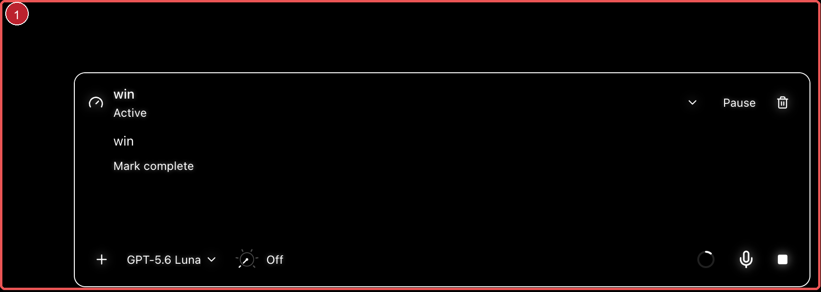
Figure 1 Goal control surface from the supplied capture
Expected result The goal interface should let the user expand the current goal, edit its objective, save or resend the edited objective, and keep the new objective visible after the update. If changing an active goal is intentionally forbidden, the composer should say so before submission and offer a clear in-place edit flow.
Diagnosis This is a real state-transition gap, not just a layout problem. The composer maps a slash goal to the start_goal action, while the runtime explicitly rejects start_goal when a goal is active, paused or blocked. There is no update_goal action in the observed control path. The result is a dead-end: the user must clear or complete a goal before starting another, even though the requested interaction is to update the goal in the goal interface.
Acceptance test Create a goal, edit it without clearing it, save or resend it, close and reopen the goal surface, and verify that the exact revised objective and state are preserved. A failed update must not replace the old goal or leave an unexplained runtime error in the conversation.

2 Goal expansion and the chat viewport are not isolated
Observed The goal row is an animated expandable control. Opening it adds the objective, agent message and Mark complete content below the compact row. During the live reproduction, the active goal continuation and the expanded goal state appeared in the same interaction window, and the chat surface moved as the control content changed.
Diagnosis The row itself only toggles local expansion, but the active goal is also a durable execution state that can trigger a continuation. The user therefore experiences a presentation action next to a running action without a strong boundary. The added height can also change the scroll anchor. This explains the reported jump feeling even when the click handler is only a disclosure toggle.
Expected result Expanding a goal should be a pure inspection action. It should not start, resume or otherwise advance agent work. The viewport should preserve its prior anchor while the animated height changes. Execution should happen only through the explicit normal control, such as Pause or Resume, and the goal surface should expose only the intended actions: expand and delete, with stopping handled by the normal chat control as requested.
Acceptance test With an active goal and a long chat, record the scroll position, expand and collapse the goal repeatedly, and verify no new agent turn starts and the reading position remains stable. Repeat with a paused and blocked goal.

3 Steering is delivered but has no durable pending state
Reproduction In a separate long-running chat, I sent a long request, entered a second diagnostic instruction while the first response was streaming, and pressed Steer.
Actual result The draft cleared immediately. A toast said Steering sent and Your instruction was accepted for the next agent step. Running tools finish before the agent responds. After the first response completed, the timeline contained the steering content as a later agent step, so the runtime did carry the instruction forward. The same Steering sent toast was still visible after completion.
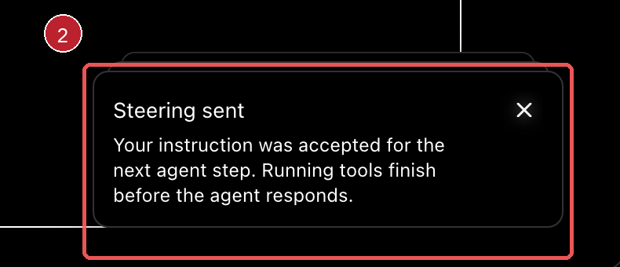
Figure 2 Supplied deferred steering confirmation
Diagnosis The execution path is partly correct: steering is intentionally not a separate turn, and the next provider call carries the instruction. The UI path has no optimistic projection, so after the draft is cleared the only evidence is a toast. There is no durable pending row, no applied-at-step marker and no automatic dismissal tied to the actual completion event. This is why steering feels unreliable even when delivery succeeds.
Expected result Show one compact pending steering state until the next safe boundary applies it. Then replace that state with an applied confirmation tied to the actual turn. Do not allow duplicate submissions while the request is pending, and dismiss or resolve the toast when the run completes.
Acceptance test Steer while a tool is running, steer again before the next provider step, stop the run, and steer when idle. Each instruction must have one visible delivery state: pending, applied, queued or rejected. No instruction may disappear silently or remain marked as newly sent after the run has completed.

4 Queue behavior is present in the runtime but unclear in the interface
Observed During the live running state, the composer exposed Steer but no separate Queue button. The current test support explicitly seeds durable deferred messages through the API independently of the removed Queue button. Earlier supplied screenshots show a separate Up next queue surface with Steer now and delete controls for every row.
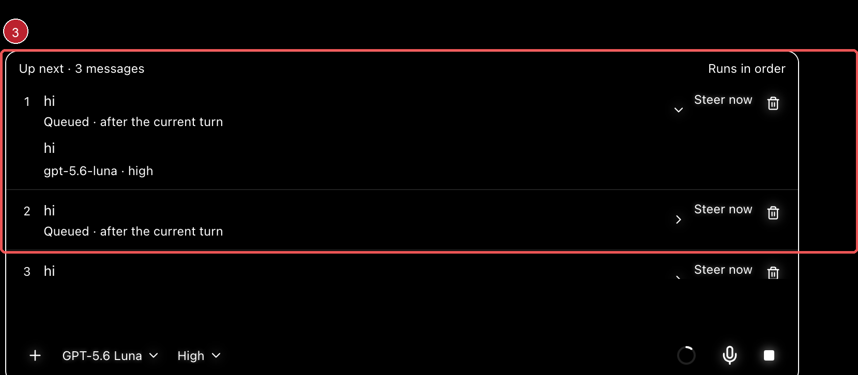
Figure 3 Earlier queue surface with repeated per-message actions
Diagnosis This is primarily a product-model mismatch, not evidence that the queue engine is absent. The runtime and tests retain FIFO queue behavior and a steer_queued action, while the composer intentionally relabels the running primary action as Steer. The old queue surface was visually noisy and duplicated steering actions; the current surface hides too much of the deferred state. The user cannot tell whether a message will interrupt the current run, wait for the next step or remain in FIFO order.
Expected result Choose one simple, explicit model. If the only primary action is Steer, show a separate pending queue indicator when a message cannot be steered immediately. If both modes are required, label them as Steer now and Queue for next turn with one consistent list and one delete action. The result must say when the instruction will take effect.
Acceptance test Submit during streaming, while tools are running, after the run completes and while the queue is paused. Verify the message appears exactly once, the delivery mode is readable, FIFO order is preserved, Steer now promotes the selected item correctly, and the UI does not show stale queue actions after delivery.

5 Conversation opening and chat updates move the reading position
Observed The supplied capture shows the Conversation section as a disclosure surface, and the user reports that opening it automatically pushes the view to the bottom. The same jump family is reported in chat, goal, queue and steering interactions. In the live long-running chat, the timeline ended at the newest content after steering and the active controls changed while the response was completing.
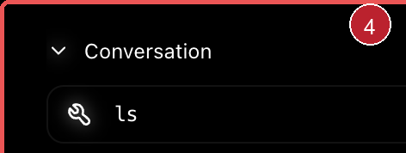
Figure 4 Conversation surface associated with the reported bottom jump
Diagnosis The symptom is credible, but the exact trigger was not isolated independently from the other expanding controls in this run. The likely boundary is scroll anchoring: disclosure height, streamed content and control-tray updates are changing the layout while the viewport is being virtualized. A user who is reading should retain the same visible anchor unless they explicitly choose to follow the live tail.
Expected result Opening or closing Conversation, Goal, Queue or Steering details must preserve the current reading position. A new-message indicator can offer a deliberate jump to newest, but the interface must not silently move the user to the bottom.
Acceptance test Scroll to the middle of a long conversation, open and close each control surface, send a message, receive a streamed response and return from a detail view. Compare the first visible message before and after each action; it should remain stable unless the user requested follow newest.

6 Solar rings remain and the motion result needs a better fixture
Observed The current solar view still shows concentric dotted rings around the central orb. The supplied side-orb capture shows the same ring treatment around a participant orb. In the live app, the selected chat displayed a single tau orb with concentric rings. Two consecutive captures did not make movement visually obvious, but the single-orb state is not enough to prove the full multi-orb animation is stopped.
 | 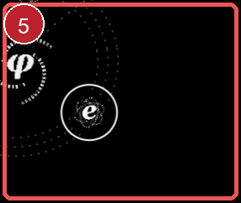
Figures 5 and 6 Remaining central and side orbital ring treatments
Diagnosis The ring-removal request is visibly not complete. Motion itself is not fully diagnosed from this run: the code contains a bounded orbital loop and the end-to-end motion test expects a transform change, while the live fixture did not show the full hierarchy of project and subagent orbs. The side-orb launch path, ring artwork and reduced-motion or stale gates should therefore be tested separately.
Expected result Remove disallowed corona rings from the planetary view while keeping only the intended orbital paths and identity marks. Use a deterministic multi-orb fixture to verify that project and subagent bodies enter directly on their assigned orbit, remain on that orbit and rotate smoothly through state transitions.
Acceptance test Open the solar view with one, two and many orbs; capture the positions over several frames; open and close the view; select a side orb; and repeat with reduced motion. Rings must match the final design rule, positions must change smoothly when motion is enabled, and no orb may appear to burst out of the center.

7 Secondary visual residues reduce trust
Sidebar A detached vertical line and fragments remain after the sidebar symbol treatment changes. The mark no longer reads as an intentional divider or identity symbol.

Figure 7 Residual sidebar line from the supplied capture
Participant finder The list repeats project labels and completion states with weak grouping. A consistent role or identity symbol and compact project grouping would make the list scannable.
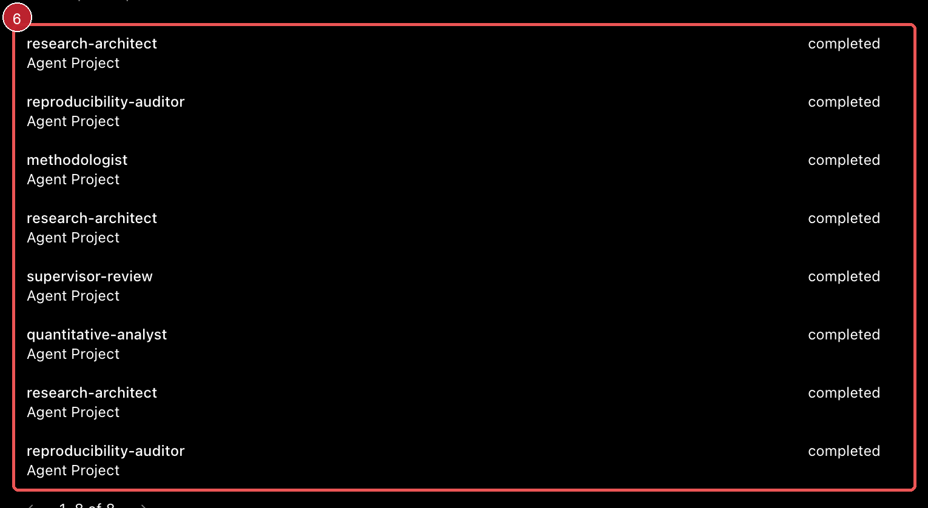
Figure 8 Repeated participant rows from the supplied capture
Priority These polish issues amplify the state bugs: unfinished symbols, grouping and dividers reduce confidence that a goal, queue item or steering instruction was applied to the correct entity.
Acceptance test Open, close and resize the sidebar; search duplicate participant names; and open a summary from each role. Geometry is intentional, grouping is obvious, and the identity symbol is consistent across finder, summary and detail.

Ranked root cause hypotheses
These are the most useful implementation hypotheses, ordered by evidence. They are not claims that a code change has already been made or verified.
Rank | Hypothesis | Evidence and prediction
1 | Goal has a start-only transition | High confidence. The composer sends start_goal and the runtime rejects it when an existing goal is active, paused or blocked. A dedicated update path should remove the error without clear or complete.
2 | Steering has no durable UI projection | High confidence. The live store explicitly has no optimistic projection and only shows a toast after receipt. A pending/applied state tied to live events should remove the uncertainty.
3 | Queue was intentionally removed but not replaced with an equivalent state cue | High confidence. Test support names the removed Queue button while runtime tests retain queue behavior. A clear pending indicator should reconcile the model.
4 | Disclosure and streaming updates disturb scroll anchoring | Medium confidence. Animated height and streamed content can change the virtualized layout. A preserved anchor should stop the jump across all control surfaces.
5 | Orbital artwork and motion gates are implemented as separate layers | Medium confidence for rings, lower for motion. The ring symptom is visible; a multi-orb fixture is required to confirm the exact animation path and transition defect.

Recommended fix order
Order | Change | Reason
1 | Add an explicit in-place goal update flow | Removes the confirmed rejection and makes the durable goal trustworthy.
2 | Separate disclosure from execution and preserve scroll anchors | Stops goal, Conversation and chat interactions from feeling like one jumpy action.
3 | Expose steering delivery as pending then applied | Makes the already-partly-correct runtime behavior observable and reliable.
4 | Define one queue interaction model | Either Steer now plus a pending queue indicator, or a clean two-mode control; remove ambiguity.
5 | Remove ring layers and test a deterministic multi-orb fixture | Separates visual cleanup from the remaining motion diagnosis.
6 | Clean sidebar, participant and identity treatments | Finishes the visual system after behavior is stable.

Final bug description
Radian still has a cluster of state and animation bugs around /goal, steering, queueing and the orbital interface. The confirmed functional blocker is that a second /goal command cannot update an existing goal: the app rejects it with UpdateSessionControlsError and leaves the old goal unchanged. Goal expansion and related control updates also alter the layout in a way that can move the chat viewport. Steering is accepted by the runtime for the next provider step, but the interface clears the draft and gives no durable pending or applied state, so the request looks lost and its toast can remain after completion. Queue behavior exists in the runtime but the separate Queue button has been removed, leaving the user without a clear indication of whether a message is steered immediately or deferred. The solar view still shows unwanted concentric rings, and the full project and subagent motion path needs a deterministic multi-orb test before its animation can be declared fixed. Residual sidebar geometry, repeated participant rows and missing identity cues add to the impression that state changes are not fully under control.
Definition of done A user can create, expand, edit and resend a goal without clearing it; open and close control surfaces without a viewport jump; steer once and see exactly when the instruction takes effect; understand any queued message and its order; and view a clean solar system where project and subagent orbs appear on their own orbit and move smoothly. The remaining sidebar and identity surfaces are visually intentional and stable.
Evidence boundary This report records live observations, supplied screenshot evidence and code-backed hypotheses. It does not claim that any source fix has been implemented. The Science Space project used for live reproduction lacked a UI source, so the agent's needs-attention result is treated as a fixture limitation rather than a Radian failure.

