Radian Product View Follow Up
New interaction and visual issues from the September review
Review date 14 September 2026 Scope Sidebar, solar system, goals and steering Status Open feedback

Purpose
This document records the new visual and interaction problems shown in the supplied screenshots. It separates visible symptoms from the intended product behavior so the follow-up can be implemented and verified without mixing it with the earlier Product View list.

Overall assessment
The new captures show residual artifacts in the sidebar, a dial that is too busy and too easy to trigger accidentally, orbital rings that remain visible, and several interaction surfaces that still jump, change state unexpectedly or defer actions without enough clarity. The participant and summary views also need a stronger visual hierarchy and matching identity cues.

Issue summary
# | Issue | User impact
1 | Stray line remains in the left sidebar | A leftover line reads like a broken symbol or unfinished layout residue.
2 | Effort dial is too busy and too sensitive | Repeated clicks can change performance and the control is not ultra-simple.
3 | Solar-system rings are still visible | The requested simplified planetary view has not been applied consistently.
4 | Find a participant layout is too dense | Repeated agent rows are difficult to scan and compare.
5 | Summary lacks matching identity symbols | Text-only summaries make the related project, role or agent harder to recognize.
6 | Conversation opens at the bottom | Opening a conversation changes the reading position before the user chooses to scroll.
7 | Chat still has a jump bug | The chat surface does not preserve a stable position during interaction.
8 | Goal state is not stable | The goal view changes unexpectedly instead of preserving the edited goal.
9 | Steering needs reliable deferred execution | A steering request must apply at the next possible moment when immediate steering is unavailable.

1 Left sidebar retains a stray line
Observed After the sidebar symbol treatment changes, a thin vertical line and small detached fragments remain on the left. The remaining mark no longer reads as the intended symbol or as a meaningful divider.

Figure 1 Remaining sidebar line and detached fragments highlighted
Why it matters Residual geometry makes the sidebar look corrupted and undermines confidence that the symbol removal or transition is complete.
Desired behavior Remove the obsolete line and detached fragments completely, or replace them with the one intentional divider or symbol defined by the final sidebar layout. The cleanup must not leave a one-pixel remnant when the sidebar opens, closes or reflows.
Acceptance check Open, close and resize the sidebar repeatedly. No detached line remains, the intended symbol or divider is the only visible geometry, and the result is stable at the smallest supported sidebar width.

2 Effort dial should be ultra simple and deliberate
Observed The current effort control is presented as a dial-like symbol with the value Max. It is visually busy for a compact setting, and repeated clicking can change the performance level in a way that feels too easy to trigger accidentally.

Figure 2 Effort control showing the current dial treatment and Max value
Why it matters Effort is consequential: an accidental input can change response time, cost or model behavior. A decorative control that is easy to click repeatedly creates uncertainty about what changed.
Desired behavior Use an ultra-simple dial with one clear value, one obvious current position and a deliberate interaction target. A click should not cycle or change performance unless it is an intentional level change; repeated clicks should be idempotent when the value is already at its limit. Keep the selected level visible and explain the change through a small state update rather than extra decoration.
Acceptance check The control is understandable without inspection, repeated clicks do not cause unintended changes, the value changes only through deliberate input, and the selected effort level remains stable across chat and goal interfaces.

3 Solar-system rings are still present
Observed The solar-system captures still show several concentric rings around the mathematical orbs, including both the central phi treatment and a side e orb. This remains visible after the request to remove the rings from the solar-system view.
 | 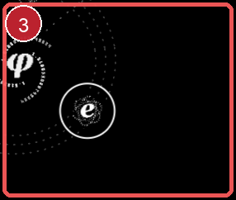
Figures 3 and 4 Remaining ring treatments around central and side orbital bodies
Why it matters The extra rings compete with the orbital paths and make the simplified planetary view feel inconsistent. Repeated rings also make it harder to distinguish identity artwork from navigation geometry.
Desired behavior Remove the unwanted corona rings from the solar-system view while preserving only the orbital paths and the minimal identity mark that is intentionally part of each body. Apply the same rule to the center and side orbs, including entry, selected and reduced-motion states.
Acceptance check Open the solar-system view with different hierarchy levels and selections. No disallowed concentric rings appear around the center or side orbs, and the remaining orbit paths stay readable and consistent.

4 Find a participant needs a clearer layout
Observed The participant finder presents a long repeated list of agent names, project labels and completion states. The rows have weak grouping and little visual separation, so the list reads as a wall of similar text.
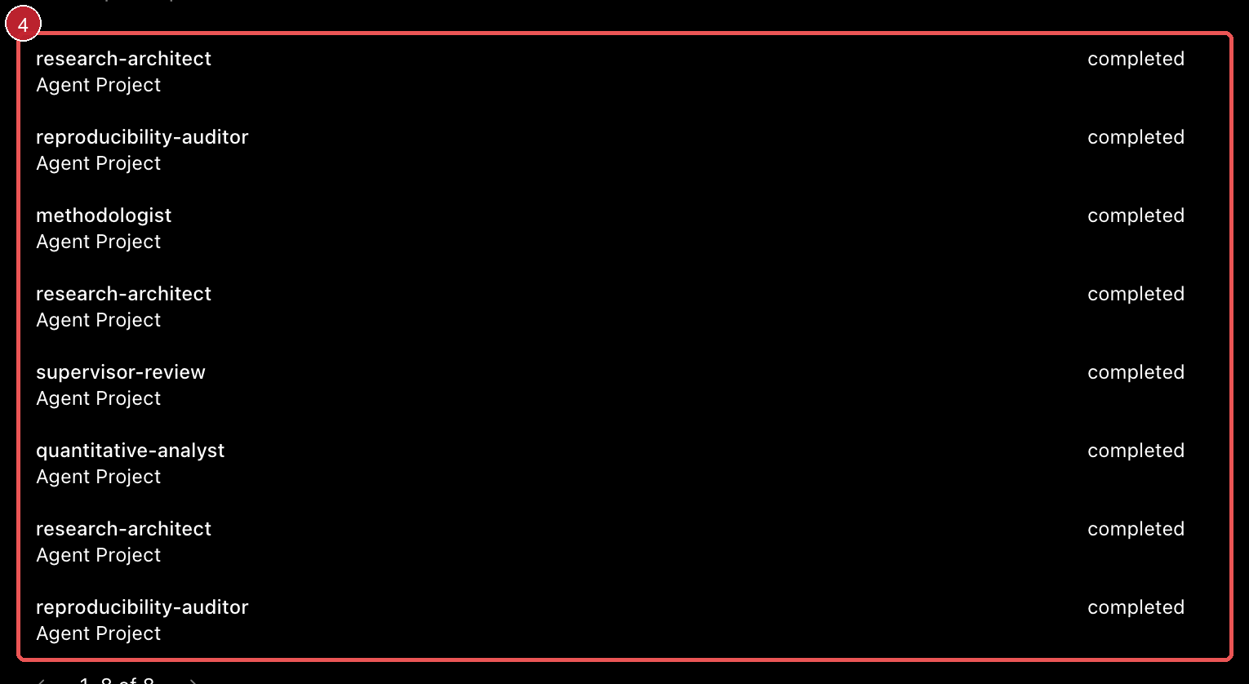
Figure 5 Participant finder list with repeated entries highlighted
Why it matters Finding the right participant requires recognition and comparison. Repeated text without role, identity or grouping cues increases search time and makes the interface feel noisy.
Desired behavior Group participants by the relevant project or context, give each row a consistent symbol for its role or identity, and make name, status and action areas visually distinct. Keep the list compact, sort it predictably and avoid repeating the project label when the grouping already communicates it.
Acceptance check A user can identify a participant and its project or role at a glance. Repeated entries are visually grouped, status is readable, symbols match the participant type, and the layout remains usable with long names and many results.

5 Summary views need matching identity symbols
Observed The summary/detail surface shows an agent result as text with a status and a Result section, but there is no clear symbol that ties the summary back to the corresponding project, agent role or participant identity.
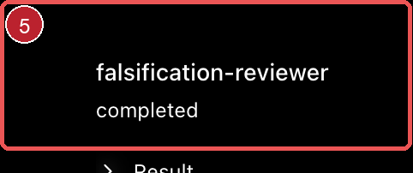
Figure 6 Agent summary and result surface
Why it matters A symbol provides fast recognition across the participant finder, summary and detail views. Without it, the user has to reread names and labels to confirm which entity is being inspected.
Desired behavior Show the matching identity or role symbol in the summary header and use the same symbol consistently in the participant finder, summary and expanded detail. Keep the symbol secondary to the name and status, with a stable size and position that does not move when sections expand.
Acceptance check The summary always shows the symbol corresponding to the displayed project, role or agent. The same identity remains recognizable when the user expands Result or navigates back to the participant list.

6 Opening Conversation should preserve the reading position
Observed When Conversation is opened, the interface is pushed to the bottom of the conversation area automatically. The user does not choose to jump there, and the visible context starts with the lower content instead of the conversation entry point.

Figure 7 Conversation surface with the automatic bottom jump context
Why it matters Automatic scrolling removes orientation and makes the opening transition feel like another jump bug. It is especially disruptive when the conversation is opened to inspect its structure rather than to continue at the newest message.
Desired behavior Open Conversation at a stable, intentional anchor: preserve the prior scroll position when returning to it, or start at the top or a clearly marked unread boundary. Scroll to the bottom only after an explicit user action or when a new message arrives and the user is already following the live tail.
Acceptance check Opening and closing Conversation does not unexpectedly move the viewport. Returning to the view restores the prior position, while explicit scroll or follow-newest behavior remains available and predictable.

7 Chat still jumps during interaction
Observed The chat interface still exhibits the reported jump bug during interaction. The visible composer and surrounding content can change position rather than remaining anchored while a command, goal or related state is processed.
Why it matters A moving chat surface makes it difficult to tell whether the user is reading, editing or watching an update. It also compounds the automatic Conversation scroll problem and makes every command feel less reliable.
Desired behavior Keep the chat viewport anchored while content, goal state or controls update. Preserve the user's scroll position unless they are actively following the newest content, and coordinate layout changes so the composer, current message and active status do not jump between frames.
Acceptance check Send messages, open the goal surface and return to chat repeatedly. The viewport and composer remain stable, no content jumps unexpectedly, and the user can still choose to follow the newest message explicitly.

8 Goal state should remain stable after editing
Observed The goal surface still does not stay fixed: the displayed goal can change or appear inconsistent after interaction. The captured state shows an active goal with controls, but the user reports that the goal itself is not preserved reliably.
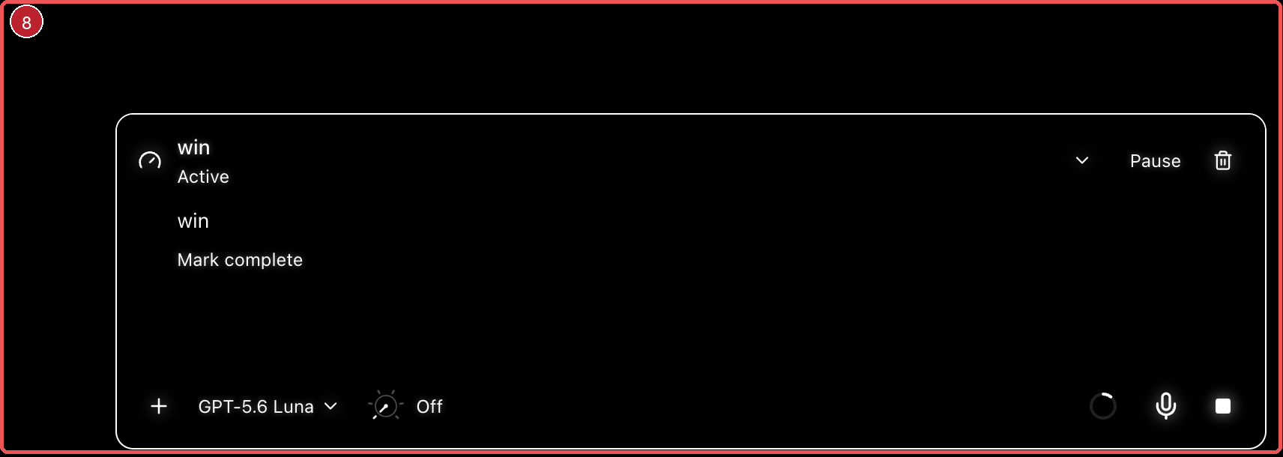
Figure 8 Goal surface with the changing state context
Why it matters A goal is a durable instruction. If its text or state changes without a deliberate edit, the user cannot know what the agent is actually pursuing or whether an update was accepted.
Desired behavior Treat the goal text and goal state as one stable record. Editing should occur in the goal interface, remain visible after saving or resending, and update the active interaction only after a clear confirmation. Do not replace the goal with a transient agent response or reset it when the user opens related controls.
Acceptance check Create, edit, resend and reopen a goal. The exact edited goal remains visible, the active or paused state is explicit, and no unrelated interaction changes the goal text or target.

9 Steering should apply at the next possible moment
Observed The interface reports that steering was accepted for the next agent step while running tools finish first. The request is acknowledged, but the user still needs a reliable guarantee that steering will be applied as soon as the current non-interruptible work ends.
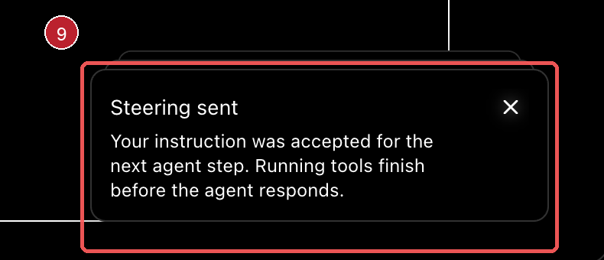
Figure 9 Deferred steering confirmation
Why it matters Steering is time-sensitive. A confirmation without visible execution state leaves the user unsure whether the instruction is pending, ignored or already applied.
Desired behavior If immediate steering is impossible, place the instruction in a single pending steering state and apply it at the next safe execution boundary. Show a concise pending status, prevent duplicate submissions from creating conflicting instructions, and update the conversation as soon as the steering takes effect. If steering is possible immediately, execute it without routing through a separate queue view.
Acceptance check Send steering while tools are running. The interface shows one pending request, applies it at the next possible moment, confirms the resulting change in the active interaction and never silently loses or duplicates the instruction.

Recommended implementation order
These changes are separate follow-up items. The order below starts with visible breakage and then moves toward clearer information hierarchy and deferred interaction behavior.
Order | Change | Reason | Priority
1 | Remove stray sidebar geometry | Restores a clean, trustworthy navigation surface. | High
2 | Simplify and harden the effort dial | Prevents accidental performance changes. | High
3 | Remove remaining solar-system rings | Applies the requested planetary simplification consistently. | High
4 | Rework participant finder grouping | Makes participants easy to scan and compare. | Medium
5 | Add matching summary symbols | Connects identity across finder and detail surfaces. | Medium
6 | Preserve Conversation scroll position | Removes the automatic bottom jump. | High
7 | Anchor chat layout during updates | Prevents the recurring chat jump bug. | High
8 | Stabilize goal records and edits | Keeps the active instruction trustworthy. | High
9 | Execute steering at the next safe boundary | Makes deferred steering reliable and visible. | High

Final follow up view
The follow-up should feel quiet, stable and intentional: no leftover sidebar fragments, no accidental effort changes, no unwanted orbital rings, and no unexplained jumps in participant, conversation, chat, goal or steering surfaces. Identity symbols should help recognition without adding clutter, and deferred actions should show exactly when they will take effect.

Evidence note
The screenshots were supplied for this follow-up review and were captured on 14 September 2026. They show presentation and interaction states; they do not by themselves establish end-to-end runtime correctness.

