Radian Product View
Interaction and visual issues in the current interface
Review date 14 September 2026 Scope Ledger, controls and effort Status Open feedback

Purpose
This document records the visual and interaction problems shown in the attached screenshots. The goal is to make the product feel deliberate, coherent and easy to control during everyday use. The descriptions below distinguish what is visible now from the desired behavior.

Overall assessment
The visual language is distinctive, but several small interaction states weaken the feeling of quality. Abrupt disappearance, static sidebar symbols, abrupt chat opening, drifting row marks, stuttering Goal/orb motion, side orbs entering from the center, project, agent and goal information overload, unreliable steering, a separate queue action, unfinished solar-system transitions, unnecessary planetary-view controls, a duplicate conversation symbol, a plain planetary background, accidental-looking focus rectangles, inconsistent divider treatment and a text-only effort selector all make the interface feel less stable than the underlying product concept. These are focused polish issues with a direct effect on trust and perceived control.

Issue summary
# | Issue | User impact
1 | Leader symbols disappear instantly | The interface feels abrupt and unfinished when a leader is opened or closed.
2 | Unexpected button rectangles | Clicking controls creates square outlines that read as visual glitches rather than intentional focus.
3 | Ledger divider color mismatch | The left and right sides do not feel like one coherent surface.
4 | Effort level is not a dial | The current dropdown does not communicate a value that can be turned up or down.
5 | Static corona rings | The orbital metaphor feels frozen, making hierarchy harder to read.
6 | Sidebar symbols do not visibly spin | The navigation loses the motion cue that connects the sidebar to the solar-system identity.
7 | Chat opens abruptly | The selected chat appears without a transition.
8 | Animated mark drifts from its label | The transition can make the symbol and text feel disconnected.
9 | Goal/orb animation stutters | Motion hitches and the orb changes position or size.
10 | Side orbs enter from the center | The orbital hierarchy looks assembled instead of spatially intentional.
11 | Project, agent and goal details open abruptly | Direct jump to dense views without progressive disclosure.
12 | Steer and queue controls do not work cleanly | Steering does not visibly take effect and the queue adds avoidable complexity.
13 | Solar-system transitions feel unfinished | State changes can read as jumps instead of one continuous space.
14 | Planetary view shows unnecessary controls | The ellipsis and close buttons add noise to an otherwise focused view.
15 | Conversation view contains a duplicate symbol | The large decorative mark adds clutter and displaces the actual conversation content.
16 | Planetary background is visually empty | The scene lacks a subtle mathematical star-map layer that could enrich the spatial identity.

1 Leader symbols disappear too quickly
Observed When the leader is opened and then closed on the left side, the related symbols disappear immediately. There is no fade-out or short settling transition.
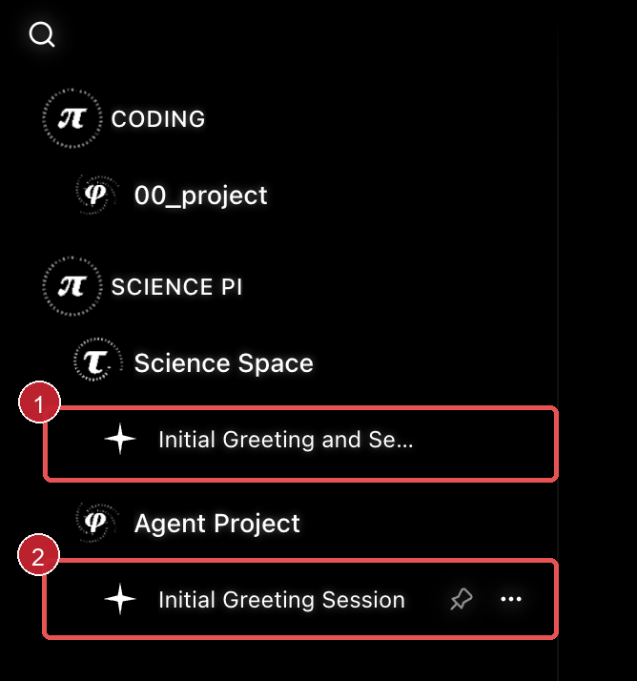
Figure 1 Ledger hierarchy with the leader and child symbols visible
Why it matters The instant removal makes the hierarchy feel like it is being deleted rather than closing. It is especially noticeable because the rest of the interface uses orbital marks and soft visual movement.
Desired behavior Keep the current symbols in place briefly and fade them out together. The transition should be short, predictable and cancelled if the leader is reopened during the fade. Reduced-motion settings should switch to an immediate but non-jarring state change.
Acceptance check Opening and closing a leader produces a coordinated fade. No child symbol blinks, jumps to a new position or vanishes before its siblings.

2 Clicked buttons show unwanted rectangles
Observed Some controls show a square outline after being clicked. The outline is much stronger than the surrounding visual language and looks like an accidental browser or native focus artifact.
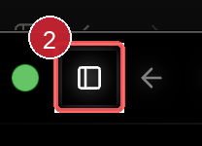 | 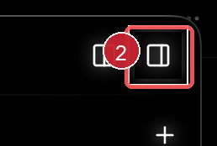
Figures 2 and 3 Rectangular outlines around layout controls after interaction
Why it matters A focus state should help the user understand where input is going. These rectangles instead compete with the icon and suggest that the control has a broken border or an unfinished selected state.
Desired behavior Remove the click-only rectangle and replace it with a quiet selected state that matches the existing glow and line treatment. Preserve a clearly visible keyboard focus state for accessibility, but make its geometry intentional and consistent with the control.
Acceptance check Clicking the control does not leave a square artifact. Tabbing to the same control still produces a visible, accessible focus indicator without changing the surrounding layout.

3 Ledger divider lines use different visual weights
Observed The divider on the right side of the workspace reads differently from the divider on the left. Their brightness and visual weight do not feel like two instances of the same ledger boundary.
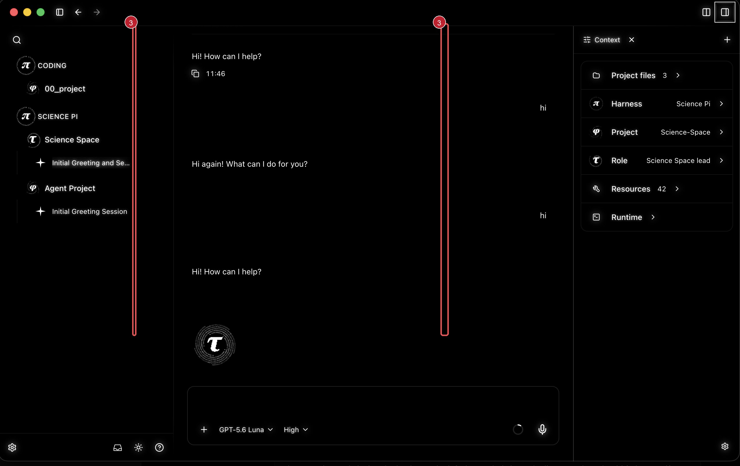
Figure 4 Full workspace view with the left and right ledger boundaries highlighted
Why it matters The mismatch makes the workspace feel assembled from separate surfaces rather than designed as one system. It is subtle, but it becomes visible when the context panel is open and the eye compares both edges.
Desired behavior Use one shared divider token for both sides: the same color, opacity, thickness and hover behavior. If the two boundaries intentionally have different roles, that distinction should be communicated through layout or labels, not an unexplained color difference.
Acceptance check With the context panel open and closed, both ledger boundaries use the same neutral line treatment and remain stable across window sizes and themes.

4 Effort level should be a turnable dial
Observed The effort level is currently presented as the text value High with a chevron. This behaves like a conventional dropdown, not like an adjustable intensity control.

Figure 5 Current effort selector showing the High value and chevron
Why it matters Effort is understood as a setting that can be increased or decreased. A dial would make that relationship visible at a glance and would reduce the feeling that the user must open another menu to understand the available levels.
Desired behavior Replace the text-only selector with a compact dial that turns up and down through the levels supported by the selected model. Use snapped detents rather than a continuous value if the provider exposes discrete reasoning levels. Support click and drag, mouse wheel or trackpad movement, and keyboard arrow keys. Keep the current level readable next to or inside the dial.
Acceptance check The user can increase and decrease effort without opening a menu. The dial has a clear current position, snaps to valid levels, updates its accessible name and remains usable with keyboard input and reduced motion.

5 Solar system coronas and orbit motion are not visible
Observed In the supplied solar-system captures, the project and subagent corona details look frozen. The screenshots do not by themselves prove whether the animation timer is stopped, but the visible result does not make continuous rotation legible.
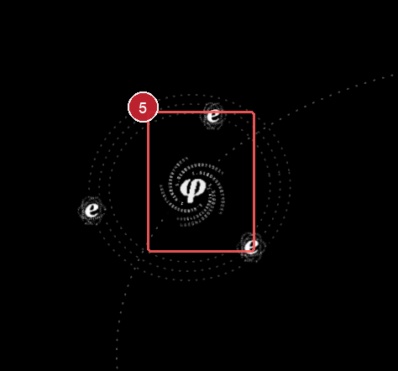 | 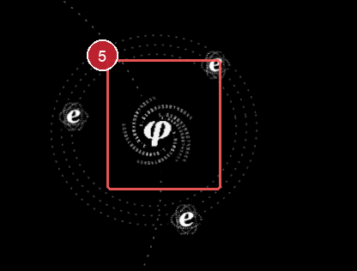
Figures 6 and 7 Solar-system captures with the project and subagent corona region highlighted
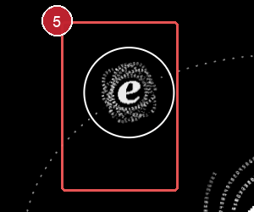
Figure 8 Close-up of a subagent corona that should communicate rotation
Current explanation The different orbital paths appear to be an intentional hierarchy choice. Primary bodies receive different radii based on their order, while nested agents receive a smaller satellite radius around their parent. The renderer uses one shared phase clock for primary lanes and a faster phase for satellites, which produces concentric or nested tracks rather than one common orbit. The implementation calculates a per-lane period, but the position update is called with zero elapsed orbit time, so that period does not control angular speed; the shared phase clock does.
Desired behavior When orbital motion is enabled and the scene is not hovered, focused, hidden or in reduced-motion mode, the project and subagent corona rings should rotate visibly. Keep child agents on nested paths if hierarchy is intended, but make the parent-child relationship obvious through consistent spacing, related phase and readable speed. Decide explicitly whether the intended visual is nested lanes or one shared orbital plane.
Acceptance check Over a two-second observation, the project and subagent corona pixels change position continuously. All enabled bodies rotate, motion pauses only under documented conditions, and selected, hovered and reduced-motion states remain stable.

6 Sidebar symbols do not visibly spin
Observed In the supplied sidebar capture, several mathematical marks appear frozen even though they use the same corona language as the solar system. The sidebar therefore does not communicate the expected ambient motion.
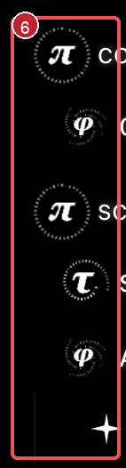
Figure 9 Sidebar symbol region with the non-spinning marks highlighted
Why it matters The sidebar is the user's persistent orientation surface. If its symbols are static while the solar system is meant to feel alive, the product reads as inconsistent and the difference between identity mark and live state is unclear.
Current explanation The sidebar uses the same ConstantOrb artwork, but navigation marks can be rendered with the still state unless their owning item is active or the motion setting allows idle animation. Global mathematical-motion settings, the workspace orbit-motion setting and prefers-reduced-motion can also pause these animations. The screenshot proves the visual symptom, but not which of those gates is responsible in this exact session.
Desired behavior Decide which sidebar marks should be ambiently animated and apply that rule consistently. At minimum, the active harness, project, leader and selected chat should share a visible but restrained rotation. The animation should pause only for documented reduced-motion, global pause or hidden-window conditions, and it should not change row geometry or make text harder to read.
Acceptance check With motion enabled, a two-second screen recording or pixel-difference check shows the intended sidebar corona layers changing position. The same marks pause predictably when motion is disabled or reduced motion is requested, and opening or collapsing a leader does not reset the animation phase unexpectedly.

7 Opening a chat happens without a transition
Observed Opening a chat makes the content appear immediately as a hard state change. There is no short entrance animation that connects the selected sidebar item to the chat surface.
Why it matters A hard pop-in makes navigation feel disconnected and makes it harder to understand what changed. The surrounding product already uses motion as part of its visual language, so the chat opening feels unusually abrupt.
Current explanation The observed behavior is an immediate navigation or render state rather than an animated transition. The intended timing, direction and relation to the existing chat animation are not specified yet; that existing animation should be the reference for the new entrance.
Desired behavior Animate the chat surface into view using the same visual language as the existing chat animation: a short, restrained entrance that preserves the final geometry and does not delay interaction. The selected row and chat content should move or fade as one coordinated transition. Respect reduced-motion and disabled-motion settings with an immediate stable state.
Acceptance check Selecting a chat produces a visible, purposeful entrance animation and reaches the same final layout without a flash or jump. Repeated opens do not accumulate motion, and reduced-motion settings skip the animation cleanly.

8 Opening or closing should keep the animated mark aligned with its label
Observed When the left-side hierarchy is opened or closed, the animated mark and the written chat label should remain one coherent row. If their placement or timing diverges, the mark can appear detached from the actual text change.
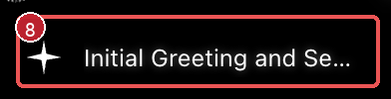
Figure 10 Chat row showing the animated mark and its written label as one alignment unit
Why it matters The mark is the visual cue for the item. If it separates from the label, users may read the transition as a layout glitch rather than a deliberate animation.
Current explanation The row combines a leading mark with text whose visibility and layout change as the hierarchy opens or closes. If the mark is animated separately while the text reflows independently, their timing can diverge. The screenshot establishes the intended visual relationship but not the exact transition timing.
Desired behavior Keep the animated mark anchored to the same row and baseline as its label throughout the transition. Animate the row as a unit or coordinate the mark's opacity and position with the text layout change. When a row is removed, its mark should follow the same exit path as the label; when inserted, both should enter together.
Acceptance check Open and close the leader repeatedly. The mark and label stay aligned during the entire transition, no mark floats in empty space or lags behind the text, and final spacing matches the static layout. Reduced-motion settings skip to the same aligned final state.

9 Goal/orb animations stutter and change position or size
Observed Entering the /goal feature produces a visible hitch instead of a smooth transition. The same animation feels buggy inside the Goal interface, and the chat orb animation can change position or size while it runs.
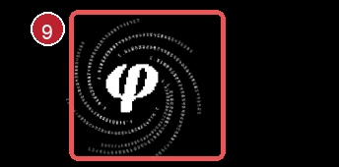
Figure 11 Orb animation with the changing position and scale region highlighted
Why it matters Motion is part of the product's identity. A hitch or shifting orb makes the interface feel unstable and distracts from the Goal state the user is trying to enter or inspect.
Current explanation The screenshot shows the orb artwork but cannot establish the exact frame-time or layout cause. The symptom suggests that the transition timing and the orb's layout box or transform scale are not being kept stable across the /goal entry and Goal interface states.
Desired behavior Make the /goal entry and the Goal interface animation smooth and consistent with the existing chat animation. Keep the orb anchored to a fixed layout box and transform origin while only its intended inner artwork animates. Avoid jumps, frame hitches and unplanned scale changes, and respect reduced-motion and disabled-motion settings with a stable final state.
Acceptance check Record repeated entries into /goal and the Goal interface. The transition remains smooth, the orb keeps the same anchor and size, and no visible hitch or jump occurs. Reduced-motion mode reaches the same final layout without animation.

10 Side orbs should appear on their own orbital paths
Observed In the supplied solar-system capture, the side orbs appear to emerge from the central orb rather than arriving as independent bodies on their own orbital paths.
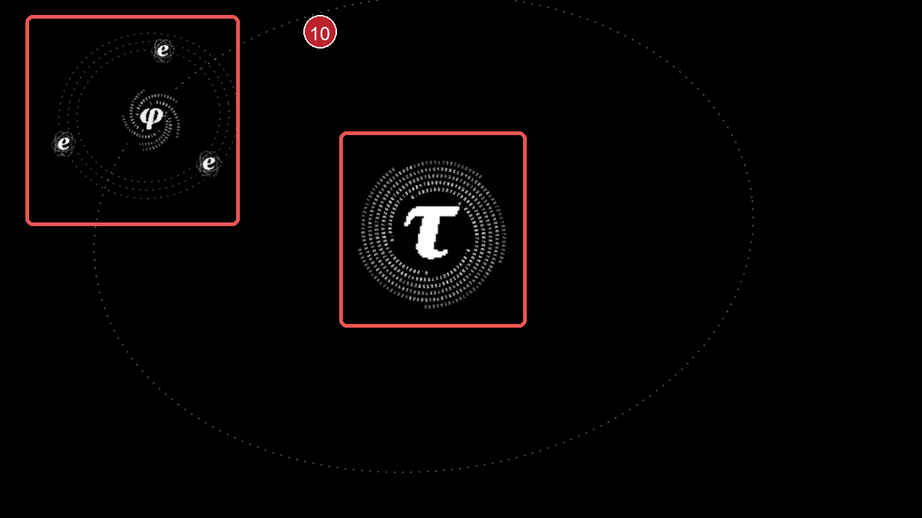
Figure 12 Central and side-orb positions showing the unintended pop-out relationship
Why it matters The orbital view is meant to communicate a spatial hierarchy. If side orbs visibly pop out of the center, the scene feels assembled by an effect instead of organized by relationships.
Current explanation The side orbs are visually attached to the central body by their entry path or shared anchor. That may be a projection or layout issue rather than the intended orbital hierarchy; the screenshot alone does not establish whether this is an entrance animation or the final placement.
Desired behavior Place each side orb directly on its assigned orbital path, with its own stable center, radius and phase. If an entrance animation is used, animate the orb along that path from an intentional starting point rather than from the middle orb. Keep the final positions independent and preserve the parent-child relationship through orbit geometry, not a pop-out effect.
Acceptance check Repeatedly open the solar-system view. Side orbs appear on their own orbital paths without visibly travelling out of the center, settle at the same final positions, and maintain their relationship to the central orb during motion and reduced-motion mode.

11 Project, agent and goal details open as an information dump
Observed Clicking a project or agent orb immediately moves the user into the information interface and exposes a large block of detail. The same abrupt information jump occurs when interacting with the /goal command and its goal interface.
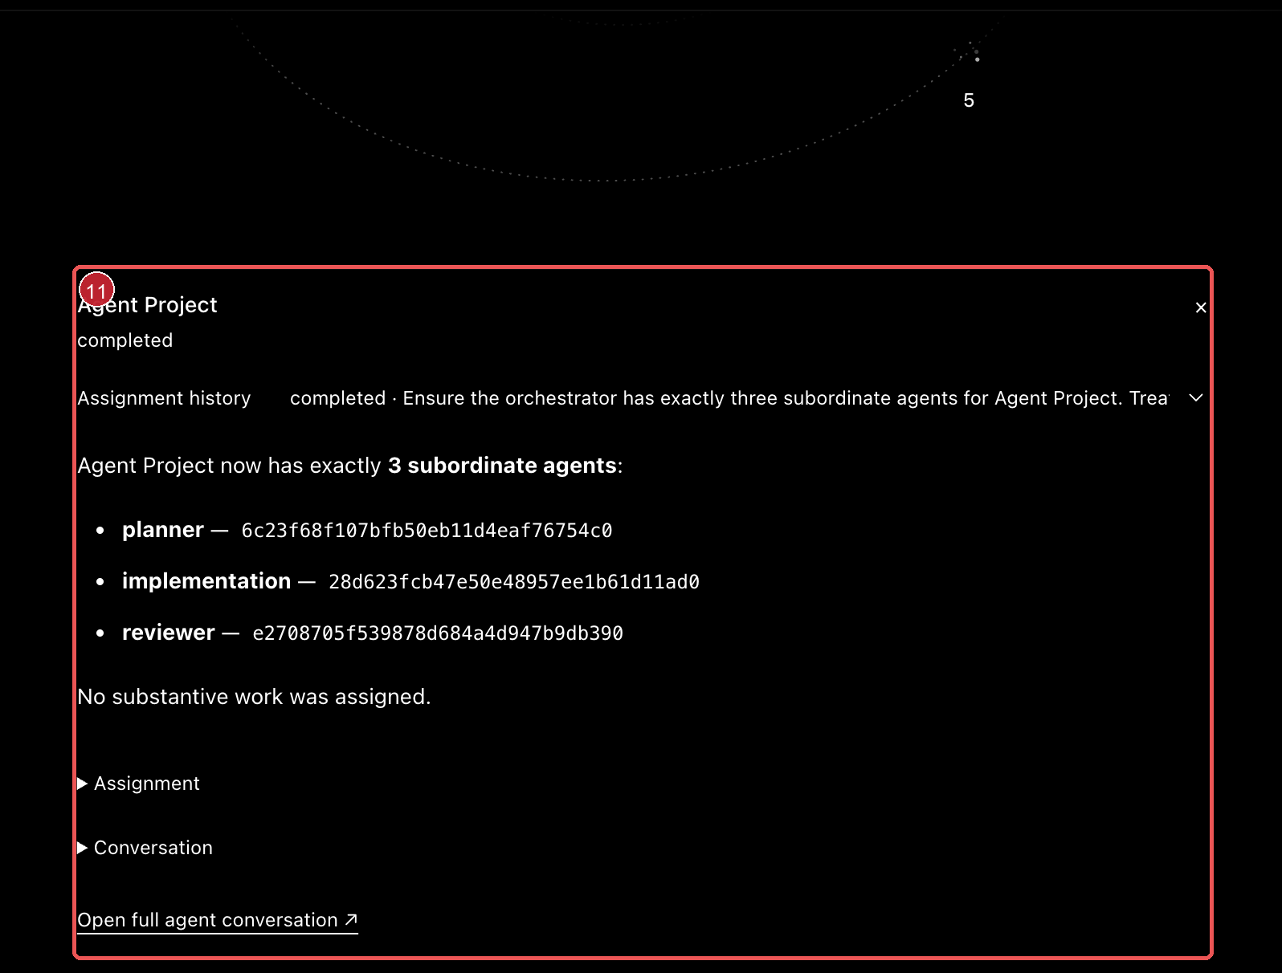 | 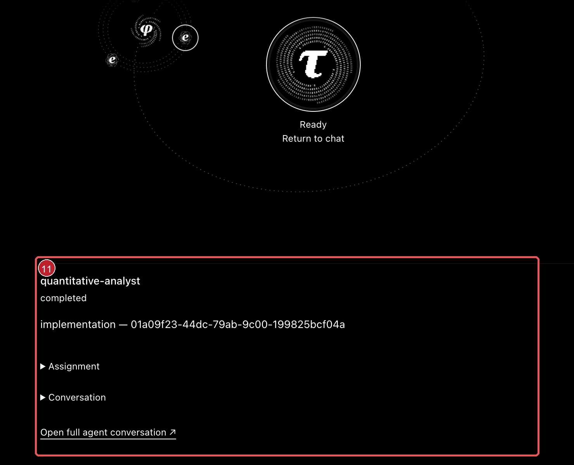 | 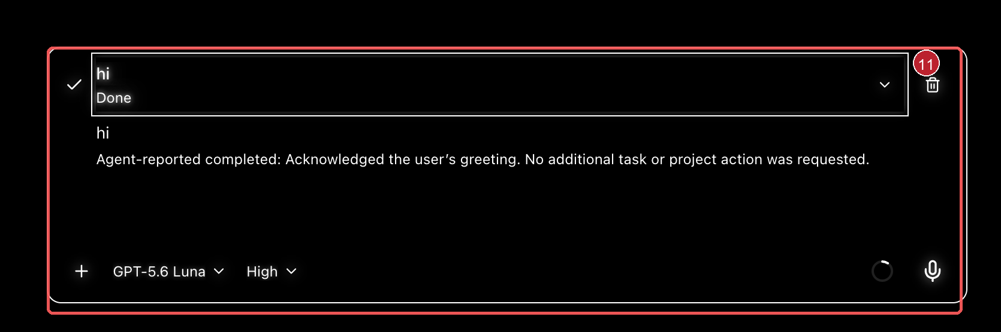
Figures 13 to 15 Project, agent and goal information views that open with dense detail
Why it matters The user loses the orbital context and is confronted with more information than is needed for the first decision. This makes exploration feel like a forced context switch rather than a controlled inspection, including when working with goals.
Current explanation The current interaction appears to combine navigation and information disclosure in one step for projects, agents and goals. The screenshots show the resulting density, but not whether the intended entry point is a modal, panel or full interface route.
Desired behavior Keep the user in the orbital view or current chat context until details are intentionally requested, or open the project, agent or goal information panel as a contained, staged transition. Reveal a concise status summary first, keep assignment, conversation and goal-editing detail collapsed by default, and use progressive disclosure. The close or back action should return to the same orbit or chat position.
Acceptance check Clicking a project or agent orb, or interacting with /goal, does not hard-jump into an information dump. The view opens with a short transition, shows summary information first, keeps deeper details collapsed, and returns to the same orbital or chat context when closed.

12 Steer and queue controls do not work cleanly
Observed The interface presents Queue as a separate action and then repeats Steer now and Delete controls inside the queue. The screenshots show a visually heavy queue panel, while clicking Steer does not visibly steer the active interaction. The same abrupt interface jump also occurs when entering or interacting with queueing and steering.
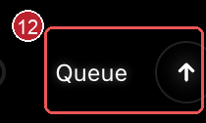
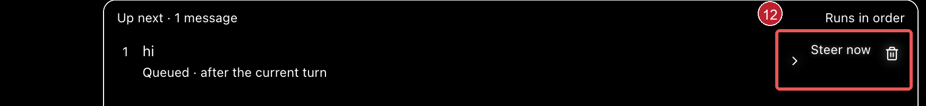
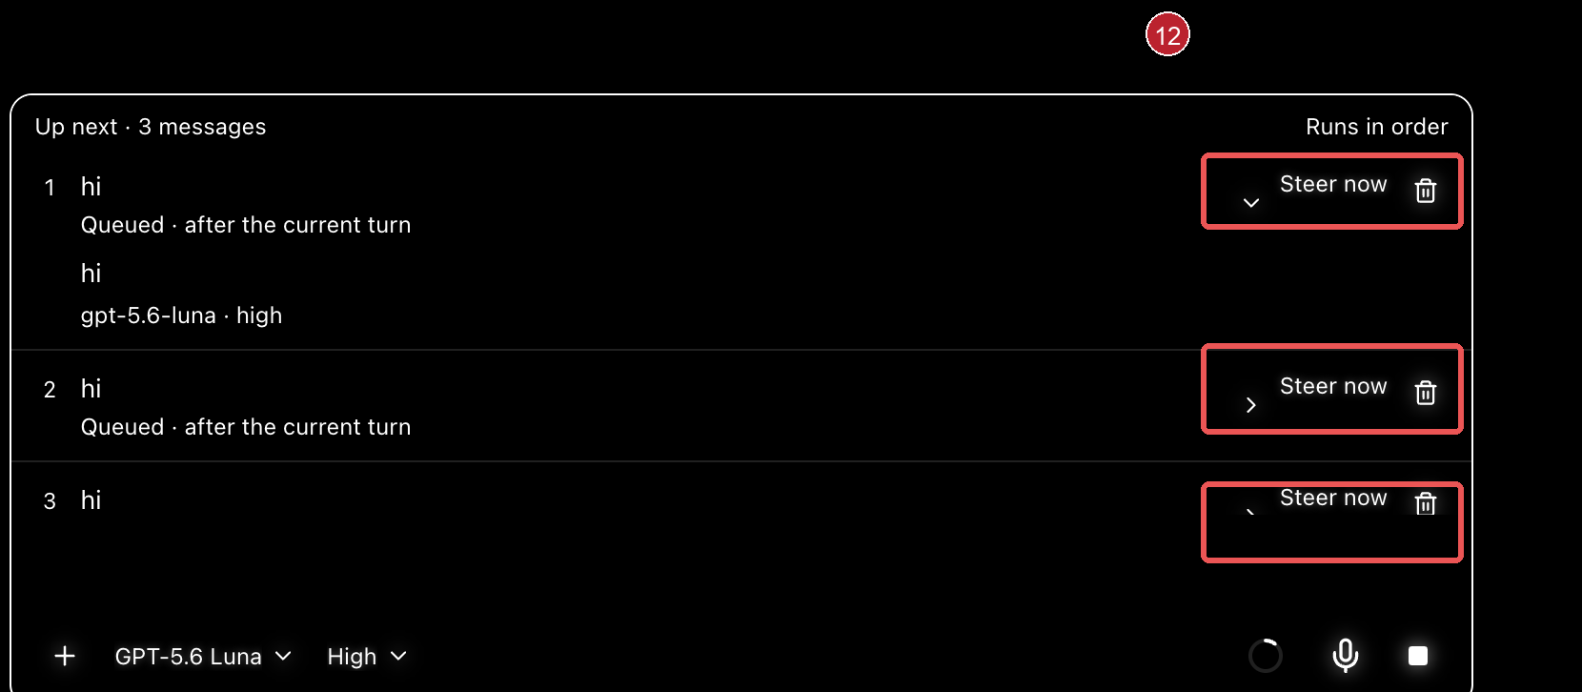
Figures 16 to 18 Separate Queue control and dense queue panels with repeated steering actions
Why it matters Steering is a primary interaction, not a decorative state. If the action has no visible effect and the queue competes with it as a separate mode, users cannot tell whether their instruction was applied, deferred or ignored.
Current explanation The captures establish the visible control structure and the reported no-op behavior, but they cannot prove which runtime event is missing. The likely product-level problem is that queueing is exposed as a parallel destination instead of supporting a clear steer action on the current turn and a quiet status for deferred messages.
Desired behavior Use only Steer and Delete as actions in this interface. Remove the separate Queue button; queueing should be represented as the state of a message, not as a competing primary action. Clicking Steer must immediately apply the selected instruction to the active interaction, update the visible conversation state and make the effect clear. Keep queued items in a clean, compact list with readable status text. Stopping remains the existing normal stop control and should not be duplicated here.
Acceptance check The interface contains only Steer and Delete actions for these items. There is no separate Queue button, no hard jump when queueing or steering, and clicking Steer produces a verifiable change in the active interaction. Queue state remains understandable for one or several messages, while the existing normal stop button continues to handle stopping.

13 Solar-system transitions feel unfinished
Observed Transitions between solar-system states are not consistently polished. Changes between orbital scenes, orb sizes, positions, rotations and entry or exit states can feel like separate animations handing off abruptly instead of one continuous spatial system.
Why it matters The solar-system metaphor depends on continuity. When related states do not share a stable visual handoff, the interface reads as jumpy and unfinished even when each individual animation looks acceptable in isolation.
Current explanation The earlier captures show the visible motion and placement symptoms, but not the exact transition timeline. The working hypothesis is that related animations use mismatched anchors, durations, easing or lifecycle resets; this should be verified by recording the full state changes rather than inspecting one frame.
Desired behavior Define one transition choreography for the solar-system view. Keep the scene coordinate system, orbit centers, radii and orb layout boxes stable; use consistent timing and easing; animate parent and child elements in a deliberate order; and interrupt or reverse transitions without teleporting or restarting at an unrelated position. Reduced-motion mode should reach the same stable final state without transitional motion.
Acceptance check Record repeated entries, exits, expansions, collapses and selections in the solar-system view. Related animations hand off without jumps, resets or mismatched scale, and the same final positions and hierarchy are preserved across normal, interrupted and reduced-motion states.

14 Planetary view shows unnecessary controls
Observed The planetary view shows an ellipsis button and a close button floating above the scene. These controls are not part of the requested planetary-view interaction and add a second layer of chrome to an otherwise focused visual surface.
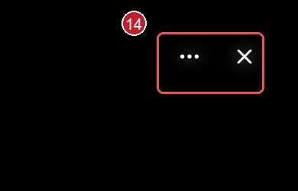
Figure 19 Planetary view with the unnecessary ellipsis and close controls highlighted
Why it matters Extra controls pull attention away from the planetary content and make the view feel like a transient control surface rather than a clear spatial mode.
Current explanation The screenshot confirms that both controls are visible in the planetary view, but it does not establish whether either action is required for navigation or dismissal. The requested direction is to remove them from this view rather than keep them as always-visible chrome.
Desired behavior Remove the ellipsis and close buttons from the planetary view. Keep the surface focused on the planetary content and use the existing normal navigation or back behavior where the product already provides it. Do not replace these with another pair of floating controls.
Acceptance check Opening the planetary view shows no ellipsis or close buttons. The view remains navigable through the existing standard interaction, returns cleanly to its prior context and does not introduce new floating controls.

15 Conversation view contains a duplicate symbol
Observed The conversation view repeats the identity mark: one symbol appears in the header and a much larger orb floats between the collapsed sections. The standalone symbol does not add conversation content and makes the interface feel visually heavier than necessary.
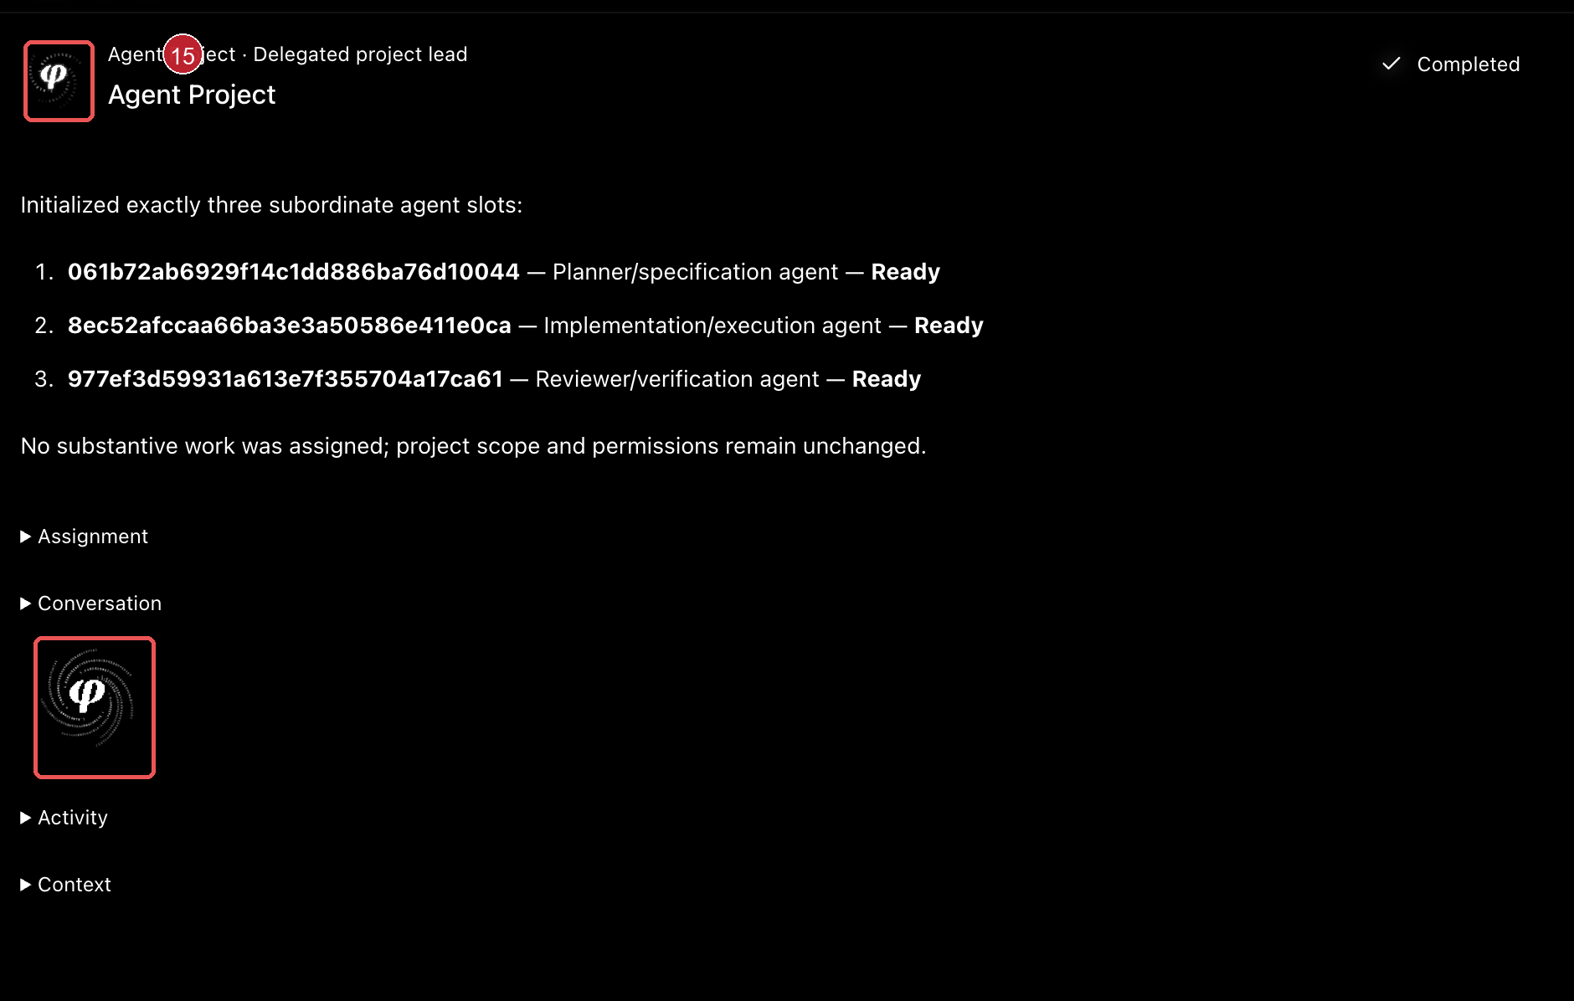
Figure 20 Conversation view with the repeated identity symbols highlighted
Why it matters The large orb competes with the project or agent status and creates a conspicuous empty region around the actual conversation controls. Repeated identity marks make the hierarchy harder to scan.
Current explanation The screenshot confirms a repeated visual identity treatment, but it does not establish that the large orb has an interaction role. The requested direction is to remove the decorative conversation-body symbol and keep the view focused on information and actions.
Desired behavior Remove the standalone symbol from the conversation body. Use at most one small, consistent identity cue in the header when it is needed for orientation, then give the available space to status, conversation content and the existing collapsed sections. Tighten the vertical spacing so the interface reads as a deliberate information view rather than a sparse canvas with a floating orb.
Acceptance check Opening a conversation shows no large decorative orb between sections. Identity is communicated once at most, secondary sections remain easy to scan, and status and conversation content occupy the visual focus without an oversized empty gap.

16 Planetary view could use a mathematical star map
Observed The planetary view is largely empty black space around the orbital scene. The visual system already uses mathematical symbols for identity, but the background does not extend that language into a star-map field.
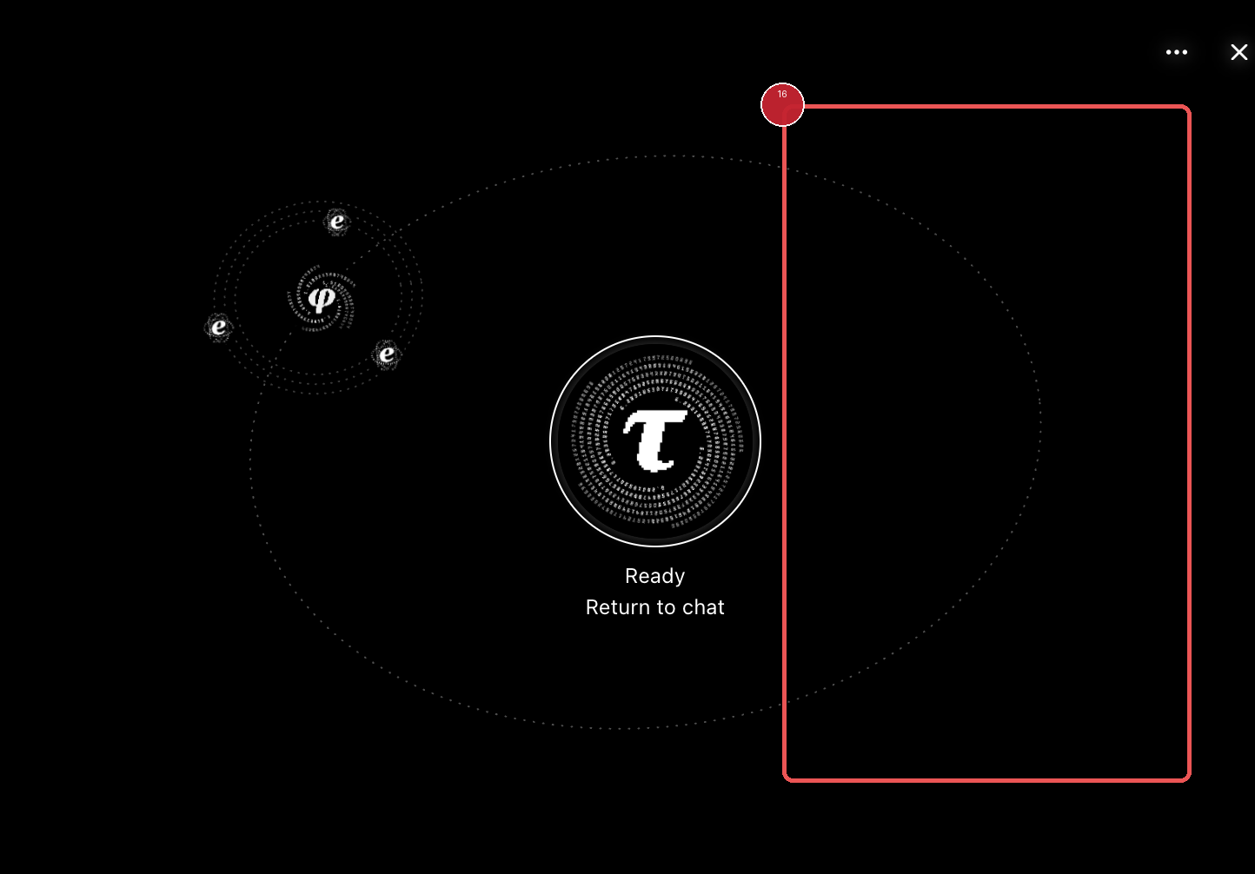
Figure 21 Open planetary background reserved for a mathematical star-map layer
Why it matters The surrounding space feels unfinished rather than intentionally quiet. A restrained mathematical star map could make the scene feel more authored and connect the orbital metaphor to the product's existing use of pi, phi and related marks.
Desired behavior Add a sparse, low-contrast star field behind the orbits. Let selected stars form recognizable mathematical constellations or formula patterns, such as Euler's identity e^(i*pi)+1=0, the Pythagorean relation a^2+b^2=c^2 and the golden-ratio relation phi=(1+sqrt(5))/2. Treat the formulas as constellations made from stars rather than large readable text. Keep them behind the orbs, avoid visual competition with status and controls, and let the layer fade or pause consistently with the existing scene motion and reduced-motion settings.
Acceptance check The planetary view has a subtle star-map background with a small number of recognizable formula-inspired constellations. The stars remain secondary, do not reduce contrast or legibility, do not overlap important controls, and preserve a stable static fallback when motion is reduced or disabled.

Recommended implementation order
These changes can be implemented independently, but the order below follows the visible impact on perceived quality and interaction confidence.
Order | Change | Reason | Priority
1 | Fade leader symbols | Fixes the most obvious abrupt transition and restores continuity. | High
2 | Normalize button focus | Removes the strongest accidental-looking visual artifact. | High
3 | Unify ledger dividers | Makes the full workspace read as one coherent surface. | Medium
4 | Build the effort dial | Improves the mental model for an adjustable reasoning setting. | Medium
5 | Validate orbital motion | Makes the central solar-system concept feel alive and confirms the intended hierarchy. | High
6 | Restore sidebar motion | Keeps the brand language consistent across navigation and the solar system. | High
7 | Animate chat opening | Connects navigation and content into one intentional interaction. | Medium
8 | Align mark and label | Keeps the transition legible when hierarchy content changes. | High
9 | Smooth Goal and orb motion | Removes distracting hitches and keeps the orb visually stable. | High
10 | Place side orbs on orbit | Makes the hierarchy feel spatially intentional. | High
11 | Stage project, agent and goal details | Reduces information overload and preserves orientation. | High
12 | Simplify steer and queue controls | Makes steering effective and keeps the composer focused. | High
13 | Unify solar-system transitions | Removes jumpiness between related scene states. | High
14 | Remove planetary-view controls | Keeps the planetary view focused on its content. | Medium
15 | Simplify the conversation view | Keeps identity cues secondary to status and content. | Medium
16 | Add a restrained formula star map | Adds atmosphere and mathematical identity without competing with the orbital scene. | Low

Final product view
The desired result is not a different visual identity. It is the same dark, minimal Radian interface with more intentional state changes. Symbols should leave gracefully, controls should show deliberate focus, boundaries should agree, and effort should look like something the user can actively tune, project, agent and goal details should open progressively, and the planetary background should use a restrained mathematical star map rather than empty black space.

Evidence note
The screenshots were supplied for this review and were captured on 14 September 2026. They show presentation and interaction states; they do not by themselves establish end-to-end runtime correctness.

