CTP Vendor Quote Agent
Technical Solution Architecture Document
Dynamics 365 Sales | Embedded Portal | Dataverse Custom API | Copilot Studio | Agent Tools
Field | Value
Solution | ctp_VendorQuoteAutomation
Primary experience | Dynamics 365 Opportunity Form with Embedded Portal
Secondary experience | Microsoft Teams / Copilot Agent Chat
Integration pattern | Dataverse Custom API + plug-in bridge to Copilot Studio Agent
Core agent tools | CTP_MatchVendorQuoteLines; CTP_ApproveAndCreateOpportunityProducts
Document status | Draft technical architecture

1. Executive Summary
The CTP Vendor Quote Agent solution processes vendor quote documents and creates Dynamics 365 Opportunity Product Lines after user review and approval. The solution supports two entry points: Teams/Agent Chat for conversational intake, and a Dynamics 365 Embedded Portal for detailed review, editing, and approval.
The Copilot Agent is responsible for reading the quote, extracting header and line items, generating the normalized payload, and orchestrating tools. The Embedded Portal is responsible for presenting the payload to the user and capturing edits and approvals. Dataverse remains the source of truth for products, mappings, staging records, and Opportunity Product Lines.
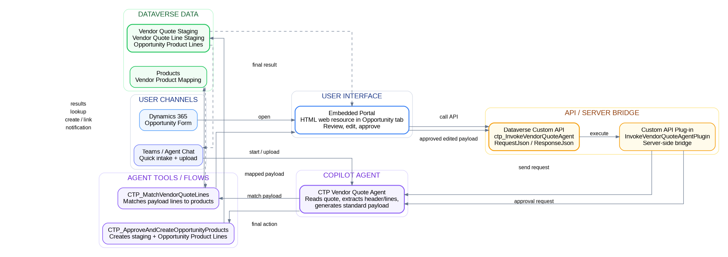
Figure 1. Technical architecture - user channels, API bridge, Copilot Agent, tools, and Dataverse data layer

2. Component Responsibilities
Component | Technical Responsibility
Teams / Agent Chat | Conversational intake channel. User can start the quote process and upload or reference a quote file.
Dynamics 365 Opportunity Form | Record context. Supplies Opportunity ID and Opportunity name to the Embedded Portal.
Embedded Portal | Single-file HTML/CSS/JavaScript web resource embedded in the Opportunity form. Provides quote upload/reference, payload preview, line editing, per-line approval, and final submission.
Dataverse Custom API | Secure interface called by the Embedded Portal using Xrm.WebApi.online.execute(). Accepts RequestJson and returns ResponseJson.
Custom API Plug-in Bridge | Server-side bridge that receives the Custom API call and invokes the Copilot Agent integration path.
CTP Vendor Quote Agent | Reads quote, extracts header/lines, generates standard payload, decides when to call tools, and returns structured JSON responses.
CTP_MatchVendorQuoteLines | Agent flow/tool that matches payload lines to Product and Vendor Product Mapping records.
CTP_ApproveAndCreateOpportunityProducts | Agent flow/tool that validates the approved payload, creates staging audit records, and creates Opportunity Product Lines.
Dataverse | Stores Opportunities, Products, Vendor Product Mapping, Quote Staging, Quote Line Staging, and Opportunity Product Lines.

3. Technical Processing Flow
Step | Flow
1 | User starts from Teams/Agent Chat or from the Dynamics 365 Opportunity form.
2 | If starting from Dynamics, the Embedded Portal collects the file reference and calls ctp_InvokeVendorQuoteAgent.
3 | Dataverse Custom API routes RequestJson to the Custom API plug-in bridge.
4 | Plug-in bridge sends the structured request to the CTP Vendor Quote Agent.
5 | Agent reads the quote, extracts header and line items, and generates the normalized CTP payload.
6 | Agent calls CTP_MatchVendorQuoteLines to enrich payload lines with product matching results.
7 | Matched payload returns to the Embedded Portal for review, editing, and per-line approval.
8 | After approval, the Embedded Portal submits the user-edited approved payload through the same Custom API.
9 | Agent calls CTP_ApproveAndCreateOpportunityProducts to create staging records and final Opportunity Product Lines.
10 | Final result returns to the Embedded Portal and/or Teams/Agent Chat.

4. API Interface Contract
Custom API Item | Value
Custom API unique name | ctp_InvokeVendorQuoteAgent
Binding | Global / unbound
Request parameter | ctp_RequestJson (String)
Response property | ctp_ResponseJson (String)
Client caller | Embedded Portal using Xrm.WebApi.online.execute()
Supported operations | extract_map_preview; approve_create_products

Example request - extract_map_preview
{
"operation": "extract_map_preview",
"opportunity": { "id": "OPPORTUNITY_GUID", "name": "Opportunity Name" },
"file": {
"fileName": "vendor-quote.pdf",
"fileReference": "SharePoint/Dataverse/Attachment reference",
"mimeType": "application/pdf"
},
"hints": { "vendorName": "optional", "userInstruction": "optional" }
}
Example response - mapped payload preview
{
"success": true,
"operation": "extract_map_preview",
"status": "Requires Review",
"message": "Quote mapped successfully. Some lines require review.",
"payload": { "header": {}, "lines": [] }
}

5. Normalized Payload Contract
The Copilot Agent normalizes different vendor document formats into one standard CTP payload. User edits and approvals update this payload before record creation.
{
"header": {
"opportunityId": "GUID",
"opportunityName": "Opportunity Name",
"vendorName": "Vendor Name",
"quoteNumber": "Quote Number",
"fileName": "Original File Name",
"fileUrl": "Source File Reference",
"currency": "USD"
},
"lines": [
{
"lineNumber": 1,
"vendorSku": "SKU or null",
"productName": "Product Name",
"description": "Line Description",
"quantity": 1,
"unitOfMeasure": "Each",
"vendorUnitCost": 100.00,
"vendorExtendedCost": 100.00,
"matchStatus": "Matched | Unmatched | Low Confidence | Write-In | Skipped",
"matchedProductId": "GUID or null",
"useWriteInProduct": false,
"userApproved": false,
"userModified": false,
"matchConfidence": 0.95,
"reason": "Match or review explanation"
}
]
}

6. Agent Tools
Tool | Input | Output | Rules
CTP_MatchVendorQuoteLines | Opportunity ID, payload JSON, vendor name, optional threshold. | Matched payload JSON, match counts, review counts, message. | Do not mark lines approved. Do not automatically set write-in product.
CTP_ApproveAndCreateOpportunityProducts | Opportunity ID, user-approved payload JSON, approval metadata, optional staging ID. | Staging ID, staging line count, Opportunity Product Line count, skipped/failed counts. | Every non-skipped line must be approved. Create staging audit snapshot before final lines.

7. Dataverse Touchpoints
Table | Role
Opportunity | Parent sales record for quote processing and final Opportunity Product Lines.
Product | Dynamics product catalog used for product matching.
ctp_vendorproductmapping | Maps vendor SKUs/product identifiers to Dynamics products.
ctp_vendorquotestaging | Header-level audit snapshot of the quote and approved payload.
ctp_vendorquotelinestaging | Line-level audit snapshot of extracted, edited, matched, and approved quote lines.
opportunityproduct | Final Opportunity Product Lines created after approval.

8. Security and Governance
- The Embedded Portal must not store Copilot secrets, Direct Line secrets, or service account credentials.
- All Dynamics-start calls should go through the Dataverse Custom API using the current Dataverse user context.
- The plug-in bridge should perform server-side validation, logging, timeout handling, and error normalization.
- The final creation tool must revalidate the user-approved payload before creating records.
- Every created Opportunity Product Line should link back to the staging header and staging line for traceability.

9. Build Phases
Phase | Completion Target
1. Embedded Portal | HTML UI embedded in Opportunity form and reads Opportunity context.
2. Custom API smoke test | Portal calls ctp_InvokeVendorQuoteAgent and receives a test ResponseJson.
3. Agent bridge | Plug-in bridge invokes Copilot Agent and returns structured JSON to Portal.
4. Product matching | Agent calls CTP_MatchVendorQuoteLines and Portal displays match results.
5. User review | User edits payload, approves each line, and saves line changes.
6. Final creation | Approved payload creates staging records and Opportunity Product Lines.
7. Teams start path | Users can start from Teams/Agent Chat and continue review in Dynamics.

10. Key Assumptions
Area | Assumption
Agent extraction | The Copilot Agent already reads quote files and generates the normalized payload.
Embedded Portal naming | Embedded Portal refers to the HTML web resource embedded in Dynamics, not a separate Power Pages portal.
Creation path | Final records are created from the user-edited and user-approved payload, not the original raw agent output.
Write-in products | Write-in behavior requires explicit user approval.
Pricing | Vendor cost is stored in custom fields; native sell price should not be overwritten unless separately designed.

