PulseWatch
Administration Guide
Setup, operation and every feature of the self-hosted uptime monitoring app. With examples and screenshots from the demo installation.
As of October 2026 · Version 0.1

Contents

1 Overview
PulseWatch checks at fixed intervals whether your services are reachable and healthy, alerts you when something is wrong and, if you wish, shows the current state on public status pages. It runs as a single Docker container with a MariaDB database. The interface is available in English and German; the language follows the browser and can be changed in your profile.

1.1 Key terms
Term | Meaning
Monitor | A single check, e.g. "request this URL every 60 seconds and expect status 200". There are over 40 types (HTTP, TCP, ping, DNS, TLS, databases, push and more).
Check / heartbeat | One run of a monitor with its result (up or down), response time and, if applicable, an error message.
Incident | Created automatically when a monitor goes down and closed on recovery. Incidents can also be created and annotated by hand.
Probe | A small agent in another network that runs checks from there (chapter 5).
Status page | A public or protected web page showing the state of selected monitors (chapter 7).
Maintenance window | A planned period in which outages are expected and no alerts are sent.
Channel | A destination for notifications: email, webhook, chat services and so on.

1.2 Roles
Role | May
viewer | View everything, change nothing. Can view incidents.
editor | Manage monitors, groups, probes, notifications and status pages; edit incidents.
admin | Additionally users, the audit log and all settings (network security, certificates, authentication, backup).

Users can additionally be restricted to individual groups of monitors (chapter 11.3). A user with access to certain groups only sees the monitors in them.

2 Installation and first start

2.1 With Docker Compose
- Download the repository and change into its directory.
- Run cp .env.example .env and set at least PW_DB_PASSWORD and PW_BASE_URL in the .env file. The base URL is the address users use to reach PulseWatch, e.g. https://status.example.com. It is used in links, emails and for single sign-on.
- Start with docker compose up -d. The database tables are created automatically on first start.
- Open the address in a browser. The very first visit shows the setup page where you create the administrator account.
Important: Back up the secret key (PW_SECRET_KEY, or the file secret.key in the data volume). Stored credentials of monitors and providers are encrypted with it. Without the key a database backup cannot be read.

2.2 Signing in
The sign-in page offers username and password, an optional two-factor code, sign-in with a passkey and any single sign-on providers you configured.
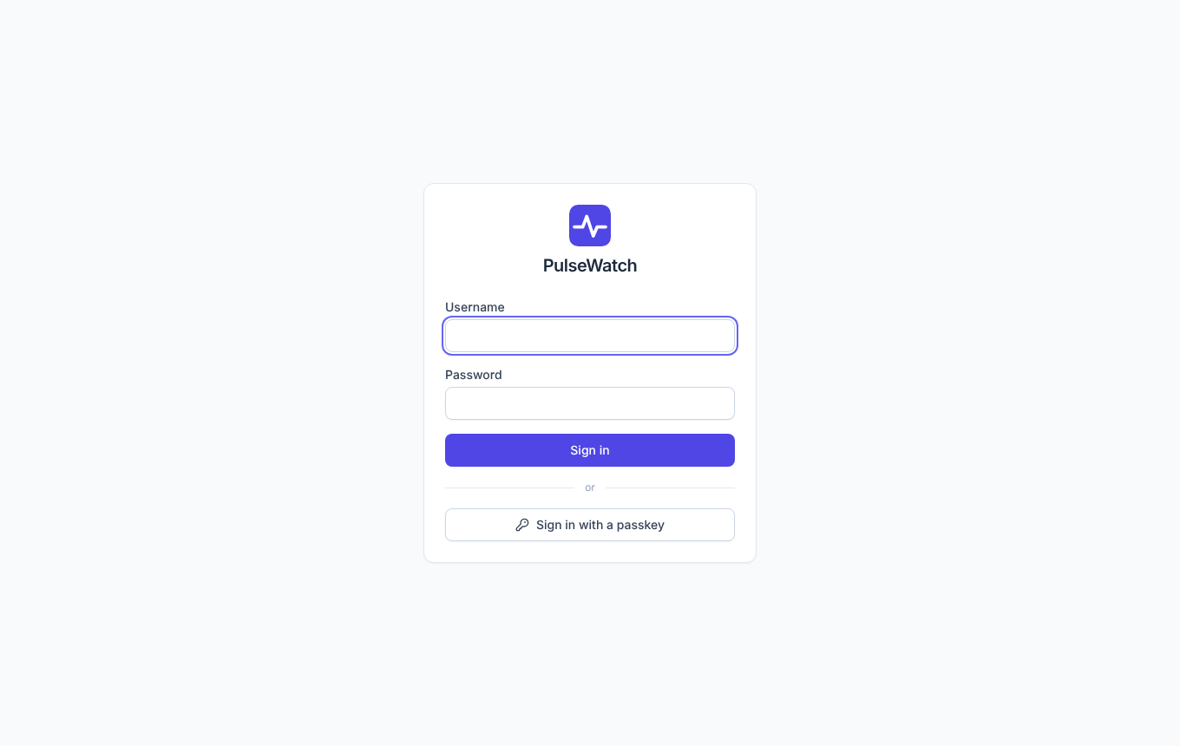
Figure 1: Sign-in page

2.3 The dashboard
After signing in you see all monitors with their current state, open incidents (counter in the sidebar and in the tab title) and saved views. The sidebar groups the application into the monitoring area (Dashboard, Incidents, Maintenance, Status pages, Insights, Reports) and the management area (Notifications, Probes, Groups & tags, Users, Audit log, Settings).
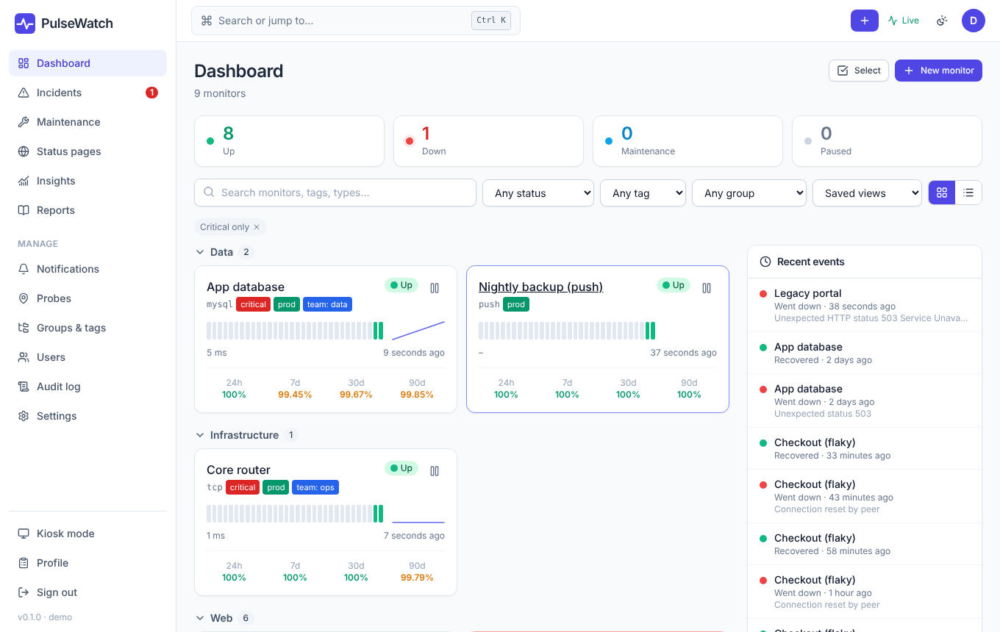
Figure 2: Dashboard of the demo installation
Ctrl+K (Mac: Cmd+K) opens the command palette: it jumps to any monitor and any page.

2.4 The demo installation
With PW_DEMO=true PulseWatch creates sample data on first start: nine monitors with a week of history, incidents, a status page and a maintenance window. The screenshots in this guide come from that demo. For production use the switch should be off.

3 Monitors

3.1 Creating a monitor
Click the plus icon at the top right or open Dashboard → New monitor. Choose the type first; the fields that belong to it then appear. The most common types:
Type | Purpose
http | Request a web page or API and check the status code (and optionally the response time).
keyword | Like http, but a search term must (or must not) appear in the response text.
json | Like http, but a value in the JSON response is checked (section 3.2).
tcp / ping | Is a port open, or does the host answer ping.
dns / tls / domain | Name resolution, certificate expiry, domain expiry date.
push | The other way round: your job reports to PulseWatch. If the report is missing, the monitor counts as down. Ideal for backups and cron jobs.
mysql, postgres, redis, mongodb … | Connection and a simple query against databases.

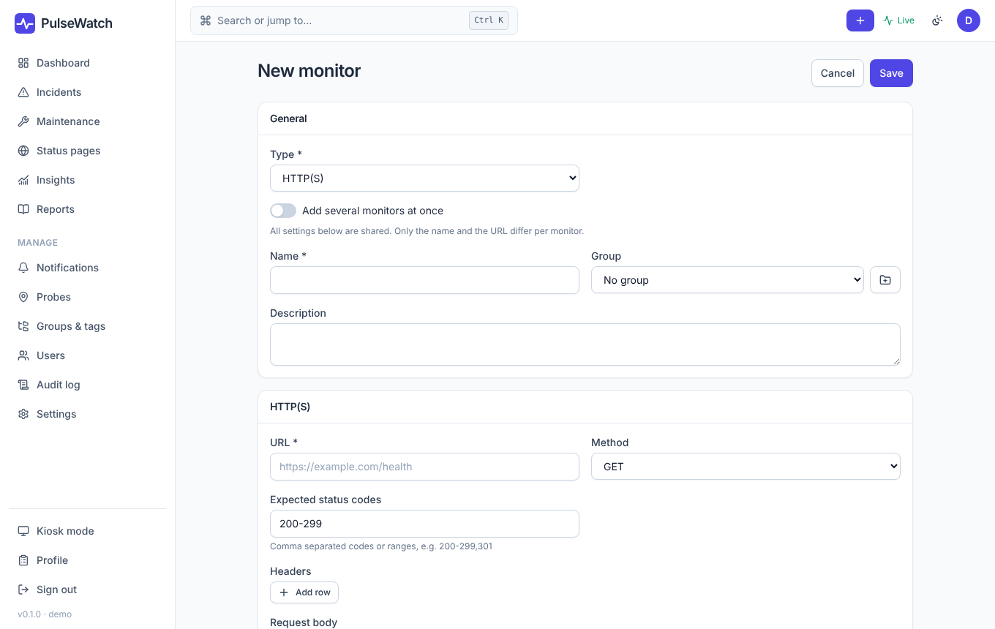
Figure 3: "New monitor" form

3.2 HTTP(S) JSON with "Fetch result"
Many services report their health as JSON, for example {"data":{"queue":{"depth":12},"healthy":true}}. For the json type you define which value is checked: a path ($.data.healthy), a comparison (=, ≠, >, <, contains, exists …) and an expected value. Typing the path by hand is error-prone, which is why there is a Fetch result button.
- Enter the URL (and method, headers and authentication if needed).
- Click Fetch result. The server calls the URL once with exactly these settings and shows status code, duration, size and the response as a collapsible tree.
- Click the value you want to monitor in the tree. Path, comparison and expected value are filled in: numbers, strings and booleans as "equals", objects and lists as "exists".
- Under Suggested checks you find hits for typical status fields (status, healthy, ok, state …) as one-click suggestions.
- A line below tells you immediately whether the current condition would pass with this response.
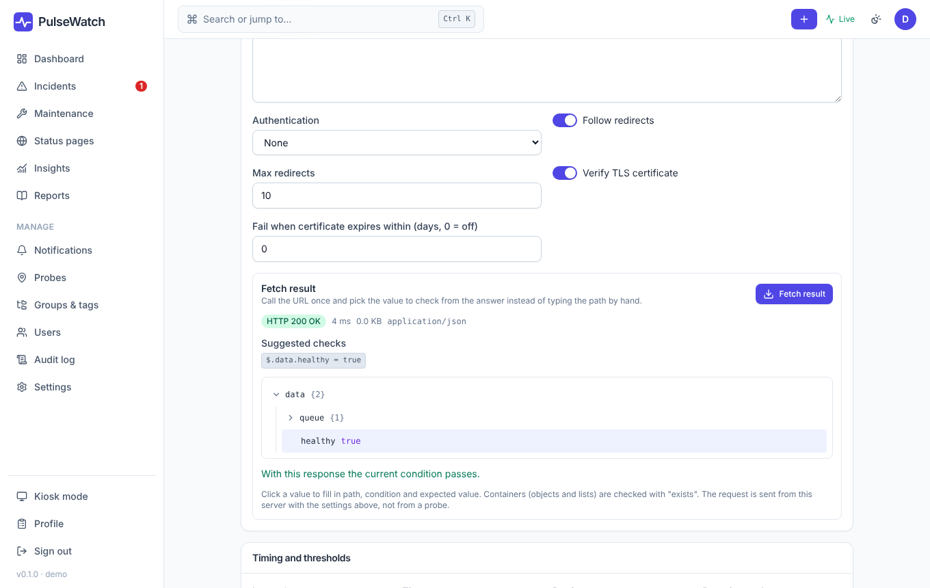
Figure 4: "Fetch result": response tree, suggestion and instant check
Good to know: The request is sent from the PulseWatch server, not from a probe, and follows the same network rules as real checks (section 11.4). When you edit an existing monitor, stored secrets (e.g. a bearer token) are used automatically even though the field is shown masked. Responses over 1 MB are truncated.

3.3 Intervals, retries and thresholds
Setting | Effect
Interval | How often the check runs (seconds).
Timeout | After how many seconds a check counts as failed. Must be smaller than the interval.
Retries / retry interval | A failed check is retried immediately before it counts. This absorbs short blips.
Up / down threshold | How many results in a row are needed before the state changes. With a down threshold of 3 an alert is only sent after three failed checks.
Flap detection | If a monitor changes state too often it is marked as "flapping" and triggers fewer alerts.

Under Settings → Defaults you define what new monitors are pre-filled with.

3.4 Dependencies, tags, groups
- Depends on: If the router fails, not every service behind it should alert. In the "Depends on" field select the monitors that may be offline without this one sending alerts.
- Tags with a value (e.g. env = production) filter the dashboard and drive reports.
- Groups organize monitors hierarchically and control permissions (chapter 11.3).
- Public badge: Enables SVG badges (/badge/<id>/status.svg, uptime-30d.svg, ping.svg), for example for a README.
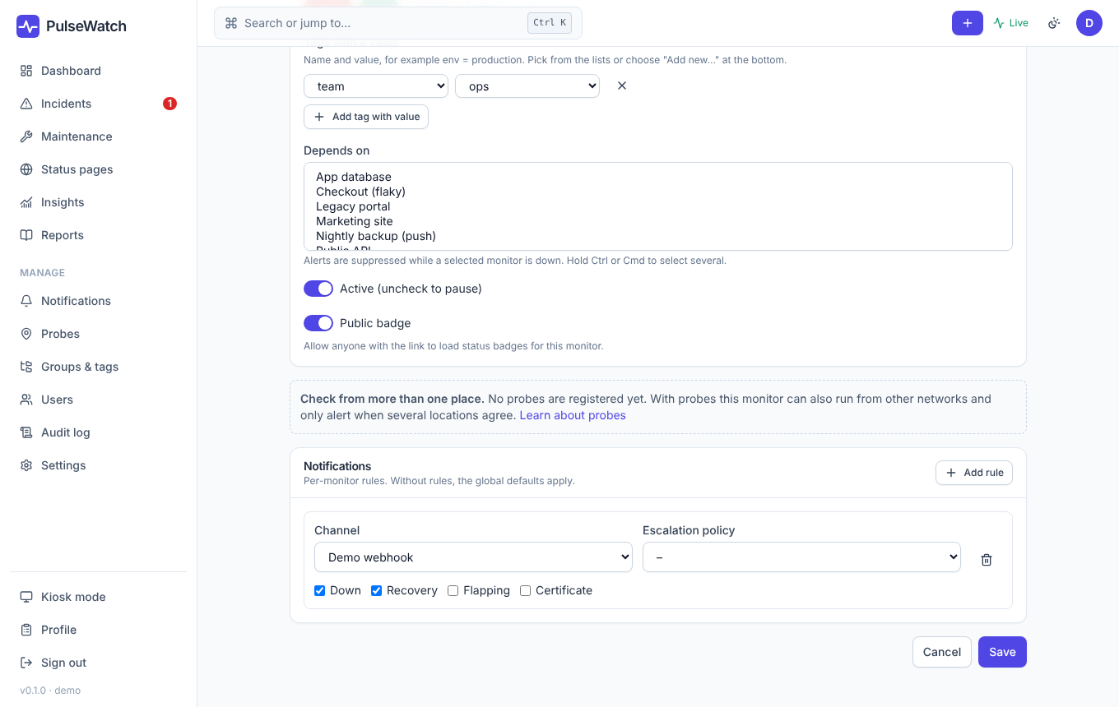
Figure 5: Lower part of the edit form with tags, dependencies, probe hint and notifications

3.5 Many monitors at once
The form has a bulk mode: paste lines of "name, address" (also straight from a spreadsheet). PulseWatch shows live what it recognizes, flags duplicates and only creates the monitors after you confirm. Faulty lines stay in the box. Existing monitors can be selected in the list and edited together. You can import from Uptime Kuma under Settings → Backup & import.

3.6 Monitor detail page
Clicking a monitor shows the response time chart, availability (24 hours to 1 year), the latest checks, events and incidents. "Check now" triggers an immediate check. A hint appears when the response time deviates clearly from the monitor's own baseline, without any external AI service.
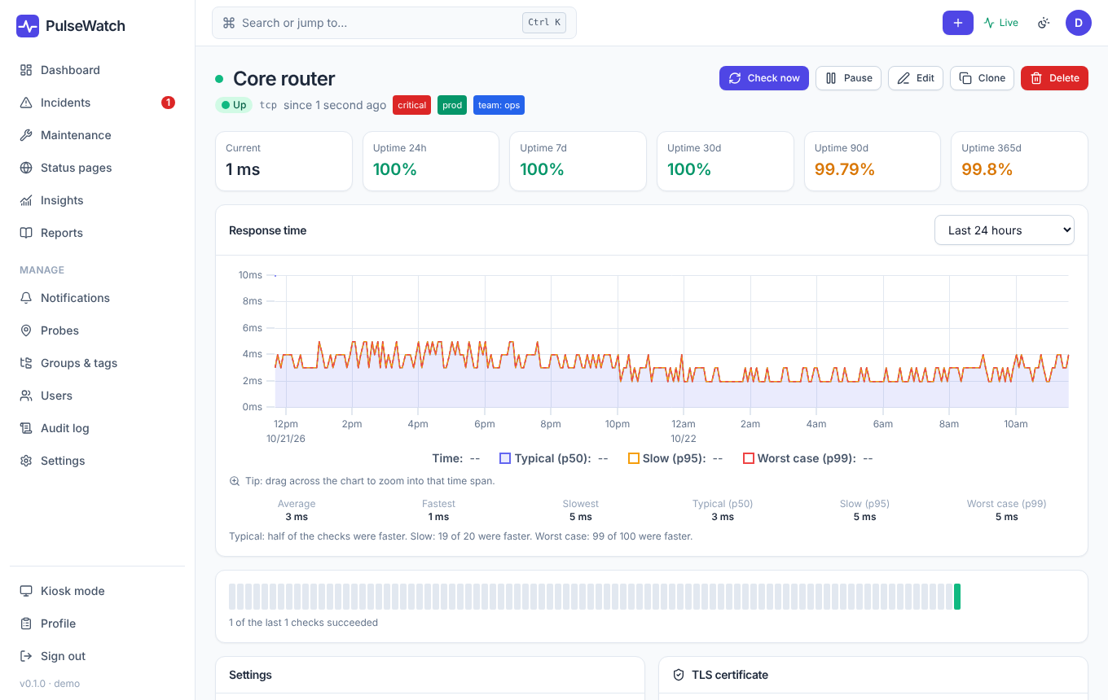
Figure 6: Monitor detail page

4 Incidents
When a monitor goes down, PulseWatch creates an incident automatically and closes it on recovery. Under Incidents you see all open and past incidents, can acknowledge them (meaning someone is on it), add notes and status updates, and write a postmortem after the end.
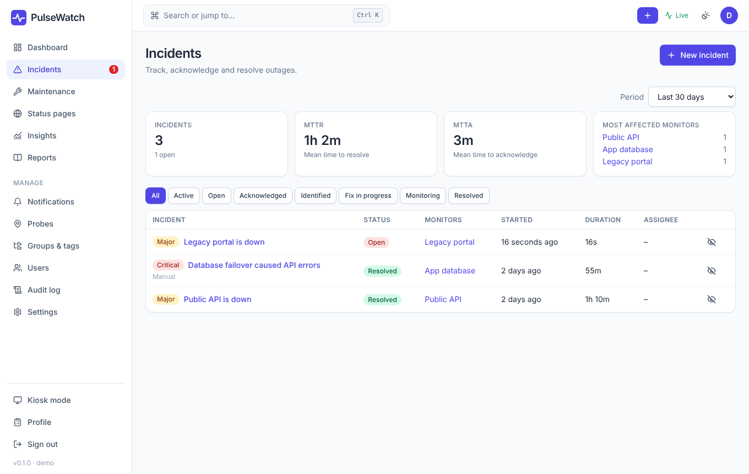
Figure 7: Incident list
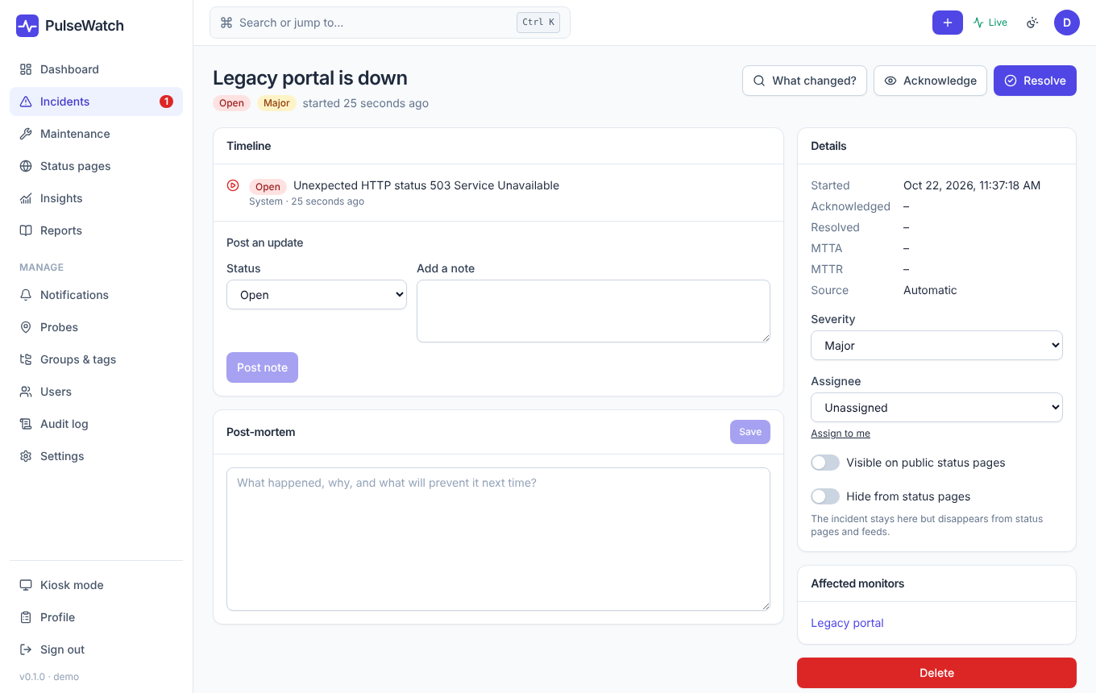
Figure 8: Incident detail with timeline
An incident can appear on the status page if it is marked as public there. Automatic incidents appear for the components of the respective page. The tab Insights → What changed? helps with root-cause analysis (chapter 8).

4.1 Maintenance windows
Under Maintenance you schedule periods in which certain monitors or groups do not alert. During a window the status page shows "Maintenance" instead of "Outage", and the availability calculation does not count that time as downtime. Windows can be one-time or recur via a cron expression.
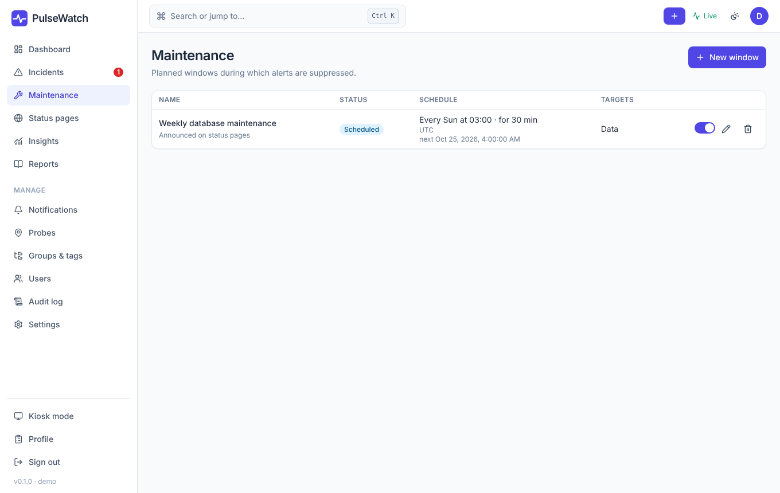
Figure 9: Maintenance windows

5 Probes: checking from other networks

5.1 Why probes?
A monitor that only checks from the PulseWatch server tells you whether the service is reachable from there. Your customers sit elsewhere. A probe is a small program you start in another network, such as a branch office, a cloud region or a DMZ. It runs checks from there and reports the results to PulseWatch. Typical cases:
- A service is reachable internally but not from outside (or the other way round).
- You want to avoid false alarms that only affect the server's network: with several locations PulseWatch only alerts when enough of them agree (the "quorum").
- Internal services that the PulseWatch server cannot reach at all should be monitored.
The probe only makes outbound HTTPS connections to PulseWatch and fetches its job list every 30 seconds. No inbound firewall rule is needed.
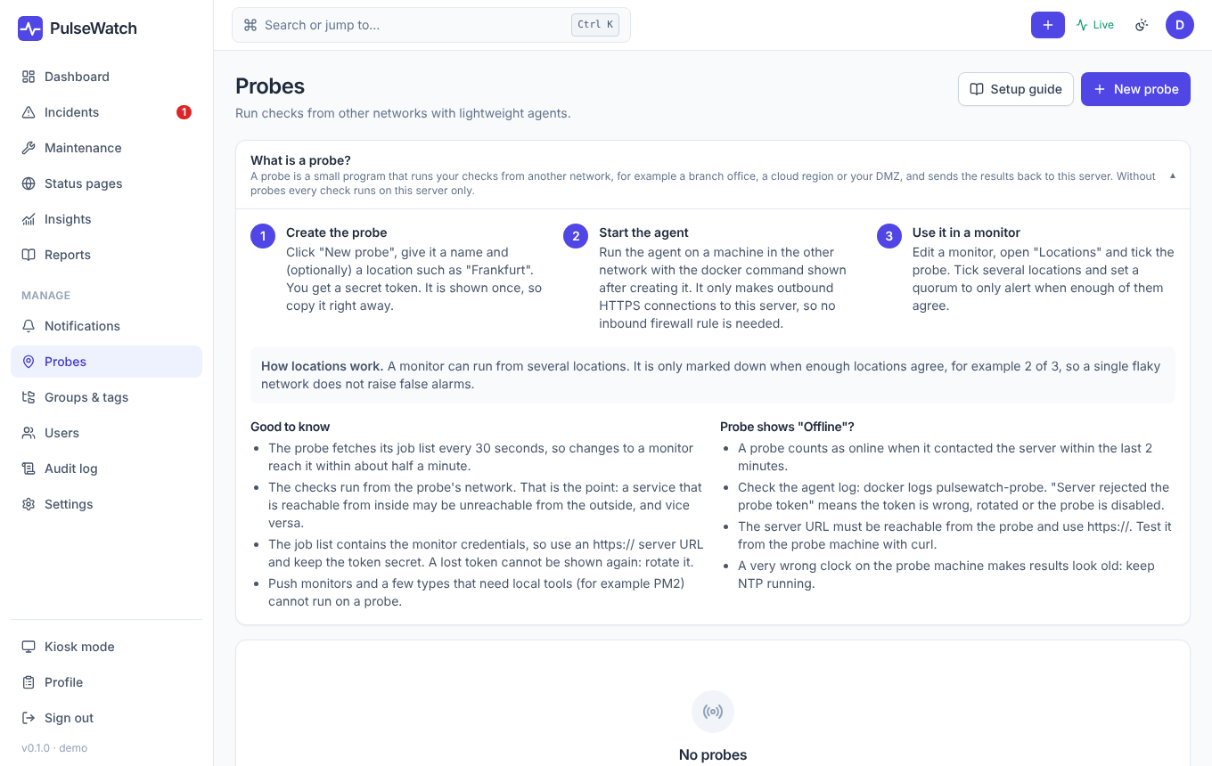
Figure 10: "Probes" page with the "What is a probe?" explanation

5.2 Setup in three steps
- Create the probe. Under Probes → New probe give it a name and optionally a location. The token (pwp_…) is shown only once. Copy it right away.
- Start the agent. On a machine in the other network:
docker run -d --restart unless-stopped --name pulsewatch-probe \
-e PW_SERVER_URL=https://pulsewatch.example.com \
-e PW_PROBE_TOKEN=pwp_YOUR_TOKEN \
--cap-drop ALL --cap-add NET_RAW --read-only \
pulsewatch/probe:latest

The Setup guide button generates these commands (also for Docker Compose) with your values, ready to copy.
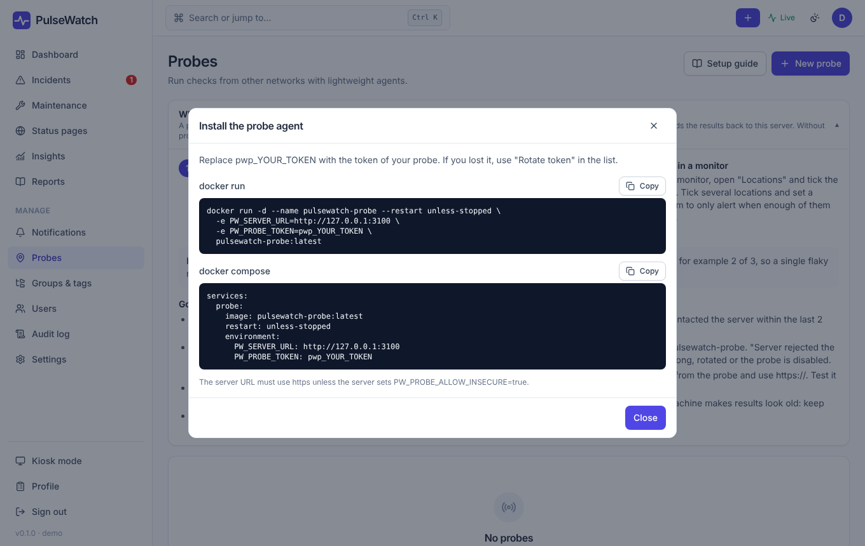
Figure 11: Setup guide with ready-made commands
- Use it in a monitor. Edit the monitor → Locations: tick probe(s) and/or "Server" and set the quorum. A quorum of "2 of 3" means the monitor only counts as down when at least two locations report errors.

5.3 Good to know
- A probe counts as online if it reported to the server within the last 2 minutes. The list also shows how many monitors use it.
- The job list contains the monitors' credentials. Therefore always use HTTPS between probe and server and keep the token secret. The agent refuses http:// except for localhost.
- A lost token cannot be shown again. Renew it in the probe list. A probe can be disabled or deleted at any time. When deleting, PulseWatch warns if monitors still use it.
- Push monitors and types that need local tools (e.g. PM2) do not run on probes.

5.4 Troubleshooting
Symptom | Cause / remedy
Probe shows "Offline" | Check the agent log (docker logs pulsewatch-probe). Test from the probe host: curl https://<server>/health.
"Server rejected the probe token" | Token wrong, renewed, or the probe is disabled.
Results look stale | The probe host's clock is far off. Enable NTP.
Certificate error towards the server | Import the internal CA under Settings → Certificates (section 11.5); it also applies to probes.

6 Notifications
Under Notifications you create channels (email, webhook and more) and optionally escalation policies that, for example, address a second channel after 10 minutes without a reaction. To assign them, add a rule under "Notifications" in the monitor, pick the channel and decide on which events it is sent: Outage, Recovery, Flapping, Certificate. Without rules the global defaults apply.
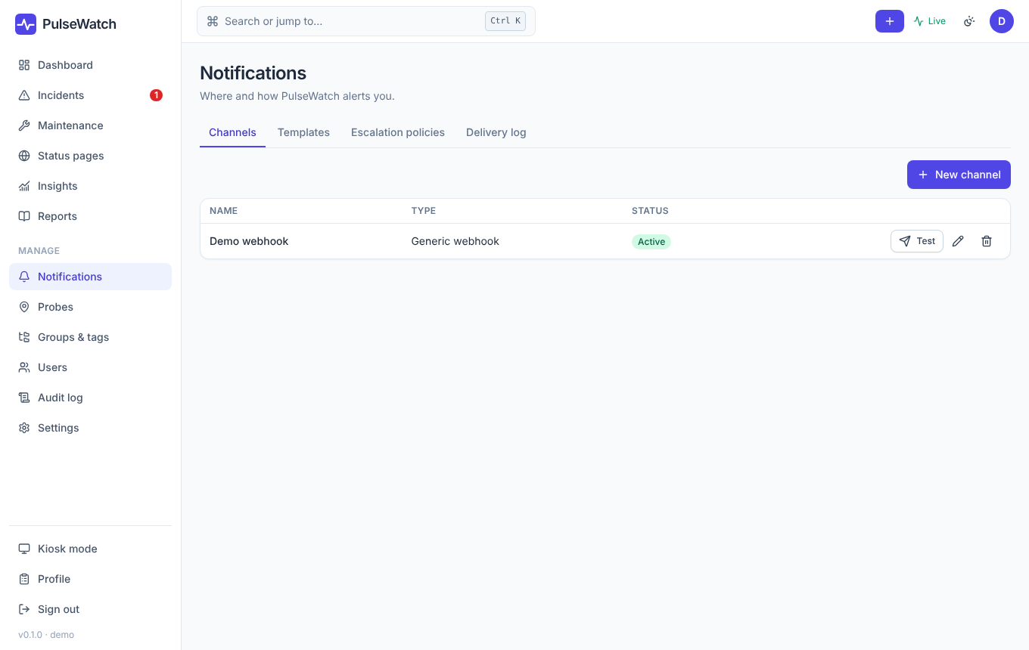
Figure 12: Channels and escalation policies
Tip: Email delivery and the daily digest need SMTP settings (PW_SMTP_HOST etc., chapter 12). Without SMTP the tabs and features that need mail are hidden, such as subscribers on status pages.

7 Status pages
A status page shows customers or colleagues the state of selected services without needing an account. You can create any number of pages, each with its own address /status/<name> (or its own domain), its own look and its own access protection.
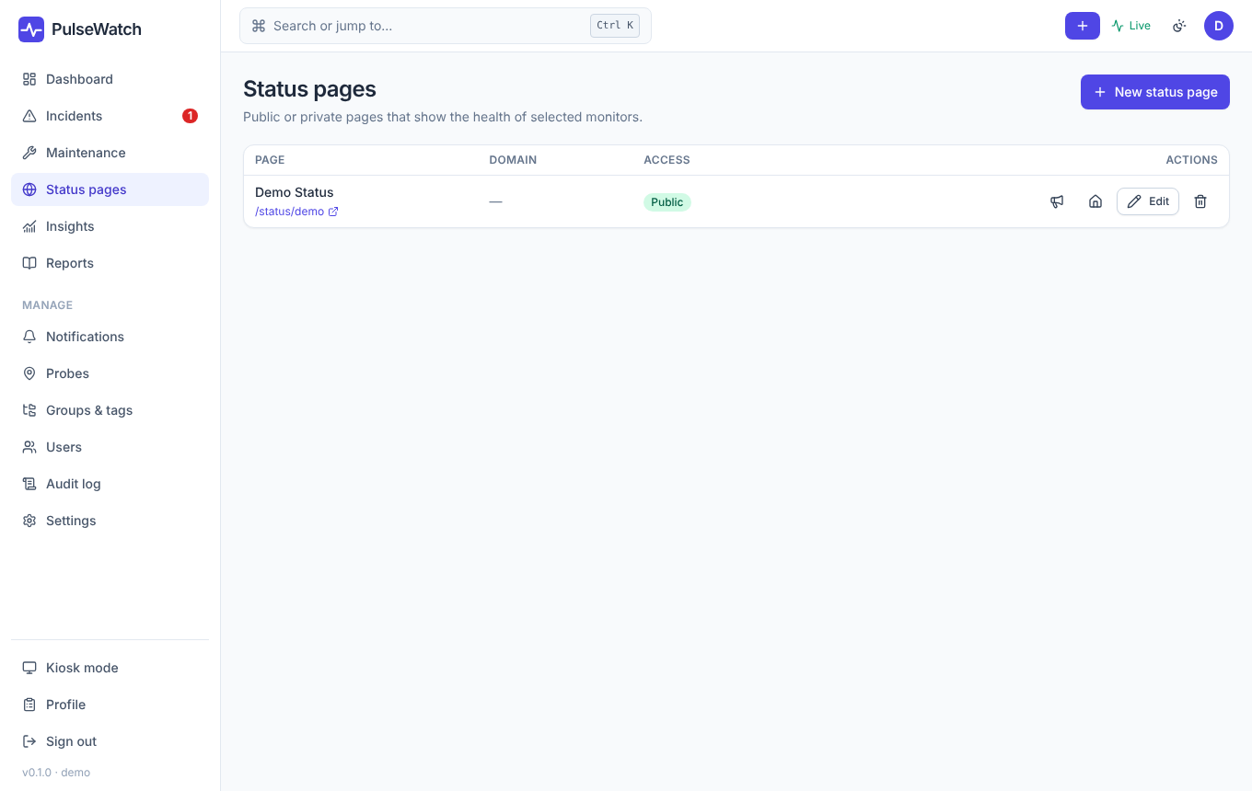
Figure 13: List of status pages

7.1 Editor layout
Tab | Content
General | Name, address (slug), description, optional custom domain, "public", password protection, "sign-in required", history days, incidents of the last N days, home page.
Components | Which monitors appear, in which sections and under which display name. Whole groups can be imported.
Extras | Additional blocks below the components (section 7.2).
Appearance | Logo, accent color, footer, custom CSS.
Announcements | Notices (info, maintenance, incident) with a time range, shown at the top of the page.
Visitor subscriptions | Email subscribers of the page (only with SMTP). There is also an RSS feed.

7.2 Extras: more than the component list
In the Extras tab you add blocks, reorder them with the arrows and remove them again. They appear below the components in this order. The figures only refer to the monitors that are on this page. At most 12 blocks per page are possible.
Block | Shows
Uptime summary | The combined availability of all components over the last 24 hours and 7, 30 and 90 days.
Heatmap | A calendar with one square per day (90, 180 or 365 days). Green: a day without failures, yellow to red: increasing outages, gray: no data. Hovering shows the details of the day.
Days without incident | How many days have passed since the end of the last incident that this page would show itself. If one is active it reads "An incident is ongoing".
Text | A heading and a paragraph, e.g. a contact address or an SLA note.

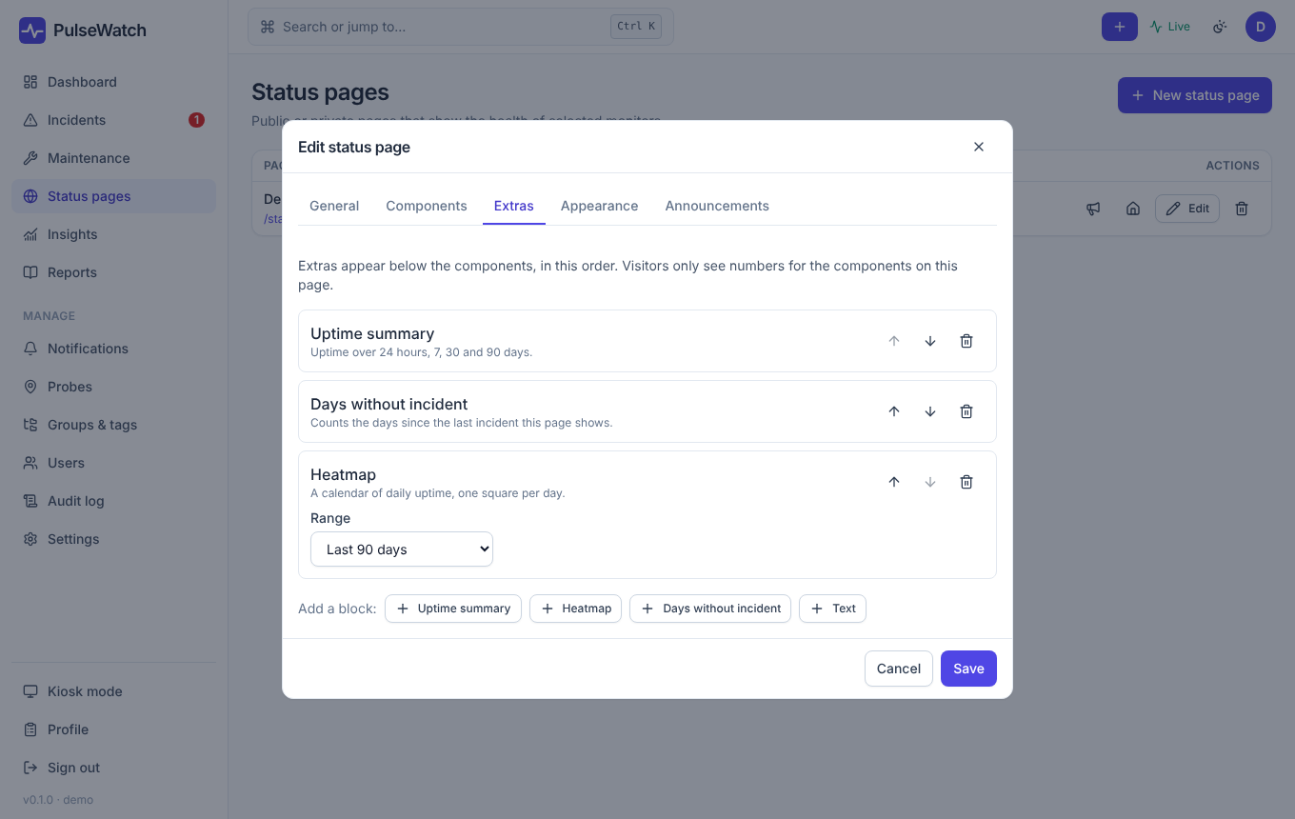
Figure 14: "Extras" tab in the editor
This is what visitors see: components with history bars, below them the summary, "days without incident" and the heatmap, followed by past incidents.
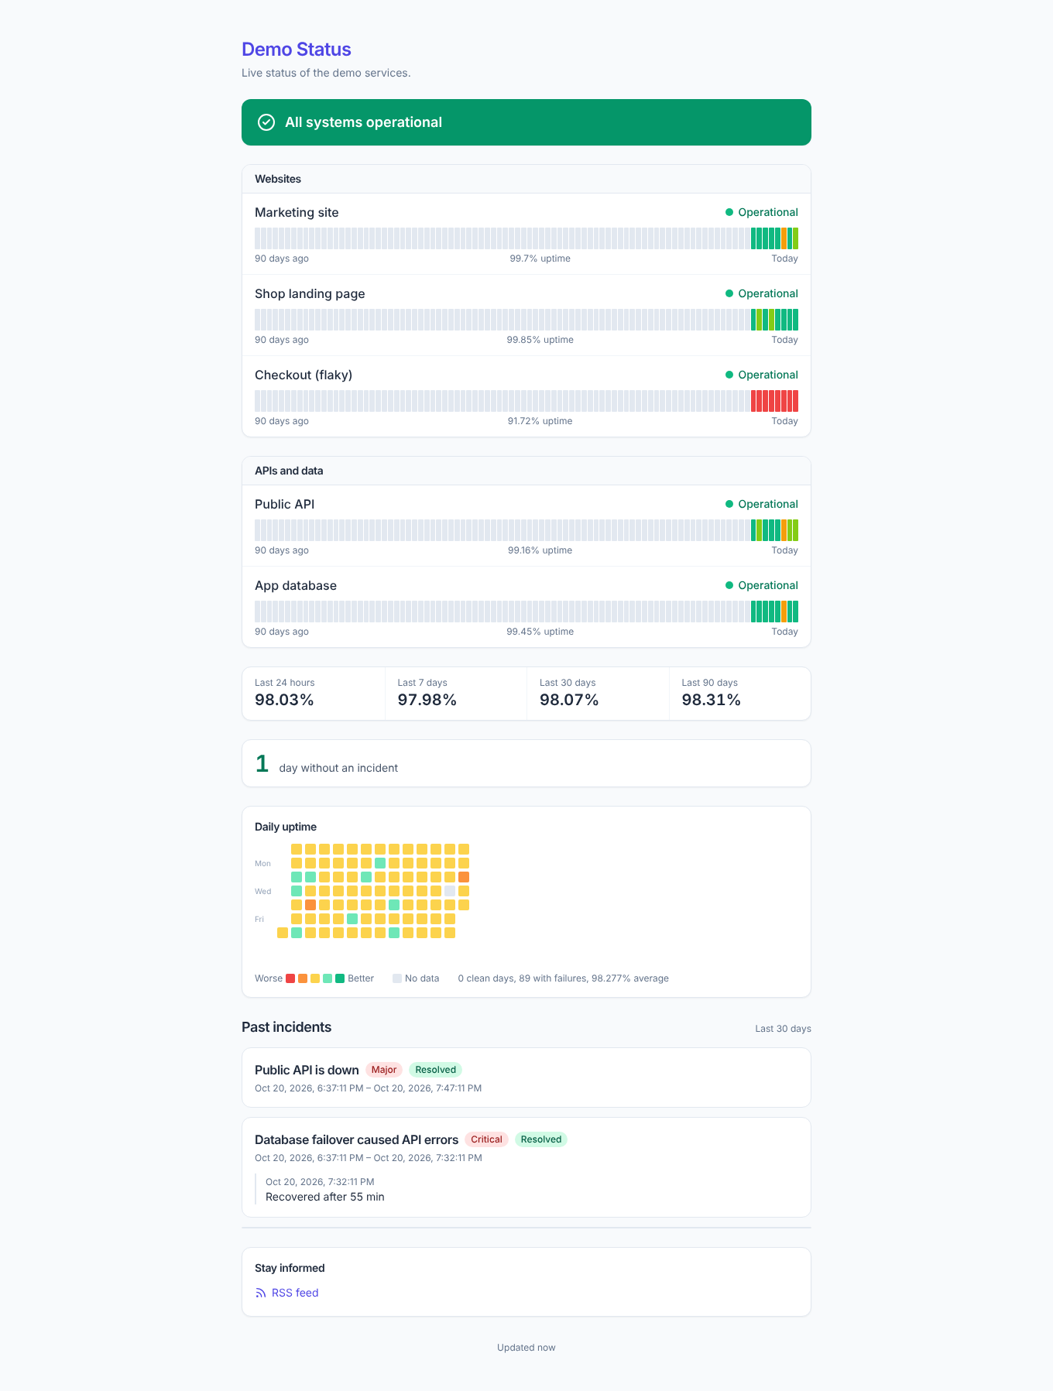
Figure 15: Public status page with extras
Note: The blocks are computed from the already aggregated history data and cached for one minute, even with many simultaneous visitors. New figures therefore appear with a delay of up to one minute. The heatmap needs daily values; a fresh monitor fills it from the first full day.

7.3 Access
- Public (no password): anyone with the link.
- Password: visitors have to enter it once.
- Sign-in required: only signed-in PulseWatch users.
- Home page: exactly one page can be the home page. It opens at the root path of the application.

8 Insights and reports

8.1 Uptime heatmap
Under Insights the heatmap shows the state of every day for up to 365 days, for all monitors or a single one. Recurring patterns stand out, such as outages every Monday morning. You can publish the same view as an extra on a status page (section 7.2).
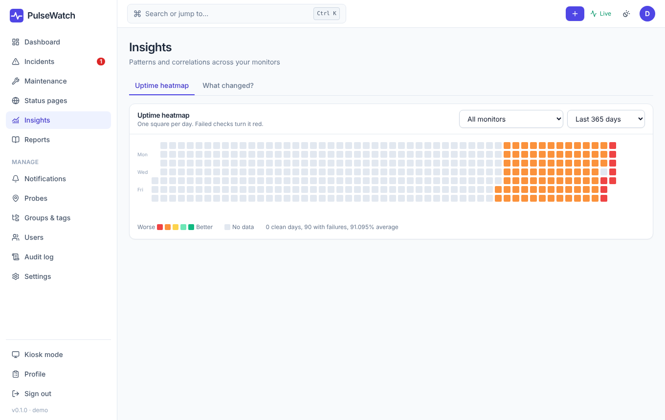
Figure 16: Insights: heatmap

8.2 What changed?
Pick an incident and a time window. PulseWatch shows which other monitors went down at the same time and how they are related (same host, same group, a dependency) to narrow down the cause faster.

8.3 Reports
Under Reports you create availability reports for a period and selected monitors (e.g. as SLA evidence) and download them as PDF or CSV. Reports can also be sent by email on a schedule.
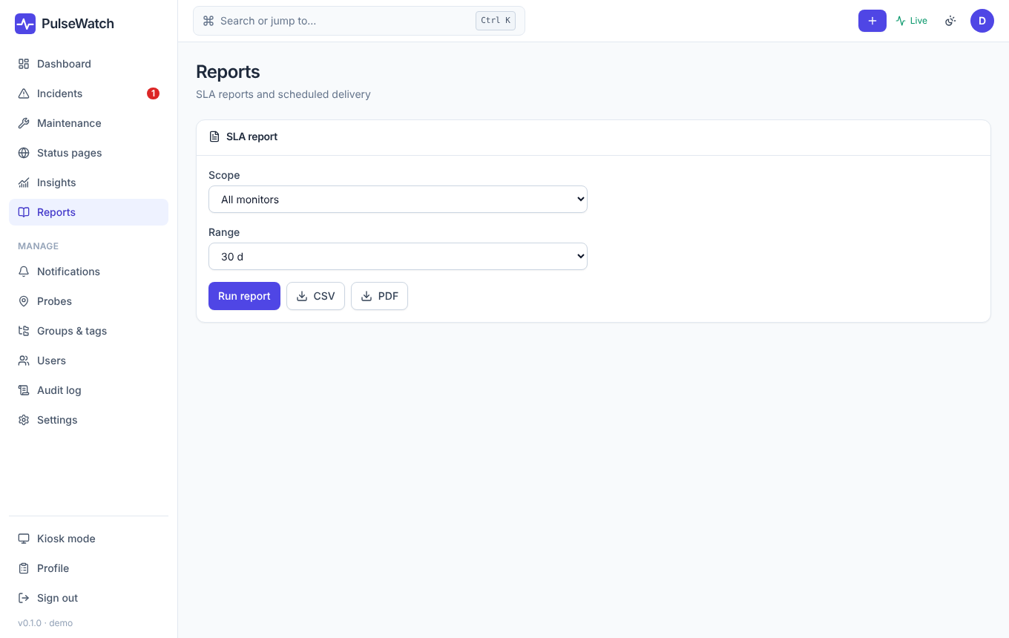
Figure 17: Reports

9 Groups, users, audit log

9.1 Groups & tags
Groups organize monitors (also nested). Permissions, status page imports and dashboard filters are based on them. You manage tags and their values on the same page.
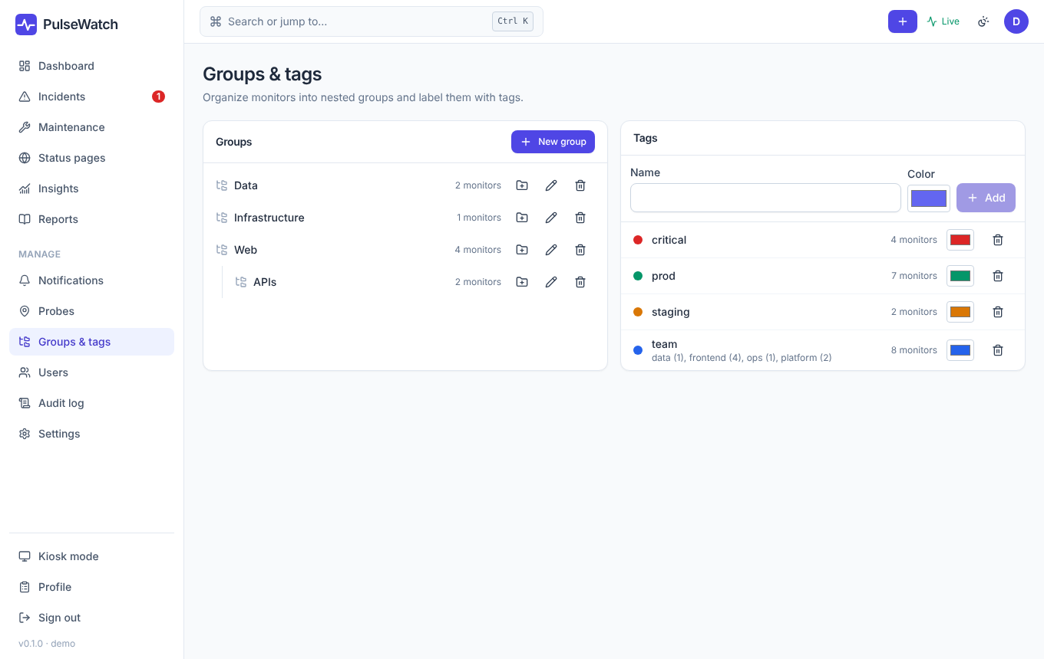
Figure 18: Groups and tags

9.2 Users
As an administrator you create accounts under Users, assign roles and can restrict a user to certain groups. For accounts from single sign-on (OIDC, LDAP, SAML) the role is derived from the directory groups at sign-in (section 11.6).
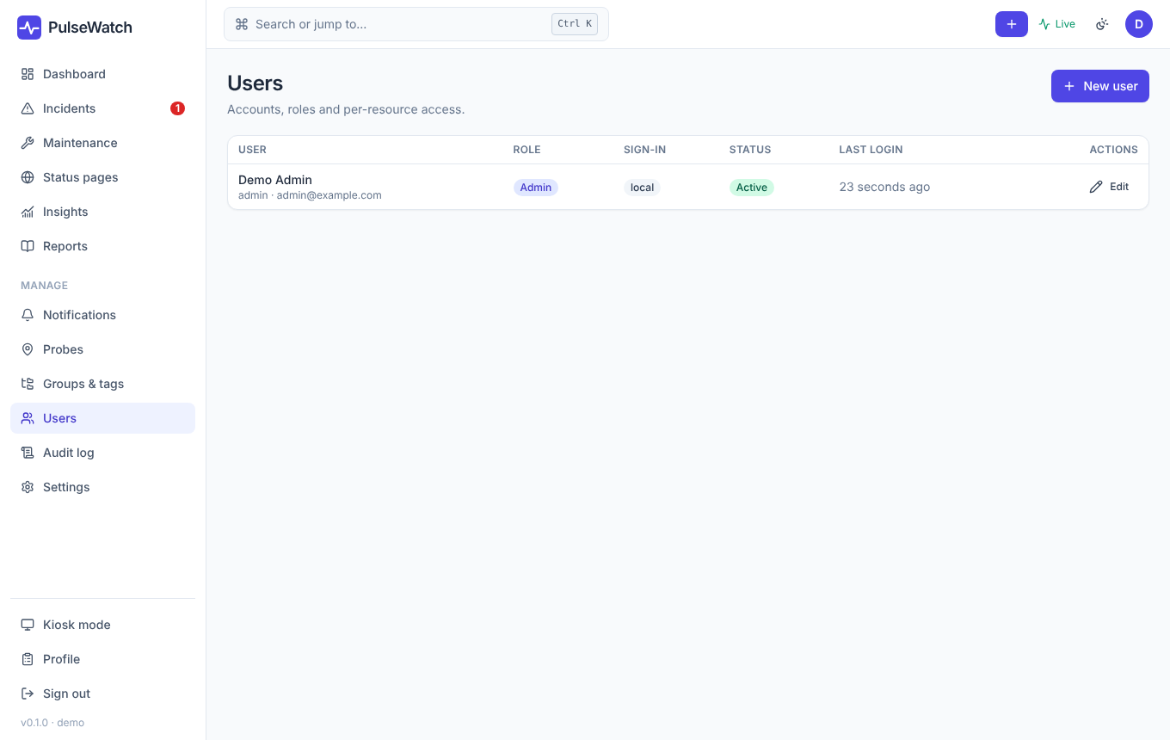
Figure 19: User management

9.3 Audit log
The audit log records important actions: sign-ins (including refused ones) and changes to monitors, users and settings. It is kept for 730 days by default (PW_RETENTION_AUDIT_DAYS).
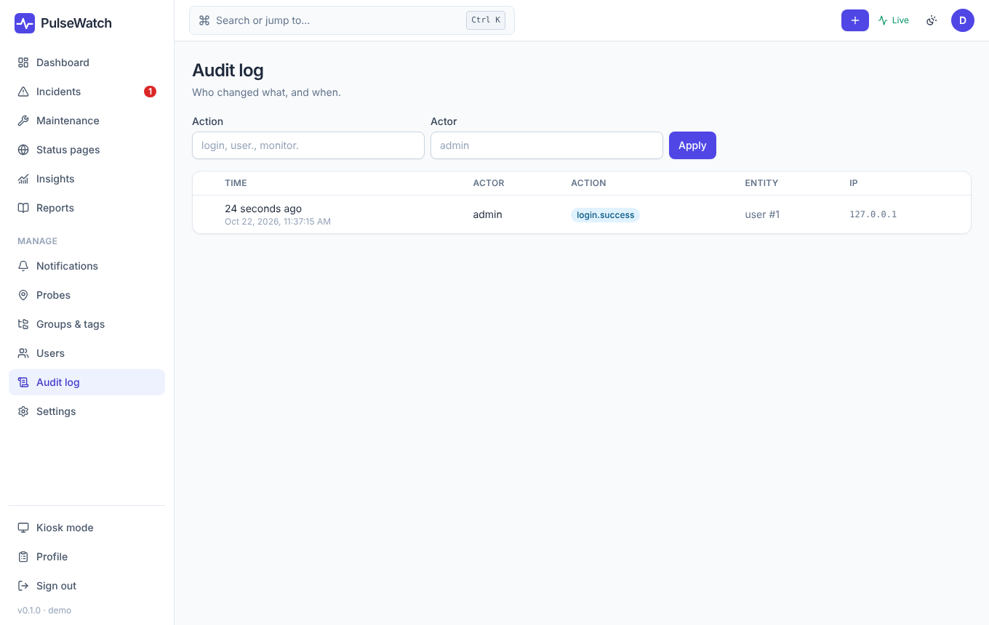
Figure 20: Audit log

10 Profile and kiosk mode
In your Profile you set language, theme (light, dark, automatic) and password, enable two-factor authentication and register passkeys and API tokens.
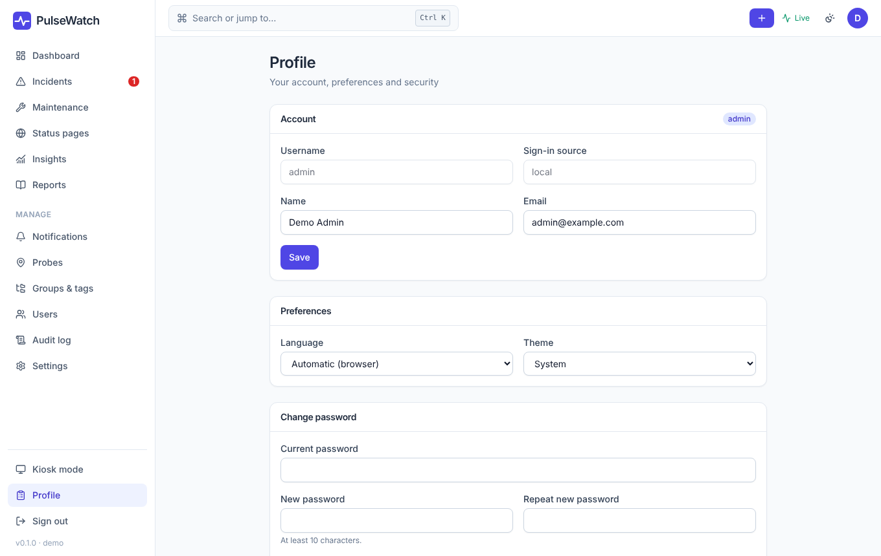
Figure 21: Profile
Kiosk mode (/kiosk) shows large tiles for wall displays and rotates between pages.
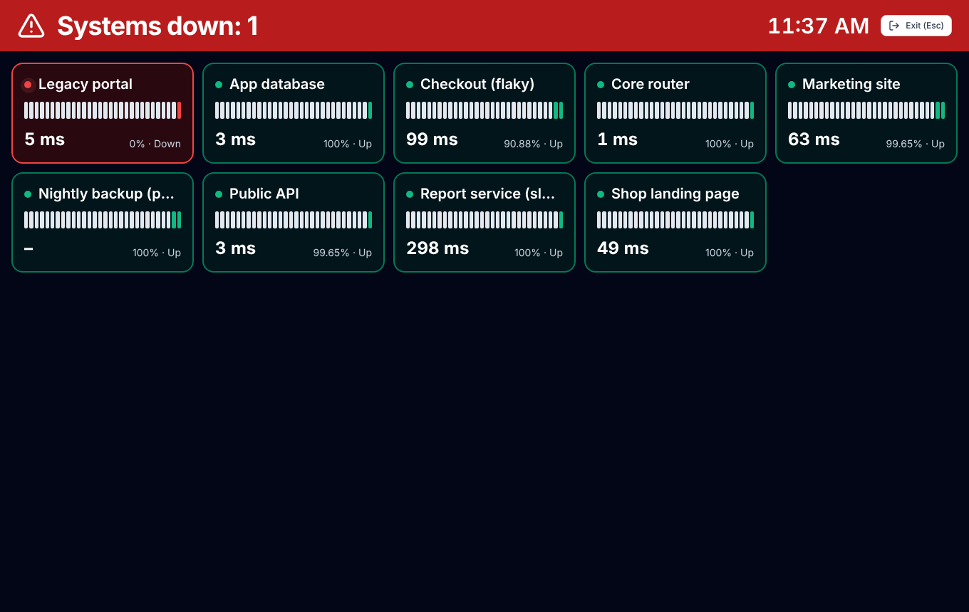
Figure 22: Kiosk mode

11 Settings (administrators only)
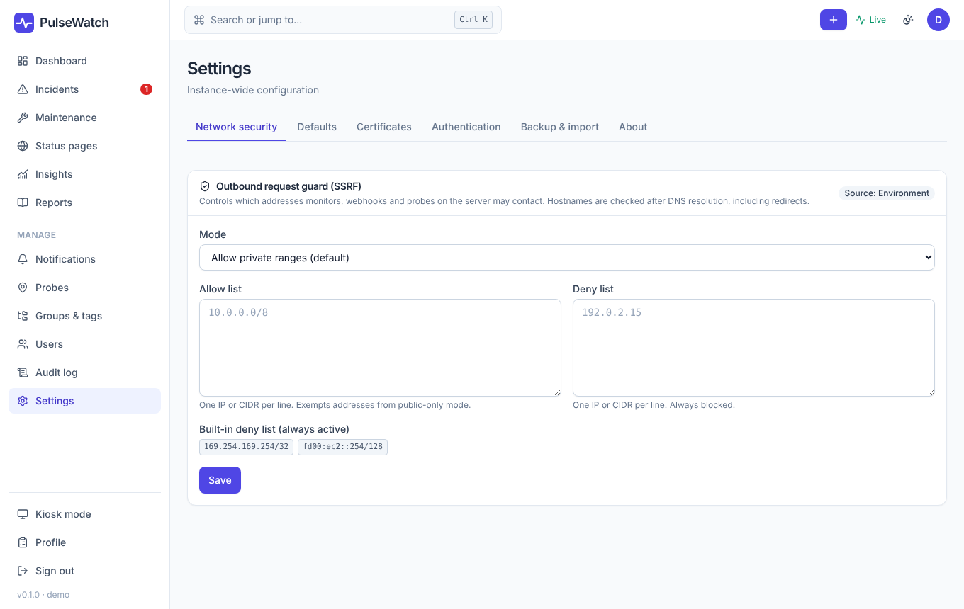
Figure 23: Settings: "Network security" tab

11.1 Backup & import
Exports the configuration (monitors, groups, channels, status pages including their extras) as YAML or JSON, with secrets masked by default, and reads it back in. This is not a replacement for a database backup (chapter 12) but is handy for versioning and moving. You also find the Uptime Kuma import here.

11.2 Defaults
Pre-fill for new monitors (interval, timeout, retries, thresholds). Existing monitors stay unchanged.

11.3 Restricting access to monitors
A user with a restriction only sees monitors in the assigned groups (including subgroups) and may only write there, as far as their role allows. Administrators are never restricted.

11.4 Network security
Checks and the "Fetch result" function pass through a protection against server-side request forgery (SSRF). The mode PW_SSRF_MODE knows allow-private (default, private addresses are allowed) and public-only (public targets only). With PW_SSRF_ALLOW and PW_SSRF_DENY you explicitly allow or block individual targets. The tab shows the effective rules.

11.5 Certificates
If your services use certificates from an internal company CA, import its certificate here as PEM text or file (.pem, .crt, .cer). It is then trusted by all TLS-capable checks and all probes in addition to the built-in root certificates. The "Choose File" button is now easy to read (dark text on a light background, inverted in dark mode).
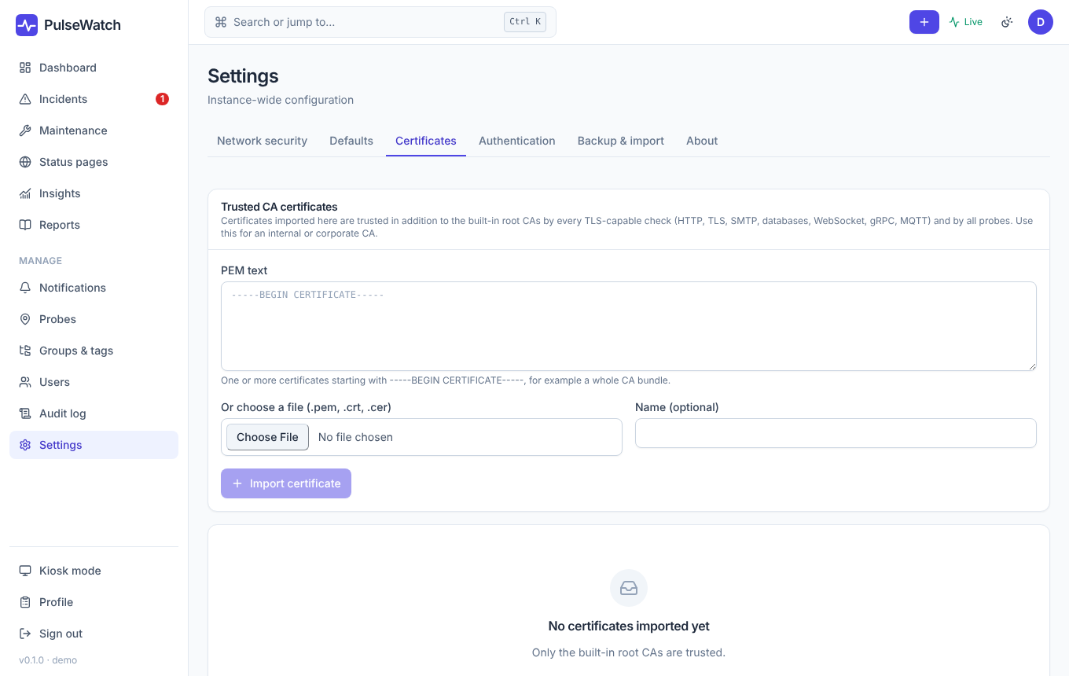
Figure 24: Importing certificates

11.6 Authentication and group access
Under Authentication you set up single sign-on: OpenID Connect (Entra ID, Google, Keycloak …), LDAP / Active Directory and SAML. Each provider has fields for the connection, email and name mapping and the mapping of groups to roles (admin groups, editor groups, default role, automatic account creation).
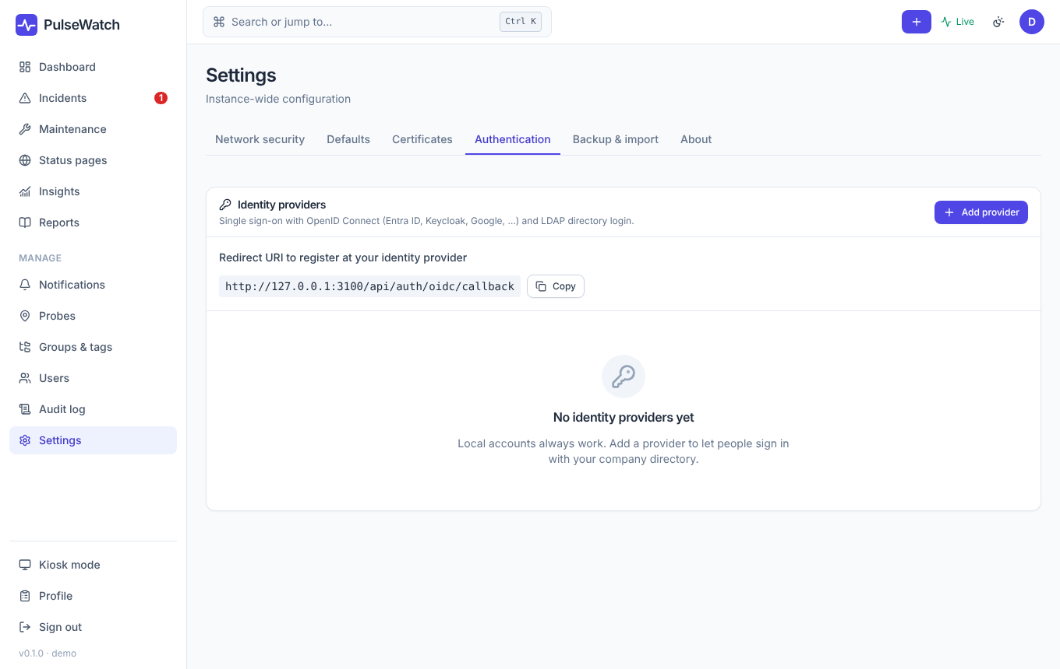
Figure 25: "Authentication" tab

Allow only certain groups
Without a restriction every user of the directory can sign in. If you want to limit access to certain groups, enter them on the provider:
Provider | Field | Format
OpenID Connect | Allowed groups | Group names or IDs separated by commas; read from the "Groups claim".
SAML | Allowed groups | As above, from the attribute "Groups attribute".
LDAP | Allowed group DNs | One distinguished name per line; the comparison ignores case.

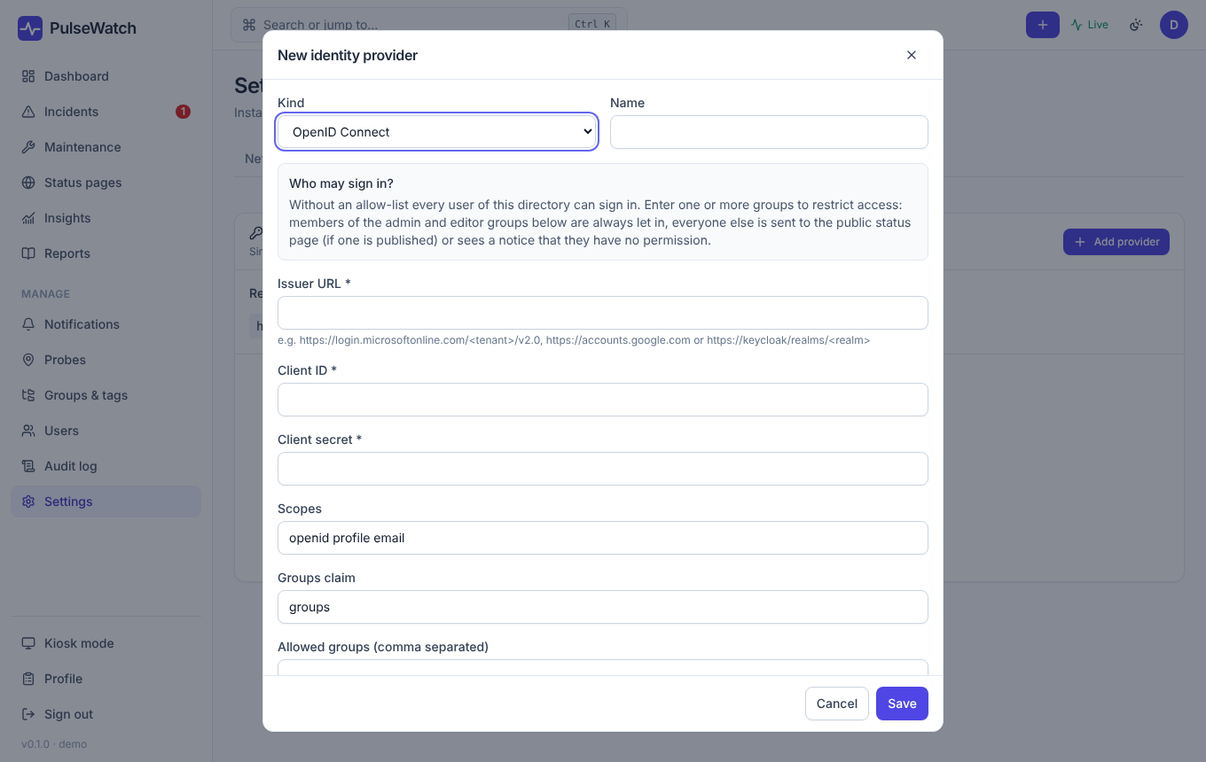
Figure 26: Provider dialog with the "Who may sign in?" notice
The behavior:
- Members of an allowed group and of the admin and editor groups get in. The latter are always allowed so you cannot lock yourself out.
- Everyone else gets no account and no session. If a status page is public (no password, no sign-in requirement) they are redirected to it, otherwise they see a notice that they lack permission.
- If an existing user loses the group, their sessions are ended at the next sign-in attempt.
- An empty field means no restriction. Providers with a list show the "Group" badge in the overview.
- Editors and admins only: The "Editors and admins only" switch lets in only members of the admin or editor groups. Anyone who would only become a viewer is turned away as described above, even if they are in an "Allowed group". This requires admin/editor groups to be set on the provider, otherwise nobody can sign in through SSO (local accounts keep working). With the default role "Editor" the switch has no effect.
- Refused sign-ins appear in the audit log as login.denied.
Example: With Entra ID you enter the object ID of the security group PulseWatch-Users as "Allowed groups". Members of this group sign in; all other employees land on the "Internal" status page.

With Entra ID the group claim must arrive in the token ("Groups claim" in the app registration). After setting it up, test with an account that is not in the group.

12 Operations

12.1 Important environment variables
Variable | Default | Meaning
PW_BASE_URL | http://localhost:3000 | Public address; used in links, emails and for SSO.
PW_DB_HOST / _PORT / _USER / _PASSWORD / _NAME | 127.0.0.1 / 3306 / pulsewatch / – / pulsewatch | Database connection (MariaDB).
PW_SECRET_KEY | generated | Key for stored secrets. Back it up!
PW_SESSION_TTL_HOURS | 168 | Validity of a sign-in.
PW_SSRF_MODE | allow-private | See section 11.4.
PW_RETENTION_RAW_DAYS / _MINUTE / _HOUR / _DAY | 14 / 60 / 400 / 3650 | Retention of raw data and aggregated values (days).
PW_SMTP_HOST, _PORT, _USER, _PASS, _FROM | – | Outgoing mail.
PW_DEADMAN_URL | – | PulseWatch pings this address regularly, so you notice when PulseWatch itself goes down.
PW_TRUST_PROXY | false | Set to true when a reverse proxy sits in front.

12.2 Backup and restore
The state lives in the database and the secret key. Back up both.
docker compose exec mariadb sh -c 'mariadb-dump -u"$MARIADB_USER" -p"$MARIADB_PASSWORD" \
--single-transaction --routines "$MARIADB_DATABASE"' | gzip > pulsewatch-$(date +%F).sql.gz
docker run --rm -v pulsewatch_data:/data -v "$PWD":/backup alpine \
tar czf /backup/pulsewatch-data-$(date +%F).tgz -C /data .

Restoring works the other way round into an empty database. The details are in the README.

12.3 Upgrading
git pull
docker compose build --pull
docker compose up -d

Database migrations run automatically at startup and only move forward. Take a backup first. The current version ships migration 014 (status page extras).

12.4 Caching of the web interface
The web interface uses a service worker that caches files. After an update the browser loads the new version as soon as the cache version has changed. If the old interface still shows after an update, reload the page with Ctrl+F5.

12.5 Common problems
Problem | Solution
"No permission" after signing in with SSO | The user is in none of the allowed groups (section 11.6). Check the group field and claim, look at the audit log.
A monitor is red for no reason | Raise the down threshold and retries, or use several locations with a quorum.
"Fetch result" returns 502 | The target cannot be reached from the server or is blocked by the network rules (section 11.4).
Status page shows no heatmap | The block is missing in "Extras", the page has no components, or there are no daily values yet.
Certificate errors with internal services | Import the internal CA (section 11.5).
Probe offline | See section 5.4.

13 Quick reference

13.1 Keyboard shortcuts
Shortcut | Effect
Ctrl+K / Cmd+K | Command palette: jump to monitors and pages.
Esc | Close a dialog.

13.2 Checklist for the first days
- Create the administrator account, store the password in a password manager and enable two-factor authentication.
- Set up SMTP and at least one notification channel and test it.
- Create your important services as monitors and set dependencies.
- Create a status page and add the summary, heatmap and "days without incident" under "Extras".
- Set up single sign-on and, if needed, allow only certain groups.
- Plan a backup of the database and the secret key and test a restore once.

