|  |
| --- |
| МИНИСТЕРСТВО НАУКИ И ВЫСШЕГО ОБРАЗОВАНИЯ РОССИЙСКОЙ ФЕДЕРАЦИИ |
| федеральное государственное бюджетное образовательное учреждение высшего образования «Российский экономический университет имени Г. В. Плеханова»  Московский приборостроительный техникум |

ОТЧЕТ

по учебной практике

УП.11.01 «Разработка и эксплуатация информационных систем»

Профессионального модуля

ПМ.11 «Разработка, администрирование и защита баз данных»

Специальность 09.02.07 Информационные системы и программирование

Студент ________________________ Пахомов Даниил Александрович

*подпись фамилия, имя, отчество*

Группа П50-3-18

Руководитель по практической подготовке от техникума

___________________________ Митасов Никита Сергеевич

*подпись фамилия, имя, отчество*

«08» февраля 2021 года

СОДЕРЖАНИЕ

ПРАКТИЧЕСКАЯ РАБОТА №1 3

ПРАКТИЧЕСКАЯ РАБОТА №2 29

ПРАКТИЧЕСКАЯ РАБОТА №1

Цель: научиться работать с базами данных Microsoft SQL Server, посредством C#.

Схема данных: схема данных, описывающая базу данных представлена на Рисунке 1.

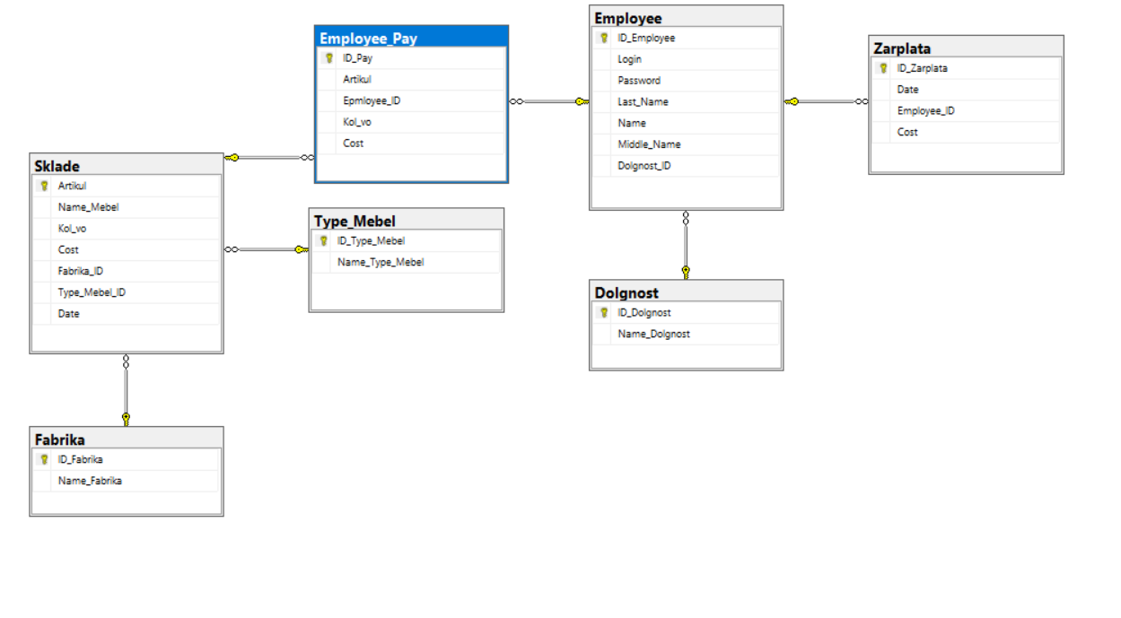

*Рисунок 1 - Схема данных*

Исходный код:

Таблица - Emloyee

|  |
| --- |
| ﻿using System;  using System.Collections.Generic;  using System.ComponentModel;  using System.Data;  using System.Data.SqlClient;  using System.Drawing;  using System.Linq;  using System.Text;  using System.Threading.Tasks;  using System.Windows.Forms;  namespace Magazin  {  public partial class Employee : Form  {  string connection = @"Data Source=DESKTOP-1CRVPTK\ISIP_D_A_PAHOMOV;Initial Catalog=Mebel;Integrated Security=True";  public Employee()  {  InitializeComponent();  }  private void Empty_text()  {  login.Text = "";  Password.Text = "";  Middle_name.Text = "";  Last_name.Text = "";  Name.Text = "";  dataGridView1.ClearSelection();  }  private void Add_Click(object sender, EventArgs e)  {  var conect = new SqlConnection(connection);  if (login.Text != "" && Password.Text != "" && Password.Text.Length<=8 && Last_name.Text !="" && Name.Text != "")  {  try  {  conect.Open();  var cmd = new SqlCommand($"insert into Employee (Login,Password,Last_Name,Name,Middle_Name,Dolgnost_ID) values ('{login.Text.Trim()}','{Password.Text.Trim()}','{Last_name.Text.Trim().ToUpper()}','{Name.Text.Trim().ToUpper()}','{Middle_name.Text.Trim().ToUpper()}',{Dolgnost.SelectedValue} )", conect);  cmd.ExecuteNonQuery();  }  catch (Exception Error)  {  MessageBox.Show(Error.Message.ToString());  }  finally  {  conect.Close();  }  select();  Empty_text();  }  }  private void delete_Click(object sender, EventArgs e)  {  var conect = new SqlConnection(connection);  if (dataGridView1.Rows.Count != 0)  {  var articul = (dataGridView1.SelectedRows[0].DataBoundItem as DataRowView).Row.ItemArray[0].ToString();  try  {  conect.Open();  var cmd = new SqlCommand($"delete from Employee where ID_Employee = '{articul}' ", conect);  cmd.ExecuteNonQuery();  }  catch (Exception Error)  {  MessageBox.Show(Error.Message.ToString());  }  finally  {  conect.Close();  }  select();  Empty_text();  }  }  private void update_Click(object sender, EventArgs e)  {  var conect = new SqlConnection(connection);  if (login.Text != "" && Password.Text != "" && Password.Text.Length <= 8 && Last_name.Text != "" && Name.Text != "")  {  if (dataGridView1.Rows.Count != 0)  {  var articul = (dataGridView1.SelectedRows[0].DataBoundItem as DataRowView).Row.ItemArray[0].ToString();  try  {  conect.Open();  var cmd = new SqlCommand();  cmd.Connection = conect;  cmd.CommandText = $"update Employee set Login = '{login.Text.Trim()}', Password = '{Password.Text.Trim()}', Last_Name = '{Last_name.Text.Trim().ToUpper()}', Name = '{Name.Text.Trim().ToUpper()}', Middle_Name = '{Middle_name.Text.Trim().ToUpper()}', Dolgnost_ID = '{Dolgnost.SelectedValue}' where ID_Employee ='{articul}' ";  cmd.ExecuteNonQuery();  }  catch (Exception Error)  {  MessageBox.Show(Error.Message.ToString());  }  finally  {  conect.Close();  }  select();  Empty_text();  }  }  }  private void clear_Click(object sender, EventArgs e)  {  Empty_text();  }  private void Employee_Load(object sender, EventArgs e)  {  select();  dataGridView1.ReadOnly = true;  Empty_text();  }  private void select()  {  var conect = new SqlConnection(connection);  string sql = "SELECT dbo.Employee.ID_Employee AS [№], dbo.Employee.Login AS Логин, dbo.Employee.Password AS Пароль, dbo.Employee.Last_Name AS Фамилия, dbo.Employee.Name AS Имя, dbo.Employee.Middle_Name AS Очество, dbo.Dolgnost.Name_Dolgnost AS[Название должности] FROM dbo.Employee INNER JOIN dbo.Dolgnost ON dbo.Employee.Dolgnost_ID = dbo.Dolgnost.ID_Dolgnost";  try  {  conect.Open();  var adapter = new SqlDataAdapter(sql, conect);  // Создаем объект Dataset  DataSet ds = new DataSet();  // Заполняем Dataset  adapter.Fill(ds);  // Отображаем данные  dataGridView1.DataSource = ds.Tables[0];  sql = "select * from Dolgnost";  adapter = new SqlDataAdapter(sql, conect);  ds = new DataSet();  adapter.Fill(ds);  List<Dolgnost> fabriks = new List<Dolgnost>();  for (int i = 0; i < ds.Tables[0].Rows.Count; i++)  {  var row = ds.Tables[0].Rows[i].ItemArray;  fabriks.Add(new Dolgnost { id = (int)row[0], Name = row[1].ToString() });  }  Dolgnost.DataSource = fabriks;  Dolgnost.DisplayMember = "Name";  Dolgnost.ValueMember = "id";  }  catch (Exception Error)  {  MessageBox.Show(Error.Message.ToString());  }  finally  {  conect.Close();  }  dataGridView1.ClearSelection();  }  private void dataGridView1_RowStateChanged(object sender, DataGridViewRowStateChangedEventArgs e)  {  if (dataGridView1.SelectedRows.Count != 0)  {  var row = (dataGridView1.SelectedRows[0].DataBoundItem as DataRowView).Row.ItemArray;  login.Text = row[1].ToString();  Password.Text = row[2].ToString();  Last_name.Text = row[3].ToString();  Name.Text = row[4].ToString();  Middle_name.Text = row[5].ToString();    for (int i = 0; i < Dolgnost.Items.Count; i++)  {  var test = Dolgnost.Items[i] as Dolgnost;  var fab = row[6].ToString();  if (test.Name == fab)  {  Dolgnost.SelectedIndex = i;  }  }    }  }  private void Employee_FormClosed(object sender, FormClosedEventArgs e)  {  Application.Exit();  }  }  class Dolgnost  {  public int id { get; set; }  public string Name { get; set; }  }  } |

Таблица - Form

|  |
| --- |
| using System;  using System.Collections.Generic;  using System.ComponentModel;  using System.Data;  using System.Data.SqlClient;  using System.Diagnostics;  using System.Drawing;  using System.Linq;  using System.Text;  using System.Threading.Tasks;  using System.Windows.Forms;  namespace Magazin  {  public partial class Form1 : Form  {  string connection = @"Data Source=DESKTOP-1CRVPTK\ISIP_D_A_PAHOMOV;Initial Catalog=Mebel;Integrated Security=True";  public Form1()  {  InitializeComponent();  }  private void Form1_Load(object sender, EventArgs e)  {  select();  Empty_Text();  dataGridView1.ClearSelection();  dataGridView1.ReadOnly = true;  }  private void select()  {  var conect = new SqlConnection(connection);  var sql = "SELECT dbo.Sklade.Artikul AS Артикул, dbo.Sklade.Date AS Дата, dbo.Sklade.Name_Mebel AS Название, dbo.Fabrika.Name_Fabrika AS Фабрика, dbo.Type_Mebel.Name_Type_Mebel AS [Тип мебели], dbo.Sklade.Kol_vo AS Количество, dbo.Sklade.Cost AS Стоимость FROM dbo.Sklade INNER JOIN dbo.Type_Mebel ON dbo.Sklade.Type_Mebel_ID = dbo.Type_Mebel.ID_Type_Mebel INNER JOIN dbo.Fabrika ON dbo.Sklade.Fabrika_ID = dbo.Fabrika.ID_Fabrika";  try  {  conect.Open();  var adapter = new SqlDataAdapter(sql, conect);  // Создаем объект Dataset  DataSet ds = new DataSet();  // Заполняем Dataset  adapter.Fill(ds);  // Отображаем данные  dataGridView1.DataSource = ds.Tables[0];  sql = "select * from Fabrika";  adapter = new SqlDataAdapter(sql, conect);  ds = new DataSet();  adapter.Fill(ds);  List<fabrik> fabriks = new List<fabrik>();  for (int i = 0; i < ds.Tables[0].Rows.Count; i++)  {  var row = ds.Tables[0].Rows[i].ItemArray;  fabriks.Add(new fabrik { id = (int)row[0], name = row[1].ToString() });  }  Name_Fabrik.DataSource = fabriks;  Name_Fabrik.DisplayMember = "name";  Name_Fabrik.ValueMember = "id";  sql = "select * from Type_Mebel";  adapter = new SqlDataAdapter(sql, conect);  ds = new DataSet();  adapter.Fill(ds);  fabriks = new List<fabrik>();  for (int i = 0; i < ds.Tables[0].Rows.Count; i++)  {  var row = ds.Tables[0].Rows[i].ItemArray;  fabriks.Add(new fabrik { id = (int)row[0], name = row[1].ToString() });  }  Type_Mebel.DataSource = fabriks;  Type_Mebel.DisplayMember = "name";  Type_Mebel.ValueMember = "id";  }  catch (Exception Error)  {  MessageBox.Show(Error.Message.ToString());  }  finally  {  conect.Close();  }  }  private void Empty_Text()  {  Artikul.Text = "";  Name_Mebel.Text = "";  Cost.Text = "0";  Kol_vo.Value = 0;  dataGridView1.ClearSelection();  }  private void Add_Click(object sender, EventArgs e)  {  var conect = new SqlConnection(connection);  if (Artikul.Text != "" && Name_Mebel.Text != "" && Kol_vo.Value > 0 && Convert.ToInt32(Cost.Text) > 0)  {  try  {  conect.Open();  var cmd = new SqlCommand($"insert into Sklade (Artikul,Date,Name_Mebel,Kol_vo,Cost,Fabrika_ID,Type_Mebel_ID) values ('{Artikul.Text.Trim().ToUpper()}','{date.Value.Date.ToString().Replace(" 0:00:00", "")}','{Name_Mebel.Text.Trim().ToUpper()}',{Kol_vo.Text},{Cost.Text},{Name_Fabrik.SelectedValue},{Type_Mebel.SelectedValue} )", conect);  cmd.ExecuteNonQuery();  }  catch (Exception Error)  {  MessageBox.Show(Error.Message.ToString());  }  finally  {  conect.Close();  }  select();  Empty_Text();  }  }  private void Delete_Click(object sender, EventArgs e)  {  var conect = new SqlConnection(connection);  if (dataGridView1.Rows.Count != 0 )  {  var articul = (dataGridView1.SelectedRows[0].DataBoundItem as DataRowView).Row.ItemArray[0].ToString();  try  {  conect.Open();  var cmd = new SqlCommand($"delete from Sklade where Artikul = '{articul}' ", conect);  cmd.ExecuteNonQuery();  }  catch (Exception Error)  {  MessageBox.Show(Error.Message.ToString());  }  finally  {  conect.Close();  }  select();  Empty_Text();  }  }  private void Update_Click(object sender, EventArgs e)  {  var conect = new SqlConnection(connection);  if (Artikul.Text != "" && Name_Mebel.Text != "" && Kol_vo.Value > 0 && Convert.ToInt32(Cost.Text) > 0)  {  if (dataGridView1.Rows.Count != 0)  {  var articul = (dataGridView1.SelectedRows[0].DataBoundItem as DataRowView).Row.ItemArray[0].ToString();  try  {  conect.Open();  var cmd = new SqlCommand();  cmd.Connection = conect;  cmd.CommandText = $"update Sklade set Date = '{date.Value.Date.ToString().Replace(" 0:00:00", "")}', Name_Mebel = '{Name_Mebel.Text.Trim().ToUpper()}', Kol_vo = {Kol_vo.Text}, Cost = {Cost.Text}, Fabrika_ID = {Name_Fabrik.SelectedValue}, Type_Mebel_ID = {Type_Mebel.SelectedValue} where Artikul ='{articul}' ";  cmd.ExecuteNonQuery();  }  catch (Exception Error)  {  MessageBox.Show(Error.Message.ToString());  }  finally  {  conect.Close();  }  select();  Empty_Text();  }  }  }  private void dataGridView1_RowStateChanged(object sender, DataGridViewRowStateChangedEventArgs e)  {  if (dataGridView1.SelectedRows.Count != 0)  {  var row = (dataGridView1.SelectedRows[0].DataBoundItem as DataRowView).Row.ItemArray;  Artikul.Text = row[0].ToString();  date.Text = row[1].ToString();  Name_Mebel.Text = row[2].ToString();  for (int i = 0; i < Name_Fabrik.Items.Count; i++)  {  var test = Name_Fabrik.Items[i] as fabrik;  var fab = row[3].ToString();  if (test.name == fab)  {  Name_Fabrik.SelectedIndex = i;  }  }  for (int i = 0; i < Type_Mebel.Items.Count; i++)  {  var test = Type_Mebel.Items[i] as fabrik;  var fab = row[4].ToString();  if (test.name == fab)  {  Type_Mebel.SelectedIndex = i;  }  }  Cost.Text = row[6].ToString();  Kol_vo.Value = (int)row[5];  }  }  private void Clear_Click(object sender, EventArgs e)  {  Empty_Text();  }  private void button1_Click(object sender, EventArgs e)  {    }  private void Form1_FormClosed(object sender, FormClosedEventArgs e)  {  Application.Exit();  }  }  }  class fabrik  {  public int id { get; set; }  public string name { get; set; }  } |

Таблица - input

|  |
| --- |
| using System;  using System.Collections.Generic;  using System.ComponentModel;  using System.Data;  using System.Data.SqlClient;  using System.Drawing;  using System.Linq;  using System.Text;  using System.Threading.Tasks;  using System.Windows.Forms;  namespace Magazin  {  public partial class Input : Form  {  public Input()  {  InitializeComponent();  }  string connection = @"Data Source=DESKTOP-1CRVPTK\ISIP_D_A_PAHOMOV;Initial Catalog=Mebel;Integrated Security=True";  public static int save_id_employee = 0;  private void button1_Click(object sender, EventArgs e)  {  var conect = new SqlConnection(connection);  string sql = "select Dolgnost_ID,Login,Password,ID_Employee from Employee";  try  {  conect.Open();  var adapter = new SqlDataAdapter(sql, conect);  // Создаем объект Dataset  DataSet ds = new DataSet();  // Заполняем Dataset  adapter.Fill(ds);  for (int i = 0; i < ds.Tables[0].Rows.Count; i++)  {  var rows = ds.Tables[0].Rows[i].ItemArray;  if (Login.Text == "Admin" && Password.Text == "Admin")  {  this.Hide();  Employee employee = new Employee();    employee.Show();  return;  }  if (Login.Text == rows[1].ToString() && Password.Text == rows[2].ToString())  {  if ((int)rows[0] == 1)  {  this.Hide();  Pay pay = new Pay();  save_id_employee = (int)rows[3];  pay.Show();  return;  }  if ((int)rows[0] == 2)  {  this.Hide();  Form1 form1 = new Form1();  form1.Show();  return;  }  if ((int)rows[0] == 3)  {  this.Hide();  Zarplata form1 = new Zarplata();  form1.Show();  return;  }  }  }  }  catch (Exception Error)  {  MessageBox.Show(Error.Message.ToString());  }  finally  {  conect.Close();  }  }  private void Input_Load(object sender, EventArgs e)  {  }  }  } |

Таблица - Pay

|  |
| --- |
| using System;  using System.Collections.Generic;  using System.ComponentModel;  using System.Data;  using System.Data.SqlClient;  using System.Drawing;  using System.Linq;  using System.Text;  using System.Threading.Tasks;  using System.Windows.Forms;  namespace Magazin  {  public partial class Pay : Form  {  string connection = @"Data Source=DESKTOP-1CRVPTK\ISIP_D_A_PAHOMOV;Initial Catalog=Mebel;Integrated Security=True";  public Pay()  {  InitializeComponent();  }  private void select()  {  var conect = new SqlConnection(connection);  try  {  conect.Open();  string sql = "SELECT ID_Pay, dbo.Employee_Pay.Artikul, CONCAT(dbo.Sklade.Artikul, ' ',dbo.Sklade.Name_Mebel) as 'Артикул и Название', CONCAT(dbo.Employee.Last_Name,' ',dbo.Employee.Name ,' ',dbo.Employee.Middle_Name) as 'Сотрудник', dbo.Employee_Pay.Kol_vo, dbo.Employee_Pay.Cost FROM dbo.Sklade INNER JOIN dbo.Employee_Pay ON dbo.Sklade.Artikul = dbo.Employee_Pay.Artikul INNER JOIN dbo.Employee ON dbo.Employee_Pay.Epmloyee_ID = dbo.Employee.ID_Employee";  var adapter = new SqlDataAdapter(sql, conect);  var ds = new DataSet();  adapter.Fill(ds);  dataGridView1.DataSource = ds.Tables[0];  dataGridView1.ReadOnly = true;  dataGridView1.Columns[0].Visible = false;  dataGridView1.Columns[1].Visible = false;  dataGridView1.AutoSizeColumnsMode = DataGridViewAutoSizeColumnsMode.AllCells;  sql = "SELECT Artikul, CONCAT(Artikul, ' ', Name_Mebel)FROM dbo.Sklade";  adapter = new SqlDataAdapter(sql, conect);  ds = new DataSet();  adapter.Fill(ds);  List<Sklade> fabriks = new List<Sklade>();  for (int i = 0; i < ds.Tables[0].Rows.Count; i++)  {  var row = ds.Tables[0].Rows[i].ItemArray;  fabriks.Add(new Sklade { art = row[0].ToString(), name = row[1].ToString() });  }  Artikul.DataSource = fabriks;  Artikul.DisplayMember = "name";  Artikul.ValueMember = "art";  }  catch (Exception Error)  {  MessageBox.Show(Error.Message.ToString());  }  finally  {  conect.Close();  }  }  private void Pay_Load(object sender, EventArgs e)  {  select();  dataGridView1.ClearSelection();  }  private void maskedTextBox1_TextChanged(object sender, EventArgs e)  {  }  private void Artikul_SelectedIndexChanged(object sender, EventArgs e)  {  if (Artikul.SelectedIndex != -1)  {  var conect = new SqlConnection(connection);  var art = (Artikul.SelectedItem as Sklade);  try  {  conect.Open();  string sql = $"SELECT Cost FROM dbo.Sklade where Artikul = '{art.art}'";  var adapter = new SqlDataAdapter(sql, conect);  var ds = new DataSet();  adapter.Fill(ds);  if (ds.Tables.Count > 0)  {  var row = ds.Tables[0].Rows[0].ItemArray;  Cost.Text = row[0].ToString();  }  }  catch (Exception Error)  {  MessageBox.Show(Error.Message.ToString());  }  finally  {  conect.Close();  }  }  }  private void add_Click(object sender, EventArgs e)  {  var conect = new SqlConnection(connection);  if (Kol_vo.Value > 0)  {  try  {  conect.Open();  var cmd = new SqlCommand($"insert into Employee_Pay values ('{(Artikul.SelectedItem as Sklade).art}',{Input.save_id_employee},{Kol_vo.Value},{Kol_vo.Value * Convert.ToInt32(Cost.Text)}" + $")", conect);  cmd.ExecuteNonQuery();  select();  }  catch (Exception Error)  {  MessageBox.Show(Error.Message.ToString());  }  finally  {  conect.Close();  }  }  }  private void Pay_FormClosed(object sender, FormClosedEventArgs e)  {  Application.Exit();  }  private void delete_Click(object sender, EventArgs e)  {  var conect = new SqlConnection(connection);  if (dataGridView1.Rows.Count != 0)  {  var articul = (dataGridView1.SelectedRows[0].DataBoundItem as DataRowView).Row.ItemArray[0].ToString();  try  {  conect.Open();  var cmd = new SqlCommand($"delete from Employee_Pay where ID_Pay = '{articul}' ", conect);  cmd.ExecuteNonQuery();  }  catch (Exception Error)  {  MessageBox.Show(Error.Message.ToString());  }  finally  {  conect.Close();  }  select();  }  }  private void update_Click(object sender, EventArgs e)  {  var conect = new SqlConnection(connection);  if (Kol_vo.Value != 0)  {  if (dataGridView1.Rows.Count != 0)  {  var articul = (dataGridView1.SelectedRows[0].DataBoundItem as DataRowView).Row.ItemArray[0].ToString();  try  {  conect.Open();  var cmd = new SqlCommand();  cmd.Connection = conect;  cmd.CommandText = $"update Employee_Pay set Artikul = '{(Artikul.SelectedItem as Sklade).art}', Kol_vo = {Kol_vo.Value}, Cost = {Kol_vo.Value * Convert.ToInt32(Cost.Text)} where ID_Pay ='{articul}' ";  cmd.ExecuteNonQuery();  }  catch (Exception Error)  {  MessageBox.Show(Error.Message.ToString());  }  finally  {  conect.Close();  }  select();  }  }  }  }  public class Sklade  {  public string art { get; set; }  public string name { get; set; }  }  } |

|  |
| --- |
| using System;  using System.Collections.Generic;  using System.ComponentModel;  using System.Data;  using System.Data.SqlClient;  using System.Drawing;  using System.Linq;  using System.Text;  using System.Threading.Tasks;  using System.Windows.Forms;  namespace Magazin  {  public partial class Zarplata : Form  {  public Zarplata()  {  InitializeComponent();  }  private void Add_Click(object sender, EventArgs e)  {  var conect = new SqlConnection(connection);  if (Convert.ToInt32(Cost.Text) > 0)  try  {  conect.Open();  var cmd = new SqlCommand($"insert into Zarplata (Date, Employee_ID,Cost) values ('{date.Value.Date.ToString().Replace(" 0:00:00", "")}',{Employee.SelectedValue},{Cost.Text} )", conect);  cmd.ExecuteNonQuery();  }  catch (Exception Error)  {  MessageBox.Show(Error.Message.ToString());  }  finally  {  conect.Close();  }  select();  }  private void delete_Click(object sender, EventArgs e)  {  var conect = new SqlConnection(connection);  if (dataGridView1.Rows.Count != 0)  {  var articul = (dataGridView1.SelectedRows[0].DataBoundItem as DataRowView).Row.ItemArray[0].ToString();  try  {  conect.Open();  var cmd = new SqlCommand($"delete from Zarplata where ID_Zarplata = '{articul}' ", conect);  cmd.ExecuteNonQuery();  }  catch (Exception Error)  {  MessageBox.Show(Error.Message.ToString());  }  finally  {  conect.Close();  }  select();  Cost.Text = "";  }  }  string connection = @"Data Source=DESKTOP-1CRVPTK\ISIP_D_A_PAHOMOV;Initial Catalog=Mebel;Integrated Security=True";  private void select()  {  var conect = new SqlConnection(connection);  string sql = "SELECT dbo.Zarplata.ID_Zarplata, CONCAT(dbo.Employee.Last_Name,' ',dbo.Employee.Name,' ', dbo.Employee.Middle_Name) as 'ФИО' , dbo.Zarplata.Date as 'Дата' , dbo.Zarplata.Cost as 'Зарплата' FROM dbo.Zarplata INNER JOIN dbo.Employee ON dbo.Zarplata.Employee_ID = dbo.Employee.ID_Employee";  try  {  conect.Open();  var adapter = new SqlDataAdapter(sql, conect);  // Создаем объект Dataset  DataSet ds = new DataSet();  // Заполняем Dataset  adapter.Fill(ds);  // Отображаем данные  dataGridView1.DataSource = ds.Tables[0];  sql = "select Employee.ID_Employee , CONCAT(dbo.Employee.Last_Name,' ',dbo.Employee.Name,' ', dbo.Employee.Middle_Name) from Employee";  adapter = new SqlDataAdapter(sql, conect);  ds = new DataSet();  adapter.Fill(ds);  dataGridView1.Columns[0].Visible = false;  List<Emploees> fabriks = new List<Emploees>();  for (int i = 0; i < ds.Tables[0].Rows.Count; i++)  {  var row = ds.Tables[0].Rows[i].ItemArray;  fabriks.Add(new Emploees { id = (int)row[0], name = row[1].ToString() });  }  Employee.DataSource = fabriks;  Employee.DisplayMember = "Name";  Employee.ValueMember = "id";  }  catch (Exception Error)  {  MessageBox.Show(Error.Message.ToString());  }  finally  {  conect.Close();  }  dataGridView1.ClearSelection();  }  private void Zarplata_Load(object sender, EventArgs e)  {  select();  }  private void update_Click(object sender, EventArgs e)  {  var conect = new SqlConnection(connection);  if (Convert.ToInt32(Cost.Text) > 0)  if (dataGridView1.Rows.Count != 0)  {  var articul = (dataGridView1.SelectedRows[0].DataBoundItem as DataRowView).Row.ItemArray[0].ToString();  try  {  conect.Open();  var cmd = new SqlCommand();  cmd.Connection = conect;  cmd.CommandText = $"update Zarplata set Date = '{date.Value.Date.ToString().Replace(" 0:00:00", "")}, Cost = {Cost.Text}, Employee_ID = {Employee.SelectedValue} where ID_Zarplata ='{articul}' ";  cmd.ExecuteNonQuery();  }  catch (Exception Error)  {  MessageBox.Show(Error.Message.ToString());  }  finally  {  conect.Close();  }  select();  }  }  }  public class Emploees  {  public int id { get; set; }  public string name { get; set; }  }  } |

Результат работы программы:

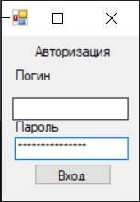

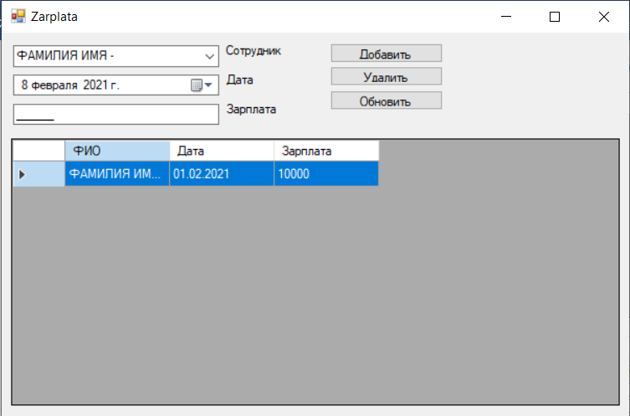

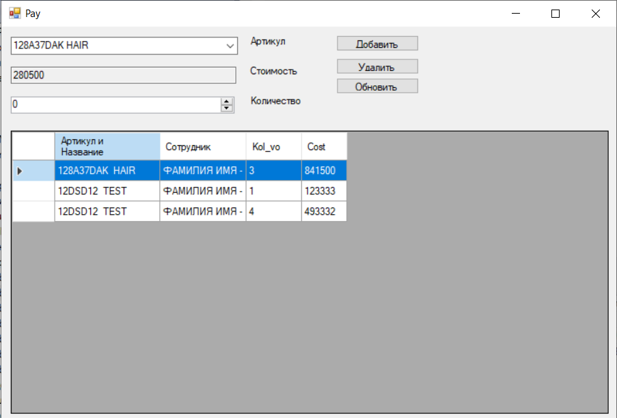

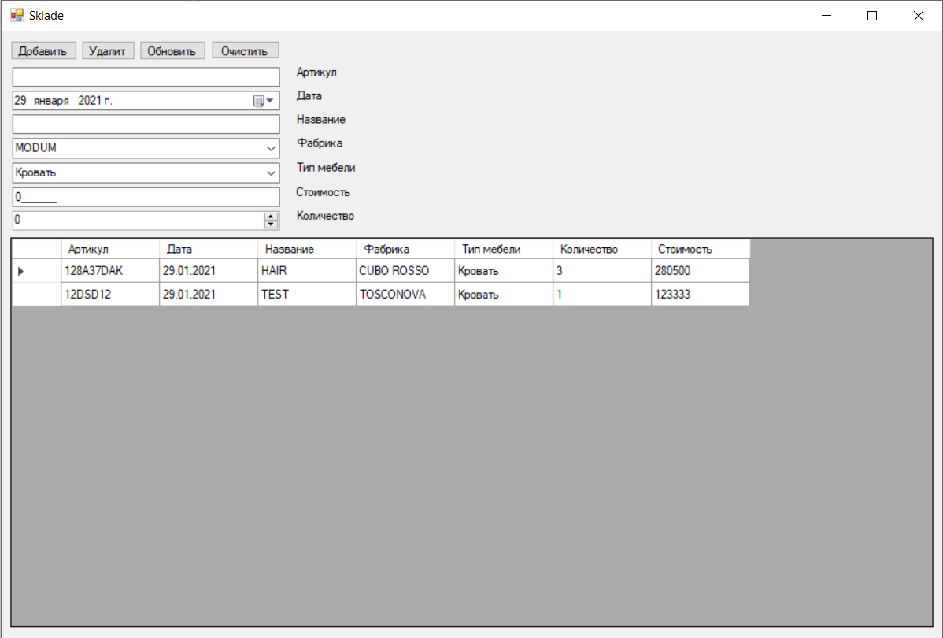

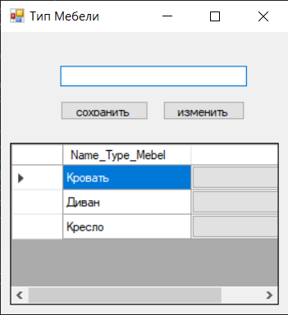

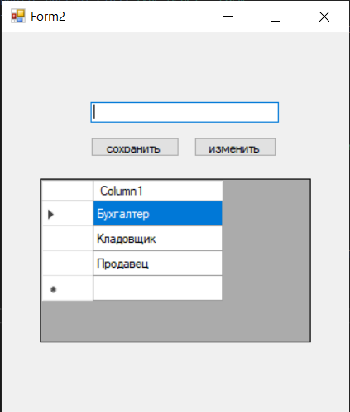

Вывод: научился работать с базами данных Microsoft SQL Server, посредством C#.

ПРАКТИЧЕСКАЯ РАБОТА №2

Цель: научиться выполнять работу по техническому заданию.

Схема данных: схема данных, описывающая базу данных представлена на Рисунке 1.

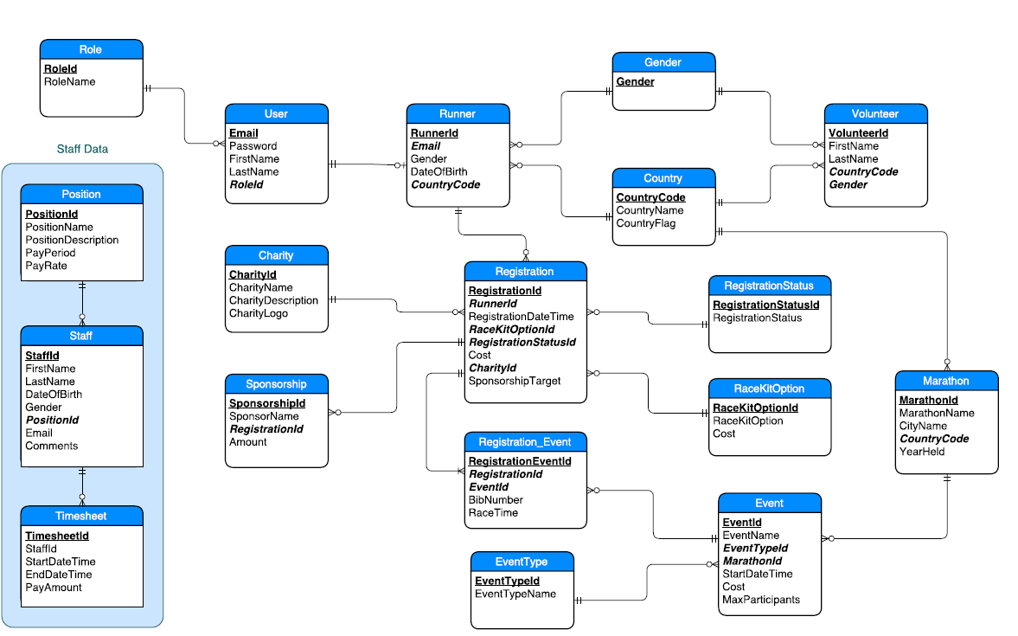

*Рисунок 1 - Схема данных*

Исходный код:

Таблица - About Marathon - Skills 2021

|  |
| --- |
| using System;  using System.Collections.Generic;  using System.ComponentModel;  using System.Data;  using System.Drawing;  using System.Linq;  using System.Text;  using System.Threading.Tasks;  using System.Windows.Forms;  namespace Marathon_Skills_2016  {  public partial class About_Marathon_Skills_2021 : Form  {  public About_Marathon_Skills_2021()  {  InitializeComponent();  }  private void About_Marathon_Skills_2021_FormClosed(object sender, FormClosedEventArgs e)  {  Application.Exit();  }  private void userControl11_Load(object sender, EventArgs e)  {  userControl11.timer1.Start();  }  private void btn_cansel_Click(object sender, EventArgs e)  {  var form = new Find_Out_More_Information();  Hide();  form.Show();  }  private void MapButton_Click(object sender, EventArgs e)  {  var form = new Interactive_Map();  Hide();  form.Show();  }  }  } |

Таблица - Administrator menu

|  |
| --- |
| using System;  using System.Collections.Generic;  using System.ComponentModel;  using System.Data;  using System.Drawing;  using System.Linq;  using System.Text;  using System.Threading.Tasks;  using System.Windows.Forms;  namespace Marathon_Skills_2016  {  public partial class Administrator_Menu : Form  {  public Administrator_Menu()  {  InitializeComponent();  }  private void Administrator_Menu_FormClosed(object sender, FormClosedEventArgs e)  {  Application.Exit();  }  private void userControl11_Load(object sender, EventArgs e)  {  userControl11.timer1.Start();  }  }  } |

Таблица - BMI Calculator

|  |
| --- |
| using System;  using System.Collections.Generic;  using System.ComponentModel;  using System.Data;  using System.Drawing;  using System.Linq;  using System.Text;  using System.Threading.Tasks;  using System.Windows.Forms;  namespace Marathon_Skills_2016  {  public partial class BMICalculator : Form  {  public BMICalculator()  {  InitializeComponent();  }  private void userControl11_Load(object sender, EventArgs e)  {  userControl11.timer1.Start();  }  private void BMI_KeyPress(object sender, KeyPressEventArgs e)  {  if ((e.KeyChar <= 47 || e.KeyChar >= 58) && e.KeyChar != 8)  e.Handled = true;  }  int a = 0, c;  double d, b;  private void BackButton_Click(object sender, EventArgs e)  {  this.Close();  }  private void CancelButton_Click(object sender, EventArgs e)  {  var form = new Find_Out_More_Information();  form.Show();  Hide();  }  private void CalculateButton_Click(object sender, EventArgs e)  {  try  {  double c = Convert.ToInt32(GrowthTextBox.Text);  double d = Convert.ToInt32(WeightTextBox.Text);  b = d / ((c / 100) * (c / 100));  b = Math.Round(b, 1);  if (b < 18)  {  ResultLabel.Text = "Недостаточный";  BMIResultPictureBox.Location = new Point(840, 650);  BMIResultsLabel.Location = new Point(840, 650);  ResultPictureBox.Image = Properties.Resources.bmi_underweight_icon;  BMIResultsLabel.Text = b.ToString();  }  else if (18 <= b && b < 25)  {  ResultLabel.Text = "Здоровый";  BMIResultPictureBox.Location = new Point(960, 680);  BMIResultsLabel.Location = new Point(960, 650);  ResultPictureBox.Image = Properties.Resources.bmi_healthy_icon;  BMIResultsLabel.Text = b.ToString();  }  else if (25 <= b && b < 30)  {  ResultLabel.Text = "Избыточный";  BMIResultPictureBox.Location = new Point(1090, 680);  BMIResultsLabel.Location = new Point(1090, 650);  ResultPictureBox.Image = Properties.Resources.bmi_overweight_icon;  BMIResultsLabel.Text = b.ToString();  }  else if (b >= 30)  {  ResultLabel.Text = "Ожирение";  BMIResultPictureBox.Location = new Point(1200,681);  BMIResultsLabel.Location = new Point(1200, 650);  ResultPictureBox.Image = Properties.Resources.bmi_obese_icon;  BMIResultsLabel.Text = b.ToString();  }  else  {  MessageBox.Show("Ошибка в подсчёте");  }  }  catch  {  MessageBox.Show("Ошибка в подсчёте");  }  }  private void btn_cansel_Click(object sender, EventArgs e)  {  var form = new Find_Out_More_Information();  form.Show();  Hide();  }  private void MalePictureBox_Click(object sender, EventArgs e)  {  FemalePictureBox.BackColor = Color.White;  MalePictureBox.BackColor = Color.Gray;  }  private void FemalePictureBox_Click(object sender, EventArgs e)  {  FemalePictureBox.BackColor = Color.Gray;  MalePictureBox.BackColor = Color.White;  }  }  } |

Таблица - BMRCalculator

|  |
| --- |
| using System;  using System.Collections.Generic;  using System.ComponentModel;  using System.Data;  using System.Drawing;  using System.Linq;  using System.Text;  using System.Threading.Tasks;  using System.Windows.Forms;  namespace Marathon_Skills_2016  {  public partial class BMR_Calculator : Form  {  public BMR_Calculator()  {  InitializeComponent();  }  int a = 0, c;  double d, b, s;  double z, x, h, g, f;  private void btn_cansel_Click(object sender, EventArgs e)  {  var fomr = new Find_Out_More_Information();  fomr.Show();  Hide();  }  private void userControl11_Load(object sender, EventArgs e)  {  userControl11.timer1.Start();  }  private void FemalePictureBox_Click(object sender, EventArgs e)  {  a = 2;  FemalePictureBox.BackColor = Color.Gray;  MalePictureBox.BackColor = Color.White;  }  private void MalePictureBox_Click(object sender, EventArgs e)  {  a = 1;  FemalePictureBox.BackColor = Color.White;  MalePictureBox.BackColor = Color.Gray;  }  private void InfoPictureBox_Click(object sender, EventArgs e)  {  MessageBox.Show("СИДЯЧИЙ ОБРАЗ НЕТ РАБОТЫ ИЛИ РАБОТА ЗА СТОЛОМ Маленькая активность Мало физических работы или занятия спортом 1 - 3 раза в неделю " +  " СРЕДНЯЯ АКТИВНОСТЬ УМЕРЕННАЯ ФИЗИЧЕСКАЯ РАБОТА ИЛИ ЗАНЯТИЯ СПОРТОМ 3 - 5 ДНЕЙ В НЕДЕЛЮ Сильная активность Сильные физическая нагрузка или занятия спортом 6 - 7 дней в неделю Максимальная активность Сильная ежедневная физическая нагрузка или спорт и физическая работа");  }  private void CalculateButton_Click(object sender, EventArgs e)  {  try  {  double c = Convert.ToInt32(GrowthTextBox.Text);  double d = Convert.ToInt32(WeightTextBox.Text);  double s = Convert.ToInt32(AgeTextBox.Text);  if (a <= 1)  {  b = 66.0 + (13.7 * c) + (5.0 * d) + (6.8 * s);  z = b * 1.2;  x = b * 1.375;  h = b * 1.55;  g = b * 1.725;  f = b * 1.9;  AmountBMRLabel.Text = b.ToString();  SedentaryAmountLabel.Text = z.ToString();  PetiteAmountLabel.Text = x.ToString();  AvarageAmountLabel.Text = h.ToString();  StrongAmountLabel.Text = g.ToString();  MaximumAmountLabel.Text = f.ToString();  }  else if (a >= 2)  {  b = 655 + (9.6 * c) + (1.8 * d) + (4.7 * s);  z = b * 1.2;  x = b * 1.375;  h = b * 1.55;  g = b * 1.725;  f = b * 1.9;  AmountBMRLabel.Text = b.ToString();  SedentaryAmountLabel.Text = z.ToString();  PetiteAmountLabel.Text = x.ToString();  AvarageAmountLabel.Text = h.ToString();  StrongAmountLabel.Text = g.ToString();  MaximumAmountLabel.Text = f.ToString();  }  else  {  MessageBox.Show("Выберете пол");  }  }  catch  {  MessageBox.Show("Ошибка в вводе");  }  }  }  } |

Таблица - Certificate_preview

|  |
| --- |
| using System;  using System.Collections.Generic;  using System.ComponentModel;  using System.Data;  using System.Drawing;  using System.Linq;  using System.Text;  using System.Threading.Tasks;  using System.Windows.Forms;  namespace Marathon_Skills_2016  {  public partial class Certificate_preview : Form  {  public Certificate_preview()  {  InitializeComponent();  }  }  } |

Таблица - Coordinator Menu

|  |
| --- |
| using System;  using System.Collections.Generic;  using System.ComponentModel;  using System.Data;  using System.Drawing;  using System.Linq;  using System.Text;  using System.Threading.Tasks;  using System.Windows.Forms;  namespace Marathon_Skills_2016  {  public partial class Coordinator_Menu : Form  {  public Coordinator_Menu()  {  InitializeComponent();  }  private void Coordinator_Menu_FormClosed(object sender, FormClosedEventArgs e)  {  Application.Exit();  }  private void userControl11_Load(object sender, EventArgs e)  {  userControl11.timer1.Start();  }  }  } |

Таблица - Edit runner profile

|  |
| --- |
| using System;  using System.Collections.Generic;  using System.ComponentModel;  using System.Data;  using System.Data.SqlClient;  using System.Drawing;  using System.IO;  using System.Linq;  using System.Text;  using System.Text.RegularExpressions;  using System.Threading.Tasks;  using System.Windows.Forms;  namespace Marathon_Skills_2016  {  public partial class Edit_runner_profile : Form  {  string email = "";  public Edit_runner_profile(string Email)  {  InitializeComponent();  this.email = Email;  }  private void Edit_runner_profile_FormClosed(object sender, FormClosedEventArgs e)  {  Application.Exit();  }  byte[] bt = null;  private void Edit_runner_profile_Load(object sender, EventArgs e)  {  lb_email.Text = email;  var conect = new SqlConnection(Properties.Resources.connection);  try  {  conect.Open();  var adapter = new SqlDataAdapter(Properties.Resources.sql_country, conect);  var ds = new DataSet();  adapter.Fill(ds);  var arraycountry = new List<Country>();  for (int i = 0; i < ds.Tables[0].Rows.Count; i++)  {  var row = ds.Tables[0].Rows[i].ItemArray;  arraycountry.Add(new Country { CountryCode = row[0].ToString(), CountryFlag = row[2].ToString(), CountryName = row[1].ToString() });  }  tb_country.DataSource = arraycountry;  tb_country.DisplayMember = "CountryName";  tb_country.ValueMember = "CountryCode";  adapter = new SqlDataAdapter($"select * from Runner where Email = '{email}'", conect);  ds = new DataSet();  adapter.Fill(ds);  var row1 = ds.Tables[0].Rows[0].ItemArray;  tb_date.Value = DateTime.Parse(row1[3].ToString());  cb_sex.SelectedItem = row1[2].ToString();  tb_country.SelectedValue = row1[4].ToString();  adapter = new SqlDataAdapter($"select * from dbo.[User] where [User].Email = '{email}'", conect);  ds = new DataSet();  adapter.Fill(ds);  row1 = ds.Tables[0].Rows[0].ItemArray;  tb_password.Text = row1[1].ToString();  tx_password2.Text = row1[1].ToString();  bt = row1[5] as byte[];  if (bt != null)  {  img_runner.Image = ByteArrayToImage(bt);  }  else  {  img_runner.Image = Image.FromFile(Application.StartupPath.Replace("\\bin\\Debug", "") + "\\Resources\\unnamed.jpg");  }  tb_last.Text = row1[3].ToString();  tb_name.Text = row1[2].ToString();  }  catch (Exception Error)  {  MessageBox.Show(Error.Message);  }  finally  {  conect.Close();  }  openFileDialog1.Filter = "*.bmp, *.jpg, *.png|*.bmp;*.jpg;*.png";  }  public Image ByteArrayToImage(byte[] bt)  {  using (var ms = new MemoryStream(bt))  {  Image image = Image.FromStream(ms);  return image;  }  }  private void btn_fail_Click(object sender, EventArgs e)  {  if (openFileDialog1.ShowDialog() == DialogResult.OK) //показываем диалог открытия  tb_path_img.Text = openFileDialog1.FileName;  }  private void btn_registration_Click(object sender, EventArgs e)  {  if (tb_name.Text != "" && tb_last.Text != "" && Password() && Date())  {  byte[] byte_img = null;  if (tb_path_img.Text == "")  {  byte_img = bt;  }  else  {  byte_img = File.ReadAllBytes(tb_path_img.Text);  }  var conect = new SqlConnection(Properties.Resources.connection);  try  {  string SQL = $" update dbo.[User] set Password = N'{tb_password.Text}', FirstName = N'{tb_last.Text}', LastName = N'{tb_name.Text}', IMG = @img where Email = N'{email}'";  string SQL1 = $"set language english update dbo.[Runner] set Gender = N'{cb_sex.SelectedItem}', DateOfBirth = CAST(N'{tb_date.Value.ToString("yyyy-MM-dd HH:mm:ss") + ".000"}' AS DateTime), CountryCode = N'{tb_country.SelectedValue}' where Email = N'{email}'";  conect.Open();  var command = new SqlCommand(SQL, conect);  command.Parameters.Add(new SqlParameter("@img", byte_img));  command.ExecuteNonQuery();  command = new SqlCommand(SQL1, conect);  command.ExecuteNonQuery();  var form = new Runner_Menu(email);  Hide();  form.Show();  }  catch (Exception er)  {  MessageBox.Show(er.Message);  }  finally  {  conect.Close();  }  }  }  private void calnsel_Click(object sender, EventArgs e)  {  var form = new Runner_Menu(email);  Hide();  form.Show();  }  private void button1_Click(object sender, EventArgs e)  {  var form = new start_screen();  Hide();  form.Show();  }  private void tb_name_Leave(object sender, EventArgs e)  {  if (((TextBox)sender).TextLength != 0)  (sender as TextBox).Text = (sender as TextBox).Text[0].ToString().ToUpper() + (sender as TextBox).Text.Substring(1, (sender as TextBox).Text.Length - 1).ToLower();  }  private void tb_name_KeyPress(object sender, KeyPressEventArgs e)  {  string Symbol = e.KeyChar.ToString();  if (!Regex.Match(Symbol, @"[а-яА-Я]|[a-zA-Z]").Success && !(e.KeyChar == (char)Keys.Back))  {  e.Handled = true;  }  }  Boolean Password()  {  if ((tb_password.Text.Contains("!") || tb_password.Text.Contains("@") || tb_password.Text.Contains("#") || tb_password.Text.Contains("$") || tb_password.Text.Contains("%") || tb_password.Text.Contains("^")) && tx_password2.Text == tb_password.Text && tb_password.Text.Length >= 6 && Regex.IsMatch(tb_password.Text, @"[0-9]") && Regex.IsMatch(tb_password.Text, @"[А-ЯA-Z]"))  {  return true;  }  return false;  }  Boolean Date()  {  var DateOfBirth = tb_date.Value.AddYears(10);  var datenow = DateTime.Now;  if (datenow >= DateOfBirth)  {  return true;  }  return false;  }  private void openFileDialog1_FileOk(object sender, CancelEventArgs e)  {  img_runner.Image = Image.FromFile(openFileDialog1.FileName);  }  }  } |

Таблица 12 - Find_Out_More_Information

|  |
| --- |
| sing System;  using System.Collections.Generic;  using System.ComponentModel;  using System.Data;  using System.Drawing;  using System.Linq;  using System.Text;  using System.Threading.Tasks;  using System.Windows.Forms;  namespace Marathon_Skills_2016  {  public partial class Find_Out_More_Information : Form  {  public Find_Out_More_Information()  {  InitializeComponent();  }  private void Find_Out_More_Information_FormClosed(object sender, FormClosedEventArgs e)  {  Application.Exit();  }  private void btn_cansel_Click(object sender, EventArgs e)  {  var form = new start_screen();  form.Show();  this.Hide();  }  private void btn_blag_organization_Click(object sender, EventArgs e)  {  var form = new List_Of_Charities();  form.Show();  this.Hide();  }  private void Find_Out_More_Information_Load(object sender, EventArgs e)  {  date_count.Start();  }  private void date_count_Tick(object sender, EventArgs e)  {  var end_date = DateTime.Parse("21-10-2021");  count_date.Text = $"{string.Format("{0:dd} дн. {0:hh} ч. {0:mm} м. {0:ss} сек.", end_date - DateTime.Now)} до старта марафона";  }  private void btn_maragon_date_Click(object sender, EventArgs e)  {  var form = new How_long_is_a_marathon();  Hide();  form.Show();  }  private void btn_marathon_skills_2021_Click(object sender, EventArgs e)  {  Hide();  var form = new About_Marathon_Skills_2021();  form.Show();  }  private void btn_results_Click(object sender, EventArgs e)  {  var form = new Previous_race_results();  form.Show();  Hide();  }  }  } |

Таблица 13 - How_long_is_a_marathon

|  |
| --- |
| using System;  using System.Collections.Generic;  using System.ComponentModel;  using System.Data;  using System.Drawing;  using System.Linq;  using System.Text;  using System.Threading.Tasks;  using System.Windows.Forms;  namespace Marathon_Skills_2016  {  public partial class How_long_is_a_marathon : Form  {  public How_long_is_a_marathon()  {  InitializeComponent();  }  private void userControl11_Load(object sender, EventArgs e)  {  userControl11.timer1.Start();  }  private void How_long_is_a_marathon_FormClosed(object sender, FormClosedEventArgs e)  {  Application.Exit();  }  private void FirstParagraphPictureBox_Click(object sender, EventArgs e)  {  SelectedParagraphPhotoPictureBox.Image = (sender as PictureBox).Image;  InformationLabel.Text = (sender as PictureBox).Tag.ToString();  label1.Text = (sender as PictureBox).Name;  }  private void btn_cansel_Click(object sender, EventArgs e)  {  var form = new Find_Out_More_Information();  Hide();  form.Show();  }  }  } |

Таблица - Interactive Maps

|  |
| --- |
| using System;  using System.Collections.Generic;  using System.ComponentModel;  using System.Data;  using System.Drawing;  using System.Linq;  using System.Text;  using System.Threading.Tasks;  using System.Windows.Forms;  namespace Marathon_Skills_2016  {  public partial class Interactive_Map : Form  {  public Interactive_Map()  {  InitializeComponent();  }  private void FirstStartPictureBox_Click(object sender, EventArgs e)  {  var type = ((PictureBox)sender).Tag;  switch (type)  {  case "Туалет":  {  MessageBox.Show("Туалет");  break;  }  case "Хрень":  {  MessageBox.Show("Стойка с энергетическими батончиками");  break;  }  case "Вода":  {  MessageBox.Show("Стойка с напитками");  break;  }  case "Информация":  {  MessageBox.Show("Стойка организаторов");  break;  }  case "Мед_Пункт":  {  MessageBox.Show("Медицинский пункт");  break;  }  case "Старт1":  {  MessageBox.Show("Бег на 5км");  break;  }  case "Старт2":  {  MessageBox.Show("Бег на 21км");  break;  }  case "Старт3":  {  MessageBox.Show("Бег на 42км");  break;  }  }  }  private void About_Marathon_Skills_2021_FormClosed(object sender, FormClosedEventArgs e)  {  Application.Exit();  }  private void btn_cansel_Click(object sender, EventArgs e)  {  Hide();  var form = new About_Marathon_Skills_2021();  form.Show();  }  }  } |

Таблица - List_Of_Charities

|  |
| --- |
| using System;  using System.Collections.Generic;  using System.ComponentModel;  using System.Data;  using System.Data.SqlClient;  using System.Diagnostics;  using System.Drawing;  using System.IO;  using System.Linq;  using System.Text;  using System.Threading.Tasks;  using System.Windows.Forms;  namespace Marathon_Skills_2016  {  public partial class List_Of_Charities : Form  {  string connection = @"Data Source=DESKTOP-1CRVPTK\ISIP_D_A_PAHOMOV;Initial Catalog=MarathonSkills2016;Integrated Security=True";  public List_Of_Charities()  {  InitializeComponent();  }  private void List_Of_Charities_Load(object sender, EventArgs e)  {  date_count.Start();  var path_project = System.IO.Directory.GetParent(@"../").Parent.FullName + @"\Properties\img\charity_data";  DirectoryInfo directory = new DirectoryInfo(path_project);  var file = directory.GetFiles();  foreach (var item in file)  {  imageList1.Images.Add(Image.FromFile(item.FullName));  }  var conect = new SqlConnection(connection);  List<Charity> charity = new List<Charity>();  try  {  conect.Open();  string sql = "select * from Charity";  var adapter = new SqlDataAdapter(sql, conect);  var ds = new DataSet();  adapter.Fill(ds);  for (int i = 0; i < ds.Tables[0].Rows.Count; i++)  {  var row = ds.Tables[0].Rows[i].ItemArray;  charity.Add(new Charity { name = row[1].ToString(), description = row[2].ToString(), logo = row[3].ToString() });  }  }  catch (Exception Error)  {  MessageBox.Show(Error.Message);  }  finally  {  conect.Close();  }  List<Panel> list_panel = new List<Panel>();  for (int i = 0; i < charity.Count; i++)  {  Panel panel = new Panel();  panel.Size = new System.Drawing.Size(900, 205);  panel.Location = new System.Drawing.Point(100, 0 + (i * 200));  PictureBox picture = new PictureBox();  picture.Size = new System.Drawing.Size(100, 100);  picture.SizeMode = System.Windows.Forms.PictureBoxSizeMode.Zoom;  var it = imageList1.Images.IndexOfKey(charity[i].logo);  // var it = imageList1.Images.IndexOfKey(charity[i].logo);  picture.Image = imageList1.Images[i];  // Debug.WriteLine();  Label label = new Label();  label.Location = new System.Drawing.Point(120, 0);  label.Text = charity[i].name;  label.Size = new System.Drawing.Size(700, 35);  label.Font = new System.Drawing.Font("Arial", 24F, System.Drawing.FontStyle.Regular, System.Drawing.GraphicsUnit.Point, ((byte)(204)));  label.ForeColor = System.Drawing.Color.FromArgb(((int)(((byte)(180)))), ((int)(((byte)(180)))), ((int)(((byte)(180)))));  TextBox label1 = new TextBox();  label1.AllowDrop = true;  label1.BackColor = System.Drawing.SystemColors.Window;  label1.BorderStyle = System.Windows.Forms.BorderStyle.None;  label1.Font = new System.Drawing.Font("Arial", 13.8F, System.Drawing.FontStyle.Regular, System.Drawing.GraphicsUnit.Point, ((byte)(204)));  label1.ForeColor = System.Drawing.Color.FromArgb(((int)(((byte)(180)))), ((int)(((byte)(180)))), ((int)(((byte)(180)))));  label1.Location = new System.Drawing.Point(120, 40);  label1.Multiline = true;  label1.ReadOnly = true;  label1.ScrollBars = System.Windows.Forms.ScrollBars.Vertical;  label1.Size = new System.Drawing.Size(800, 150);  label1.TabIndex = 53;  label1.Text = charity[i].description;  label1.Visible = true;  panel.Controls.Add(label);  panel.Controls.Add(label1);  panel.Controls.Add(picture);  list_panel.Add(panel);  }  foreach (var item in list_panel)  {  panel_list_blag_organozation.Controls.Add(item);  }  }  private void date_count_Tick(object sender, EventArgs e)  {  var end_date = DateTime.Parse("21-10-2021");  count_date.Text = $"{string.Format("{0:dd} дн. {0:hh} ч. {0:mm} м. {0:ss} сек.", end_date - DateTime.Now)} до старта марафона";  }  private void bt_cansel_Click(object sender, EventArgs e)  {  var form = new Find_Out_More_Information();  form.Show();  this.Hide();  }  private void List_Of_Charities_FormClosed(object sender, FormClosedEventArgs e)  {  Application.Exit();  }  }  public class Charity  {  public string name { get; set; }  public string description { get; set; }  public string logo { get; set; }  }  } |

Таблица - Login

|  |
| --- |
| using System;  using System.Collections.Generic;  using System.ComponentModel;  using System.Data;  using System.Data.SqlClient;  using System.Drawing;  using System.Linq;  using System.Text;  using System.Threading.Tasks;  using System.Windows.Forms;  namespace Marathon_Skills_2016  {  public partial class Login : Form  {  string connection = @"Data Source=DESKTOP-1CRVPTK\ISIP_D_A_PAHOMOV;Initial Catalog=MarathonSkills2016;Integrated Security=True";  public Login()  {  InitializeComponent();  }  private void btn_login_Click(object sender, EventArgs e)  {  var conect = new SqlConnection(connection);  try  {  conect.Open();  string sql = $"select [User].Email,[User].Password,[User].RoleId from [User] where ([User].Email = '{tb_email.Text}' )";  var adapter = new SqlDataAdapter(sql, conect);  var ds = new DataSet();  adapter.Fill(ds);  var row = ds.Tables[0].Rows[0].ItemArray;  if (tb_password.Text == row[1].ToString())  {  if (row[2].ToString() == "R")  {  var form = new Runner_Menu(tb_email.Text);  form.Show();  this.Hide();  }  if (row[2].ToString() == "A")  {  var form = new Coordinator_Menu();  form.Show();  this.Hide();  }  if (row[2].ToString() == "C")  {  var form = new Administrator_Menu();  form.Show();  this.Hide();  }  }  }  catch (Exception Error)  {  MessageBox.Show(Error.Message);  }  finally  {  conect.Close();  }  }  private void Login_FormClosed(object sender, FormClosedEventArgs e)  {  Application.Exit();  }  private void btn_cansel_Click(object sender, EventArgs e)  {  var form = new start_screen();  form.Show();  this.Hide();  }  private void userControl11_Load(object sender, EventArgs e)  {  userControl11.timer1.Start();  }  }  } |

Таблица - Manager_a_runner

|  |
| --- |
| using System;  using System.Collections.Generic;  using System.ComponentModel;  using System.Data;  using System.Data.SqlClient;  using System.Drawing;  using System.IO;  using System.Linq;  using System.Text;  using System.Threading.Tasks;  using System.Windows.Forms;  namespace Marathon_Skills_2016  {  public partial class Manager_a_runner : Form  {  string Email = "";  public Manager_a_runner(string Email)  {  InitializeComponent();  this.Email = Email;  }  private void userControl11_Load(object sender, EventArgs e)  {  userControl11.timer1.Start();  }  private void Manager_a_runner_Load(object sender, EventArgs e)  {  var connect = new SqlConnection(Properties.Resources.connection);  try  {  var addapter = new SqlDataAdapter(Properties.Resources.sql_manager_a_runner + $" WHERE (dbo.Runner.Email = N'{this.Email}')", connect);  var ds = new DataSet();  addapter.Fill(ds);  email.Text = Email;  name.Text = ds.Tables[0].Rows[0][1].ToString();  familia.Text = ds.Tables[0].Rows[0][2].ToString();  sex.Text = ds.Tables[0].Rows[0][3].ToString();  data.Text = ds.Tables[0].Rows[0][4].ToString();  strana.Text = ds.Tables[0].Rows[0][5].ToString();  blag.Text = ds.Tables[0].Rows[0][6].ToString();  pogert.Text = ds.Tables[0].Rows[0][7].ToString();  paket.Text = ds.Tables[0].Rows[0][8].ToString();  // ds.Tables[0].Rows[0][9]  //ds.Tables[0].Rows[0][10];  if (ds.Tables[0].Rows[0][10].ToString() == "1")  {  status1.Image = Properties.Resources.tick_icon;  }  if (ds.Tables[0].Rows[0][10].ToString() == "2")  {  status1.Image = Properties.Resources.tick_icon;  status2.Image = Properties.Resources.tick_icon;  }  if (ds.Tables[0].Rows[0][10].ToString() == "3")  {  }  if (ds.Tables[0].Rows[0][10].ToString() == "4")  {  status1.Image = Properties.Resources.tick_icon;  status2.Image = Properties.Resources.tick_icon;  status3.Image = Properties.Resources.tick_icon;  status4.Image = Properties.Resources.tick_icon;  }  if (ds.Tables[0].Rows[0][9].ToString() != "")  pictureBox1.Image = ByteArrayToImage(ds.Tables[0].Rows[0][9] as byte[]);  }  catch (Exception er)  {  MessageBox.Show(er.Message);  }  finally  {  }  }  public Image ByteArrayToImage(byte[] bt)  {  using (var ms = new MemoryStream(bt))  {  Image image = Image.FromStream(ms);  return image;  }  }  private void btn_cansel_Click(object sender, EventArgs e)  {  var form = new Runner_Menu(Email);  form.Show();  Hide();  }  private void btn_logout_Click(object sender, EventArgs e)  {  var form = new start_screen();  form.Show();  Hide();  }  }  } |

Таблица - My Sponsorship

|  |
| --- |
| using System;  using System.Collections.Generic;  using System.ComponentModel;  using System.Data;  using System.Data.SqlClient;  using System.Drawing;  using System.IO;  using System.Linq;  using System.Text;  using System.Threading.Tasks;  using System.Windows.Forms;  namespace Marathon_Skills_2016  {  public partial class My_Sponsorship : Form  {  private string email = "";  public My_Sponsorship(string Email)  {  InitializeComponent();  email = Email;  }  private void btn_logout_Click(object sender, EventArgs e)  {  var fomr = new start_screen();  fomr.Show();  Hide();  }  private void btn_cansel_Click(object sender, EventArgs e)  {  var fomr = new Runner_Menu(email);  fomr.Show();  Hide();  }  private void My_Sponsorship_Load(object sender, EventArgs e)  {  var connect = new SqlConnection(Properties.Resources.connection);  try  {  connect.Open();  var adapter = new SqlDataAdapter(Properties.Resources.sql_sponsor_runner + $" WHERE (dbo.Runner.Email = N'{email}')", connect);  var ds = new DataSet();  adapter.Fill(ds);  List<UserControl3> test = new List<UserControl3>();  if (ds.Tables[0].Rows.Count != 0)  {  var summ = 0;  var path_project = System.IO.Directory.GetParent(@"../").Parent.FullName + @"\Properties\img\charity_data";  DirectoryInfo directory = new DirectoryInfo(path_project);  var row = ds.Tables[0].Rows[1].ItemArray; ;  for (int i = 0; i < ds.Tables[0].Rows.Count; i++)  {  row = ds.Tables[0].Rows[i].ItemArray;  var testus = new UserControl3();  testus.Dock = System.Windows.Forms.DockStyle.Top;  testus.Location = new System.Drawing.Point(0, 0);  testus.Name = $"userControl3{i}";  testus.Size = new System.Drawing.Size(463, 30);  testus.label1.Text = row[3].ToString();  testus.label2.Text = row[4].ToString();  description.Text = row[1].ToString();  blag.Text = row[0].ToString();  summ += Convert.ToInt32(row[4]);  test.Add(testus);  }  var file = directory.GetFiles();  foreach (var item in file)  {  var img = ds.Tables[0].Rows[0][2].ToString();  if (item.Name == img )  {  pictureBox1.Image = Image.FromFile(item.FullName);  }  }  summa.Text = $"Всего: $ {summ}";  foreach (var item in test)  {  panel2.Controls.Add(item);  }  }  }  catch (Exception)  {  }  finally  {  connect.Close();  }  }  private void userControl11_Load(object sender, EventArgs e)  {  userControl11.timer1.Start();  }  private void My_Sponsorship_FormClosed(object sender, FormClosedEventArgs e)  {  Application.Exit();  }  }  } |

Таблица - My_race_results

|  |
| --- |
| using System;  using System.Collections.Generic;  using System.ComponentModel;  using System.Data;  using System.Data.SqlClient;  using System.Drawing;  using System.Linq;  using System.Text;  using System.Threading.Tasks;  using System.Windows.Forms;  namespace Marathon_Skills_2016  {  public partial class My_race_results : Form  {  private string email = "";  public My_race_results(string Email)  {  InitializeComponent();  email = Email;  }  private void My_race_results_Load(object sender, EventArgs e)  {  var conect = new SqlConnection(Properties.Resources.connection);  try  {  conect.Open();  var adapter = new SqlDataAdapter(Properties.Resources.sql_my_results + $" WHERE(dbo.[User].Email = N'{email}')", conect);  var ds = new DataSet();  adapter.Fill(ds);  List<UserControl2> test = new List<UserControl2>();  if (ds.Tables[0].Rows.Count != 0)  {  for (int i = 0; i < ds.Tables[0].Rows.Count; i++)  {  var row = ds.Tables[0].Rows[i].ItemArray;  var testus = new UserControl2();  testus.Dock = System.Windows.Forms.DockStyle.Top;  testus.Location = new System.Drawing.Point(0, 0);  testus.Name = $"userControl2{i}";  testus.Size = new System.Drawing.Size(1400, 70);  testus.label1.Text = row[0].ToString();  testus.label2.Text = row[1].ToString();  testus.label4.Text = row[2].ToString();  testus.label3.Text = "#123";  label2.Text = $"Пол: { row[3]}";  test.Add(testus);  }  foreach (var item in test)  {  panel2.Controls.Add(item);  }  }  }  catch (Exception)  {  throw;  }  finally  {  conect.Close();  }  //  }  private void userControl11_Load(object sender, EventArgs e)  {  userControl11.timer1.Start();  }  private void button1_Click(object sender, EventArgs e)  {  var form = new Previous_race_results();  form.Show();  Hide();  }  private void btn_cansel_Click(object sender, EventArgs e)  {  var form = new Runner_Menu(email);  form.Show();  Hide();  }  private void btn_logout_Click(object sender, EventArgs e)  {  var form = new start_screen();  form.Show();  Hide();  }  private void My_race_results_FormClosed(object sender, FormClosedEventArgs e)  {  Application.Exit();  }  }  } |

Таблица - Naimenovanie_sponsora

|  |
| --- |
| using System;  using System.Collections.Generic;  using System.ComponentModel;  using System.Data;  using System.Drawing;  using System.IO;  using System.Linq;  using System.Text;  using System.Threading.Tasks;  using System.Windows.Forms;    namespace Marathon_Skills_2016  {  public partial class Naimenovanie_sponsora : Form  {  private string name = "";  private string descrip = "";  private string log = "";      public Naimenovanie_sponsora(string name, string description, string log)  {  InitializeComponent();  this.name = name;  this.descrip = description;  this.log = log;  }    private void close_Click(object sender, EventArgs e)  {  this.Close();  }    private void Naimenovanie_sponsora_Load(object sender, EventArgs e)  {  var path_project = System.IO.Directory.GetParent(@"../").Parent.FullName + @"\Properties\img\charity_data";    DirectoryInfo directory = new DirectoryInfo(path_project);    var file = directory.GetFiles();    foreach (var item in file)  {  if (item.Name == log)  {  icon_log.Image = Image.FromFile(item.FullName);  }  }  name_sponsor.Text = name;  description.Text = descrip;  }  }  } |

Таблица - Previous_race_reslts

|  |
| --- |
| using System;  using System.Collections.Generic;  using System.ComponentModel;  using System.Data;  using System.Drawing;  using System.Linq;  using System.Text;  using System.Threading.Tasks;  using System.Windows.Forms;  namespace Marathon_Skills_2016  {  public partial class Previous_race_reslts : Form  {  public Previous_race_reslts()  {  InitializeComponent();  }  }  } |

Таблица - Previous_race_results

|  |
| --- |
| using System;  using System.Collections.Generic;  using System.ComponentModel;  using System.Data;  using System.Data.SqlClient;  using System.Drawing;  using System.Globalization;  using System.Linq;  using System.Text;  using System.Threading.Tasks;  using System.Windows.Forms;  namespace Marathon_Skills_2016  {  public partial class Previous_race_results : Form  {  public Previous_race_results()  {  InitializeComponent();  }  private void userControl11_Load(object sender, EventArgs e)  {  userControl11.timer1.Start();  }  private void Previous_race_results_FormClosed(object sender, FormClosedEventArgs e)  {  Application.Exit();  }  private void btn_cansel_Click(object sender, EventArgs e)  {  var form = new Find_Out_More_Information();  form.Show();  Hide();  }  private void Previous_race_results_Load(object sender, EventArgs e)  {  List<ComboBox_sourse> ComboBox_sourses = new List<ComboBox_sourse>()  {  new ComboBox_sourse { EventTypeID = "FM", EventTypeName = "Ful Marathon" },  new ComboBox_sourse { EventTypeID = "FR", EventTypeName = "5km Fun Run" },  new ComboBox_sourse { EventTypeID = "HM", EventTypeName = "Half Marathon" }  };  distantion.DataSource = ComboBox_sourses;  distantion.DisplayMember = "EventTypeName";  distantion.ValueMember = "EventTypeID";  ComboBox_sourses = new List<ComboBox_sourse>()  {  new ComboBox_sourse { EventTypeID = "2011", EventTypeName = "Marathon Skills 2011" },  new ComboBox_sourse { EventTypeID = "2012", EventTypeName = "Marathon Skills 2012" },  new ComboBox_sourse { EventTypeID = "2013", EventTypeName = "Marathon Skills 2013" },  new ComboBox_sourse { EventTypeID = "2014", EventTypeName = "Marathon Skills 2014" },  new ComboBox_sourse { EventTypeID = "2015", EventTypeName = "Marathon Skills 2015" }  };  marafon.DataSource = ComboBox_sourses;  marafon.DisplayMember = "EventTypeName";  marafon.ValueMember = "EventTypeID";  }  private void filter_Click(object sender, EventArgs e)  {  var conect = new SqlConnection(Properties.Resources.connection);  try  {  conect.Open();  var adapter = new SqlDataAdapter(Properties.Resources.sql_results + $" WHERE (Event_1.EventTypeId = N'{distantion.SelectedValue}') AND (Marathon_1.YearHeld = {marafon.SelectedValue})ORDER BY dbo.RegistrationEvent.RaceTime", conect);  var ds = new DataSet();  adapter.Fill(ds);  results.DataSource = ds.Tables[0];  count_start.Text = $"Всего бегунов:{ds.Tables[0].Rows.Count}";  var count = 0;  for (int i = 0; i < ds.Tables[0].Rows.Count; i++)  { var row = ds.Tables[0].Rows[i].ItemArray;  if (row[0].ToString()!="")  {  count++;  }  }  count_finish.Text = $"Всего финишировало:{count}";  }  catch (Exception mess)  {  MessageBox.Show(mess.Message);  }  finally  {  conect.Close();  }  }  }  class ComboBox_sourse  {  public string EventTypeID { get; set; }  public string EventTypeName { get; set; }  }  } |

Таблица 23 - Register_as_a_runner

|  |
| --- |
| using System;  using System.Collections.Generic;  using System.ComponentModel;  using System.Data;  using System.Data.SqlClient;  using System.Diagnostics;  using System.Drawing;  using System.IO;  using System.Linq;  using System.Text;  using System.Text.RegularExpressions;  using System.Threading.Tasks;  using System.Windows.Forms;  namespace Marathon_Skills_2016  {  public partial class Register_as_a_runner : Form  {  public Register_as_a_runner()  {  InitializeComponent();  }  private void userControl11_Load(object sender, EventArgs e)  {  userControl11.timer1.Start();  }  private void btn_cansel_Click(object sender, EventArgs e)  {  var form = new start_screen();  form.Show();  this.Visible = false;  }  private void Register_as_a_runner_Load(object sender, EventArgs e)  {  cb_sex.SelectedIndex = 1;  openFileDialog1.Filter = "*.bmp, *.jpg, *.png|*.bmp;*.jpg;*.png";  var conect = new SqlConnection(Properties.Resources.connection);  try  {  conect.Open();  var adapter = new SqlDataAdapter(Properties.Resources.sql_country, conect);  var ds = new DataSet();  adapter.Fill(ds);  var arraycountry = new List<Country>();  for (int i = 0; i < ds.Tables[0].Rows.Count; i++)  {  var row = ds.Tables[0].Rows[i].ItemArray;  arraycountry.Add(new Country { CountryCode = row[0].ToString(), CountryFlag = row[2].ToString(), CountryName = row[1].ToString() });  }  tb_country.DataSource = arraycountry;  tb_country.DisplayMember = "CountryName";  tb_country.ValueMember = "CountryCode";  }  catch (Exception Error)  {  MessageBox.Show(Error.Message);  }  finally  {  conect.Close();  }  }  private void btn_fail_Click(object sender, EventArgs e)  {  if (openFileDialog1.ShowDialog() == DialogResult.OK) //показываем диалог открытия  tb_path_img.Text = openFileDialog1.FileName;  }  private void tb_name_Leave(object sender, EventArgs e)  {  if (((TextBox)sender).TextLength != 0)  (sender as TextBox).Text = (sender as TextBox).Text[0].ToString().ToUpper() + (sender as TextBox).Text.Substring(1, (sender as TextBox).Text.Length - 1).ToLower();  }  private void tb_name_KeyPress(object sender, KeyPressEventArgs e)  {  string Symbol = e.KeyChar.ToString();  if (!Regex.Match(Symbol, @"[а-яА-Я]|[a-zA-Z]").Success && !(e.KeyChar == (char)Keys.Back))  {  e.Handled = true;  }  }  private void tb_email_Leave(object sender, EventArgs e)  {  try  {  var addr = new System.Net.Mail.MailAddress(tb_email.Text);  }  catch  {  tb_email.Text = "";  }  }  private void openFileDialog1_FileOk(object sender, CancelEventArgs e)  {  img_runner.Image = Image.FromFile(openFileDialog1.FileName);  }  Boolean Password()  {  Debug.WriteLine(tb_password.Text.Contains("!"));  Debug.WriteLine(tb_password.Text.Contains("@"));  Debug.WriteLine(tb_password.Text.Contains("#"));  Debug.WriteLine(tb_password.Text.Contains("$"));  Debug.WriteLine(tb_password.Text.Contains("%"));  Debug.WriteLine(tb_password.Text.Contains("^"));  Debug.WriteLine(tx_password2 == tb_password);  if ((tb_password.Text.Contains("!") || tb_password.Text.Contains("@") || tb_password.Text.Contains("#") || tb_password.Text.Contains("$") || tb_password.Text.Contains("%") || tb_password.Text.Contains("^")) && tx_password2.Text == tb_password.Text && tb_password.Text.Length >= 6 && Regex.IsMatch(tb_password.Text, @"[0-9]") && Regex.IsMatch(tb_password.Text, @"[А-ЯA-Z]"))  {  return true;  }  return false;  }  Boolean Date()  {  var DateOfBirth = tb_date.Value.AddYears(10);  var datenow = DateTime.Now;  if (datenow >= DateOfBirth)  {  return true;  }  return false;  }  private void btn_registration_Click(object sender, EventArgs e)  {  var path_img = "";  if (tb_path_img.Text == "")  {  path_img = Application.StartupPath.Replace("\\bin\\Debug", "") + "\\Resources\\unnamed.jpg";  }  else  {  path_img = openFileDialog1.FileName;  }  if (tb_name.Text != "" && tb_last.Text != "" && Password() && Date() && tb_email.Text != "")  {  string SQL1 = $"set language english insert Runner (Email,Gender,DateOfBirth,CountryCode) values(N'{tb_email.Text}',N'{cb_sex.SelectedItem}',CAST(N'{tb_date.Value.ToString("yyyy-MM-dd HH:mm:ss") + ".000"}' AS DateTime),N'{tb_country.SelectedValue}')";  string SQL = $"insert [User] values(N'{tb_email.Text}',N'{tb_password.Text}',N'{tb_name.Text}',N'{tb_last.Text}',N'R',@img)";  var img_byte = File.ReadAllBytes(path_img);  var conect = new SqlConnection(Properties.Resources.connection);  try  {  conect.Open();  var command = new SqlCommand(SQL, conect);  command.Parameters.Add(new SqlParameter("@img", img_byte));  command.ExecuteNonQuery();  command = new SqlCommand(SQL1, conect);  command.ExecuteNonQuery();  Hide();  var form = new Register_for_an_event(tb_email.Text);  form.Show();  }  catch (Exception ee)  {  MessageBox.Show(ee.Message);  }  finally  {  conect.Close();  }  path_img = "";  }  }  private void Register_as_a_runner_FormClosed(object sender, FormClosedEventArgs e)  {  Application.Exit();  }  }  public class Country  {  public string CountryCode { get; set; }  public string CountryName { get; set; }  public string CountryFlag { get; set; }  }  } |

Таблица - Register_for_an_event

|  |
| --- |
| using System;  using System.Collections.Generic;  using System.ComponentModel;  using System.Data;  using System.Data.SqlClient;  using System.Drawing;  using System.Linq;  using System.Text;  using System.Threading.Tasks;  using System.Windows.Forms;  namespace Marathon_Skills_2016  {  public partial class Register_for_an_event : Form  {  string email = "";  public Register_for_an_event(string Email)  {  InitializeComponent();  this.email = Email;  }  List<ComBox> arraylist = null;  private void userControl11_Load(object sender, EventArgs e)  {  userControl11.timer1.Start();  var conect = new SqlConnection(Properties.Resources.connection);  try  {  conect.Open();  string sql = "select * from [Charity]";  var adapter = new SqlDataAdapter(sql, conect);  var ds = new DataSet();  adapter.Fill(ds);  arraylist = new List<ComBox>();  for (int i = 0; i < ds.Tables[0].Rows.Count; i++)  {  var row = ds.Tables[0].Rows[i].ItemArray;  arraylist.Add(new ComBox { name = row[1].ToString(), blag = row[0].ToString(), logo = row[3].ToString(), desription = row[2].ToString() });  }  cb_runner.DataSource = arraylist;  cb_runner.DisplayMember = "name";  cb_runner.ValueMember = "blag";  }  catch (Exception Error)  {  MessageBox.Show(Error.Message);  }  finally  {  conect.Close();  }  }  private void btn_cansel_Click(object sender, EventArgs e)  {  Hide();  var form = new Runner_Menu(email);  form.Show();  }  private void Register_for_an_event_FormClosed(object sender, FormClosedEventArgs e)  {  Application.Exit();  }  private void Logout_Click(object sender, EventArgs e)  {  Hide();  var form = new start_screen();  form.Show();  }  int vznos = 0;  private void checkBox2_CheckedChanged(object sender, EventArgs e)  {  var test = sender.GetType().Name;  if (test == "CheckBox")  {  if (((CheckBox)sender).Checked == true)  {  vznos += Convert.ToInt32(((CheckBox)sender).Tag);  Reg_vznos.Text = $"${vznos}";  }  else  {  vznos -= Convert.ToInt32(((CheckBox)sender).Tag);  Reg_vznos.Text = $"${vznos}";  }  }  else  {  if (((RadioButton)sender).Checked == true)  {  vznos += Convert.ToInt32(((RadioButton)sender).Tag);  Reg_vznos.Text = $"${vznos}";  }  else  {  vznos -= Convert.ToInt32(((RadioButton)sender).Tag);  Reg_vznos.Text = $"${vznos}";  }  }  }  private void icon_information_Click(object sender, EventArgs e)  {  var index = cb_runner.SelectedIndex;  var form = new Naimenovanie_sponsora(arraylist[index].name, arraylist[index].desription, arraylist[index].logo);  form.ShowDialog();  }  private void textBox1_KeyPress(object sender, KeyPressEventArgs e)  {  if ((e.KeyChar <= 47 || e.KeyChar >= 58) && e.KeyChar != 8)  e.Handled = true;  }  private void button2_Click(object sender, EventArgs e)  {  if (textBox1.Text.Length != 0)  if ((checkBox1.Checked == true || checkBox2.Checked == true || checkBox3.Checked == true) && Convert.ToInt32(textBox1.Text) >= vznos)  {  var form = new Registration_confirmation(email);  form.Show();  Hide();  }  else  {  }  }  }  } |

Таблица - Registration_confirmation

|  |
| --- |
| using System;  using System.Collections.Generic;  using System.ComponentModel;  using System.Data;  using System.Drawing;  using System.Linq;  using System.Text;  using System.Threading.Tasks;  using System.Windows.Forms;  namespace Marathon_Skills_2016  {  public partial class Registration_confirmation : Form  {  string email = "";  public Registration_confirmation(string Email)  {  InitializeComponent();  this.email = Email;  }  private void btn_cansel_Click(object sender, EventArgs e)  {  var form = new Runner_Menu(email);  Hide();  form.Show();  }  private void button1_Click(object sender, EventArgs e)  {  var form = new start_screen();  Hide();  form.Show();  }  private void Registration_confirmation_FormClosed(object sender, FormClosedEventArgs e)  {  Application.Exit();  }  }  } |

Таблица - Rigister_as_runner

|  |
| --- |
| using System;  using System.Collections.Generic;  using System.ComponentModel;  using System.Data;  using System.Drawing;  using System.Linq;  using System.Text;  using System.Threading.Tasks;  using System.Windows.Forms;  namespace Marathon_Skills_2016  {  public partial class Rigister_as_runner : Form  {  public Rigister_as_runner()  {  InitializeComponent();  }  private void btn_old_runner_Click(object sender, EventArgs e)  {  var form = new Login();  form.Show();  this.Hide();  }  private void userControl11_Load(object sender, EventArgs e)  {  userControl11.timer1.Start();  }  private void btn_cansel_Click(object sender, EventArgs e)  {  var form = new start_screen();  form.Show();  this.Hide();  }  private void btn_new_runner_Click(object sender, EventArgs e)  {  var form = new Register_as_a_runner();  form.Show();  this.Hide();  }  private void Rigister_as_runner_FormClosed(object sender, FormClosedEventArgs e)  {  Application.Exit();  }  }  } |

Таблица - Runner_management

|  |
| --- |
| using System;  using System.Collections.Generic;  using System.ComponentModel;  using System.Data;  using System.Data.SqlClient;  using System.Drawing;  using System.Linq;  using System.Text;  using System.Threading.Tasks;  using System.Windows.Forms;  namespace Marathon_Skills_2016  {  public partial class Runner_management : Form  {  public Runner_management()  {  InitializeComponent();  }  private void userControl11_Load(object sender, EventArgs e)  {  userControl11.timer1.Start();  }  SqlConnection connect = new SqlConnection(Properties.Resources.connection);  private void Runner_management_Load(object sender, EventArgs e)  {  marafon.SelectedIndex = 0;  try  {  connect.Open();  var adapter = new SqlDataAdapter(Properties.Resources.sql_edit_runn, connect);  var ds = new DataSet();  adapter.Fill(ds);  results.DataSource = ds.Tables[0];  }  catch (Exception)  {  }  finally  {  connect.Close();  }  }  private void filter_Click(object sender, EventArgs e)  {  try  {  connect.Open();  var adapter = new SqlDataAdapter(Properties.Resources.sql_edit_runn + $" WHERE (dbo.RegistrationStatus.RegistrationStatus = N'{marafon.SelectedItem}')", connect);  var ds = new DataSet();  adapter.Fill(ds);  results.AutoGenerateColumns = true;  results.DataSource = ds.Tables[0];  }  catch (Exception)  {  }  finally  {  connect.Close();  }  }  private void button1_Click(object sender, EventArgs e)  {  }  private void results_SelectionChanged(object sender, EventArgs e)  {    }  private void results_CellContentClick(object sender, DataGridViewCellEventArgs e)  {  var senderGrid = (DataGridView)sender;  if (senderGrid.Columns[e.ColumnIndex] is DataGridViewButtonColumn &&  e.RowIndex >= 0)  {  MessageBox.Show(e.RowIndex.ToString() + results.Rows[e.RowIndex].Cells[3].Value.ToString());  var form = new Manager_a_runner(results.Rows[e.RowIndex].Cells[3].Value.ToString());  Hide();  form.Show();  }    }  private void btn_cansel_Click(object sender, EventArgs e)  {  Hide();  var form = new Coordinator_Menu();  form.Show();  }  private void button3_Click(object sender, EventArgs e)  {  Hide();  var form = new start_screen();  form.Show();  }  }  } |

Таблица - Runer_Menu

|  |
| --- |
| using System;  using System.Collections.Generic;  using System.ComponentModel;  using System.Data;  using System.Drawing;  using System.Linq;  using System.Text;  using System.Threading.Tasks;  using System.Windows.Forms;  namespace Marathon_Skills_2016  {  public partial class Runner_Menu : Form  {  string email = "";  public Runner_Menu(string Email)  {  InitializeComponent();  this.email = Email;  }  private void userControl11_Load(object sender, EventArgs e)  {  userControl11.timer1.Start();  }  private void btn_contact_Click(object sender, EventArgs e)  {  var form = new Runner_menu_kontakt_dialog();  form.ShowDialog();  }  private void Runner_Menu_FormClosed(object sender, FormClosedEventArgs e)  {  Application.Exit();  }  private void btn_cansel_Click(object sender, EventArgs e)  {  var form = new start_screen();  Hide();  form.Show();  }  private void btn_rigistration_marathon_Click(object sender, EventArgs e)  {  var form = new Register_for_an_event(email);  Hide();  form.Show();  }  private void Runner_Menu_Load(object sender, EventArgs e)  {  }  private void btn_edit_profile_Click(object sender, EventArgs e)  {  var form = new Edit_runner_profile(email);  form.Show();  Hide();  }  private void btn_results_Click(object sender, EventArgs e)  {  var form = new My_race_results(email);  form.Show();  Hide();  }  private void btn_sponsor_Click(object sender, EventArgs e)  {  var form = new My_Sponsorship(email);  form.Show();  Hide();  }  }  } |

Таблица 29 - Runner_menu_kontakt_dialog

|  |
| --- |
| using System;  using System.Collections.Generic;  using System.ComponentModel;  using System.Data;  using System.Drawing;  using System.Linq;  using System.Text;  using System.Threading.Tasks;  using System.Windows.Forms;  namespace Marathon_Skills_2016  {  public partial class Runner_menu_kontakt_dialog : Form  {  public Runner_menu_kontakt_dialog()  {  InitializeComponent();  }  private void pictureBox1_Click(object sender, EventArgs e)  {  Close();  }  }  } |

Таблица - Runner Sponsor

|  |
| --- |
| using System;  using System.Collections.Generic;  using System.ComponentModel;  using System.Data;  using System.Data.SqlClient;  using System.Drawing;  using System.Linq;  using System.Text;  using System.Text.RegularExpressions;  using System.Threading.Tasks;  using System.Windows.Forms;  namespace Marathon_Skills_2016  {  public partial class Runner_Sponsor_test : Form  {  string connection = @"Data Source=DESKTOP-1CRVPTK\ISIP_D_A_PAHOMOV;Initial Catalog=MarathonSkills2016;Integrated Security=True";  public Runner_Sponsor_test()  {  InitializeComponent();  }  List<ComBox> arraylist = null;  private void Runner_Sponsor_test_Load(object sender, EventArgs e)  {  tb_summa.Text = "0";  summa.Text = $"${ tb_summa.Text}";  date_cont.Start();  var conect = new SqlConnection(connection);  try  {  conect.Open();  string sql = Properties.Resources.sql_select_Runner_Sponsor;  var adapter = new SqlDataAdapter(sql, conect);  var ds = new DataSet();  adapter.Fill(ds);  arraylist = new List<ComBox>();  for (int i = 0; i < ds.Tables[0].Rows.Count; i++)  {  var row = ds.Tables[0].Rows[i].ItemArray;  arraylist.Add(new ComBox { name = row[1].ToString(), blag = row[2].ToString(), logo = row[3].ToString(), desription = row[4].ToString() , email = row[5].ToString() });  }  cb_runner.DataSource = arraylist;  cb_runner.DisplayMember = "name";  cb_runner.ValueMember = "blag";    }  catch (Exception Error)  {  MessageBox.Show(Error.Message);  }  finally  {  conect.Close();  }  }  private void date_cont_Tick(object sender, EventArgs e)  {  var end_date = DateTime.Parse("21-10-2021");  // count_date.Text = $"{string.Format("{0:dd} дн. {0:hh} ч. {0:mm} м. {0:ss} сек.", end_date - DateTime.Now)} до старта марафона";  }  private void Runner_Sponsor_test_FormClosed(object sender, FormClosedEventArgs e)  {  Application.Exit();  }  private void btn_cansel_Click(object sender, EventArgs e)  {  var form = new start_screen();  form.Show();  this.Hide();  }  private void btn_plus_summ_Click(object sender, EventArgs e)  {  summa_count = summa_count + 10;  tb_summa.Text = summa_count.ToString();  summa.Text = $"${ summa_count}";  }  public static int summa_count = 0;  private void btn_minus_summ_Click(object sender, EventArgs e)  {  summa_count = summa_count - 10;  if (summa_count >= 0)  {  tb_summa.Text = summa_count.ToString();  summa.Text = $"${ summa_count }";  }  else  {  summa_count = summa_count + 10;  }  }  private void tb_summa_TextChanged(object sender, EventArgs e)  {  if (tb_summa.Text.Length != 0)  {  if (!Regex.IsMatch(tb_summa.Text, @"[A-я]"))  {  if (tb_summa.Text != "")  {  summa.Text = $"${tb_summa.Text}";  summa_count = Convert.ToInt32(summa.Text.Replace("$", ""));  }  else  {  summa.Text = $"${tb_summa.Text}";  summa_count = Convert.ToInt32("");  }  }  else  {  tb_summa.Text = "0";  }  }  else  {  tb_summa.Text = "0";  }  }  private void btn_pay_Click(object sender, EventArgs e)  {  int year = 0;  int month = 0;  if (mstb_month.Text != "" && mstb_year.Text != "")  {  month = Convert.ToInt32(mstb_month.Text);  year = Convert.ToInt32(mstb_year.Text);  }  bool month_prov = (month > 0 && month < 13);  bool year_prov = (year >= DateTime.Now.Year);  if (tb_name.Text != "" && tx_cart_name.Text != "" && mstb_nomer_cart.Text.Replace(" ", "").Length == 16 && month_prov && year_prov && mstb_cvc.Text != "" && summa_count != 0)  {  SaveDate_Sponsor_Runner.name_runner = cb_runner.SelectedItem.ToString();  SaveDate_Sponsor_Runner.name_blag_organization = name_fond.Text;  SaveDate_Sponsor_Runner.cost = Convert.ToInt32(tb_summa.Text);  var conect = new SqlConnection(connection);  try  {  conect.Open();  string sql = Properties.Resources.sql_select_Runner_Sponsor;  var adapter = new SqlDataAdapter($"update Registration set dbo.Registration.Cost = dbo.Registration.Cost + {tb_summa.Text} FROM dbo.Runner INNER JOIN dbo.Registration ON dbo.Runner.RunnerId = dbo.Registration.RunnerId WHERE(dbo.Runner.Email = N'{arraylist[cb_runner.SelectedIndex].email}')", conect);  var ds = new DataSet();  adapter.Fill(ds);  }  catch (Exception Error)  {  MessageBox.Show(Error.Message);  }  finally  {  conect.Close();  }  var form = new Sponsorship_Confirmation();  form.Show();  this.Hide();  }  else  {  MessageBox.Show("Не корректный данные");  }  }  private void cb_runner_SelectedValueChanged(object sender, EventArgs e)  {  name_fond.Text = cb_runner.SelectedValue.ToString();  }  private void icon_information_Click(object sender, EventArgs e)  {  var index = cb_runner.SelectedIndex;  var form = new Naimenovanie_sponsora(arraylist[index].blag, arraylist[index].desription, arraylist[index].logo);  form.ShowDialog();  }  private void tb_summa_KeyPress(object sender, KeyPressEventArgs e)  {  if ((e.KeyChar <= 47 || e.KeyChar >= 58) && e.KeyChar != 8)  e.Handled = true;  }  private void userControl11_Load(object sender, EventArgs e)  {  userControl11.timer1.Start();  }  }  public class ComBox  {  public string name { get; set; }  public string blag { get; set; }  public string logo { get; set; }  public string desription { get; set; }  public string email { get; set; }  }  public class SaveDate_Sponsor_Runner  {  public static string name_runner { get; set; }  public static string name_blag_organization { get; set; }  public static int cost { get; set; }  }  } |

Таблица - Sponsorship_Confirmation

|  |
| --- |
| using System;  using System.Collections.Generic;  using System.ComponentModel;  using System.Data;  using System.Drawing;  using System.Linq;  using System.Text;  using System.Threading.Tasks;  using System.Windows.Forms;  namespace Marathon_Skills_2016  {  public partial class Sponsorship_Confirmation : Form  {  public Sponsorship_Confirmation()  {  InitializeComponent();  }  private void Sponsorship_Confirmation_FormClosed(object sender, FormClosedEventArgs e)  {  Application.Exit();    }  private void Sponsorship_Confirmation_Load(object sender, EventArgs e)  {  summa.Text = $"${SaveDate_Sponsor_Runner.cost.ToString()}";  name_organization.Text = SaveDate_Sponsor_Runner.name_blag_organization.ToString();  name_sponsora.Text = SaveDate_Sponsor_Runner.name_runner.ToString();  }  private void btn_cansel_Click(object sender, EventArgs e)  {  var form = new start_screen();  form.Show();  this.Hide();  }    }  } |

Таблица -Sponsorship_overview

|  |
| --- |
| using System;  using System.Collections.Generic;  using System.ComponentModel;  using System.Data;  using System.Data.SqlClient;  using System.Drawing;  using System.IO;  using System.Linq;  using System.Text;  using System.Threading.Tasks;  using System.Windows.Forms;  namespace Marathon_Skills_2016  {  public partial class Sponsorship_overview : Form  {  public Sponsorship_overview()  {  InitializeComponent();  }  private void Sponsorship_overview_Load(object sender, EventArgs e)  {  var connection = new SqlConnection(Properties.Resources.connection);  try  {  var adapter = new SqlDataAdapter("SELECT TOP (100) PERCENT CharityName, CharityLogo FROM dbo.Charity ORDER BY CharityName DESC", connection);  var ds = new DataSet();  adapter.Fill(ds);  List<UserControl4> test = new List<UserControl4>();  if (ds.Tables[0].Rows.Count != 0)  {  var path_project = System.IO.Directory.GetParent(@"../").Parent.FullName + @"\Properties\img\charity_data";  DirectoryInfo directory = new DirectoryInfo(path_project);  var row = ds.Tables[0].Rows[1].ItemArray; ;  var file = directory.GetFiles();  blag_coun.Text = "Благотворительные организации: " + ds.Tables[0].Rows.Count.ToString();  for (int i = 0; i < ds.Tables[0].Rows.Count; i++)  {  row = ds.Tables[0].Rows[i].ItemArray;  var testus = new UserControl4();  testus.Dock = System.Windows.Forms.DockStyle.Top;  testus.Location = new System.Drawing.Point(0, 0);  testus.Name = $"userControl4{i}";  testus.Size = new System.Drawing.Size(1000, 150);  testus.label1.Text = row[0].ToString();  foreach (var item in file)  {  var img = row[1].ToString();  if (item.Name == img)  {  testus.pictureBox1.Image = Image.FromFile(item.FullName);  }  }  test.Add(testus);  }  adapter = new SqlDataAdapter(Properties.Resources.sql_amount_summ, connection);  ds = new DataSet();  adapter.Fill(ds);  var summ = 0;  for (int i = 0; i < ds.Tables[0].Rows.Count; i++)  {  var tes = ds.Tables[0].Rows[i].ItemArray;  test[i].label2.Text = tes[0].ToString();  summ += Convert.ToInt32(tes[0]);  }  label1.Text = "Всего спонсорских взносов: $" + summ.ToString();  foreach (var item in test)  {  panel2.Controls.Add(item);  }  }  }  catch (Exception s)  {  MessageBox.Show(s.Message);  }  finally  {  connection.Open();  }  }  private void Sponsorship_overview_FormClosed(object sender, FormClosedEventArgs e)  {  Application.Exit();  }  private void userControl11_Load(object sender, EventArgs e)  {  userControl11.timer1.Start();  }  private void btn_cansel_Click(object sender, EventArgs e)  {  var form = new Coordinator_Menu();  Hide();  form.Show();  }  private void btn_logout_Click(object sender, EventArgs e)  {  var form = new start_screen();  Hide();  form.Show();  }  }  } |

Таблица - start_screen

|  |
| --- |
| using System;  using System.Collections.Generic;  using System.ComponentModel;  using System.Data;  using System.Drawing;  using System.Linq;  using System.Text;  using System.Threading;  using System.Threading.Tasks;  using System.Windows.Forms;  namespace Marathon_Skills_2016  {  public partial class start_screen : Form  {  public start_screen()  {  InitializeComponent();  }  private void to_runner_sponsor_Click(object sender, EventArgs e)  {  this.Hide();  Runner_Sponsor_test runner_Sponsor = new Runner_Sponsor_test();  runner_Sponsor.Show();  }  private void start_screen_FormClosed(object sender, FormClosedEventArgs e)  {  Application.Exit();  }  private void btn_more_information_Click(object sender, EventArgs e)  {  var form = new Find_Out_More_Information();  form.Show();  this.Hide();  }  private void btn_rigister_runner_Click(object sender, EventArgs e)  {  var form = new Rigister_as_runner();  form.Show();  this.Hide();  }  private void btn_login_Click(object sender, EventArgs e)  {  var form = new Login();  form.Show();  this.Hide();  }  private void userControl11_Load(object sender, EventArgs e)  {  userControl11.timer1.Start();  }    }  } |

Таблица - UserControl1

|  |
| --- |
| using System;  using System.Collections.Generic;  using System.ComponentModel;  using System.Drawing;  using System.Data;  using System.Linq;  using System.Text;  using System.Threading.Tasks;  using System.Windows.Forms;  namespace Marathon_Skills_2016  {  public partial class UserControl1 : UserControl  {  public UserControl1()  {  InitializeComponent();  }  private void timer1_Tick(object sender, EventArgs e)  {  var end_date = DateTime.Parse("08-02-2021 15:40:00");  count_date.Text = $"{string.Format("{0:dd} дн. {0:hh} ч. {0:mm} м. {0:ss} сек.", end_date - DateTime.Now)} до старта марафона";  }  }  } |

Таблица - activity_bm

|  |
| --- |
| <?xml version="1.0" encoding="utf-8"?>  <androidx.constraintlayout.widget.ConstraintLayout xmlns:android="http://schemas.android.com/apk/res/android"  xmlns:app="http://schemas.android.com/apk/res-auto"  xmlns:tools="http://schemas.android.com/tools"  android:layout_width="match_parent"  android:layout_height="match_parent"  tools:context=".BMI">  <LinearLayout  android:id="@+id/linearLayout21"  android:layout_width="409dp"  android:layout_height="100dp"  android:orientation="horizontal"  app:layout_constraintEnd_toEndOf="parent"  app:layout_constraintStart_toStartOf="parent"  app:layout_constraintTop_toTopOf="parent">  <Button  android:id="@+id/button15"  android:layout_width="wrap_content"  android:layout_height="wrap_content"  android:layout_weight="1"  android:text="Назад" />  <TextView  android:id="@+id/textView20"  android:layout_width="wrap_content"  android:layout_height="wrap_content"  android:layout_weight="1"  android:text="BMIкалькулятор"  android:textSize="24sp" />  </LinearLayout>  <LinearLayout  android:id="@+id/linearLayout24"  android:layout_width="205dp"  android:layout_height="200dp"  android:layout_marginTop="1dp"  android:orientation="horizontal"  app:layout_constraintStart_toStartOf="parent"  app:layout_constraintTop_toBottomOf="@+id/linearLayout21">  <Button  android:id="@+id/button8"  android:layout_width="wrap_content"  android:layout_height="match_parent"  android:layout_weight="1"  android:text="Мужской" />  <Button  android:id="@+id/button10"  android:layout_width="wrap_content"  android:layout_height="200dp"  android:layout_weight="1"  android:text="Женский" />  </LinearLayout>  <LinearLayout  android:id="@+id/linearLayout25"  android:layout_width="205dp"  android:layout_height="100dp"  android:orientation="horizontal"  app:layout_constraintStart_toStartOf="parent"  app:layout_constraintTop_toBottomOf="@+id/linearLayout24">  <TextView  android:id="@+id/textView14"  android:layout_width="wrap_content"  android:layout_height="wrap_content"  android:layout_weight="1"  android:text="Рост" />  <EditText  android:id="@+id/editTextTextPersonName"  android:layout_width="122dp"  android:layout_height="wrap_content"  android:layout_weight="1"  android:ems="10"  android:inputType="number" />  <TextView  android:id="@+id/textView16"  android:layout_width="wrap_content"  android:layout_height="wrap_content"  android:layout_weight="1"  android:text="см" />  </LinearLayout>  <LinearLayout  android:id="@+id/linearLayout26"  android:layout_width="205dp"  android:layout_height="100dp"  android:layout_marginTop="1dp"  android:orientation="horizontal"  app:layout_constraintStart_toStartOf="parent"  app:layout_constraintTop_toBottomOf="@+id/linearLayout25">  <TextView  android:id="@+id/textView17"  android:layout_width="wrap_content"  android:layout_height="wrap_content"  android:layout_weight="1"  android:text="Вес:" />  <EditText  android:id="@+id/editTextTextPersonName2"  android:layout_width="102dp"  android:layout_height="wrap_content"  android:layout_weight="1"  android:ems="10"  android:inputType="number" />  <TextView  android:id="@+id/textView18"  android:layout_width="wrap_content"  android:layout_height="wrap_content"  android:layout_weight="1"  android:text="кг" />  </LinearLayout>  <LinearLayout  android:layout_width="205dp"  android:layout_height="100dp"  android:layout_marginTop="1dp"  android:orientation="horizontal"  app:layout_constraintBottom_toBottomOf="parent"  app:layout_constraintStart_toStartOf="parent"  app:layout_constraintTop_toBottomOf="@+id/linearLayout26">  <Button  android:id="@+id/button12"  android:layout_width="wrap_content"  android:layout_height="match_parent"  android:layout_weight="1"  android:onClick="Clik1"  android:text="Рассчитать" />  <Button  android:id="@+id/button13"  android:layout_width="wrap_content"  android:layout_height="100dp"  android:layout_weight="1"  android:text="Отмена" />  </LinearLayout>  <LinearLayout  android:layout_width="204dp"  android:layout_height="501dp"  android:layout_marginTop="1dp"  android:orientation="vertical"  app:layout_constraintBottom_toBottomOf="parent"  app:layout_constraintEnd_toEndOf="parent"  app:layout_constraintTop_toBottomOf="@+id/linearLayout21">  <ImageView  android:id="@+id/imageView18"  android:layout_width="match_parent"  android:layout_height="261dp"  app:srcCompat="@drawable/bmiunderweighticon" />  <TextView  android:id="@+id/textView13"  android:layout_width="match_parent"  android:layout_height="239dp"  android:text="Здоровый"  android:textSize="24sp" />  </LinearLayout>  </androidx.constraintlayout.widget.ConstraintLayout> |

Таблица - activity_bmr

|  |
| --- |
| <?xml version="1.0" encoding="utf-8"?>  <androidx.constraintlayout.widget.ConstraintLayout xmlns:android="http://schemas.android.com/apk/res/android"  xmlns:app="http://schemas.android.com/apk/res-auto"  xmlns:tools="http://schemas.android.com/tools"  android:layout_width="match_parent"  android:layout_height="match_parent"  tools:context=".BMR">  <LinearLayout  android:layout_width="204dp"  android:layout_height="80dp"  android:orientation="horizontal"  app:layout_constraintEnd_toEndOf="parent"  app:layout_constraintTop_toBottomOf="@+id/linearLayout31">  <TextView  android:id="@+id/textView35"  android:layout_width="61dp"  android:layout_height="match_parent"  android:layout_weight="1"  android:text="Максимальная активность" />  <TextView  android:id="@+id/textView36"  android:layout_width="wrap_content"  android:layout_height="match_parent"  android:layout_weight="1"  android:text="3173" />  </LinearLayout>  <LinearLayout  android:id="@+id/linearLayout31"  android:layout_width="204dp"  android:layout_height="80dp"  android:orientation="horizontal"  app:layout_constraintEnd_toEndOf="parent"  app:layout_constraintTop_toBottomOf="@+id/linearLayout30">  <TextView  android:id="@+id/textView33"  android:layout_width="62dp"  android:layout_height="match_parent"  android:layout_weight="1"  android:text="Сильная активность" />  <TextView  android:id="@+id/textView34"  android:layout_width="wrap_content"  android:layout_height="match_parent"  android:layout_weight="1"  android:text="2881" />  </LinearLayout>  <LinearLayout  android:id="@+id/linearLayout30"  android:layout_width="204dp"  android:layout_height="80dp"  android:orientation="horizontal"  app:layout_constraintEnd_toEndOf="parent"  app:layout_constraintTop_toBottomOf="@+id/linearLayout29">  <TextView  android:id="@+id/textView31"  android:layout_width="61dp"  android:layout_height="match_parent"  android:layout_weight="1"  android:text="Средняя активность" />  <TextView  android:id="@+id/textView32"  android:layout_width="wrap_content"  android:layout_height="match_parent"  android:layout_weight="1"  android:text="2589" />  </LinearLayout>  <LinearLayout  android:id="@+id/linearLayout29"  android:layout_width="204dp"  android:layout_height="80dp"  android:orientation="horizontal"  app:layout_constraintEnd_toEndOf="parent"  app:layout_constraintTop_toBottomOf="@+id/linearLayout28">  <TextView  android:id="@+id/textView29"  android:layout_width="57dp"  android:layout_height="match_parent"  android:layout_weight="1"  android:text="Маленькая активность" />  <TextView  android:id="@+id/textView30"  android:layout_width="wrap_content"  android:layout_height="match_parent"  android:layout_weight="1"  android:text="2296" />  </LinearLayout>  <LinearLayout  android:id="@+id/linearLayout23"  android:layout_width="409dp"  android:layout_height="100dp"  android:orientation="horizontal"  app:layout_constraintEnd_toEndOf="parent"  app:layout_constraintStart_toStartOf="parent"  app:layout_constraintTop_toTopOf="parent">  <Button  android:id="@+id/button25"  android:layout_width="wrap_content"  android:layout_height="wrap_content"  android:layout_weight="1"  android:text="Назад" />  <TextView  android:id="@+id/textView44"  android:layout_width="wrap_content"  android:layout_height="84dp"  android:layout_weight="1"  android:text="BMR калькулятор"  android:textSize="24sp" />  </LinearLayout>  <LinearLayout  android:id="@+id/linearLayout27"  android:layout_width="204dp"  android:layout_height="100dp"  android:layout_marginTop="1dp"  android:orientation="vertical"  app:layout_constraintEnd_toEndOf="parent"  app:layout_constraintTop_toBottomOf="@+id/linearLayout23">  <TextView  android:id="@+id/textView24"  android:layout_width="match_parent"  android:layout_height="34dp"  android:text="Ваш BMR" />  <TextView  android:id="@+id/textView25"  android:layout_width="match_parent"  android:layout_height="42dp"  android:text="1670" />  <TextView  android:id="@+id/textView26"  android:layout_width="match_parent"  android:layout_height="wrap_content"  android:text="Ежедневно тратиться калорий" />  </LinearLayout>  <LinearLayout  android:id="@+id/linearLayout28"  android:layout_width="204dp"  android:layout_height="80dp"  android:layout_marginTop="1dp"  android:orientation="horizontal"  app:layout_constraintEnd_toEndOf="parent"  app:layout_constraintTop_toBottomOf="@+id/linearLayout27">  <TextView  android:id="@+id/textView27"  android:layout_width="wrap_content"  android:layout_height="match_parent"  android:layout_weight="1"  android:text="Сидячий" />  <TextView  android:id="@+id/textView28"  android:layout_width="wrap_content"  android:layout_height="match_parent"  android:layout_weight="1"  android:text="2004" />  </LinearLayout>  <LinearLayout  android:id="@+id/linearLayout32"  android:layout_width="205dp"  android:layout_height="180dp"  android:layout_marginTop="1dp"  android:orientation="horizontal"  app:layout_constraintStart_toStartOf="parent"  app:layout_constraintTop_toBottomOf="@+id/linearLayout23">  <Button  android:id="@+id/button19"  android:layout_width="wrap_content"  android:onClick="Clik1"  android:layout_height="match_parent"  android:layout_weight="1"  android:text="Male" />  <Button  android:id="@+id/button20"  android:layout_width="wrap_content"  android:onClick="Clik2"  android:layout_height="180dp"  android:layout_weight="1"  android:text="Female" />  </LinearLayout>  <LinearLayout  android:id="@+id/linearLayout33"  android:layout_width="205dp"  android:layout_height="80dp"  android:layout_marginTop="1dp"  android:orientation="horizontal"  app:layout_constraintStart_toStartOf="parent"  app:layout_constraintTop_toBottomOf="@+id/linearLayout32">  <TextView  android:id="@+id/textView37"  android:layout_width="61dp"  android:layout_height="50dp"  android:layout_weight="1"  android:text="Рост" />  <EditText  android:id="@+id/editTextTextPersonName6"  android:layout_width="91dp"  android:layout_height="wrap_content"  android:layout_weight="1"  android:ems="10"  android:inputType="number" />  <TextView  android:id="@+id/textView39"  android:layout_width="wrap_content"  android:layout_height="50dp"  android:layout_weight="1"  android:text="см" />  </LinearLayout>  <LinearLayout  android:id="@+id/linearLayout34"  android:layout_width="205dp"  android:layout_height="80dp"  android:orientation="horizontal"  app:layout_constraintStart_toStartOf="parent"  app:layout_constraintTop_toBottomOf="@+id/linearLayout33">  <TextView  android:id="@+id/textView40"  android:layout_width="48dp"  android:layout_height="50dp"  android:layout_weight="1"  android:text="Вес" />  <EditText  android:id="@+id/editTextTextPersonName7"  android:layout_width="91dp"  android:layout_height="wrap_content"  android:layout_weight="1"  android:ems="10"  android:inputType="number" />  <TextView  android:id="@+id/textView41"  android:layout_width="wrap_content"  android:layout_height="50dp"  android:layout_weight="1"  android:text="кг" />  </LinearLayout>  <LinearLayout  android:id="@+id/linearLayout35"  android:layout_width="205dp"  android:layout_height="80dp"  android:layout_marginTop="1dp"  android:orientation="horizontal"  app:layout_constraintStart_toStartOf="parent"  app:layout_constraintTop_toBottomOf="@+id/linearLayout34">  <TextView  android:id="@+id/textView42"  android:layout_width="wrap_content"  android:layout_height="50dp"  android:layout_weight="1"  android:text="Возраст" />  <EditText  android:id="@+id/editTextTextPersonName8"  android:layout_width="91dp"  android:layout_height="wrap_content"  android:layout_weight="1"  android:ems="10"  android:inputType="number" />  <TextView  android:id="@+id/textView43"  android:layout_width="wrap_content"  android:layout_height="50dp"  android:layout_weight="1"  android:text="лет" />  </LinearLayout>  <LinearLayout  android:layout_width="205dp"  android:layout_height="77dp"  android:layout_marginTop="1dp"  android:orientation="horizontal"  app:layout_constraintStart_toStartOf="parent"  app:layout_constraintTop_toBottomOf="@+id/linearLayout35">  <Button  android:id="@+id/button23"  android:layout_width="wrap_content"  android:layout_height="match_parent"  android:layout_weight="1"  android:onClick="Clik"  android:text="Рассчитать" />  <Button  android:id="@+id/button24"  android:layout_width="wrap_content"  android:layout_height="77dp"  android:layout_weight="1"  android:text="Отмена" />  </LinearLayout>  </androidx.constraintlayout.widget.ConstraintLayout> |

Таблица - activity_interectiv_kart

|  |
| --- |
| <?xml version="1.0" encoding="utf-8"?>  <androidx.constraintlayout.widget.ConstraintLayout xmlns:android="http://schemas.android.com/apk/res/android"  xmlns:app="http://schemas.android.com/apk/res-auto"  xmlns:tools="http://schemas.android.com/tools"  android:layout_width="match_parent"  android:layout_height="match_parent"  tools:context=".InteractivKart">  <LinearLayout  android:id="@+id/linearLayout22"  android:layout_width="409dp"  android:layout_height="100dp"  android:orientation="vertical"  app:layout_constraintEnd_toEndOf="parent"  app:layout_constraintStart_toStartOf="parent"  app:layout_constraintTop_toTopOf="parent">  <TextView  android:id="@+id/textView11"  android:layout_width="match_parent"  android:layout_height="wrap_content"  android:text="Интерактивная карта"  android:textSize="24sp" />  <Button  android:id="@+id/button9"  android:layout_width="match_parent"  android:layout_height="wrap_content"  android:text="Назад" />  </LinearLayout>  <ImageView  android:id="@+id/imageView19"  android:layout_width="wrap_content"  android:layout_height="wrap_content"  android:scaleType="fitStart"  app:layout_constraintEnd_toEndOf="parent"  app:layout_constraintHorizontal_bias="0.0"  app:layout_constraintStart_toStartOf="parent"  app:layout_constraintTop_toBottomOf="@+id/linearLayout22"  app:srcCompat="@drawable/marathonskills2016marathonmap" />  <ImageView  android:id="@+id/imageView20"  android:layout_width="84dp"  android:layout_height="63dp"  app:layout_constraintStart_toStartOf="parent"  app:layout_constraintTop_toBottomOf="@+id/linearLayout22"  app:srcCompat="@drawable/mapiconinformation" />  <ImageView  android:id="@+id/imageView21"  android:layout_width="73dp"  android:layout_height="70dp"  app:layout_constraintEnd_toEndOf="parent"  app:layout_constraintTop_toBottomOf="@+id/linearLayout22"  app:srcCompat="@drawable/mapicontoilets" />  <ImageView  android:id="@+id/imageView22"  android:layout_width="75dp"  android:layout_height="65dp"  app:layout_constraintEnd_toStartOf="@+id/imageView21"  app:layout_constraintStart_toEndOf="@+id/imageView20"  app:layout_constraintTop_toBottomOf="@+id/linearLayout22"  app:srcCompat="@drawable/mapiconstart" />  <ImageView  android:id="@+id/imageView23"  android:layout_width="87dp"  android:layout_height="68dp"  android:layout_marginTop="100dp"  app:layout_constraintEnd_toEndOf="parent"  app:layout_constraintStart_toStartOf="parent"  app:layout_constraintTop_toBottomOf="@+id/imageView22"  app:srcCompat="@drawable/mapiconmedical" />  <ImageView  android:id="@+id/imageView24"  android:layout_width="70dp"  android:layout_height="74dp"  app:layout_constraintBottom_toBottomOf="parent"  app:layout_constraintEnd_toEndOf="parent"  app:layout_constraintTop_toBottomOf="@+id/imageView21"  app:srcCompat="@drawable/mapicontoilets" />  <TextView  android:id="@+id/textView7"  android:layout_width="wrap_content"  android:layout_height="wrap_content"  android:text="Синий значок: стойка информации"  app:layout_constraintBottom_toBottomOf="parent"  app:layout_constraintEnd_toEndOf="parent"  app:layout_constraintStart_toStartOf="parent" />  <TextView  android:id="@+id/textView8"  android:layout_width="wrap_content"  android:layout_height="wrap_content"  android:text="Зелёный значок: старт"  app:layout_constraintBottom_toTopOf="@+id/textView7"  app:layout_constraintEnd_toEndOf="parent"  app:layout_constraintStart_toStartOf="parent" />  <TextView  android:id="@+id/textView9"  android:layout_width="wrap_content"  android:layout_height="wrap_content"  android:layout_marginBottom="8dp"  android:text="Серый значок: туалет"  app:layout_constraintBottom_toTopOf="@+id/textView8"  app:layout_constraintEnd_toEndOf="parent"  app:layout_constraintStart_toStartOf="parent" />  <TextView  android:id="@+id/textView10"  android:layout_width="wrap_content"  android:layout_height="wrap_content"  android:layout_marginBottom="8dp"  android:text="Красный значёк: медицинский пункт"  app:layout_constraintBottom_toTopOf="@+id/textView9"  app:layout_constraintEnd_toEndOf="parent"  app:layout_constraintStart_toStartOf="parent" />  </androidx.constraintlayout.widget.ConstraintLayout> |

Таблица - activity_main

|  |
| --- |
| <?xml version="1.0" encoding="utf-8"?>  <androidx.constraintlayout.widget.ConstraintLayout xmlns:android="http://schemas.android.com/apk/res/android"  xmlns:app="http://schemas.android.com/apk/res-auto"  xmlns:tools="http://schemas.android.com/tools"  android:layout_width="match_parent"  android:layout_height="match_parent"  tools:context=".MainActivity">  <Button  android:id="@+id/button2"  android:layout_width="wrap_content"  android:layout_height="wrap_content"  android:onClick="Clik1"  android:text="ButtonНасколько долгий марафон"  app:layout_constraintBottom_toTopOf="@+id/button4"  app:layout_constraintEnd_toEndOf="parent"  app:layout_constraintStart_toStartOf="parent"  app:layout_constraintTop_toTopOf="parent" />  <TextView  android:id="@+id/textView"  android:layout_width="wrap_content"  android:layout_height="wrap_content"  android:text="Информация о Marathon Skills 2016"  app:layout_constraintHorizontal_bias="0.498"  app:layout_constraintLeft_toLeftOf="parent"  app:layout_constraintRight_toRightOf="parent"  app:layout_constraintTop_toTopOf="parent" />  <Button  android:id="@+id/button"  android:layout_width="wrap_content"  android:layout_height="wrap_content"  android:onClick="Clik"  android:text="Marathon Skills 2016"  app:layout_constraintBottom_toTopOf="@+id/button2"  app:layout_constraintEnd_toEndOf="parent"  app:layout_constraintStart_toStartOf="parent"  app:layout_constraintTop_toBottomOf="@+id/textView" />  <Button  android:id="@+id/button4"  android:layout_width="wrap_content"  android:layout_height="wrap_content"  android:layout_marginEnd="40dp"  android:layout_marginRight="40dp"  android:onClick="Clik5"  android:text="BMIкалькулятор"  app:layout_constraintBottom_toBottomOf="parent"  app:layout_constraintEnd_toEndOf="parent"  app:layout_constraintTop_toTopOf="parent"  app:layout_constraintVertical_bias="0.499" />  <Button  android:id="@+id/button5"  android:layout_width="wrap_content"  android:layout_height="wrap_content"  android:onClick="Clik3"  android:text="Интерактивная карта"  app:layout_constraintBottom_toTopOf="@+id/button4"  app:layout_constraintEnd_toEndOf="parent"  app:layout_constraintStart_toStartOf="parent"  app:layout_constraintTop_toBottomOf="@+id/button2" />  <Button  android:id="@+id/button6"  android:layout_width="wrap_content"  android:layout_height="wrap_content"  android:layout_marginStart="40dp"  android:layout_marginLeft="40dp"  android:onClick="Clik4"  android:text="BMRкалькулятор"  app:layout_constraintBottom_toBottomOf="parent"  app:layout_constraintStart_toStartOf="parent"  app:layout_constraintTop_toTopOf="parent"  app:layout_constraintVertical_bias="0.499"  tools:text="BMRкалькулятор" />  </androidx.constraintlayout.widget.ConstraintLayout> |

Таблица - activity_marafon

|  |
| --- |
| <?xml version="1.0" encoding="utf-8"?>  <androidx.constraintlayout.widget.ConstraintLayout xmlns:android="http://schemas.android.com/apk/res/android"  xmlns:app="http://schemas.android.com/apk/res-auto"  xmlns:tools="http://schemas.android.com/tools"  android:layout_width="match_parent"  android:layout_height="match_parent"  tools:context=".MarafonActivity">  <LinearLayout  android:id="@+id/linearLayout8"  android:layout_width="409dp"  android:layout_height="100dp"  android:orientation="vertical"  app:layout_constraintEnd_toEndOf="parent"  app:layout_constraintStart_toStartOf="parent"  app:layout_constraintTop_toTopOf="parent">  <TextView  android:id="@+id/textView4"  android:layout_width="match_parent"  android:layout_height="wrap_content"  android:text="Насколько долгий марафон"  android:textSize="24sp" />  <Button  android:id="@+id/button3"  android:layout_width="match_parent"  android:layout_height="wrap_content"  android:text="Назад" />  </LinearLayout>  <LinearLayout  android:id="@+id/linearLayout9"  android:layout_width="200dp"  android:layout_height="501dp"  android:orientation="vertical"  app:layout_constraintBottom_toBottomOf="parent"  app:layout_constraintStart_toStartOf="parent"  app:layout_constraintTop_toBottomOf="@+id/linearLayout8">  <ImageView  android:id="@+id/imageView6"  android:layout_width="match_parent"  android:layout_height="wrap_content"  app:srcCompat="@drawable/f1car" />  </LinearLayout>  <LinearLayout  android:id="@+id/linearLayout10"  android:layout_width="104dp"  android:layout_height="30dp"  android:orientation="vertical"  app:layout_constraintStart_toEndOf="@+id/linearLayout9"  app:layout_constraintTop_toBottomOf="@+id/linearLayout8">  <TextView  android:id="@+id/textView2"  android:layout_width="match_parent"  android:layout_height="wrap_content"  android:text="Дистанция" />  </LinearLayout>  <LinearLayout  android:id="@+id/linearLayout15"  android:layout_width="105dp"  android:layout_height="30dp"  android:orientation="vertical"  app:layout_constraintEnd_toEndOf="parent"  app:layout_constraintStart_toEndOf="@+id/linearLayout10"  app:layout_constraintTop_toBottomOf="@+id/linearLayout8">  <TextView  android:id="@+id/textView3"  android:layout_width="match_parent"  android:layout_height="wrap_content"  android:text="Скорость" />  </LinearLayout>  <LinearLayout  android:id="@+id/linearLayout11"  android:layout_width="104dp"  android:layout_height="94dp"  android:orientation="vertical"  app:layout_constraintStart_toEndOf="@+id/linearLayout9"  app:layout_constraintTop_toBottomOf="@+id/linearLayout10">  <ImageView  android:id="@+id/imageView8"  android:layout_width="match_parent"  android:layout_height="wrap_content"  app:srcCompat="@drawable/airbusa380" />  </LinearLayout>  <LinearLayout  android:id="@+id/linearLayout12"  android:layout_width="104dp"  android:layout_height="94dp"  android:layout_marginTop="1dp"  android:orientation="vertical"  app:layout_constraintStart_toEndOf="@+id/linearLayout9"  app:layout_constraintTop_toBottomOf="@+id/linearLayout11">  <ImageView  android:id="@+id/imageView9"  android:layout_width="match_parent"  android:layout_height="wrap_content"  app:srcCompat="@drawable/pairofhavaianas" />  </LinearLayout>  <LinearLayout  android:id="@+id/linearLayout13"  android:layout_width="104dp"  android:layout_height="94dp"  android:orientation="vertical"  app:layout_constraintStart_toEndOf="@+id/linearLayout9"  app:layout_constraintTop_toBottomOf="@+id/linearLayout12">  <ImageView  android:id="@+id/imageView10"  android:layout_width="match_parent"  android:layout_height="wrap_content"  app:srcCompat="@drawable/footballfield" />  </LinearLayout>  <LinearLayout  android:id="@+id/linearLayout14"  android:layout_width="104dp"  android:layout_height="94dp"  android:layout_marginStart="1dp"  android:layout_marginLeft="1dp"  android:orientation="vertical"  app:layout_constraintStart_toEndOf="@+id/linearLayout9"  app:layout_constraintTop_toBottomOf="@+id/linearLayout13">  <ImageView  android:id="@+id/imageView11"  android:layout_width="match_parent"  android:layout_height="wrap_content"  app:srcCompat="@drawable/ronaldinho" />  </LinearLayout>  <LinearLayout  android:id="@+id/linearLayout20"  android:layout_width="104dp"  android:layout_height="94dp"  android:orientation="vertical"  app:layout_constraintBottom_toBottomOf="parent"  app:layout_constraintStart_toEndOf="@+id/linearLayout9"  app:layout_constraintTop_toBottomOf="@+id/linearLayout14">  <ImageView  android:id="@+id/imageView12"  android:layout_width="match_parent"  android:layout_height="wrap_content"  app:srcCompat="@drawable/bus" />  </LinearLayout>  <LinearLayout  android:id="@+id/linearLayout16"  android:layout_width="105dp"  android:layout_height="94dp"  android:orientation="vertical"  app:layout_constraintEnd_toEndOf="parent"  app:layout_constraintStart_toEndOf="@+id/linearLayout11"  app:layout_constraintTop_toBottomOf="@+id/linearLayout15">  <ImageView  android:id="@+id/imageView13"  android:layout_width="match_parent"  android:layout_height="wrap_content"  app:srcCompat="@drawable/capybara" />  </LinearLayout>  <LinearLayout  android:id="@+id/linearLayout17"  android:layout_width="105dp"  android:layout_height="94dp"  android:layout_marginStart="1dp"  android:layout_marginLeft="1dp"  android:layout_marginTop="1dp"  android:orientation="vertical"  app:layout_constraintEnd_toEndOf="parent"  app:layout_constraintStart_toEndOf="@+id/linearLayout12"  app:layout_constraintTop_toBottomOf="@+id/linearLayout16">  <ImageView  android:id="@+id/imageView14"  android:layout_width="match_parent"  android:layout_height="wrap_content"  app:srcCompat="@drawable/f1car" />  </LinearLayout>  <LinearLayout  android:id="@+id/linearLayout18"  android:layout_width="105dp"  android:layout_height="94dp"  android:layout_marginStart="1dp"  android:layout_marginLeft="1dp"  android:orientation="vertical"  app:layout_constraintEnd_toEndOf="parent"  app:layout_constraintStart_toEndOf="@+id/linearLayout13"  app:layout_constraintTop_toBottomOf="@+id/linearLayout17">  <ImageView  android:id="@+id/imageView15"  android:layout_width="match_parent"  android:layout_height="wrap_content"  app:srcCompat="@drawable/sloth" />  </LinearLayout>  <LinearLayout  android:id="@+id/linearLayout19"  android:layout_width="104dp"  android:layout_height="94dp"  android:layout_marginStart="2dp"  android:layout_marginLeft="2dp"  android:layout_marginTop="1dp"  android:orientation="vertical"  app:layout_constraintEnd_toEndOf="parent"  app:layout_constraintStart_toEndOf="@+id/linearLayout14"  app:layout_constraintTop_toBottomOf="@+id/linearLayout18">  <ImageView  android:id="@+id/imageView16"  android:layout_width="match_parent"  android:layout_height="wrap_content"  app:srcCompat="@drawable/slug" />  </LinearLayout>  <LinearLayout  android:layout_width="105dp"  android:layout_height="94dp"  android:layout_marginStart="1dp"  android:layout_marginLeft="1dp"  android:orientation="vertical"  app:layout_constraintBottom_toBottomOf="parent"  app:layout_constraintEnd_toEndOf="parent"  app:layout_constraintStart_toEndOf="@+id/linearLayout20"  app:layout_constraintTop_toBottomOf="@+id/linearLayout19">  <ImageView  android:id="@+id/imageView17"  android:layout_width="match_parent"  android:layout_height="wrap_content"  app:srcCompat="@drawable/worm" />  </LinearLayout>  </androidx.constraintlayout.widget.ConstraintLayout> |

Таблица - activity_marathon_skills2016

|  |
| --- |
| <?xml version="1.0" encoding="utf-8"?>  <androidx.constraintlayout.widget.ConstraintLayout xmlns:android="http://schemas.android.com/apk/res/android"  xmlns:app="http://schemas.android.com/apk/res-auto"  xmlns:tools="http://schemas.android.com/tools"  android:layout_width="match_parent"  android:layout_height="match_parent"  tools:context=".MarathonSkills2016">  <LinearLayout  android:id="@+id/linearLayout"  android:layout_width="409dp"  android:layout_height="60dp"  android:orientation="vertical"  app:layout_constraintEnd_toEndOf="parent"  app:layout_constraintStart_toStartOf="parent"  app:layout_constraintTop_toTopOf="parent">  <TextView  android:id="@+id/textView5"  android:layout_width="match_parent"  android:layout_height="wrap_content"  android:text="Информация о Marathon Skills 2021"  android:textSize="24sp" />  </LinearLayout>  <LinearLayout  android:id="@+id/linearLayout2"  android:layout_width="150dp"  android:layout_height="100dp"  android:orientation="vertical"  app:layout_constraintStart_toStartOf="parent"  app:layout_constraintTop_toBottomOf="@+id/linearLayout">  <ImageView  android:id="@+id/imageView"  android:layout_width="match_parent"  android:layout_height="wrap_content"  app:srcCompat="@drawable/marathonskills2016marathonmap" />  </LinearLayout>  <LinearLayout  android:id="@+id/linearLayout6"  android:layout_width="259dp"  android:layout_height="541dp"  android:orientation="vertical"  app:layout_constraintBottom_toBottomOf="parent"  app:layout_constraintEnd_toEndOf="parent"  app:layout_constraintTop_toBottomOf="@+id/linearLayout">  <TextView  android:id="@+id/textView6"  android:layout_width="match_parent"  android:layout_height="match_parent"  android:text='О Marathon Skills 2016 Marathon Skills - фестиваль бега, проводимый каждый год в разных частях мира. Может быть три зачета: Полный Марафон, Полумарафон и забег для новичков - таким образом фестиваль подходит всем. В прошлых годах марафон был проведен в Осаке, Япония (2014); Лейпциг, Германия (2013); Ханой, Вьетнам (2012) и Йорк, Англия (2011). В этом году, Marathon Skills очень зрелищно, продет в Сан-Паоло, Бразилия, он должен быть самым большим фестивалем бега. Это финансовый центр Бразилии и самый большой город в Южной Америке.Сан-Пауло увидят тысячи бегунов, которые будут бежать мимо небоскребов, зеленые парки и великолепная архитектура. Этот фестиваль привлек рекордное количество бегунов со всего мира. особое внимание будет обращено на участников из Кении и Ямайки, поскольку мы надеемся увидеть победителя 2014 года. (Эфиоп закончил гонку за 45 минут 4 секунды.) Атмосфера праздника обещает развлечения для всех зрителей. События: - Программа "Самба" Полный Марафон начнется в Руа-Ду-Американо в 6 утра. - Программа "Джонго" Полумарафон начнет в 7 утра Бегуны будут стартовать от недалеко от пересечения улицы Руа Ciniciata и Авенида. - Программа "Капоэйра" в 5 км забег для новичков начнется в 15 часов Наши новички побегут от Мемориала Унинове. Спасибо всем волонтерам, которые будут помогать нам проводить марафон!'  android:textSize="12sp" />  </LinearLayout>  <LinearLayout  android:id="@+id/linearLayout3"  android:layout_width="149dp"  android:layout_height="100dp"  android:layout_marginTop="1dp"  android:orientation="vertical"  app:layout_constraintEnd_toStartOf="@+id/linearLayout6"  app:layout_constraintStart_toStartOf="parent"  app:layout_constraintTop_toBottomOf="@+id/linearLayout2">  <ImageView  android:id="@+id/imageView2"  android:layout_width="match_parent"  android:layout_height="wrap_content"  app:srcCompat="@drawable/ibirapueraparklake" />  </LinearLayout>  <LinearLayout  android:id="@+id/linearLayout4"  android:layout_width="150dp"  android:layout_height="100dp"  android:orientation="vertical"  app:layout_constraintEnd_toStartOf="@+id/linearLayout6"  app:layout_constraintStart_toStartOf="parent"  app:layout_constraintTop_toBottomOf="@+id/linearLayout3">  <ImageView  android:id="@+id/imageView3"  android:layout_width="match_parent"  android:layout_height="wrap_content"  app:srcCompat="@drawable/marathonimage" />  </LinearLayout>  <LinearLayout  android:id="@+id/linearLayout5"  android:layout_width="150dp"  android:layout_height="100dp"  android:layout_marginTop="1dp"  android:orientation="vertical"  app:layout_constraintEnd_toStartOf="@+id/linearLayout6"  app:layout_constraintStart_toStartOf="parent"  app:layout_constraintTop_toBottomOf="@+id/linearLayout4">  <ImageView  android:id="@+id/imageView4"  android:layout_width="match_parent"  android:layout_height="wrap_content"  app:srcCompat="@drawable/teatromunicipal" />  </LinearLayout>  <LinearLayout  android:id="@+id/linearLayout7"  android:layout_width="150dp"  android:layout_height="100dp"  android:orientation="vertical"  app:layout_constraintEnd_toStartOf="@+id/linearLayout6"  app:layout_constraintStart_toStartOf="parent"  app:layout_constraintTop_toBottomOf="@+id/linearLayout5">  <ImageView  android:id="@+id/imageView5"  android:layout_width="match_parent"  android:layout_height="wrap_content"  app:srcCompat="@drawable/footballfield" />  </LinearLayout>  <Button  android:id="@+id/button7"  android:layout_width="wrap_content"  android:layout_height="wrap_content"  android:text="Назад"  app:layout_constraintBottom_toBottomOf="parent"  app:layout_constraintEnd_toStartOf="@+id/linearLayout6"  app:layout_constraintStart_toStartOf="parent"  app:layout_constraintTop_toBottomOf="@+id/linearLayout7" />  </androidx.constraintlayout.widget.ConstraintLayout> |

Таблица - BMI

|  |
| --- |
| package com.example.marathonskills2016  import android.content.Intent  import androidx.appcompat.app.AppCompatActivity  import android.os.Bundle  import android.view.View  import kotlinx.android.synthetic.main.activity_b_m_i.*  class BMI : AppCompatActivity() {  override fun onCreate(savedInstanceState: Bundle?) {  super.onCreate(savedInstanceState)  setContentView(R.layout.activity_b_m_i)  }  fun Clik1(view: View) {  //вес/(рост\100*рост\100) textView13  var ves = editTextTextPersonName2.text.toString().toDouble()  var rost = editTextTextPersonName.text.toString().toDouble()  var bmi = ves/(rost/100*rost/100)  if (bmi < 18)  {  textView13.text = "Недостаточный вес"  }  else if (bmi >= 18 && bmi < 25)  {  textView13.text = "Здоровый вес"  }  else if (bmi >= 25 && bmi < 30)  {  textView13.text = "Избыточный"  }  else if (bmi >= 30)  {  textView13.text = "Ожирение"  }    }  } |

Таблица - BMR

|  |
| --- |
| package com.example.marathonskills2016  import androidx.appcompat.app.AppCompatActivity  import android.os.Bundle  import android.view.View  import kotlinx.android.synthetic.main.activity_b_m_i.*  import kotlinx.android.synthetic.main.activity_b_m_r.*  class BMR : AppCompatActivity() {  override fun onCreate(savedInstanceState: Bundle?) {  super.onCreate(savedInstanceState)  setContentView(R.layout.activity_b_m_r)  }  var a = 1  fun Clik1(view: View) {  a = 1  }  fun Clik2(view: View) {  a = 2  }  fun Clik(view: View) {  var ves = editTextTextPersonName7.text.toString().toDouble()  var rost = editTextTextPersonName6.text.toString().toDouble()  var god = editTextTextPersonName8.text.toString().toDouble()  if(a <= 1)  {  var bmr = 66 + (13.7 * ves)+(5 * rost) - (6.8 * god)  textView25.text = bmr.toString()  bmr = bmr * 1.2  textView28.text = bmr.toString()  bmr = bmr * 1.375  textView30.text = bmr.toString()  bmr = bmr * 1.55  textView32.text = bmr.toString()  bmr = bmr * 1.725  textView34.text = bmr.toString()  bmr = bmr * 1.9  textView36.text = bmr.toString()  }  else if (a >= 2)  {  var bmr = 655 + (9.6 * ves) + (1.8 * rost) - (4.7 * god)  }  }  } |

Таблица - InteractiveKart

|  |
| --- |
| package com.example.marathonskills2016  import androidx.appcompat.app.AppCompatActivity  import android.os.Bundle  class InteractivKart : AppCompatActivity() {  override fun onCreate(savedInstanceState: Bundle?) {  super.onCreate(savedInstanceState)  setContentView(R.layout.activity_interactiv_kart)  }  } |

Таблица - MainActivity

|  |
| --- |
| package com.example.marathonskills2016  import android.content.Intent  import androidx.appcompat.app.AppCompatActivity  import android.os.Bundle  import android.view.View  import android.widget.Button  import kotlinx.android.synthetic.main.activity_main.*  import java.util.*  class MainActivity : AppCompatActivity() {  @Override  override fun onCreate(savedInstanceState: Bundle?) {  super.onCreate(savedInstanceState)  setContentView(R.layout.activity_main)  }  fun Clik(view: View) {  var intent = Intent(this, MarathonSkills2016::class.java);  startActivity(intent);  }  fun Clik1(view: View) {  var intent = Intent(this, MarafonActivity::class.java);  startActivity(intent);  }  fun Clik2(view: View) {  var intent = Intent(this, InteractivKart::class.java);  startActivity(intent);  }  fun Clik3(view: View) {  var intent = Intent(this, InteractivKart::class.java);  startActivity(intent);  }  fun Clik4(view: View) {  var intent = Intent(this, BMI::class.java);  startActivity(intent);  }  fun Clik5(view: View) {  var intent = Intent(this, BMR::class.java);  startActivity(intent);  }  } |

Таблица - MarafonActivity

|  |
| --- |
| package com.example.marathonskills2016  import androidx.appcompat.app.AppCompatActivity  import android.os.Bundle  class MarafonActivity : AppCompatActivity() {  override fun onCreate(savedInstanceState: Bundle?) {  super.onCreate(savedInstanceState)  setContentView(R.layout.activity_marafon)  }  } |

Таблица - MarathonSkills2016

|  |
| --- |
| package com.example.marathonskills2016  import androidx.appcompat.app.AppCompatActivity  import android.os.Bundle  class MarathonSkills2016 : AppCompatActivity() {  override fun onCreate(savedInstanceState: Bundle?) {  super.onCreate(savedInstanceState)  setContentView(R.layout.activity_marathon_skills2016)  }  } |

Результат работы программы:

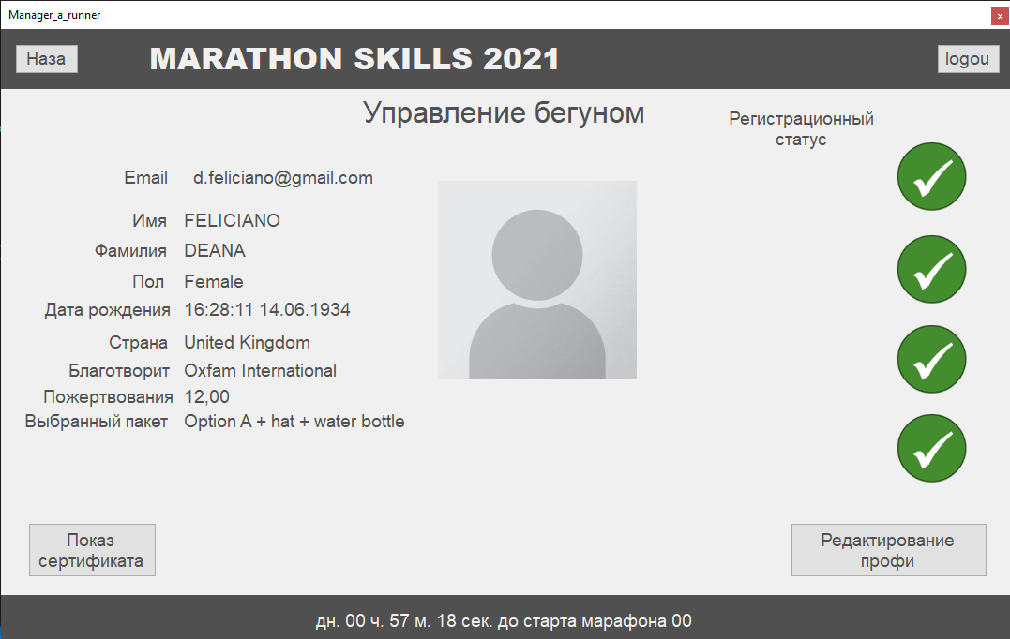

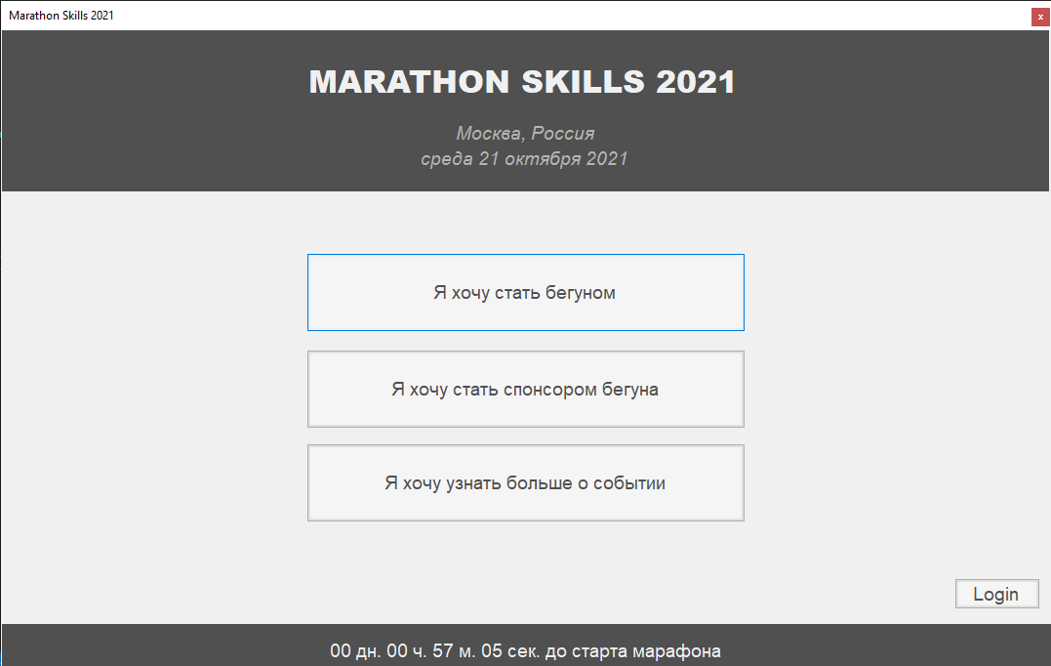

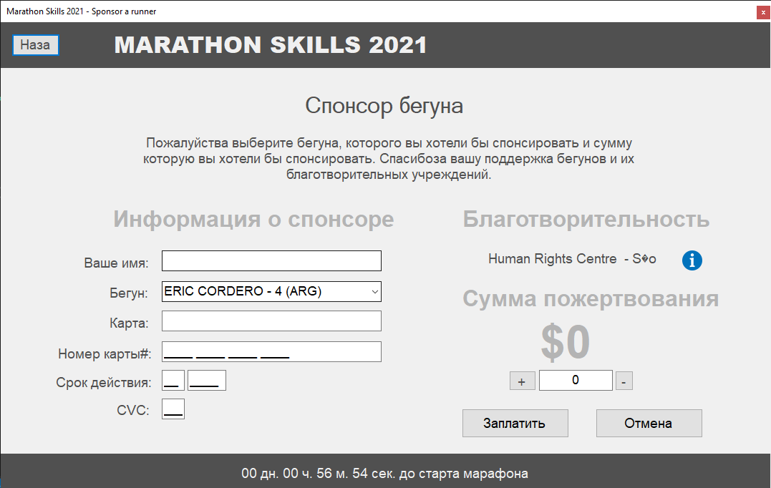

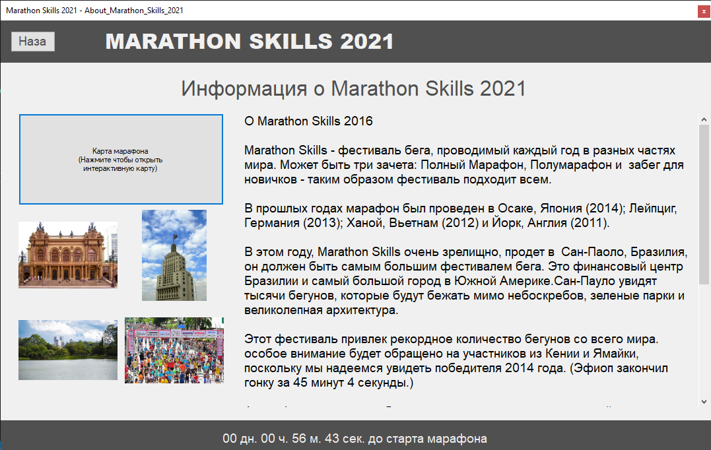

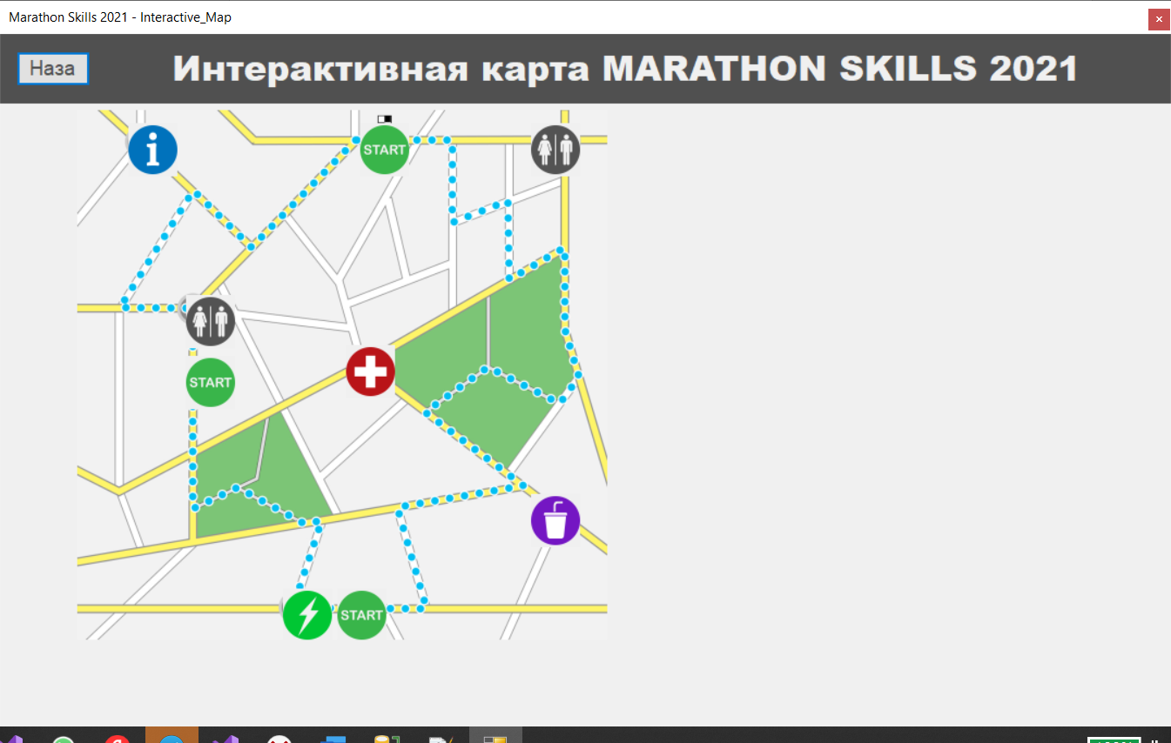

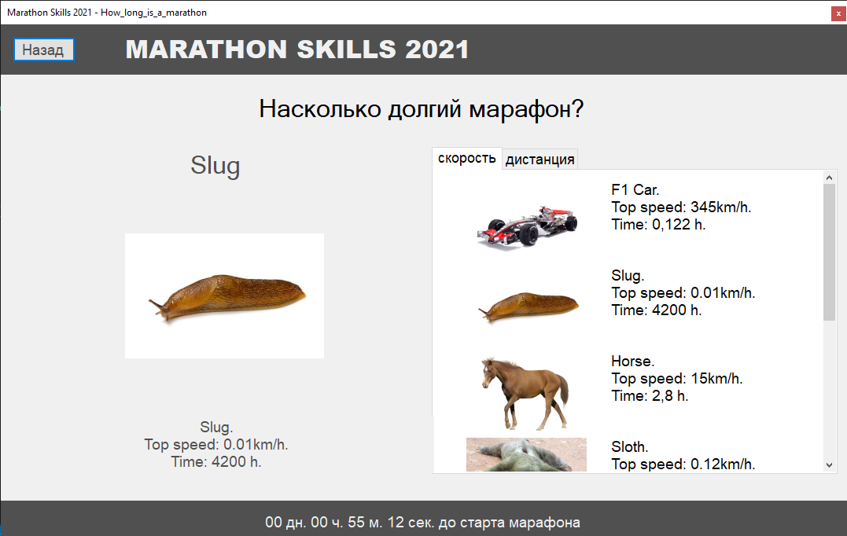

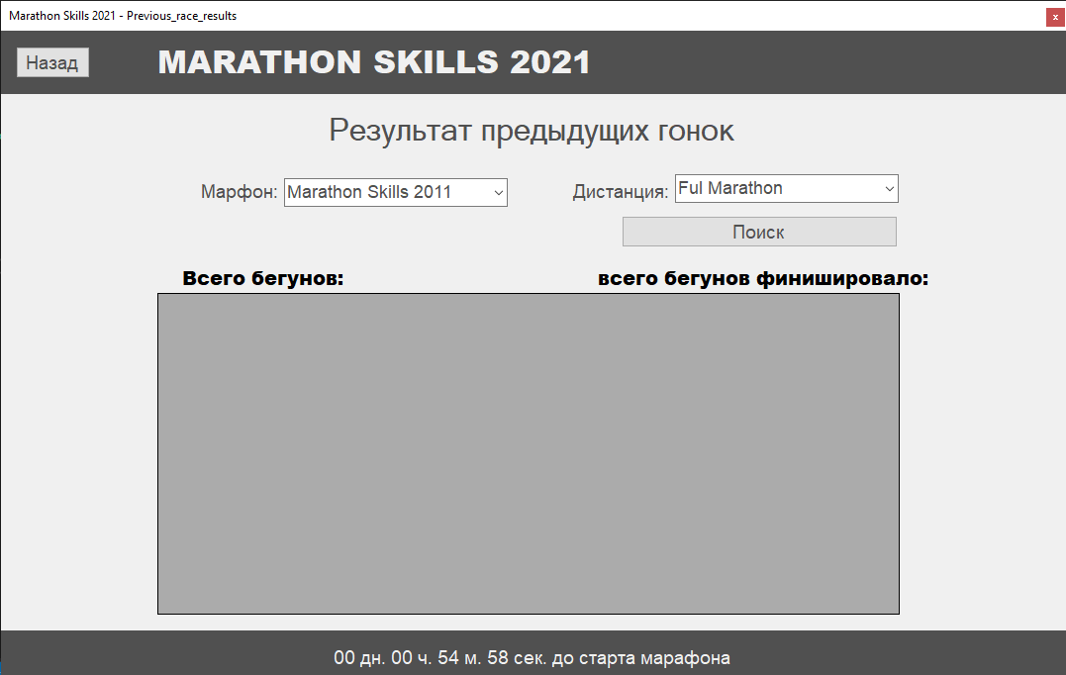

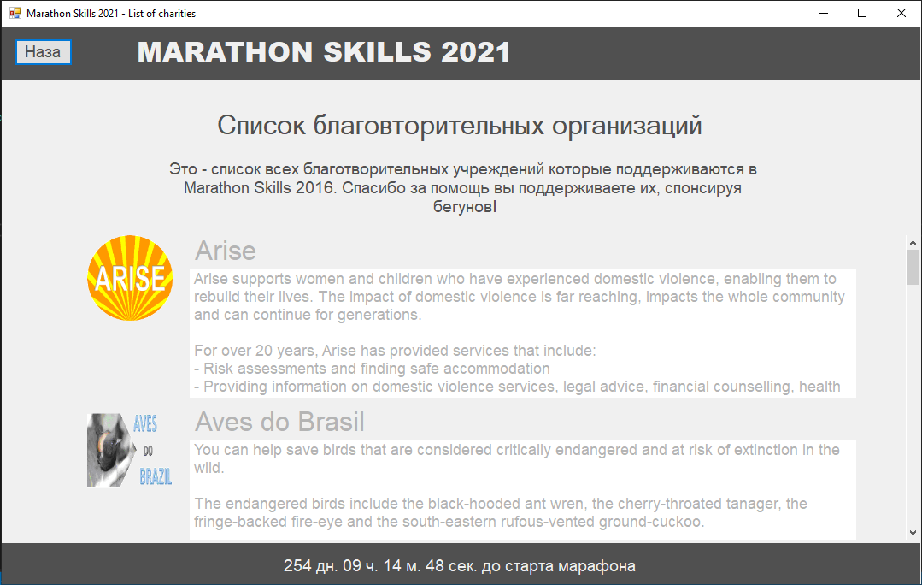

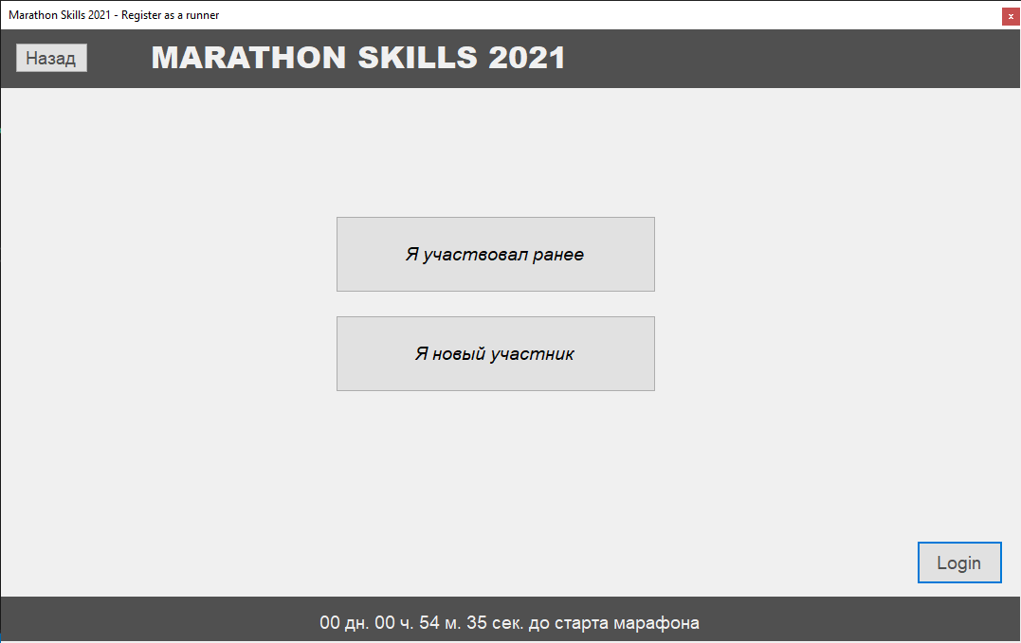

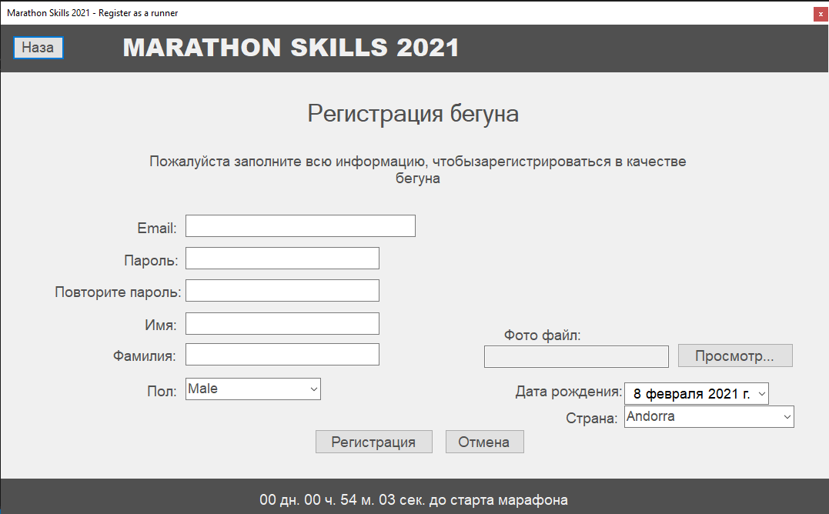

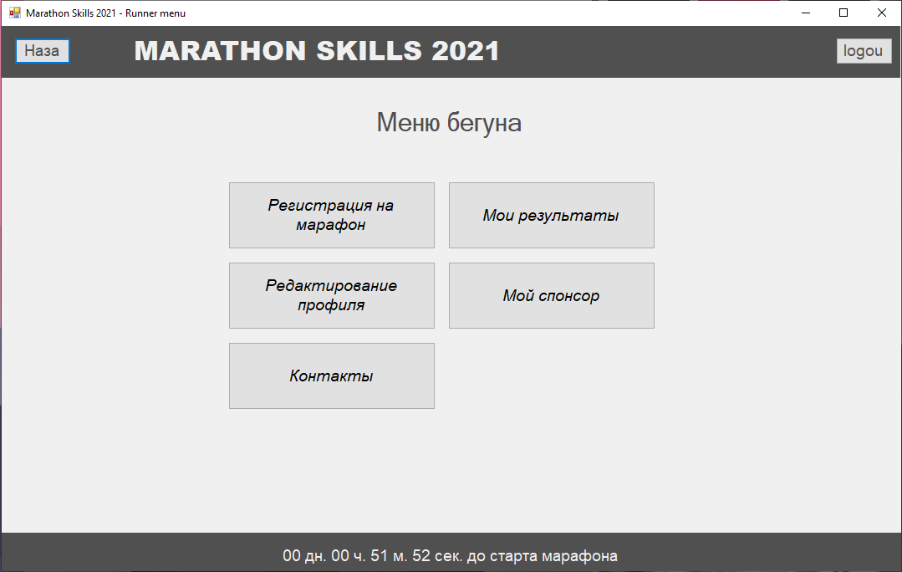

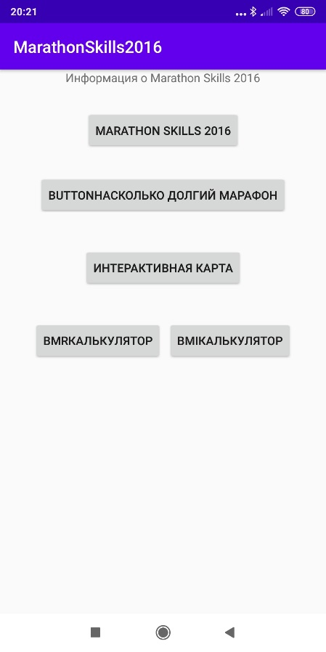

Рисунок 25 мобильное главное меню

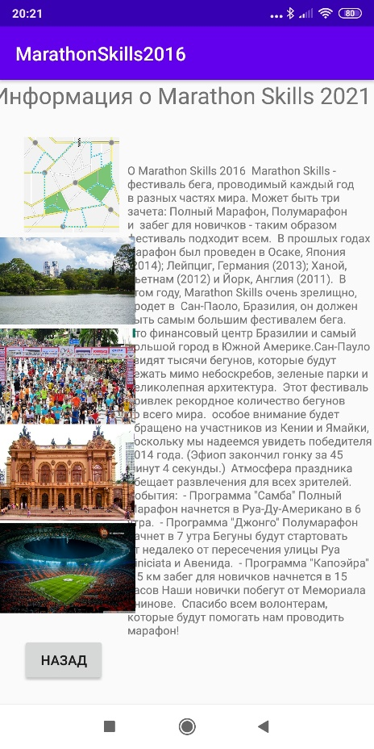

Рисунок 26 Информация о марафон скиллс

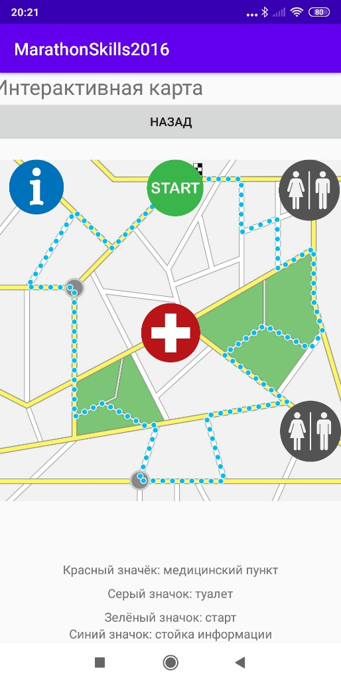

Рисунок 27 интерактивная карта

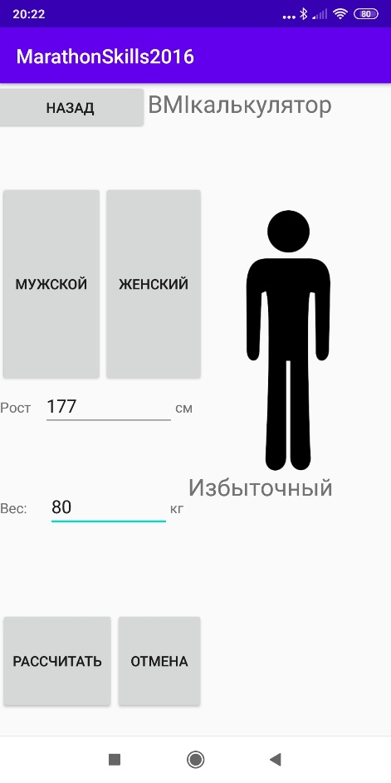

Вывод: научился выполнять работу по техническому заданию.