FULL WORKFLOW EXPLAINED WITH GITOPS

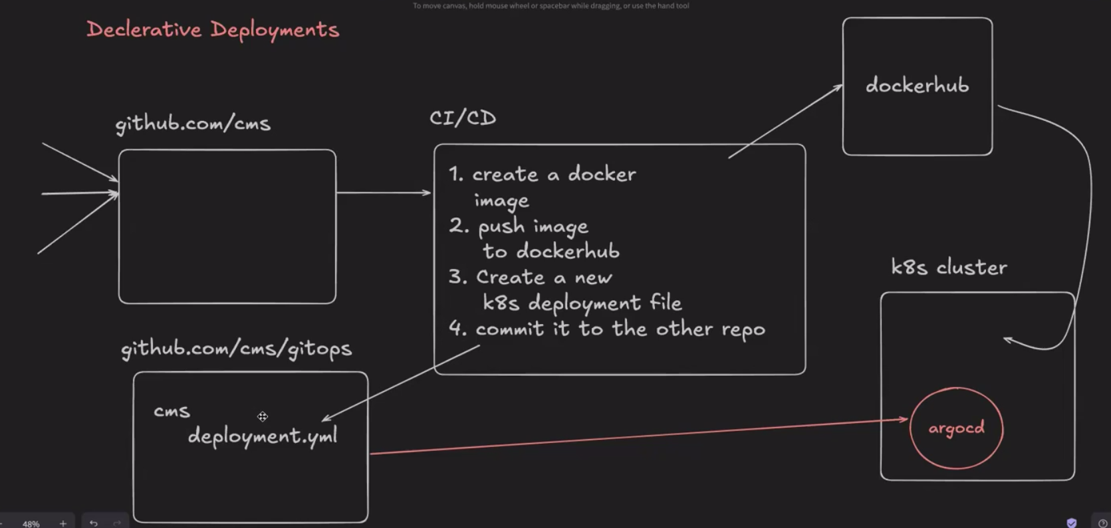

imagine 2 repos one with the code and other one with the yml files only which the k8s access

now in this imagine someone made some changes so than it runs on the github workflows
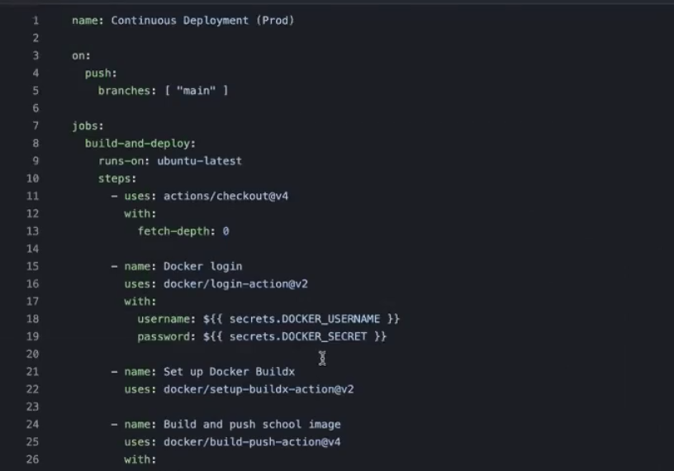
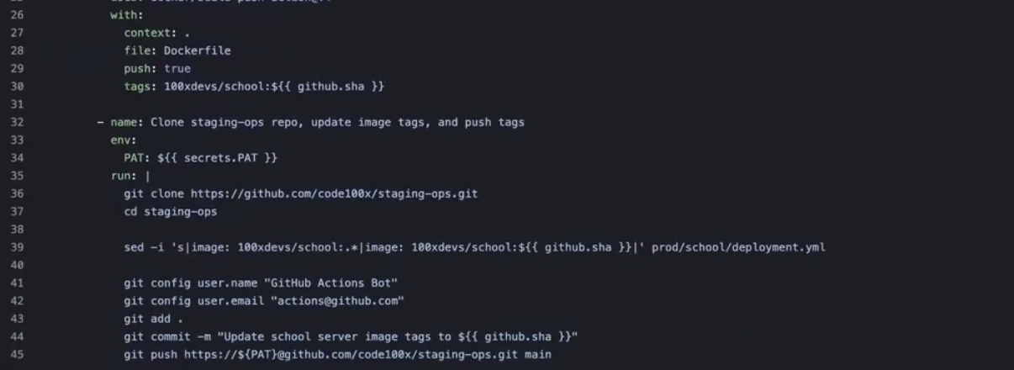
now first the docker login is done and the docker new file is made with the sha of the github commit and then pushed to the dockerhub
then the yml file repo is cloned and then the docker file name is changed in that file and then the commit is pushed in that repo also

THIS IS LIKE WE HAVE DESCRIBED THE OPS FILE USING GIT
THIS IS CALLED AS DECLARATIVE DEPLOYMENT(THIS IS LIKE WE HAVE DECLARED WHAT TYPE OF FILE WE WANT AND HOPING THAT THE K8S WILL CREATE THAT)

NOW IN THE K8S SOMETHING IS PRESENT WHICH IS PULLING EVERY 5-10 SEC NEW DATA FROM THE OPS REPO(WHICH IS CALLED AS ARGOCD GITHUB PROVIDER)
SAME AS ARGO CD THERE IS SOMETHING CALLED AS FLUX
REACT IS A DECLARATIVE UI(ISME BHI HAAM DECLARE KARDETE HAI KAISA DIKHNA CHAIYE AND WOH FHIR DIKH JATA HAI)

ADV:
GIT LOGS ARE PRESENT, UNDO THE CHANGES, ETC

ACTUALLY LEARNING ABOUT THE GITOPS AND ARGOCD
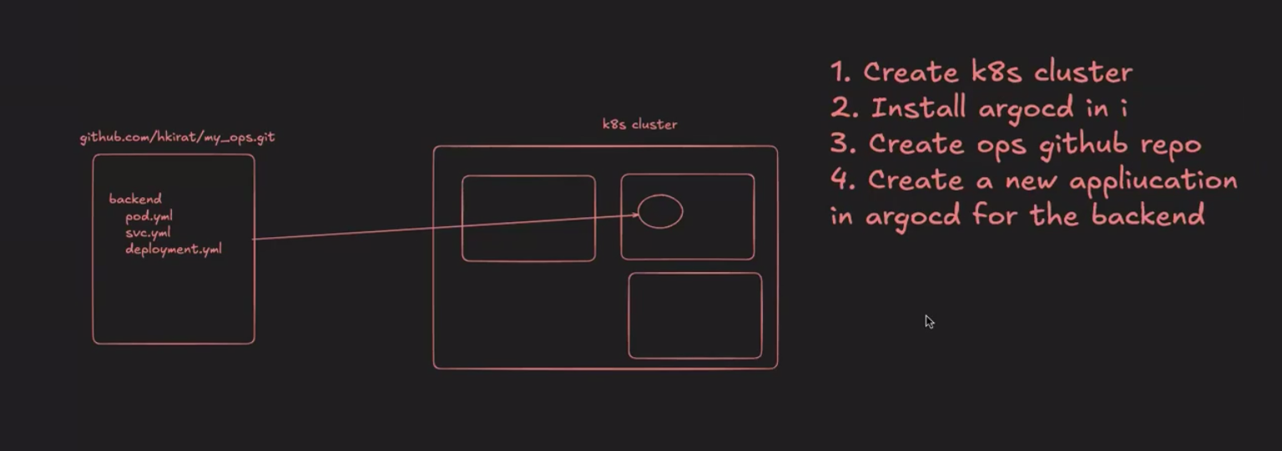
1. CREATE A FRESH K8S CLUSTER and name is gitops
copy the config file

2. installing the argocd (it just means applying a very big manifest file)
kubectl create namespace argocd
kubectl apply -n argocd -f https://raw.githubusercontent.com/argoproj/argo-cd/stable/manifests/install.yaml

or also you can use DO marketplace

in the cluster settings directly install the argocd from the marketplace with a simple install button

3. created a ops repo

https://github.com/PDGamerSG/argo-deployment

4.now what we want is to access the argocd for that we can either use the ui or the commands
the commands are:
Install argocd CLI (not required but recommended)
brew install argocd
- Access the argocd ui
kubectl port-forward svc/argocd-server -n argocd 8080:443
- Get the argocd password
kubectl -n argocd get secret argocd-initial-admin-secret -o jsonpath="{.data.password}"
- Debugging
kubectl logs -n argocd deployment/argocd-application-controller
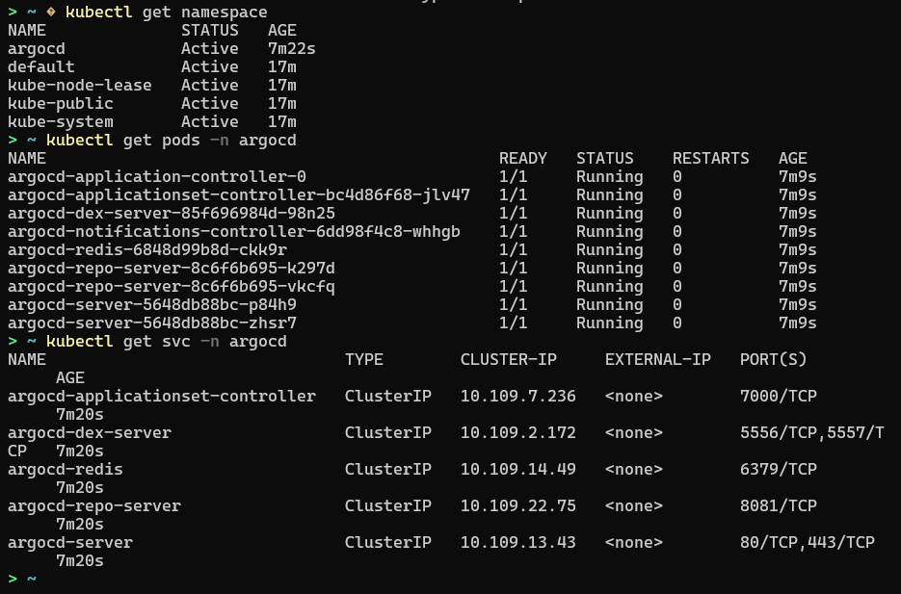
BUT WE ARE USING SOMETHING ELSE
LIKE YOU CAN SEE IN THIS THE ARGOCD EXPOSES A SERVER WHICH EXPOSED FE ALSO SO WE WANT TO ACCESS THAT WE CAN USE LOADBALANCER BUT WHY TO USE THAT

WE CAN USE SOMETHING NEW CALLED AS PORT FORWARDING

the argocd-server is the one which we want to port forward too

kubectl port-forward svc/argocd-server -n argocd 8080:443

use this command to port forward

now at localhost:8080
you can see the argocd ui

NOW IN THIS WE CAN TELL ARGOCD ISS REPO SAE CODE PULL KARNA HAI

username: admin
password: use this command
kubectl -n argocd get secret argocd-initial-admin-secret -o jsonpath="{.data.password}"
now this password is in base64 encoded because its stored in the secrets.yml file but in configfile we store plain only
V0E0d3JISzBOcFhlTGpiZw==
convert that again use this website
https://www.base64decode.org/

don’t base64encode use base64decode.org
OR USE

echo “pass” | base64 --decode

now you can login and see the UI

now create the project
choose name
backend-school
project name == default
sync policy == automatic (AND MANUAL MEANS DEV HAS TO CLICK AND APPROVE)
then there are some options
ENABLE AUTO SYNC ✅
PRUNE RESOURCES ✅ (this means if the yml repo is deleted the project will also be deleted)
SELF HEAL✅

NOW PUT THE REPO URL
PATH IS THE ROOT FOLDER FOR NOW PUT DOT .
CLUSTER URL == https://kubernetes.default.svc
NAMESPACE = DEFAULT
DIRECTORY RECURSE == IF THERE ARE OTHER FOLDERS INSIDE THE REPO THAT FILES WILL ALSO BE APPLIED

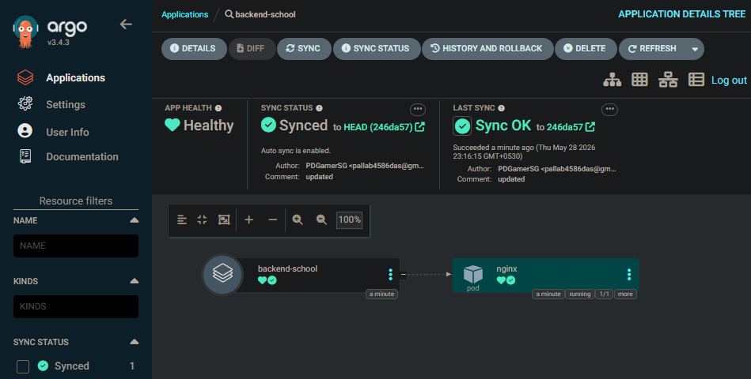
NOW CREATE

NOW CLICK ON HEALTHY IT WILL SHOW WHAT ALL THINGS ARE RUNNING

now if you check in the kubectl get pods it will show nginx is running which automatically ran using the argo cd DAMNNNNNN

NOW IF WE MAKE CHANGES IN THE YML FILE

NOW IN THE ARGO CD CLICK ON SYNC TO GET THE NEW FILE
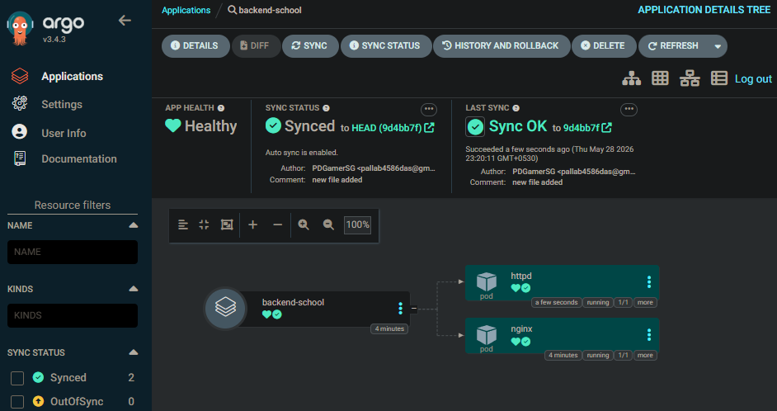
NOW YOU CAN SEE WE ADDED A NEW CONTAINER AND ITS ADDED

NOW ITS LIKE WE HAVE TO JUST MAKE CHANGES IN THE YML FILE AND AUTOMATICALLY THE CHANGES WILL HAPPEN

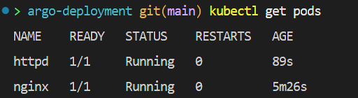
ALSO THIS SHOWS THAT

JUST THE USE OF THIS IS THE GIT COMMITS WILL KEEP A TRACK LIKE WHAT ALL CHANGES WERE DONE AT WHAT TIME

AND ALSO LIKE IF ONE REPO HAS TO PUSH SOMETHING TO ANOTHER REPO USING THE CI CD PIPELINE WE HAVE TO CREATE SOME TYPE OF PAT FILE AND THEN USE IT

CREATING A WHOLE WORKFLOW OF GITOPS

npx create-next-app@latest
create the next js application

now create a repo and push the code
and now create .github/workflows folder

now create a prob.yml and copy this

name: Continuous Deployment (Prod)

on:
push:
branches: [ "main" ]

jobs:
build-and-deploy:
runs-on: ubuntu-latest
steps:
- uses: actions/checkout@v4
with:
fetch-depth: 0

- name: Docker login
uses: docker/login-action@v2
with:
username: ${{ secrets.DOCKER_USERNAME }}
password: ${{ secrets.DOCKER_SECRET }}

- name: Set up Docker Buildx
uses: docker/setup-buildx-action@v2

- name: Build and push school image
uses: docker/build-push-action@v4
with:
context: .
file: Dockerfile
push: true
tags: pdgamersg/todo-app-week-39:${{ github.sha }}

now add the docker secrets in the github in the yml file github
settings/secret and variables/actions
create secrets for the docker username, and secret

from the settings add these secrets

also create a docker file because the workflow needs that

A QUESTION LIKE JS, NODE IS SINGLE THREADED AND GOLANG IS MULTI THREADED WHICH MEANS IT CAN RUN A LONG TASK FASTER BY DIVIDING THE WORK INTO MULTIPLE CORES WHEREAS THE NODEJS CANNOT DO THAT AS IT CAN ONLY USE SINGLE CORE AT ONCE

CONCURRENCY MEANS IT CAN DO 2 DIFFERENT THINGS TOGETHER BUT IN A SINGLE CORE ONLY, LIKE AEK CHIJ THODI RUN HUI FHIR THODI RUN HUI JS IS CONCURRENT
WINDOWS RUNS THE APPLICATIONS CONCURRENTLY NOT PARRELELLY OR OTHERWISE WOULD HAVE REQUIRED LIKE 50 CORES

------------------------------------------------------------

NOW ON THIS url the docker file is present

https://hub.docker.com/r/pdgamersg/todo-app-week-39

NOW TO DO IT MANUALLY JUST GO TO THE https://github.com/PDGamerSG/argo-deployment AND JUST ADD THIS ABOVE DOCKER LINK TO THAT

and the ARGO CD will automatically deploy that

NOW TO REMOVE THAT MANUAL STEP WE HAVE TO MAKE SOME CHANGES IN THE PROD.YML
- name: Clone staging-ops repo, update image tags, and push tags
env:
PAT: ${{ secrets.PAT }}
run: |
git clone https://github.com/PDGamerSG/argo-deployment
cd argo-deployment

sed -i 's|image: 100xdevs/todo-app-week-39:.*|image: 100xdevs/todo-app-week-39:${{ github.sha }}|' manifest.yml

git config user.name "GitHub Actions Bot"
git config user.email "actions@github.com"
git add .
git commit -m "Update school server image tags to ${{ github.sha }}"
git push https://${PAT}@github.com/pdgamersg/argo-deployment.git main

now for this we have to create a PAT(personal access token)
for that go to first the account settings and then the developer settings and then the PAT TOKEN CLASSIC

create a token for the argo repository
and add that in the todo app secret

and then push the code
the actions success

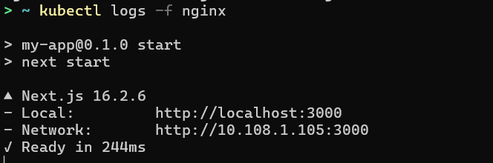
running now lets go

FOR LIKE ONCE YOU HAVE TO CHANGE THE URL IN THE MANIFEST.YML IN THE ARGO DEPLOYMENT REPO AND THEN ALSO IT STARTS TO CHANGE THE NAME

HELM
choco install kubernetes-helm
cat .\clusters.yml
kind: Cluster
apiVersion: kind.x-k8s.io/v1alpha4
nodes:
- role: control-plane
- role: worker
- role: worker
kind delete cluster -n local
kind create cluster --config .\clusters.yml -n local

ITS LIKE A WAY OF MAKING THE LIFE EASY LIKE EARLIER IF WE HAVE TO START LIKE THE POSTGRESS WE HAVE TO CREATE SO MANY THINGS OURSELF SO TO FIX THAT WE CAN JUST USE THAT AND JUST MAKE SOME CHANGES TO THE CONFIG FILE AS PER OUR USAGE

