
A
Final Year Internship Proposal On “Pravidhi Web Application” At “Pravidhi Digital Innovations Nepal PVT LTD”

Submitted in Partial Fulfillment of the Requirement for Degree of Bachelor of Science in Computer Science and Information Technology (B.Sc. CSIT) Awarded by Tribhuvan University

Submitted by:
Nirdosh Poudel (30099/078)

Submitted to:
Institute of Science and Technology Tribhuvan University

DEPARTMENT OF COMPUTER SCIENCE AND
INFORMATION TECHNOLOGY
Mount Annapurna Campus

Pokhara-5, Parshyang
November,2025

TABLE OF CONTENTS
LIST OF FIGURES 3
LIST OF TABLES 4
CHAPTER 1 : INTRODUCTION Error! Bookmark not defined.
1.1. Introduction to Internship 5
1.2. Introduction to Project 5
1.3. Problem Statement 6
1.4. Objective of Internship 6
1.5. Objective of Project 6
CHAPTER 2 : INTERNSHIP DESCRIPTION 7
2.1. Organization Description 7
2.2. Description of Internship Duration 8
2.3. Internship Plan 8
2.3.1. Internship Activities 8
2.4. Development Methodology 10
2.4.1. Gantt Chart 11
CHAPTER 3 : EXPECTED OUTCOMES 12
3.1. Expected Outcome of Project 12
3.2. Expected Outcome of Internship 12
REFERENCES 13

LIST OF FIGURES

Figure 1: Pravidhi Digital Innovations Logo ....................................................................... 3
Figure 2: Operational Hierarchy of Pravidhi Digital Innovations........................................ 4
Figure 3: Iterative Software Development Cycle ................................................................ 6
Figure 4: Proposed Gantt Chart for Internship Activities .................................................... 7

LIST OF TABLES

Table 1: Organization Information ...................................................................................... 3
Table 2: Internship Description Table ................................................................................. 4

CHAPTER 1

INTRODUCTION

Introduction to Internship
The internship serves as a bridge between the theoretical knowledge acquired in the classroom and the practical application of skills in a real-world setting. It provides opportunity to immerse in the dynamic and ever-evolving field of technology, gaining invaluable hands-on experience, refining technical skills, and developing a deeper understanding of industry practices and standards.
The internship applies theoretical concepts and methodologies learned in the classroom to real-world scenarios, contributing to meaningful projects and initiatives within the organization. The internship is important part of the “Bachelors of Science in Computer Science and Information Technology” course affiliated with reputed university, Tribhuvan University. This internship carries six credits and lasts minimum of ten weeks or 180 hours. The main goal of our internship is to provide students with the opportunity to apply the theoretical knowledge gained during their bachelor's degree program to real-world scenarios.

Introduction to Project
As an intern at Pravidhi Digital Innovations, I will be working as a Frontend Developer, focusing primarily on building interactive, user-facing parts of websites and apps, turning designs into code using React to create reusable components, manage data flow, ensure responsiveness across devices, and connect with backend services. My main project involves developing a web-based application for the company, where I will be responsible for Building User Interfaces (UI)s, Convert UI/UX designs (wireframes, mockups) into functional code, Communicate with backend APIs to get and send data and manage that data, ensure Responsiveness of the web application. Throughout this internship, I will be engaged in the complete Frontend development lifecycle from planning and implementation to testing and optimization. This project allows me to strengthen my skills in React, Responsive designs, and software development workflows while contributing directly to the company’s operational requirements.This internship project not only supports my academic learning but also equips me with practical, industry-relevant experience in Frontend development and modern web technologies.

Problem Statement
In many organizations, a major challenge lies in the lack of a centralized digital system where they can efficiently manage, store, and track essential data. Companies often rely on scattered tools, manual processes, or multiple third-party services, which increases operational complexity and cost. This absence of a unified and reliable platform leads to data inconsistencies, slower workflows, and reduced productivity. As a result, organizations face difficulties in maintaining smooth operations and delivering quality services to clients and stakeholders.

Objective of Internship
The internship program is designed to provide students with meaningful professional exposure through hands-on involvement in industry-level projects. By applying academic knowledge to practical situations, interns develop stronger technical, analytical, and problem-solving skills. This experience also promotes teamwork, self-confidence, and overall personal growth.
During the internship, students get the opportunity to contribute to actual organizational projects, collaborate with development teams, and enhance their understanding of professional software development practices.
The primary objective of the internship program is:
- Gain Practical Industry Experience: Develop hands-on skills by working on real-world web development tasks using React, bridging the gap between classroom knowledge and professional practice.

Objective of Project
The project I am developing during my internship at Pravidhi Digital Innovations focuses on creating Interactive user-facing parts of website using React.js. The aim is to provide the organization with a reliable and scalable Frontend platform that supports efficient data management, process automation, and seamless integration with backend systems.
The objectives of this project are:
- To build interactive, user-facing parts of websites and apps, turning designs into code using React to create reusable components, manage data flow, ensure responsiveness across devices, and connect with backend services, focusing on a fast, smooth, and visually appealing user experience.

CHAPTER 2

INTERNSHIP DESCRIPTION

2.1. Organization Description
Pravidhi Digital Innovations is a renowned IT service provider based in Srijana Chowk, Pokhara-8. The company's mission is to facilitate skill development and career advancement through a range of services, including IT courses, academic programs, job-related trainings, internship opportunities, and job placements. Pravidhi Digital Innovations aims to bridge the gap between education and industry by providing practical, hands-on learning experiences. (Pravidhi, 2020).
Figure 1: Pravidhi Digital Innovations Logo

Table 1: Organization Information
Name | Pravidhi Digital Innovations
Organization Type | Private Limited
Address | Pokhara-8, Srijanachowk
Phone | +977 9856282224
Email | infopravidhinepal@gmail.com
Website | www.pravidhinepal.com

The following is the organizational hirearchy:
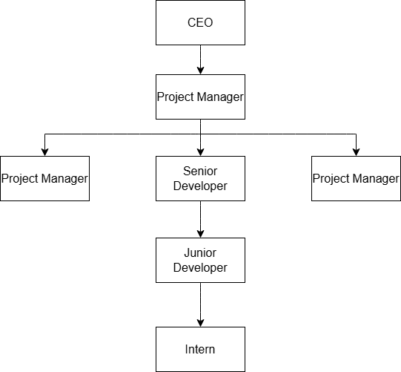
Figure 2: Operational Hierarchy of Pravidhi Digital Innovations

2.2. Description of Internship Duration
As per the requirement of the curriculum of BSc. CSIT 8th Semester, the minimum requirement of internship period is 10 weeks/180 hours. It consists of different phase of training or tasks performed with a specific objective for each phase. Each phase shows the progress of intern in internship. It also consists of information about how and when interns will accomplish objectives of each task.

Table 2: Internship Description Table
Start Date | 27th November, 2025
Duration | 10 Weeks
Office Hours | 11:00 am- 5:00pm
Working Hours | 6 hours per day
Working Days | 6 days a week (except Saturday)
Position | Intern
Mentor | Purnima Wagle

2.3. Internship Plan

2.3.1. Internship Activities
The internship plan consists of structured weekly tasks and development milestones designed to support progressive learning, hands-on experience, and successful completion of the backend project. The plan ensures continuous growth, technical improvement, and proper contribution to the project at Pravidhi Digital Innovations.

Week 1: Orientation and Project Familiarization
- Introduction to the project requirements, UI/UX goals, and its purpose within Pravidhi Digital Innovations. Familiarization with Django, project architecture, backend workflow, and coding standards used by the company.
- Familiarization with React, project folder structure, component architecture, and company coding standards.
- Setup of development environment (Node.js, package managers), Git version control, and project management tools..

Weeks 2–3: UI Architecture & Component Planning
- Analyze application modules and identify required UI components, routes, and state flows.
- Plan the component architecture: reusable components, pages, layouts, and global states.
- Map backend API endpoints to frontend views, defining how data will be fetched and displayed..
- Discuss challenges related to responsiveness, performance, state management, and UI consistency..
Weeks 4–5: Core Frontend Feature Development:
- Implement core UI components using React, Tailwind CSS (or company’s preferred UI library)..
- Build essential UI screens and reusable components based on the design.
- Implement routing (React Router) and set up page-level navigation.
Weeks 6–7: Feature Expansion and UI Optimization:
- Add additional modules, pages, or interactive features required by the system
- Improve additional modules, pages, or interactive features required by the system
- Strengthen frontend security: input validation, sanitized rendering, and secure API consumption.
- Enhance system reliability through refactoring and optimizing existing code.

Weeks 8–9: Testing and Final Adjustments:
- Perform functional testing of all UI components and API-integrated screens..
- Identify and Fix issues related to layout, responsiveness, data display, authentication, and navigation.
- Conduct integration testing between different pages and workflows for consistency.
- Validate performance in different browsers and devices..
Week 10: Documentation and Project Finalization:
- Document the component structure, routing configuration, state management logic, and API usage
- Prepare the final production build and assist with deployment (Vercel, Netlify, or internal servers).
- Create a structured presentation explaining the UI features, architecture, and design decisions..
- Participate in a knowledge handover session to ensure future maintainability and scalability..

2.4. Development Methodology
The Software Development Life Cycle (SDLC) outlines the structured phases required for building a software application, including planning, analysis, design, implementation, and testing. For this project, the Iterative Development Model has been selected as the primary methodology.
The iterative model emphasizes repeated cycles of development, where each iteration results in a functional version of the software. This allows for continuous improvement, early detection of issues, and regular integration of feedback. Each cycle includes designing, building, reviewing, and refining the system based on evolving requirements.
The choice of the Iterative Development Model is ideal for this project because the backend system is being developed for internal use at Pravidhi Digital Innovations, where requirements may evolve throughout the development process. Since the project does not have fully fixed or finalized initial requirements, multiple iterations allow new features to be added progressively.
User and team feedback plays a crucial role in shaping the system. Each version introduces enhancements, fixes, and additional functionalities based on practical needs, ensuring the backend becomes more reliable, scalable, and aligned with organizational workflows.
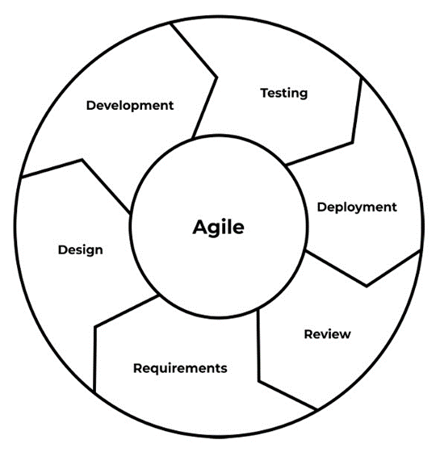

Figure 3: Iterative Software Development Cycle

2.4.1. Gantt Chart
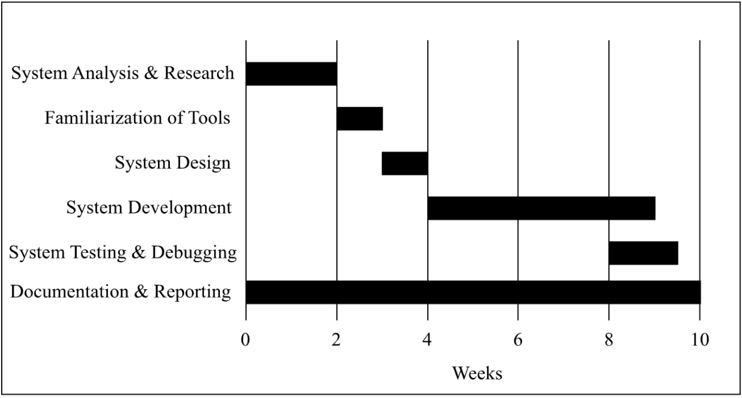

Figure 4: Proposed Gantt Chart for Internship Activities

CHAPTER 3

EXPECTED OUTCOMES

3.1. Expected Outcome of Project
During this internship at Pravidhi Digital Innovations, the primary goal is to deliver a reliable, scalable, and well-structured backend system for the organization. This includes building a interactive, user-friendly application for users.
The project emphasizes data accuracy, efficient logic implementation, and consistent performance. By the end of the internship, the expected result is a fully functional frontend system that supports smooth operations, simplifies data management, and meets the functional requirements defined by the company. This outcome ensures the organization has a dependable and maintainable system for ongoing internal use.

3.2. Expected Outcome of Internship
Participating in this backend development internship at Pravidhi Digital Innovations is expected to provide valuable practical experience in real-world software development. It allows me to apply theoretical knowledge in web development and React to a structured project environment, enhancing my skills in frontend programming, UI/UX designs and responsive designs.. The internship will improve my problem-solving abilities, debugging techniques, and understanding of professional development workflows, while also fostering teamwork, communication, and collaboration within a professional setting. Additionally, it will build confidence in handling production-level tasks, broaden my industry exposure, and strengthen my career readiness by providing demonstrable, hands on experience that will be beneficial for future employment opportunities.

REFERENCES
Pravidhi Digital Innovations. (2025). Home. Retrieved from https://pravidhi.com
React. (2025). React Documentation. Retrieved from https://react.dev
React Router. (2025). React Router Documentation. Retrieved from https://reactrouter.com
Tailwind CSS. (2025). Tailwind CSS Documentation. Retrieved from https://tailwindcss.com
Framer Motion. (2025). Animation Library Documentation. Retrieved from https://www.framer.com/motion
Redux Toolkit. (2025). Redux Toolkit Documentation. Retrieved from https://redux-toolkit.js.org

